END-OF-PHASE 1 PERFORMANCE REPORT

to the

Domestic Nuclear Detection Office

(Dept. of Homeland Security)

Detection of Heavily Shielded Nuclear Contraband through Muon Radiography with Advanced Micro-pattern Detectors

Contract # 2007-DN-077-ER0006

submitted by

Dr. Marcus Hohlmann, P.I.,

Patrick Ford, Dr. Kondo Gnanvo, Jennifer Helsby, David Pena,
Dept. of Physics & Space Sciences,

Richard Hoch, Dr. Debasis Mitra, Co-P.I.
Dept. of Computer Science

Florida Institute of Technology, Melbourne, Florida

DNDO Program Officer: Dr. Joel Rynes

May 31, 2008

Table of Contents

- Overview
- Technical Developments
  - Construction of Computing Cluster
  - Software Tools
    - GEANT4 Monte Carlo
    - Validation of CRY generator
  - Reconstruction Algorithms
    - Point-of-Closest Approach
    - Estimation Maximization
- Simulation results for a cosmic ray muon tomography station
  - Geometry
  - Muon energy loss
  - Coverage of interrogation volume with cosmic ray muons
    - Acceptance for station with top and bottom detector planes only
    - Acceptance for station with additional lateral detector planes
  - Z-discrimination based on scattering angles
    - Basic target scenarios
      - Monoenergetic muons
      - Cosmic ray muons
    - Signal significance
    - Detector resolution effects
    - Scenarios of special interest
      - Shielded target scenarios
      - Vertical clutter scenarios
- Conclusions
- References

- Overview
This report describes work performed and results obtained by the Florida Tech High Energy Physics Group under Contract #2007-DN-077-ER0006 during the first year of performance from May 1, 2007 to March 26, 2008. The research team comprises Dr. Marcus Hohlmann, P.I., Dr. Debasis Mitra, (inofficial) Co-P.I., faculty in the Fl. Tech Computer Science Dept., Dr. Kondo Gnanvo, post-doctoral associate, Richard Hoch, Computer Science graduate student, and physics undergraduates Patrick Ford, Jennifer Helsby, and David Pena.

- Technical Developments

The first year of the project focused entirely on the simulation and reconstruction of muons scattered by nuclear contraband and other material using a Monte Carlo method. This required building computing infrastructure at Florida Tech and implementing various software packages including the GEANT4 Monte Carlo package on this infrastructure.

  - Construction of Computing Cluster

A computing cluster was constructed initially using 20 dual-CPU Pentium-3 servers made available to us by the High Energy Physics group at the University of Florida. Gigabit network switches were procured and integrated into the cluster including one high-end CISCO switch which interconnects the main components. A frontend node controls the external traffic to the internet via a firewall. The current networking topology of the cluster is shown in Fig.1. At the time of writing, the cluster operates with 44 CPUs, ~13 GB of RAM, and ~2.7 TB of disk space out of which 1.3 TB are “Network Attached Storage” (NAS) in RAID5 configuration for mass storage of simulation data. The usage of the frontend and compute nodes can be monitored online at http://uscms1.fltech-grid3.fit.edu/ganglia. A large 19” server rack was procured for housing additional hardware, such as a 5kW uninterruptible power supply and state-of-the-art server hardware, i.e. a raided 10TB NAS, a new front-end with dual quad-core processors, and several compute nodes with dual quad-core processors and 2GB of RAM per core.
As the operating system for the cluster the free Linux-based ROCKS system was chosen (http://www.rocksclusters.org), which is a revamped CentOS distribution that allows cluster customization using a collection of XML files and software packages. The cornerstone of ROCKS is the kickstart graph, which lays out the internal structure and available appliances within ROCKS, and a MySQL database to manage the nodes from a central location, i.e. the frontend. The connections between bubbles on the kickstart graph tell ROCKS which packages to install on each appliance. Connections can be made on the graph by editing and creating ROCKS XML files, which in turn changes what software packages are distributed to the nodes. We initially installed ROCKS version 3.3.0 and later upgraded the entire cluster to ROCKS 4.2.1. A batch job system based on the condor and globus packages was also installed.
Problems with automounting and the MySQL cluster database on the frontend forced us to reinstall the cluster frontend on a new machine, which we also equipped with a larger disk. Due to this experience we installed a frontend configuration also 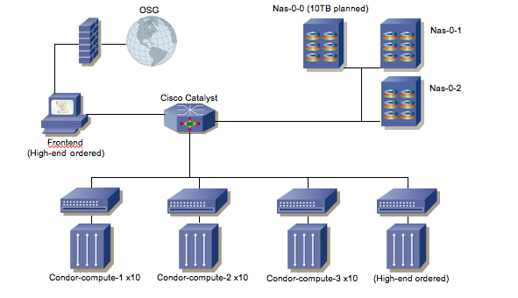Fig. 1 Topology of the computing cluster that was developed and used for simulation work. The current frontend node and the 20 compute nodes are servers with dual 1-GHz Pentium-3 CPUs. The two small Network Access Storage (NAS) devices were built at Florida Tech and comprise 1.3 TB of hard disk space in RAID5 arrays. A larger commercial NAS with ~10TB of storage space available is being integrated into the cluster.

on a second machine which can be used as a backup anytime in case the regular frontend machine fails again, which improves resilience against potential future frontend malfunctions.
We also succeeded in integrating the cluster into the Open Science Grid (OSG, http://www.opensciencegrid.org), which is a distributed computing infrastructure that is used for large-scale scientific work, in particular in High Energy Physics. OSG is backed by the NSF and the Department of Energy's Office of Science. After registration with OSG, authentication of the cluster and individual users, and verification of all the main grid functions, the cluster was placed in the OSG Integration Test Bed (ITB). An official map of the current OSG sites is shown in Fig.2. The dot on the Central East coast of Florida symbolizes our cluster with its green color indicating that the cluster is fully functional on the ITB. While getting on the grid, we have been documenting the set up and debugging process and created a website to host the documentation at http://uscms1.fltech-grid3.fit.edu.

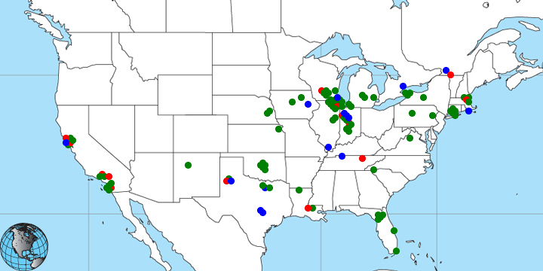

Fig. 2 Sites on the Open Science Grid as of March 2008. Our cluster is symbolized as a fully functional site by the green dot on the Central East coast of Florida (arrow).

  - Software Tools

    - GEANT4 Monte Carlo

Motivated by similar concerns about resilience against frontend failure, senior David Pena moved all user home directories to the RAIDed Network Attached Storage (NAS) and created a second GEANT4 installation and a GEANT4 user account on the NAS. As a consequence, there is no more need to install and maintain GEANT4 individually on each of the 20 nodes. Needed support libraries such as CLHEP and OpenMotif were installed and scripts were created so that GEANT4 jobs can now be submitted in batch job mode to the compute nodes from the new GEANT user account. For batch jobs the Condor batch job facility was installed, which can also balance the load across the cluster.
The CRY Monte Carlo generator for cosmic rays, which was developed by Doug Wright et al. at LLNL, was installed on the cluster and interfaced to our GEANT installation. CRY is designed to generate muons with angular distribution and energy spectrum corresponding to those of cosmic ray muons at sea level. As one of his first contributions to the project, Dr. Gnanvo interfaced the Java-based analysis tool AIDA with GEANT on the frontend machine. It allows the user to predefine a set of analysis histograms which get filled as the program is running and which can be monitored during the run. The students developed code that allows them to plot simulation results with CERN’s data analysis package “root”.

    - Validation of CRY generator

We have performed some basic checks on the output of the Cosmic Ray generator CRY that was developed at LLNL [need Ref.] and that we are currently using for generating cosmic ray muon input for the GEANT4 simulation. Specifically, we have checked the muon energy distribution and the zenith angle (from vertical down) distribution for a CRY muon sample comprising 2.5M events. The results are shown in Fig.8.
There are some concerns about these results. In both cases, we expected smooth distributions, but find “saw tooth”-like distributions with several edges that are not physical. Neglecting the saw tooth superstructure, the overall energy distribution with its maximum around 1 GeV and a mean around 3 GeV appears to be compatible with the known energy distribution for cosmic ray muons at sea level. However, we question if the overall zenith angle distribution with a maximum around 35º from the vertical down direction is physical. We expected a distribution proportional to cos²θ that peaks at 0º, but instead we find a distribution that appears to be proportional to sinθ⋅cos²θ. As a consequence, CRY does not, for example, generate any muons that come down vertically, which we think does not describe physical reality.
The P.I. is in contact with Dr. Doug Wright at LLNL, the P.I. of the group that produced the CRY generator, to resolve the issue. In fact, the P.I. was able to meet with Doug Wright in person at the 2007 IEEE Nuclear Science Symposium to discuss the question of the zenith angle distribution. For now and in all work shown below, we have decided to use CRY as is until the issue gets resolved.

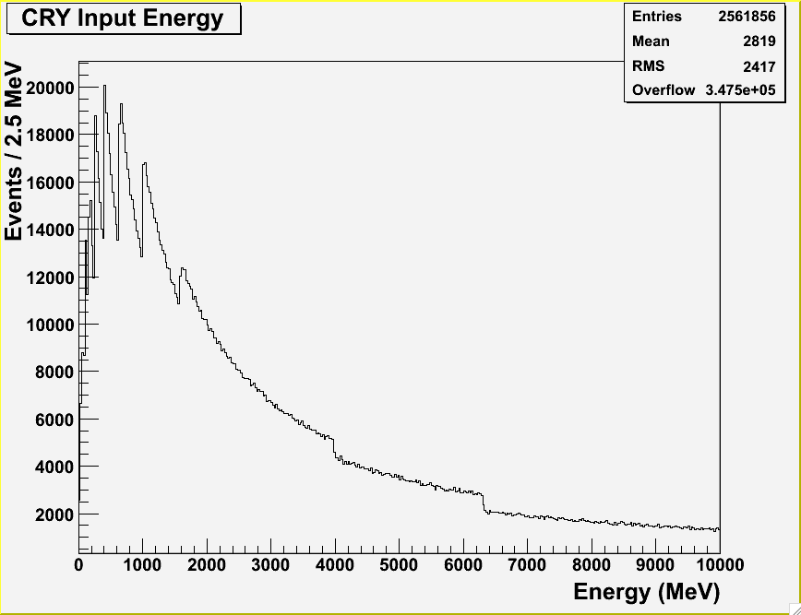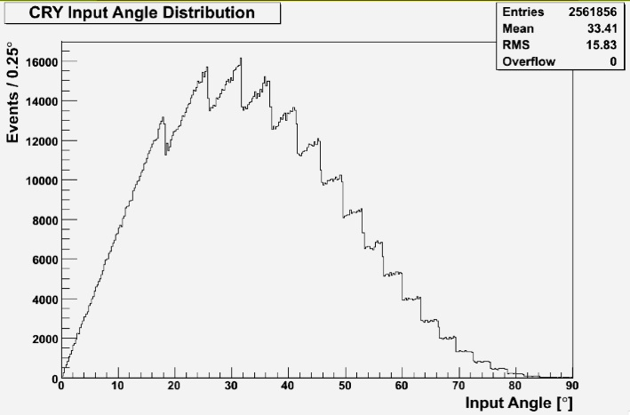

Fig. 3 Energy (left) and angle from vertical down (right) distributions for cosmic ray muons at sea level generated with the CRY package. Sample size is 2.5M events.

  - Reconstruction Algorithms

    - Point-of-Closest Approach

Debasis Mitra and graduate student Richard Hoch completed the implementation of our first basic muon tomography reconstruction algorithm using the “Point of Closest Approach” (POCA) method. The program finds the closest point to the two linear muon tracks in top and bottom detectors and calculates the scattering angle between the two tracks. Richie Hoch was also responsible for writing some utility software for the data analysis, e.g. a coverage calculation (section 3.3) and a validation tool (section 3.4.1.2).
The POCA reconstruction is a primitive technique as it does not use all information available to it. We have used an efficient version of the POCA algorithm provided by Dan Sunday [1]. It involves extending two infinite lines L1 and L2 through the entering and exiting muon tracks respectively. Each of these two lines are obtained by least-squares fitting of three detector points above or below the probed volume. In 3D the two tracks may not intersect. In that case the shortest line segment between the tracks is estimated by finding the pair of points of closest approach between the two lines. The mid point of this line segment is considered as the scattering point of the muon. The algorithm is as follows:
1) Take two tracks: L1 and L2 with direction vectors u and v respectively
2) Take w(s,t) as a vector connecting L1 and L2 at arbitrary points s on L1 and t on L2: w(s,t) = L1(s) - L2(t)
3) L1 and L2 are closest when the distance between s and t on w is at a minimum value and w is perpendicular to the two lines L1 and L2: w·u=0, w·v=0
4) Rewrite w(s,t): w(s,t) = L1(s) - L2(t) = w₀ + su - tv with w₀ = s₀ –t₀, where s₀ is an arbitrary initial point on L1 and t₀ an arbitrary initial point on L2.
5) Substitute (4) into equations at (3): (w₀ + su - tv)·u = 0 and (w₀ + su - tv)·v = 0 => (u·u)s - (u·v)t = -u·w₀ and (u·v)s - (v·v)t = -v·w₀
6) Set a = (u·u), b = (u·v) , c = (v·v), d = w₀·u and e = w₀·v and solve for s and t: s = be-cd/(ac-b^2) and t = ae-bd/(ac-b^2)
7) Estimate the scattering point p (we call it the “POCA-point”) as the mid point between s and t.
The scattering angle is also determined by finding the difference in the angles between the two tracks L1 and L2. For basic visualization of the reconstruction, a 3D scatter plot can be made using the locations of the reconstructed POCA-points with points colored for the values of the respective scattering angles. This algorithm is implemented in C.
    - Expectation Maximization
The expectation maximization algorithm (EM) was originally developed by Larry Schultz et al.[2]. EM uses more information (displacement, scattering angle, and muon momentum) as input than POCA does. It computes the scattering density of the material in each voxel of the probed volume. This method should more accurately deal with the underlying multiple scattering process than POCA, which is treating the process simply as single-point scattering.
We are implementing the EM algorithm in MATLAB as part of Richard Hoch’s M.S. thesis. Some aspects of the scattering physics are also being worked out. The EM-based reconstruction algorithm works as follows:
1) Gather data for all muons: (ΔX, ΔY, ΔΘ_{X}, ΔΘ_{Y}, p_{r}²)
Here ΔX & ΔY are the displacements in the respective X and Y directions (see Figs. 9 and 10 below: X is the direction of vehicle’s movement, Z is the vertical direction and Y is the direction across the vehicle) between the muon tracks at the top and bottom. ΔΘ_{X} and ΔΘ_{Y} are the scatterings in the respective directions of the muon and p_{r} is the ratio of nominal momentum to the actual momentum of the muon. This initial information is gathered from our POCA program. For this purpose, the point s where L1 (see above) hits the lowest of the top detector-stack is determined, similarly the point t where L2 hits the top of the bottom detector-stack is determined, and the muon path is determined by connecting s to the POCA point and t to the POCA point. ΔX and ΔY are determined using the points s and t; ΔΘ_{X} and ΔΘ_{Y} are determined using lines L1 and L2. The muon path determines which voxels a muon has actually traversed and thus is subjected to scattering in these voxels.
2) Estimate L_{ij}, the path of the i-th muon within the voxel j, and T_{ij}, the vertical height of the voxel from the bottom detector. Here L_{ij} is set to 0 for the voxels j which did not see any muon passing through.
This information is processed by a coverage analysis program. L is equal to the path length through a voxel and is defined by L = H * (1 + tan(Θ_{x0})² + tan(Θ_{y0}) ²) ^{0.5}, where H is the voxel size. As mentioned above, T is defined as the height of the exit point of a voxel to the exit point of the reconstruction volume. The coverage analysis keeps track of every voxel a muon travels through and then outputs the L and T of each voxel which the EM algorithm then stores in a matrix.
3) Compute (w_{Θ}, w_{Θx}, w_{x})_{ij} for every voxel of every muon
These are the components of the covariance matrix
w_{Θ,ij} = L_{ij}; w_{Θx,ij} = L_{ij}² / 2 + L^{ij} * T_{ij}; w_{x,ij} = L_{ij}³ / 3 + L_{ij}² * T_{ij} + L_{ij} * T_{ij}²
Σ = λ_{j} * [w_{Θ,ij}, w_{Θx,ij}; w_{Θx,ij}, w_{x,ij}] * p_{r}²
4) Initialize λ_{old} for all voxels
λ_{j} is the scattering density of each voxel j. It should be initialized to an arbitrary small value greater than 0 (as appropriate for the background material). Typical scattering densities (in milliradians²/cm) for certain materials are as follows: Aluminum (2), Iron (14), and Uranium (78). We intend to experiment with some heuristics for initializing λ_{j}’s such that the algorithm converges faster and to better local optima.
5) Do while (stopping criterion is not satisfied)
a) Compute V_{i} for all muons
V_{i} = Σ⁻¹ = [V_{11i}, V_{12i}; V_{21i}, V_{22i}]. This symmetric matrix may change in each iteration.
b) Compute C_{ij} for every voxel for every muon
C_{ij} =p_{r}²* (a_{i} -V_{11i}) * w_{Θ,ij} + p_{r}² * (c_{i}-V_{12i}) * w_{Θx,ij} + p_{r}² * (b_{i}-V_{22i}) * w_{x,ij}
a_{i} = (a_{xi}² + a_{yi}²) / 2; b_{i} = (b_{xi}² + b_{yi}²) / 2; c_{i} = (c_{xi}² + c_{yi}²) / 2 ;
a_{xi} = ΔΘ_{xi} * V_{11i} + Δx_{i} * V_{12i}; b_{xi} = ΔΘ_{xi} * V_{21i} + Δx_{i} * V_{22i} ;
c_{xi} = a_{xi} * b_{xi} (and same for y)
c) Update λ for every voxel
λ_{j} = λ_{old,j} + (λ_{old,j})² * (1 / (2 * M_{j})) * [sum over i, of C_{ij} ‘s, for the j-th voxel hit by i-th muon track, or for muons with L_{ij} !=0],
where M_{j} is the number of rays hitting the j-th voxel
d) Set, λ_{old} = λ, for all voxels
6) End Do
By following the actual track rather than going over each voxel within the iteration (lines 5 and 6 above) we have improved the efficiency of the algorithm. Currently we are using only the station geometries with top and bottom detectors without any detectors on the sides. The initialized geometric parameters (ΔX, ΔY, ΔΘ_{X}, ΔΘ_{Y}) and T_{ij} will have to be computed differently when we introduce the side detector arrays. We expect to modify Schultz’s algorithm for better efficiency and compare our results with POCA in the next phase of the project.

- Simulation results for a cosmic ray muon tomography station

  - Geometry of Cosmic Ray Muon Tomography Station

The typical geometry that we use for the cosmic ray studies is shown in Fig.4. CRY generates muons over a 5 × 5 m² (= 250,000 cm²) square plane. Underneath this CRY plane a top and a bottom detector - each comprising 3 GEM planes - sandwich a “floating” target cube of 1 liter volume (10×10×10 cm³). The GEM detector planes have an area of 3×3 m². The sizes of the CRY plane and the detector planes were deliberately chosen to have much larger dimensions than the target so that cosmic ray muons with large zenith angles up to ~ 70º can be taken into account. Distances between planes are indicated in Fig.9. The volume of the simulated experimental hall is filled with air.

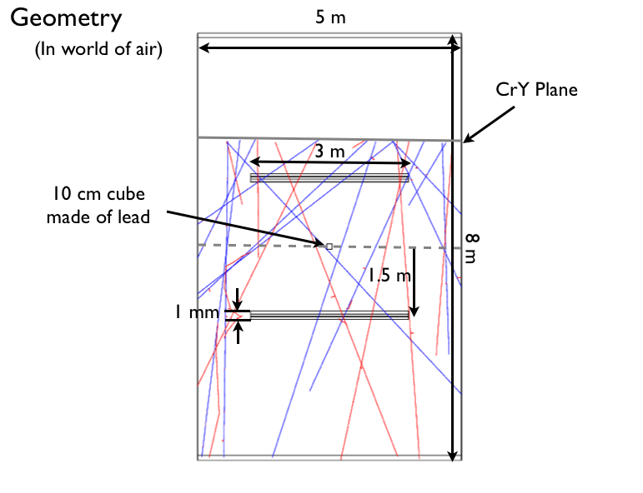
Target:
Muons originate here over
an area of 250,000 cm²
GEM detector planes
Top View
5m
3m
CRY plane
GE M s
Side View
μ⁺
μ⁻

Fig. 4 Geometry for basic studies of multiple scattering of cosmic ray muons in “floating cube” targets. Several simulated muon tracks originating in the CRY plane and traversing the simulated geometry are shown in red and blue.

  - Muon energy loss

We have developed an initial basic simulation scenario for monoenergetic muons hitting a simple target as shown in Fig. 5. Since DNDO is interested in liter-sized objects we use10×10×10 cm³ cubes made of Al, Fe, Cu, Pb, and U as targets. Of course, in this case mainly the target thickness of 10 cm is relevant. We simulated muons with energies in an energy range similar to that of cosmic rays, i.e.1 GeV, 3 GeV, 10 GeV, and 20 GeV. The physics processes taken into account for charged particles in this simulation are ionization, knock-on electrons (δ-rays), Bremsstrahlung, and multiple scattering. For photons photoeffect, Compton scattering, and pair production are used.
For a basic check of our simulation results, we calculate the total energy loss of each muon traversing a target by subtracting the muon energy upon exit from the target from the muon energy at entrance into the target. In Fig.3 we show the resulting energy losses of muons for the chosen materials at 1 GeV and 10 GeV. Fig. 4 compares energy losses in ₈₂Pb and ₉₂U for all four chosen energies. Sample sizes are ~250k events for each element and energy. Non-Gaussian distributions with long tails are observed in each case as expected. The energy loss curves in Fig.3 are found to be separated into three groups: low-Z Al, medium-Z Fe and Cu together with high-Z Pb, and high-Z U. Even though Pb and U differ only by ΔZ=10, the resulting energy loss distributions barely overlap for all energies considered (Fig.4) because U is about twice as dense as Pb.

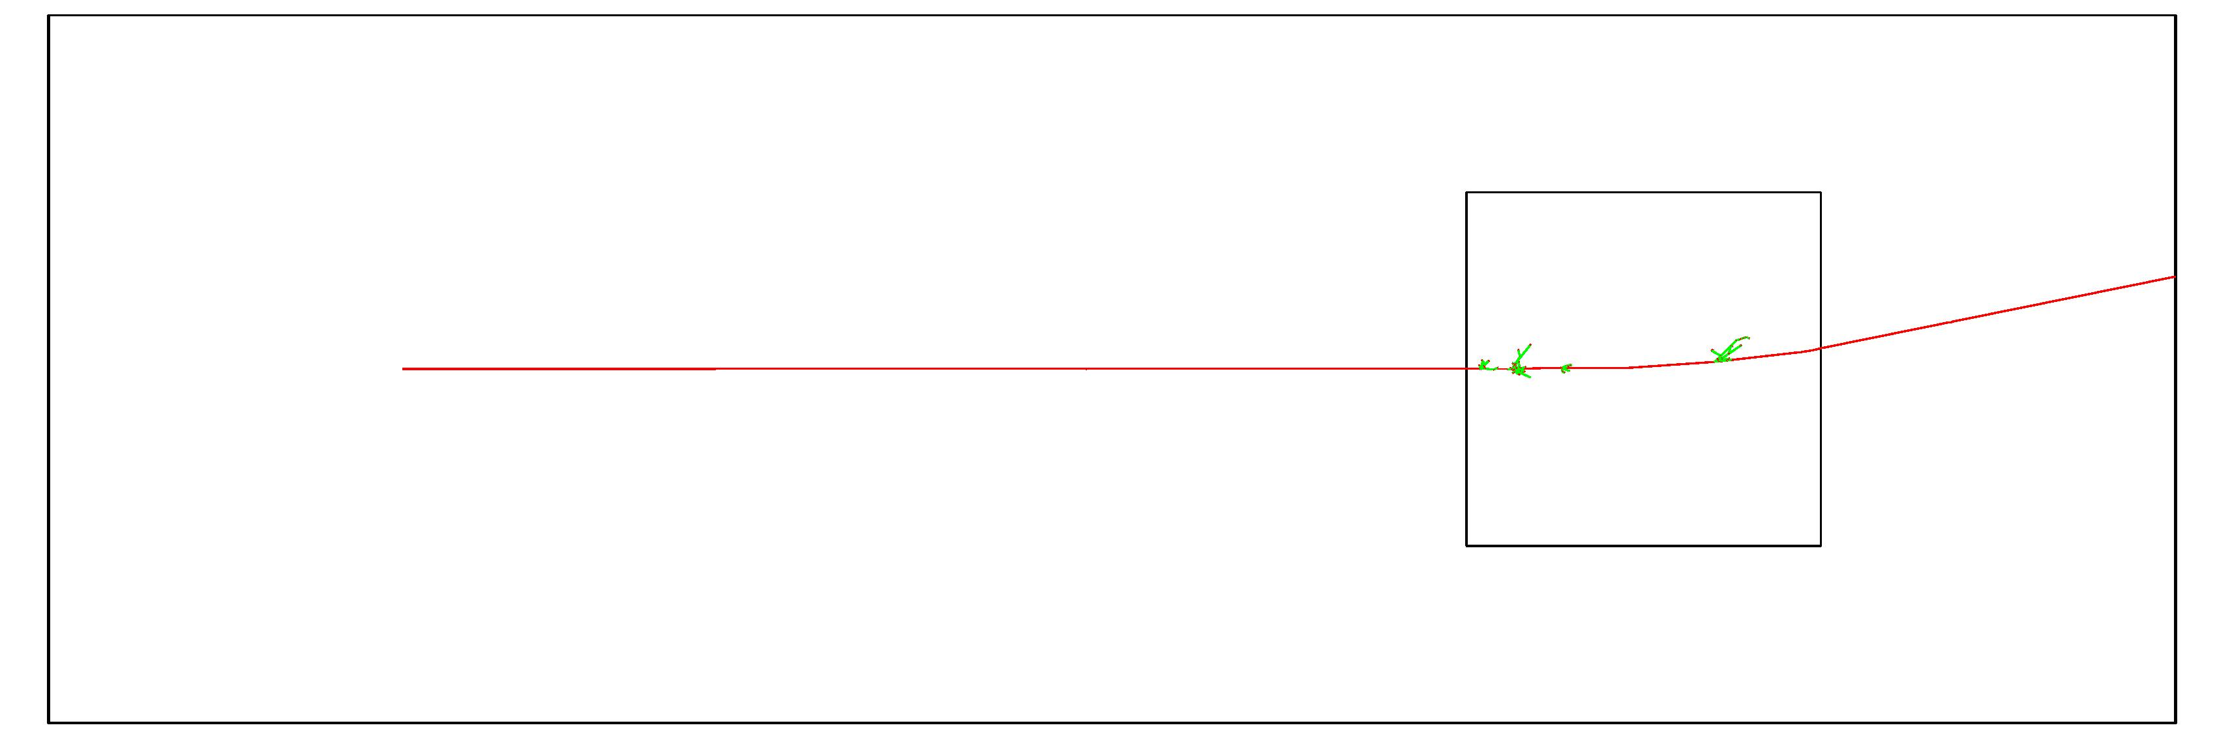
Experimental Hall with Ar atmosphere
3 GeV muon
Pb
θ_{plane}
Bremsstrahlung
Photons
10 cm

Fig. 5 Basic GEANT4 simulation scenario for monoenergetic muons impinging on 10 cm thick target.

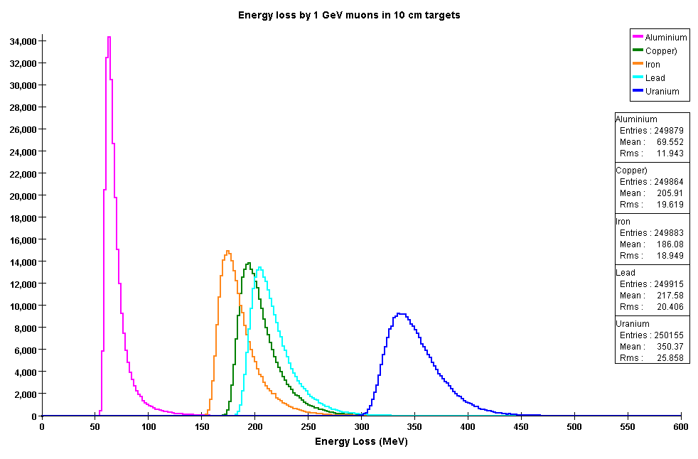
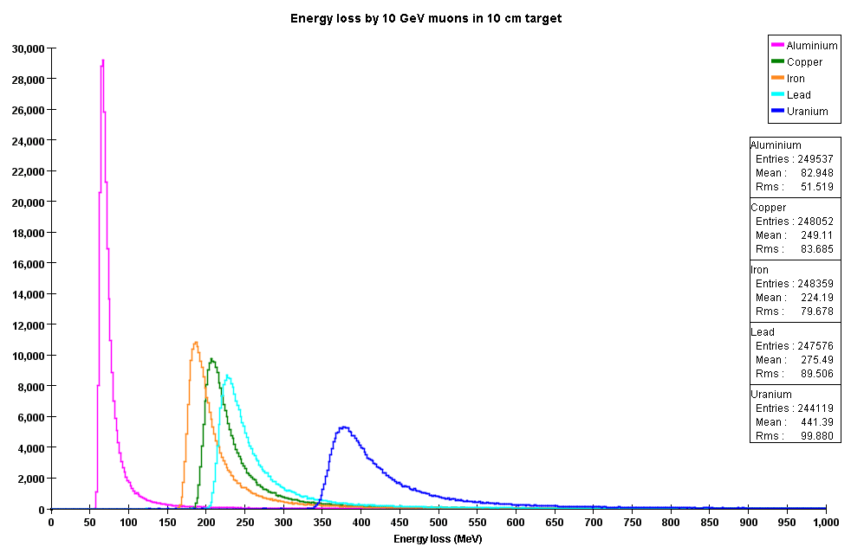
Fig. 6 Muon energy losses in 10 cm targets made of different elements for E_{μ} = 1 GeV (top) and E_{μ} = 10 GeV (bottom) obtained with GEANT4 simulation.
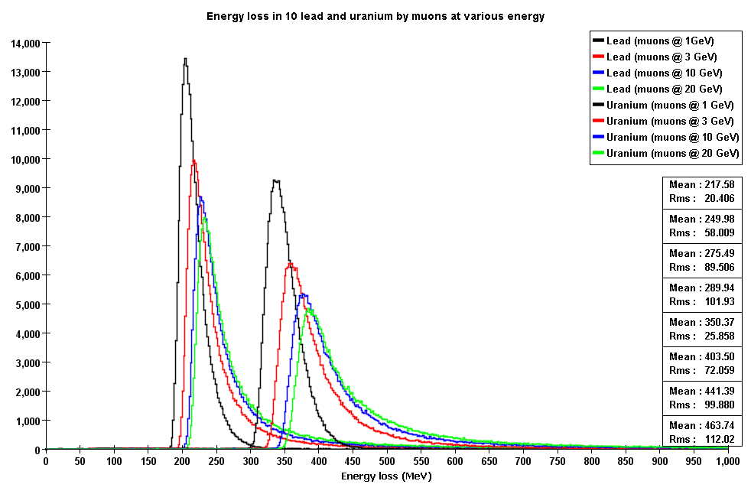
Fig. 7 Muon energy losses in 10 cm targets made of ₈₂Pb and ₉₂U for E_{μ} = 1, 3, 10, and 20 GeV obtained with GEANT4 simulation. All sample sizes are about 250k events.

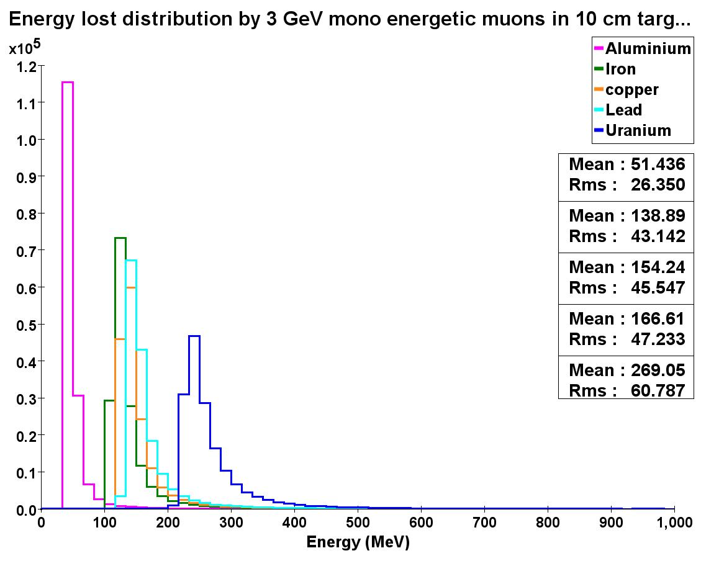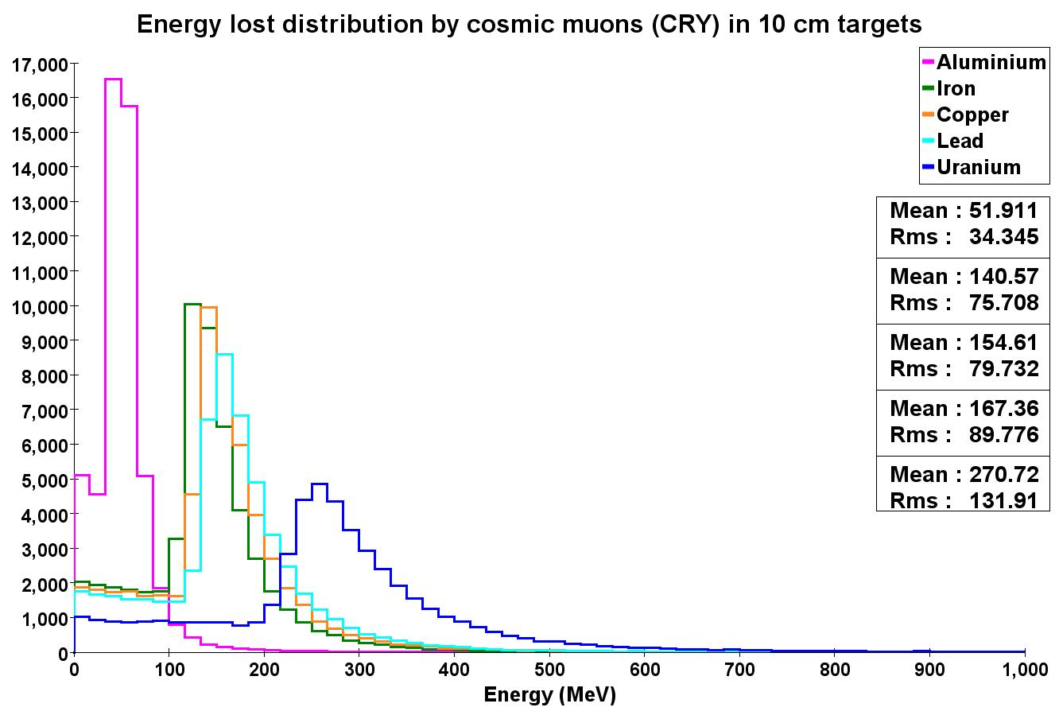
Cosmic ray muons
3 GeV muons

Fig. 8 Muon energy loss for monoenergetic 3 GeV muons in 10 cm thick targets (left) and for cosmic ray muons (right) in liter-sized cubes (10 cm x 10 cm x 10 cm) placed in the center of a muon tomography station for five different materials (Al, Fe, Cu, Pb, U).

  - Coverage of interrogation volume with cosmic ray muons

A cosmic ray muon track must always be measured before and after hitting a volume that is to be interrogated so that information about multiple scattering can be reconstructed from the tracks measurements. By necessity, the interrogation volume cannot be fully enclosed by detectors because cargo or vehicles have to be able to enter and leave the interrogation volume. The uninstrumented sides of the muon tomography station will allow muons to enter or leave the volume without being measured, e.g. a muon might enter through the top detector but escape through a side without detector. In addition, the incoming muon flux depends on the zenith angle (see Fig.3). Together, these effects lead to a non-uniform acceptance, or volume coverage, of the MT station for muons that can actually be used in the reconstruction. It is important to know what this acceptance non-uniformity is. The numbers of fully tracked muons that cross each sub-volume of the interrogated volume determine the achievable statistical significance of the MT method. Consequently, the needed integration time for a specific sub-volume depends on this acceptance.
We have studied the acceptance for two scenarios: One has only top and bottom detectors (Fig.9); the other has additional detectors that fully cover the sides of the interrogation volume, but only those two sides that are not traversed by entering and exiting cargo or vehicles (Fig.10). For our acceptance study, a 4m long × 4m wide × 3m tall empty detector volume is divided into 48k smaller sub-volumes called voxels (10cm×10cm×10cm). The path of each muon is stepped through the detector volume within the GEANT4 simulation. All voxels that this path traverses are considered as covered by the probing muon. Every voxel traversed by each muon is counted and the total count for each voxel is histogrammed at the end.
In addition, for scenarios containing interrogation targets within the detector volume, a similar algorithm was devised where the muon path is estimated by connecting the entering and exiting detector points to the POCA point. This efficient algorithm has the time-complexity M*I, where M is the number of actual voxels covered, and I is the number of muons, rather than V*I, where V is the total number of all voxels, since V >> M. This algorithm is also incremental, that is, it does not have to wait for all the data to be available before starting to work, as it follows each muon track independent of the other tracks.
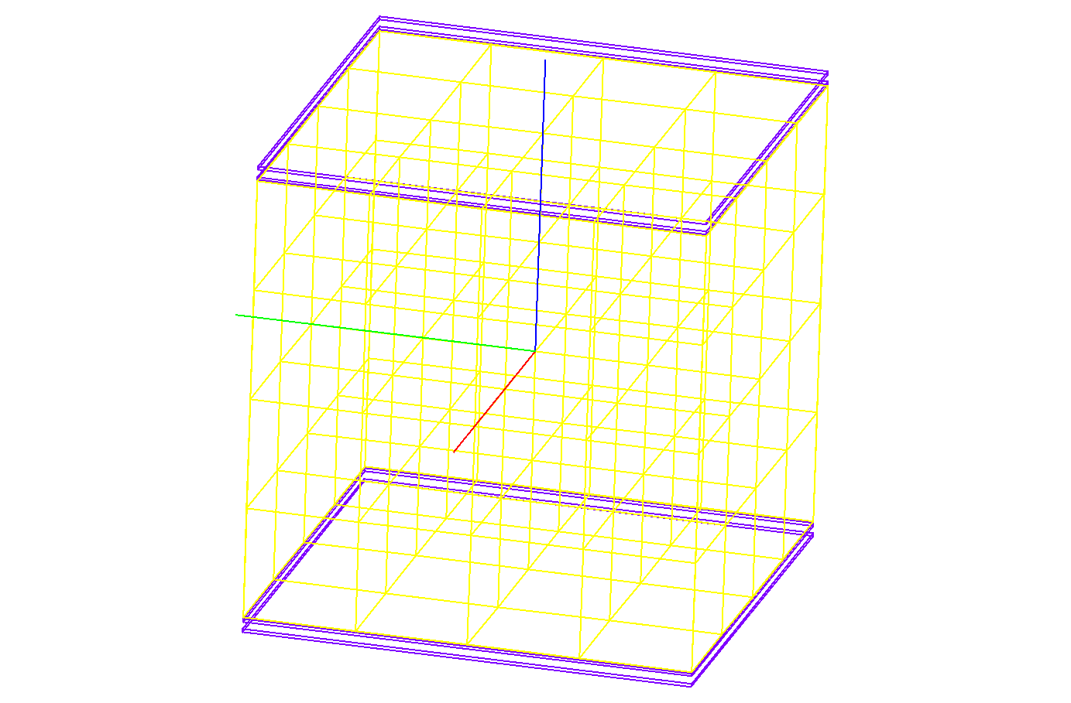
Z
X
Y

Fig. 9 Example of the voxelization of the muon tomography volume with a coarse voxelization for studying the coverage with only top and bottom detectors (purple) present. The actual voxel size used is 10cm × 10cm × 10cm, i.e. smaller than shown here.
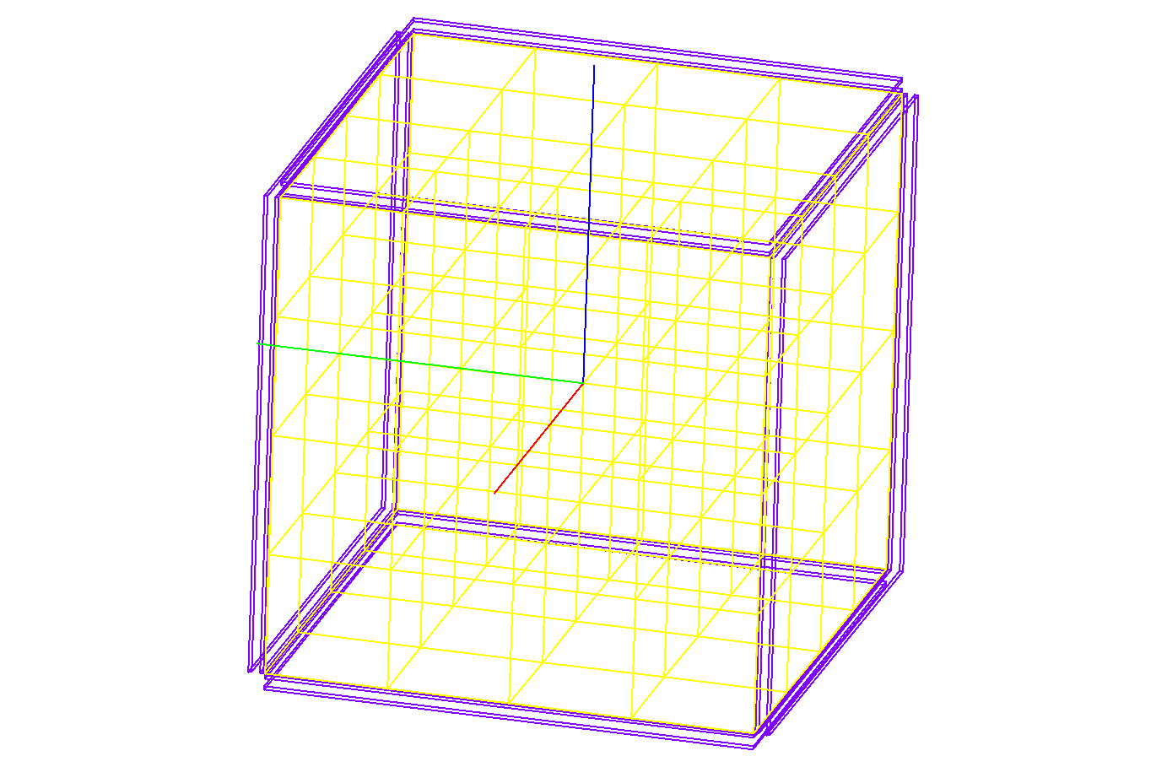
Z
X
Y
Fig. 10 Same as Fig.9 for a muon tomography station with detectors (purple) at the top and bottom as well as on the sides in the x-z plane.

    - Acceptance for station with top and bottom detector planes only

The relative acceptance that we find for the station with only top and bottom detectors present is shown in Figs. 11 and 12. In total, 10 million muons were generated over a CRY plane of 10m × 10m corresponding to a ~10 min exposure to cosmic ray muons. The CRY plane was chosen to be this large to guarantee that muons with large zenith angles entering the station are properly taken into account.
Fig. 10 shows cross sections of the station volume in the x-y plane, i.e. in the top view of the station, at different positions along the vertical z-axis near the station center, edges and half-way in between (z = +1450mm, +750mm, +50mm, -50mm, -750mm, -1450mm). The voxel contents are normalized to the content of the voxel crossed by the maximum number of muons in the entire volume (2486 muons), for which the relative acceptance is set to 1. Contour lines and color coding indicate acceptance changes in steps of 0.1. Fig.11 provides a side view with cross sections in the x-z plane along the negative y-axis (y = -1950mm, -1550mm, -750mm, -550mm, -50mm, -50mm).
As expected, the highest acceptance is found near the center of the station. The relative acceptance drops off quickly to 0.1 or less at ~30cm from the station’s edges. In the x-z projection the lines of constant acceptance form an “hour-glass” shape as expected given the station geometry and muon zenith angle distribution. The central area, where the relative acceptance is 80% or higher, is roughly spherical with a radius of ~0.7m; it comprises ~1.4m³ of the central volume or only ~3% of the entire station volume. We also observe that the center of the main acceptance area is offset from the geometric center of the station by about 20cm in +z direction towards the top.

    - Acceptance for station with additional detector planes on the sides

Figs. 13 and 14 show the analogous results using 10 million muons for a station that has two additional detector planes covering the sides of the station in the x-z planes (see Fig.10). Fig. 15 also shows the relative acceptance in the y-z plane at six different positions along the x-axis. We find that the absolute value for the maximum acceptance in any voxel in this case is 2692 muons, i.e. 8% higher than before. This value is used for normalization in the calculation of the relative acceptances.
The central acceptance area is significantly extended for this geometry and spans basically the entire width of the station along the y-axis. The central area, where the relative acceptance is 80% or higher, is roughly a slab of length 1.2m in x, width 4m in y, and height 1.9m in z. It comprises ~9.1m³ of the central volume or ~19% of the entire station volume. The center of the main acceptance area is offset ~70cm in the +z direction towards the top from the geometric center of the station, i.e. considerably more than in the previous top-bottom geometry.
Adding the lateral detector planes would roughly double the total detector area and thus also double the cost. In return for this additional investment the central acceptance of the muon tomography station would increase by more than a factor of six. Consequently, adding detectors onto the sides of the station does appear to be a good investment.

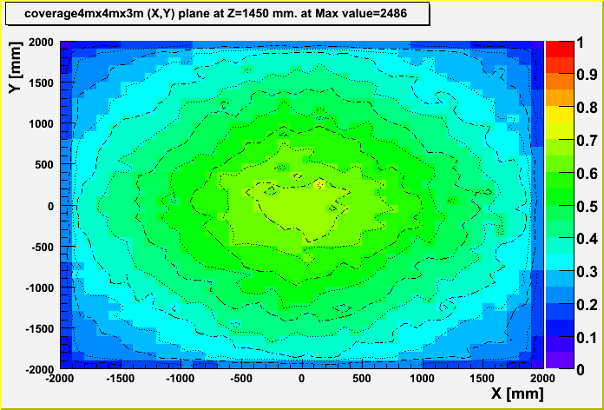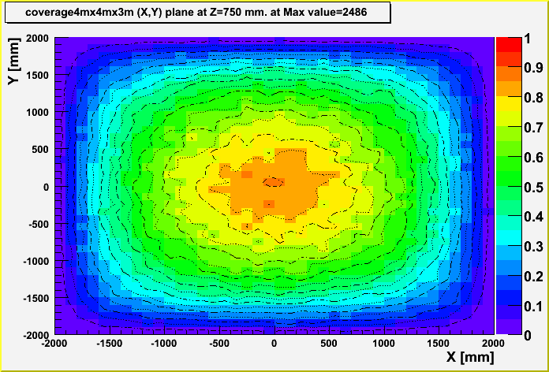
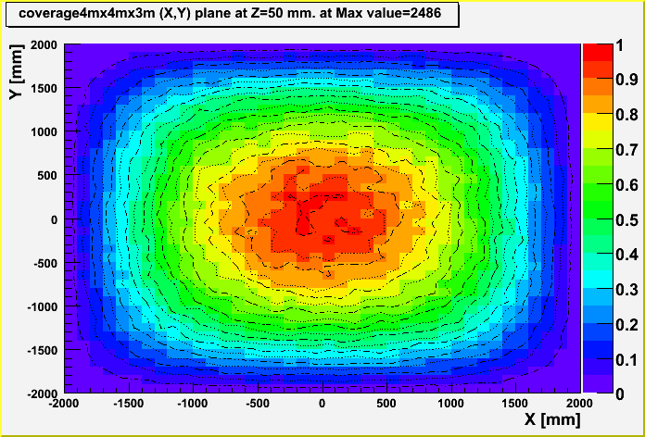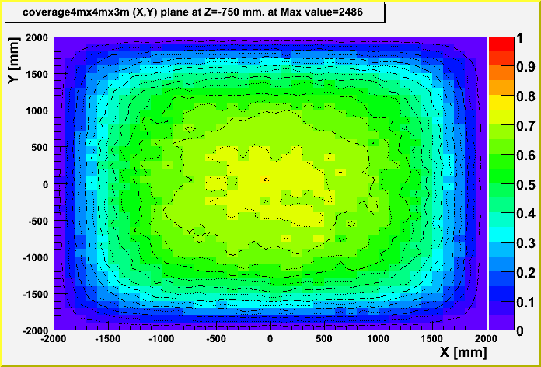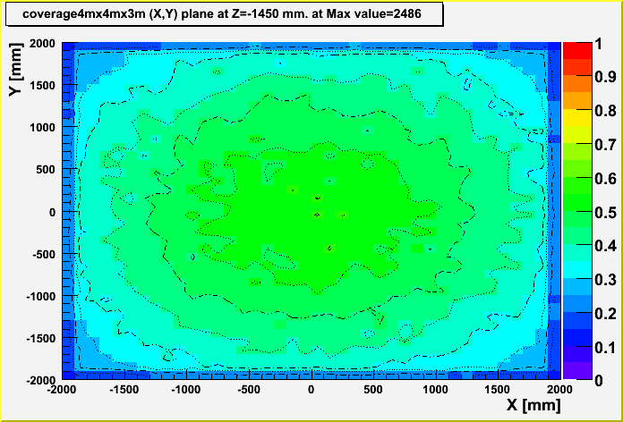

Fig. 11 Relative muon coverage of 10cm×10cm×10cm voxels in the x-y plane (top view) within a 4m×4m tomography station with top and bottom detectors separated by 3m. Six slices through the volume at different z-position along the vertical axis are shown (z = +1450mm, +750mm, +50mm, -50mm, -750mm, -1450mm). The voxel contents are normalized to the voxel crossed by the maximum number of muons in the entire volume (2486 muons).
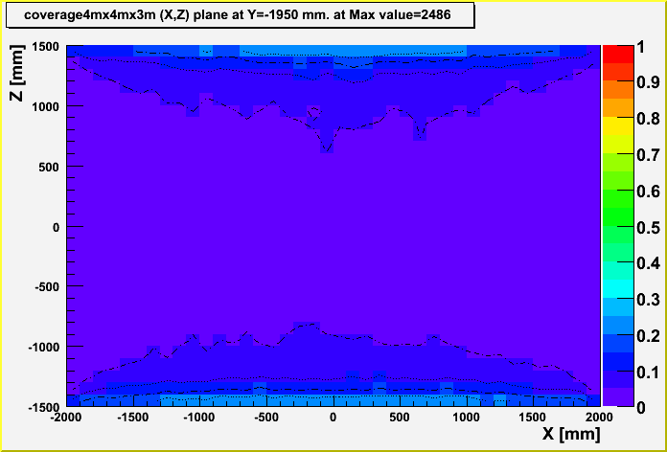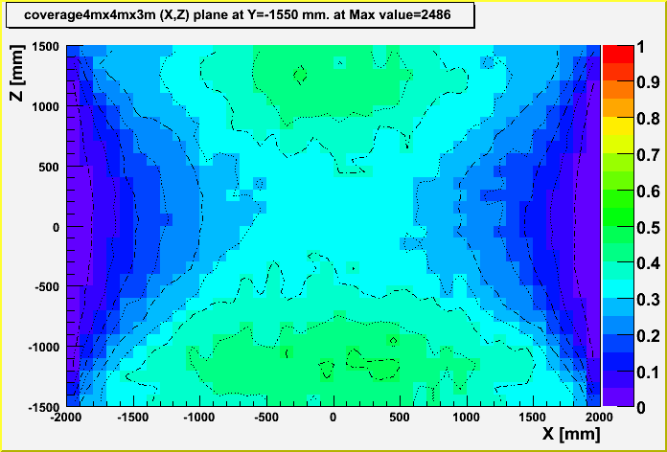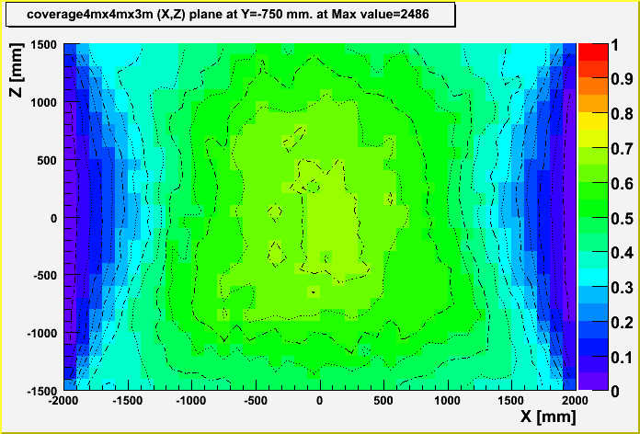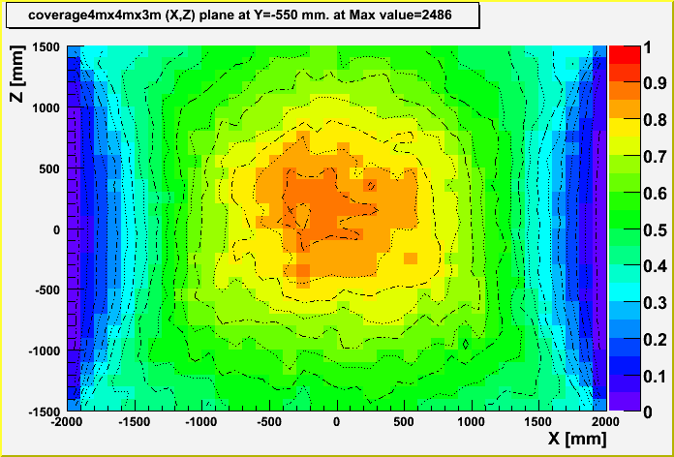
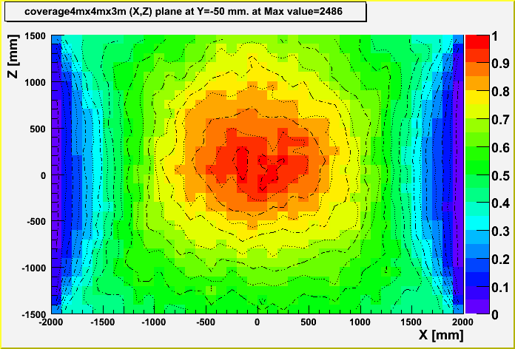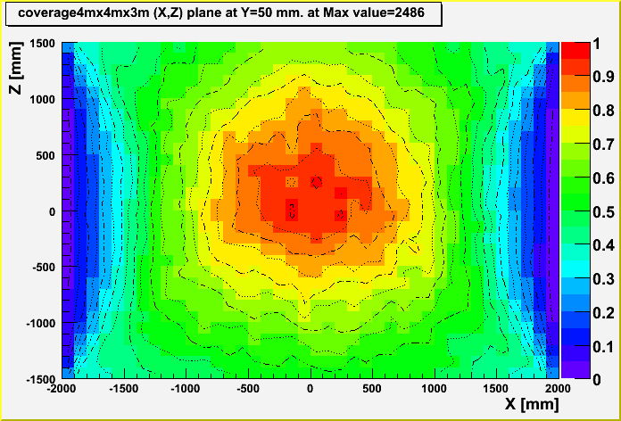

Fig. 12 Relative muon coverage of 10cm×10cm×10cm voxels in the x-z plane (side view) within a 4m×4m tomography station with top and bottom detectors separated by 3m. Six slices through the volume at different y-position are shown (y = -1950mm, -1550mm, -750mm, -550mm, -50mm, +50mm). The voxel contents are normalized to the voxel crossed by the maximum number of muons in the entire volume (2486 muons).

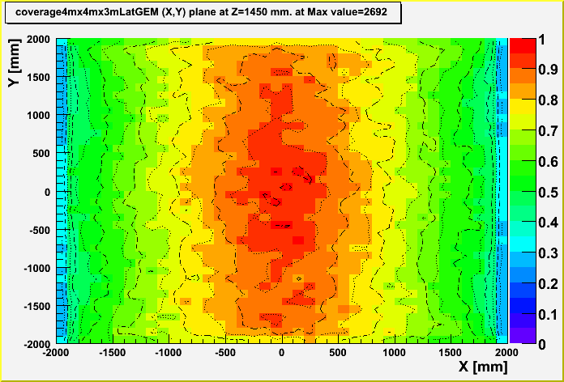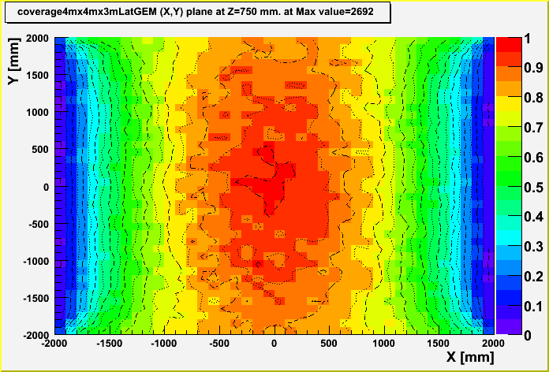
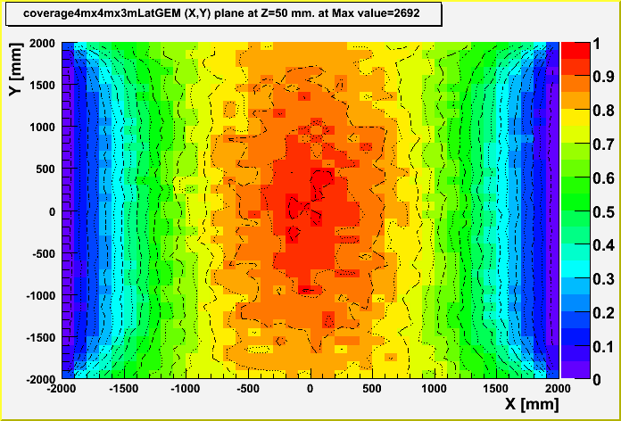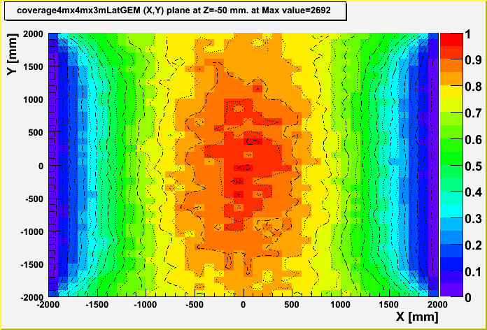
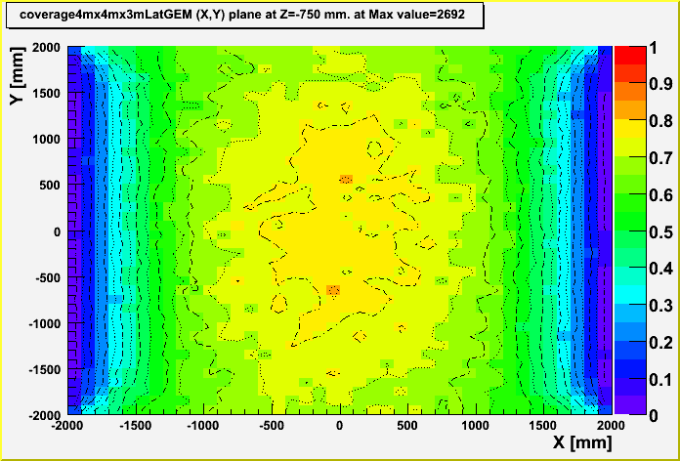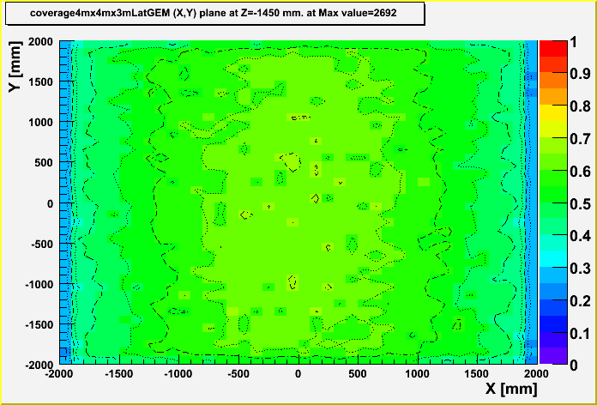

Fig. 13 Relative muon coverage of 10cm×10cm×10cm voxels in the x-y plane (top view) within a 4m×4m tomography station with top and bottom detectors separated by 3m and with additional detectors placed at the x-z sides of the station. Six slices through the volume at different z-position along the vertical axis are shown (z = +1450mm, +750mm, +50mm, -50mm, -750mm, -1450mm). The voxel contents are normalized to the voxel crossed by the maximum number of muons in the entire volume (2692 muons).

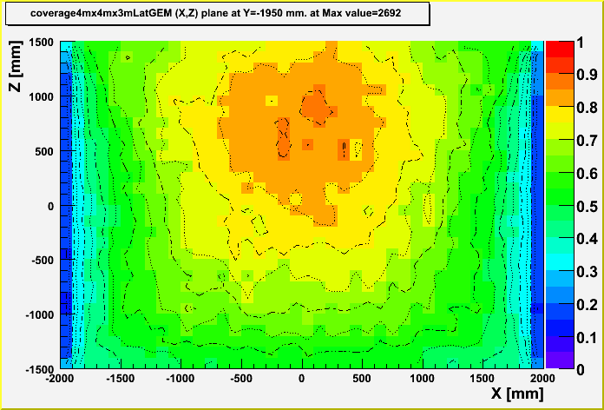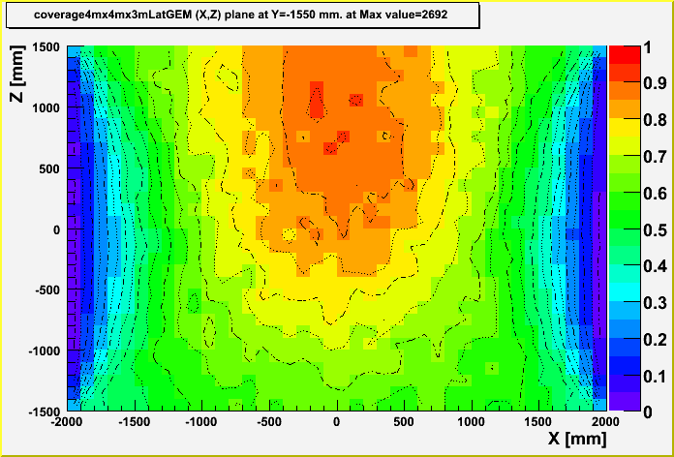
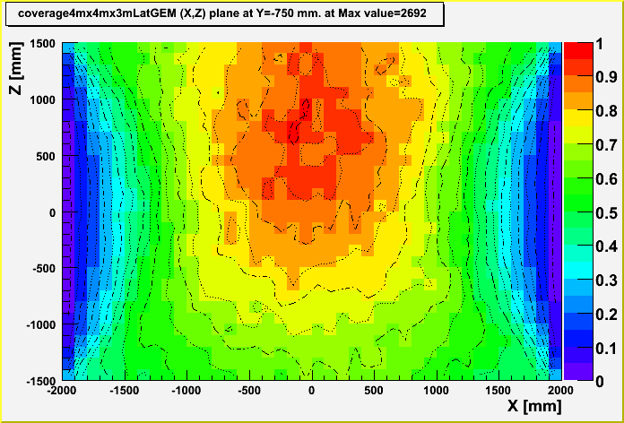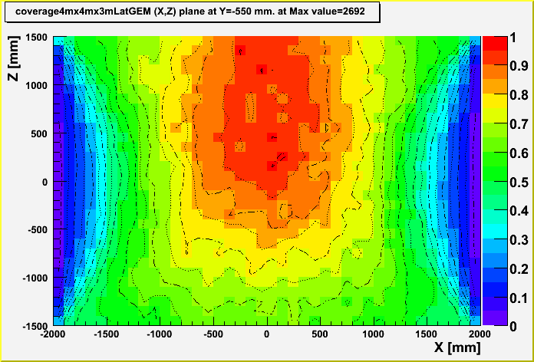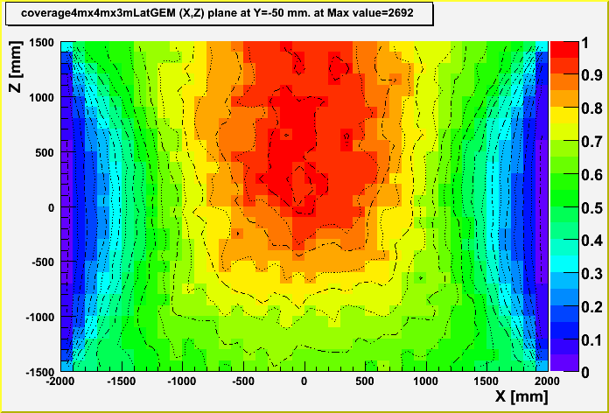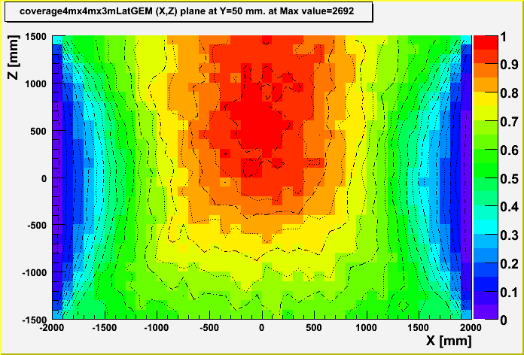

Fig. 14 Relative muon coverage of 10cm×10cm×10cm voxels in the x-z plane (side view) within a 4m×4m tomography station with top and bottom detectors separated by 3m and with additional detectors placed at the x-z sides of the station. Six slices through the volume at different y-positions are shown (y = -1950mm, -1550mm, -750mm, -550mm, -50mm, +50mm). The voxel contents are normalized to the voxel crossed by the maximum number of muons in the entire volume (2692 muons).

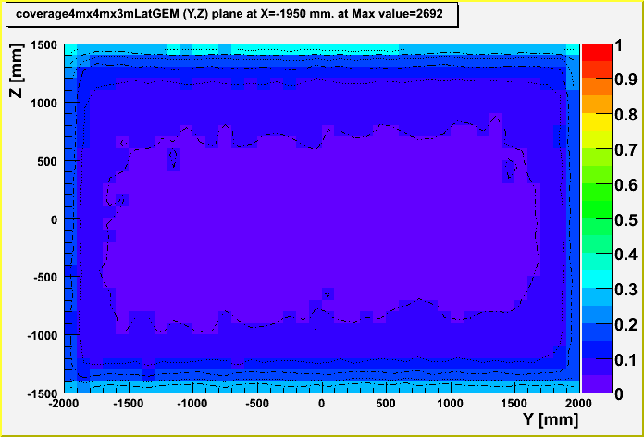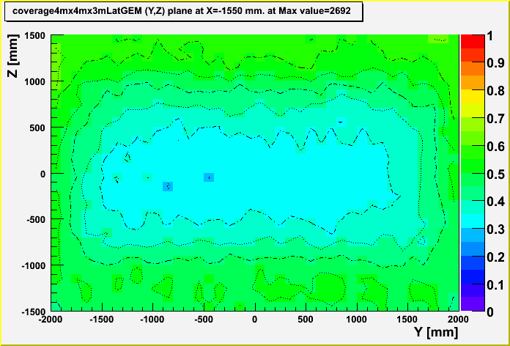
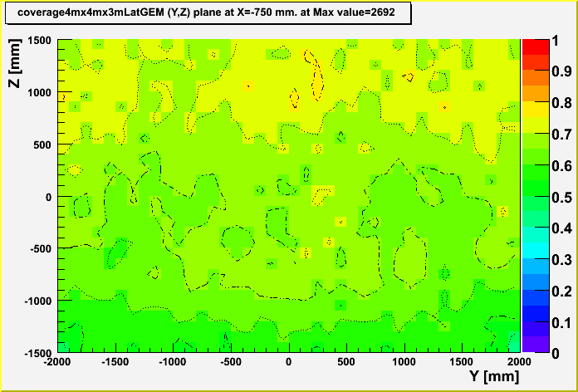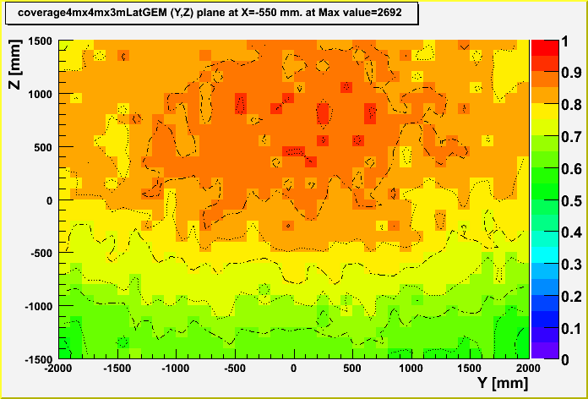
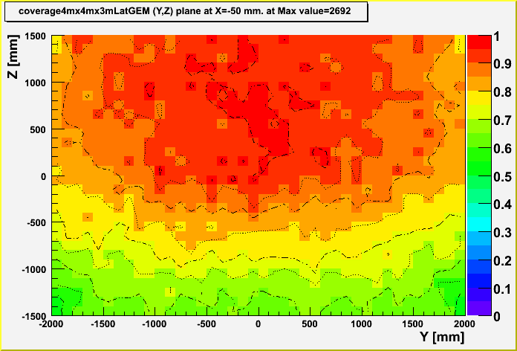

Fig. 15 Relative muon coverage of 10cm×10cm×10cm voxels in the y-z plane (other side view) within a 4m×4m tomography station with top and bottom detectors separated by 3m and with additional detectors placed at the x-z sides of the station. Six slices through the volume at different x-positions are shown (x = -1950mm, -1550mm, -750mm, -550mm, -50mm, +50mm). The voxel contents are normalized to the voxel crossed by the maximum number of muons in the entire volume (2692 muons).

  - Z-discrimination based on scattering angles

    - Basic target scenarios

      - Monoenergetic muons

To investigate the basics of multiple scattering we consider the initial simulation scenario for monoenergetic muons hitting a simple target as shown in Fig. 5 and plot scattering angle distributions for monoenergetic muons for different energies and elements in Figs. 16 and 17 using linear and logarithmic scales, respectively. As expected the distributions are shifted over to smaller and smaller angles as the muon energy increases. However, the relative positions and shapes of the angular distributions do not change significantly, i.e. on a scale of 0-3º the distributions for 20 GeV muons look quite similar to the distributions for 1 GeV muons on a scale of 0-25º (Fig.17). In the large-angle tails of the distributions the relative ratios for the different materials are found to be close to constant, e.g. U/Fe ~ 10-20 and U/Pb ~ 2, for all muon energies. This means that signal over background S/B is constant and independent of energy for multiple scattering angles on the tails. This implies that S/√B or “significance” of a large-scattering-angle signal steadily increases with increasing angle. When developing criteria for discriminating high-Z material from low-Z and medium-Z material this increasing significance can be traded off against the time needed to acquire counts for a signal S.
The simplest Z discrimination method is to place a cut on an angle and count all events with scattering angles above that particular cut value. By integrating the distributions in Fig.16 from the cut angle to infinity we calculate the acceptance for events with scattering angles above such cut values for Fe, Pb, and U using 1º steps. Fig.18 shows the resulting integrated distributions for 3 GeV muons and the ratio of these distributions for U/Fe, Pb/Fe, and Al/Fe. We find S/B ~ 17 for U/Fe for an angle cut of 3º or higher. In this case, cutting at Θ₀ > 3º would optimize S/B and achieve a 27% acceptance for a U signal while suppressing Fe background by a factor of 17.
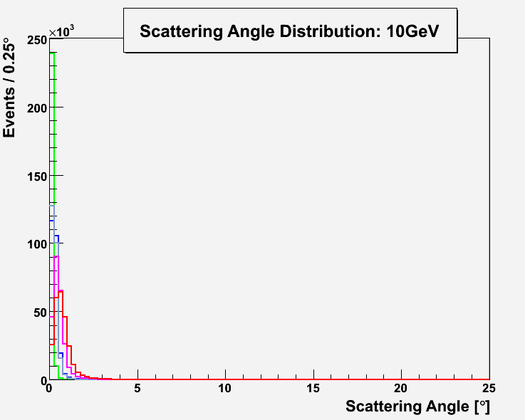
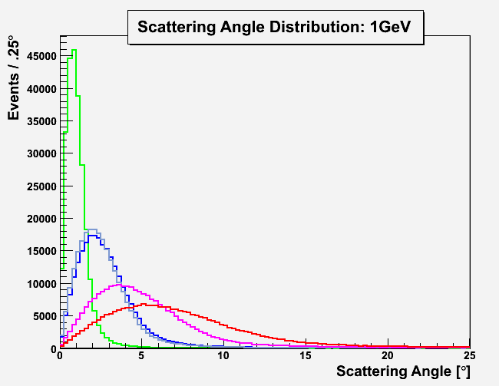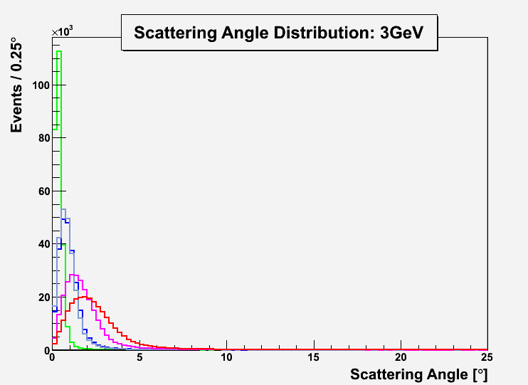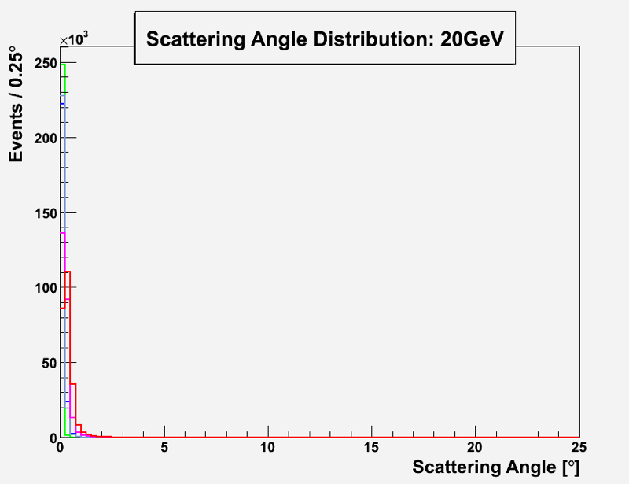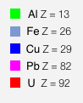
E_{μ} = 3 GeV
E_{μ} = 10 GeV
E_{μ} = 1 GeV
E_{μ} = 20 GeV
~ 250k events generated
for each material

Fig. 16 Muon scattering angle distributions for 10 cm thick targets made of five different elements at four different muon energies obtained with GEANT4 simulation.

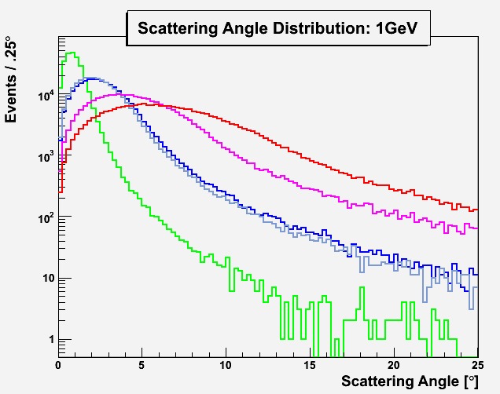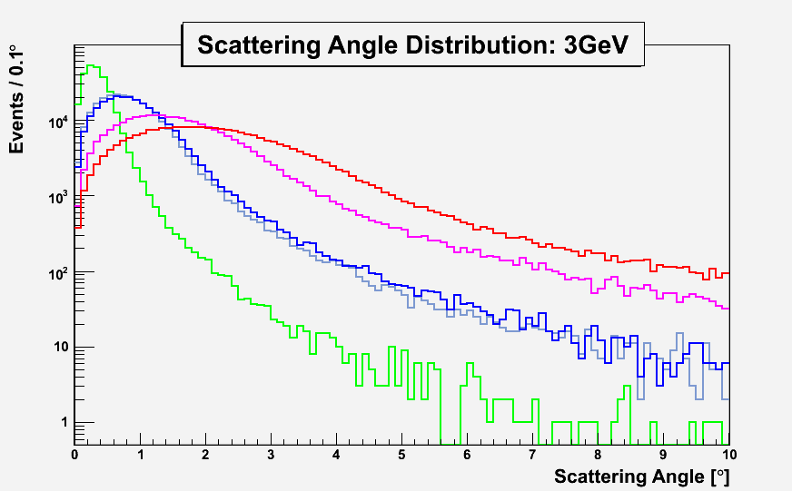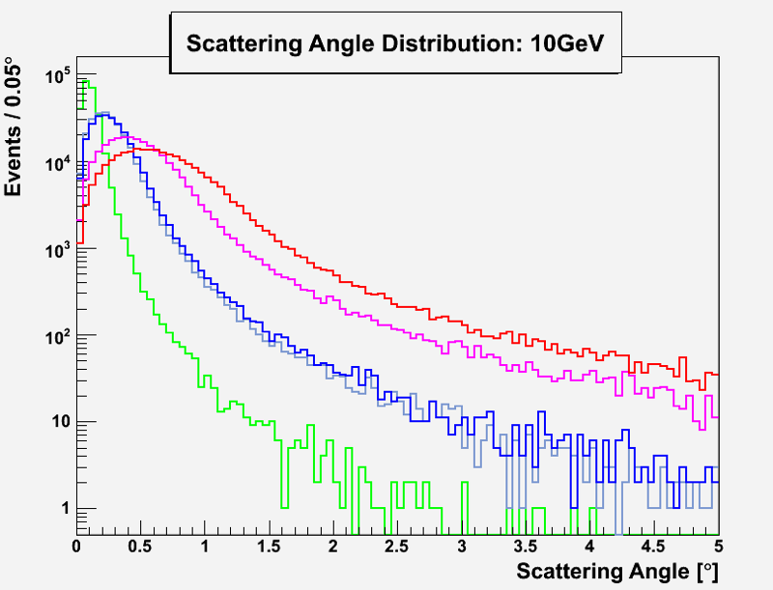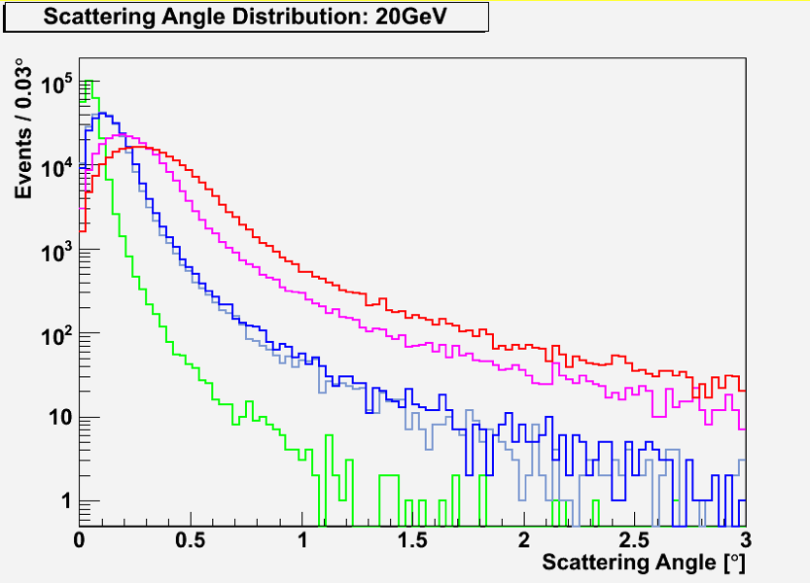

Fig. 17 Same as Fig.16 but with logarithmic vertical scale. Note the different ranges of the x-axes.

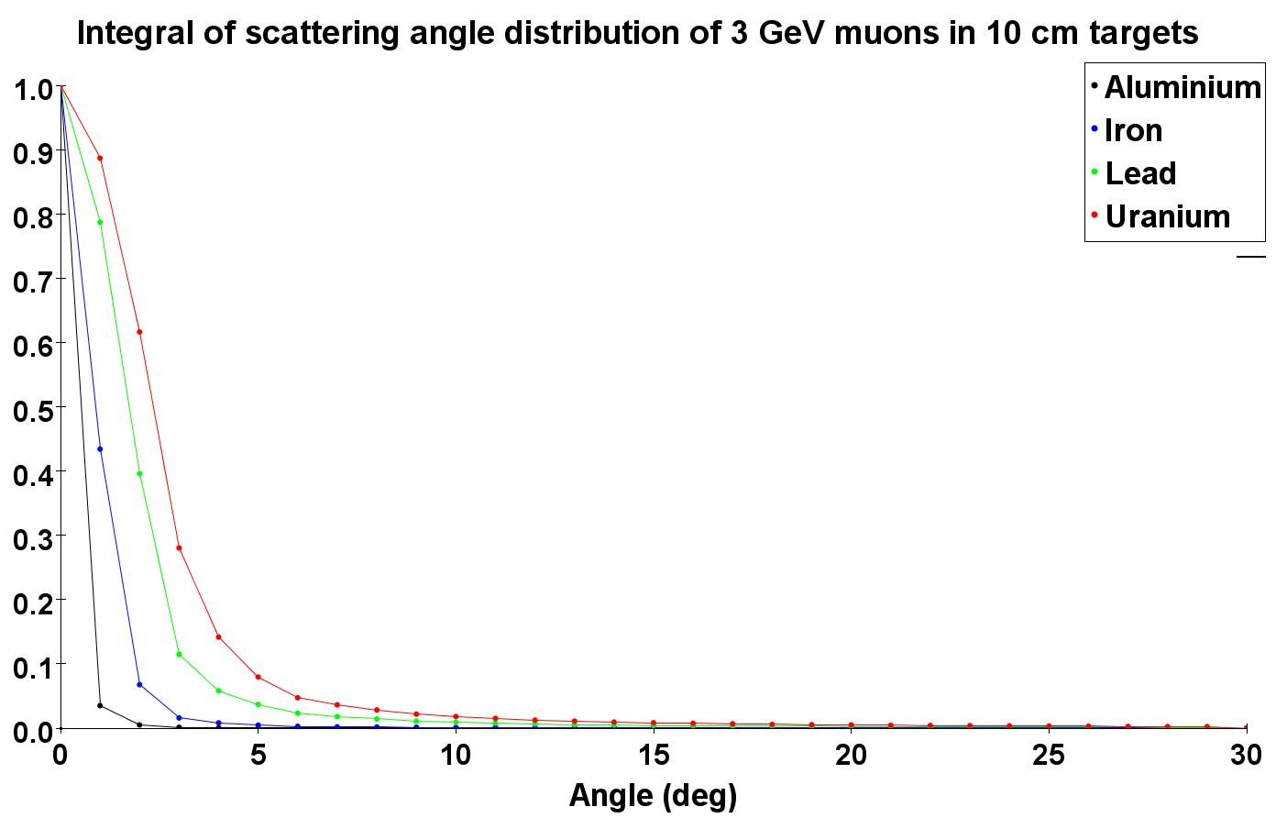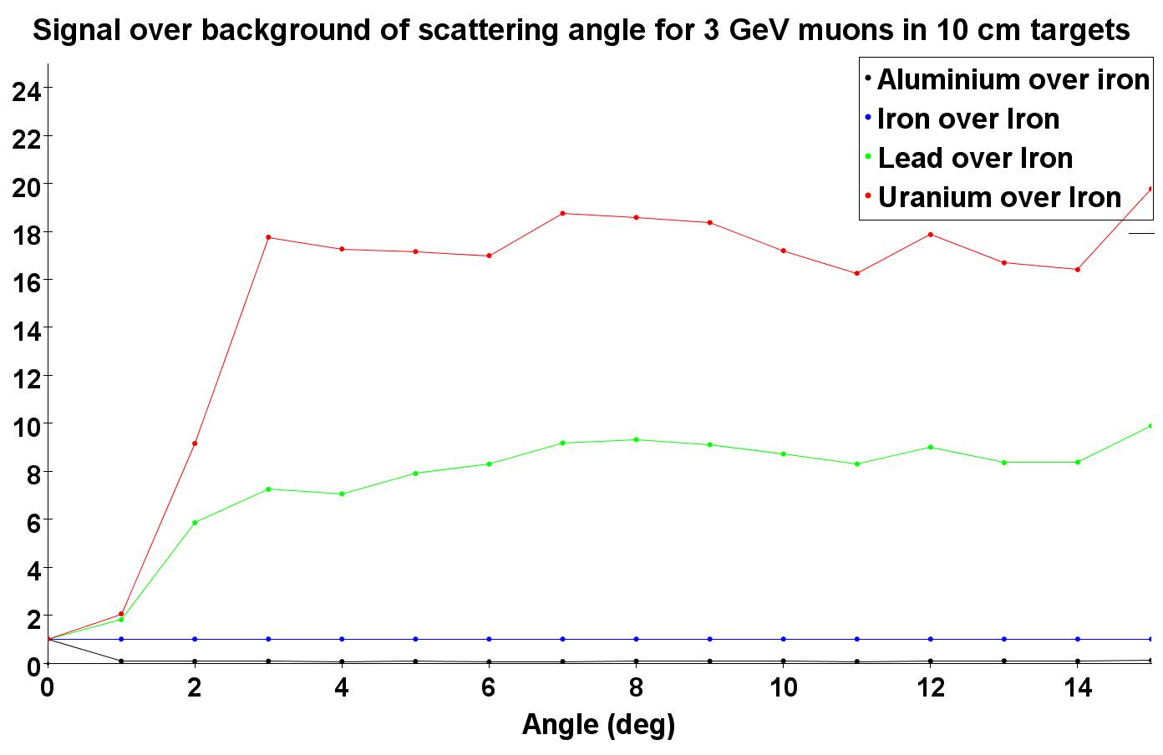

Fig. 18 Integrals from angle Θ₀ to infinity of the scattering angle distributions for 3 GeV muons from Fig.16 vs. Θ₀ (left) and ratios of these integrated distributions using the Fe distribution as the denominator in each case vs. Θ₀ (right).

      - Cosmic ray muons

Scattering results for a single liter-sized target cubes

We have generated a sample of 2.5M CRY events for a target cube made of Pb, which took about five hours to complete on the frontend machine. Assuming a cosmic ray muon rate of 1 muon per minute per cm², this sample corresponds to a 10 min exposure to cosmic ray muons. 316k events or 12.6% of all generated muons traverse both detector planes and can be reconstructed. Out of these, 1494 muons actually hit the target cube. This corresponds to a total acceptance of 0.06% and a rate of 150 ± 4 muons/minute on target that can be reconstructed in this particular geometry. Note that this rate is significantly larger than the 100 muons/minute impinging on a 10×10 cm² area as the target cube can be hit from the sides as well.
We reconstruct the muon tracks in the top and bottom detectors by fitting lines through the simulated hits in the three GEM planes in each detector and calculate the scattering angle for each of the 316k events that can be reconstructed in this way. In Fig.10 we compare the scattering angle for the 1494 muons that actually hit the Pb target cube with the scattering angle obtained for muons that miss the target. In both cases we find steeply falling distributions. The mean scattering angle for muons hitting the Pb target is 1.8º, which is very similar to the mean scattering angle of 1.9º found for monoenergetic 3 GeV muons (see Fig. 5). This is not surprising since the mean energy of cosmic ray muons is about 3 GeV. The rms width of 2.7º in the scattering angle distribution for muons hitting the target is ~10 times larger than for those that do not hit the target and only scatter in air; the mean is 15 times larger.
The next step will be to generate and analyze equivalent CRY samples with identical geometry but different target materials, so that we can estimate the discrimination power for high-Z materials with cosmic ray muons in the same way as we did above for monoenergetic muons.

Reconstructing scattering points for liter-sized Pb cube using POCA

As our first attempt at muon tomography, we reconstruct the scattering points for the scenario with the floating Pb cube target using the Point of Closest Approach Algorithm that we have implemented. We study the large 2.5M event sample as well as a smaller 250k event sample, which corresponds to 1 min of exposure. We visualize the results in Figs.11 and 12 by plotting the POCA points in 3D space and color-coding them

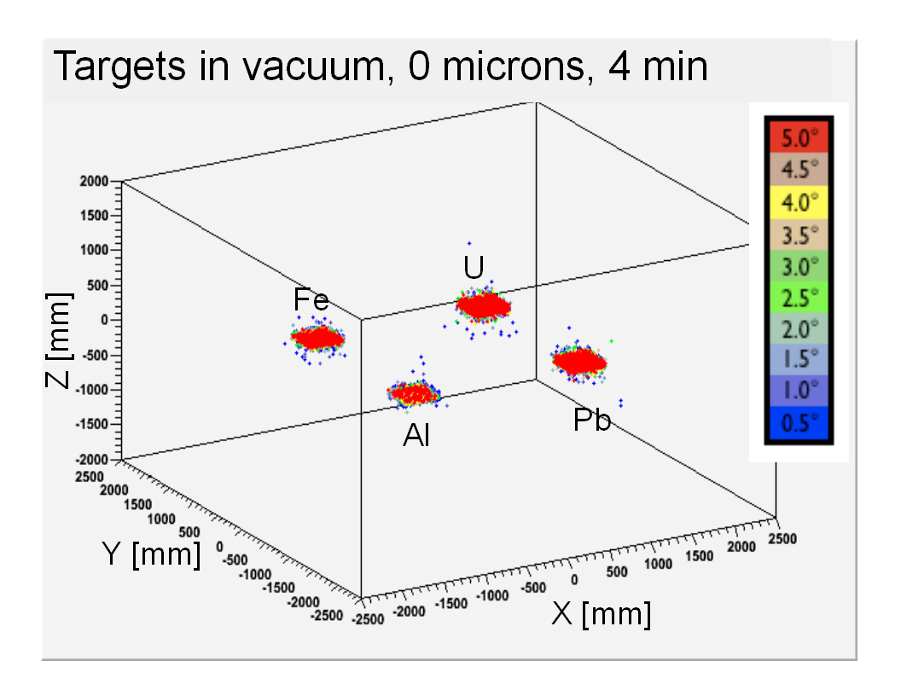
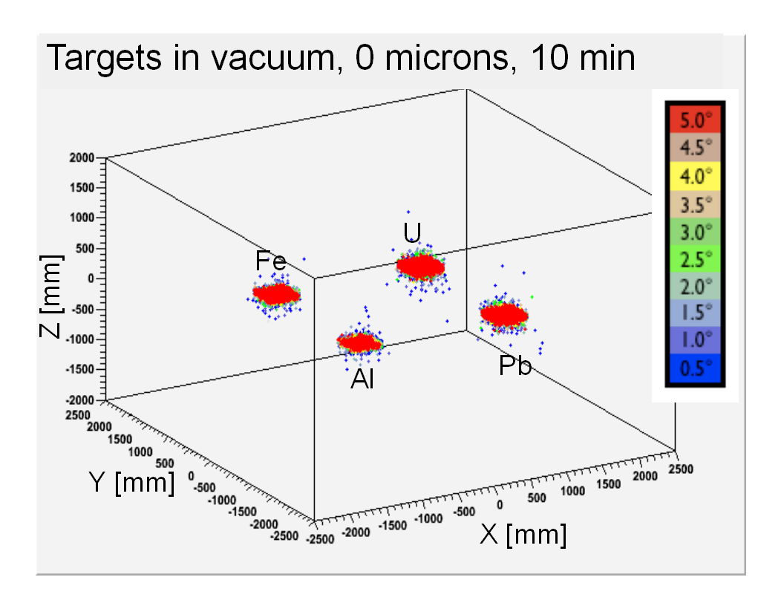
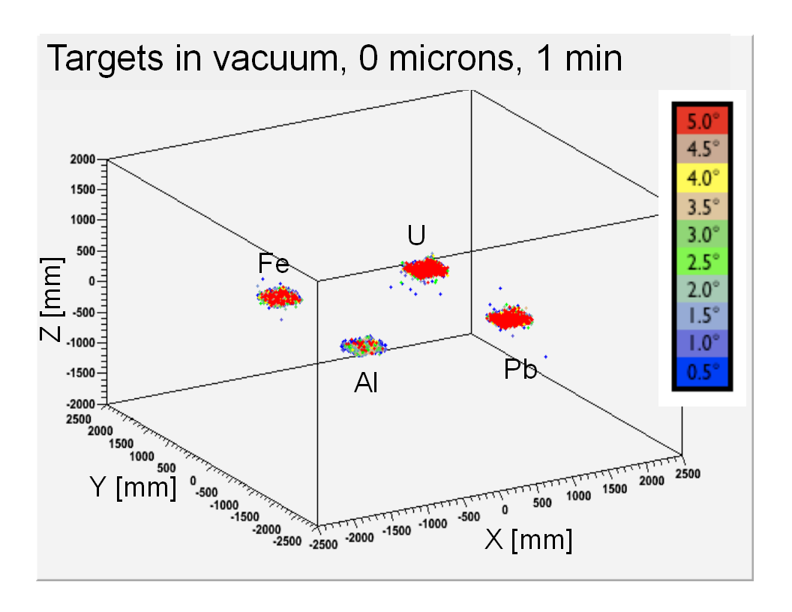
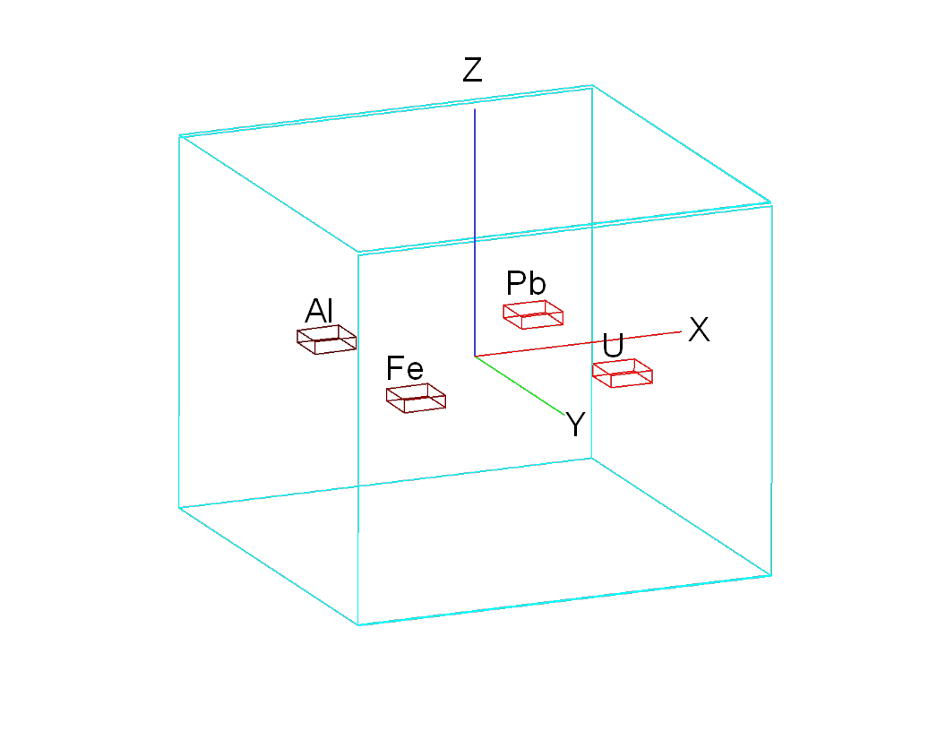
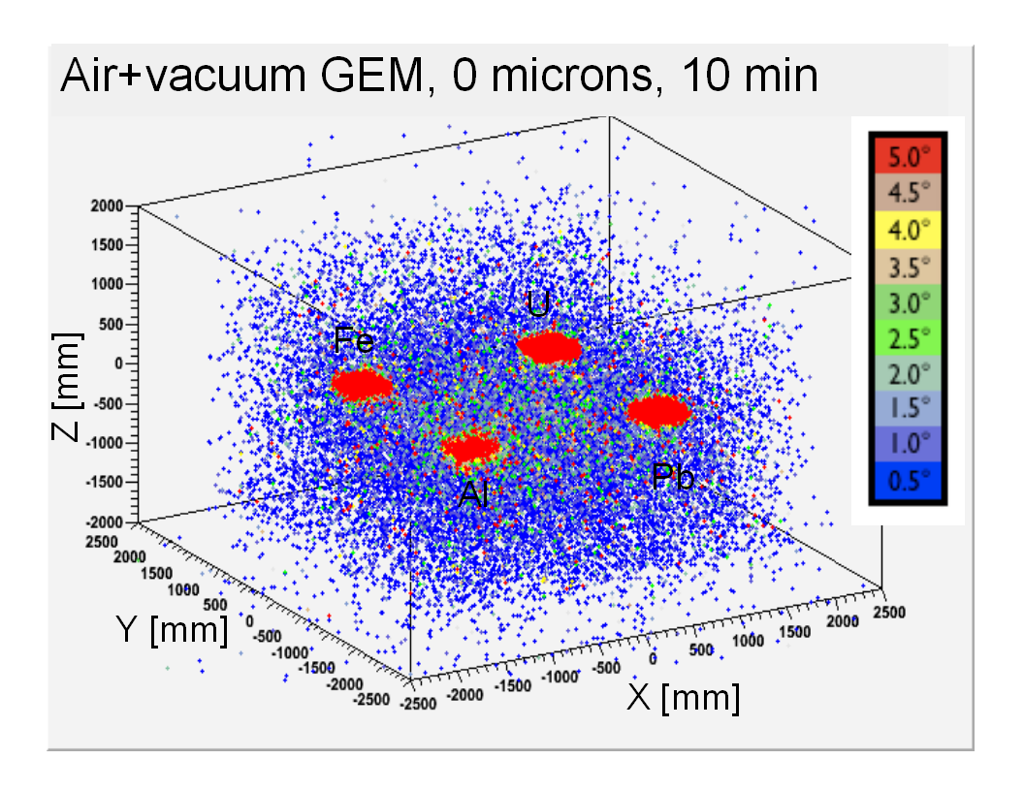
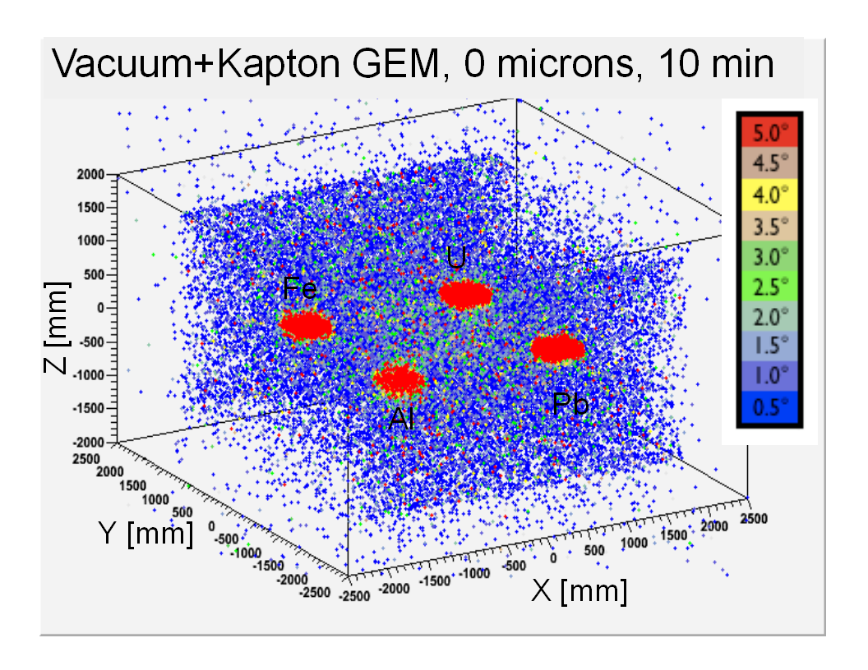
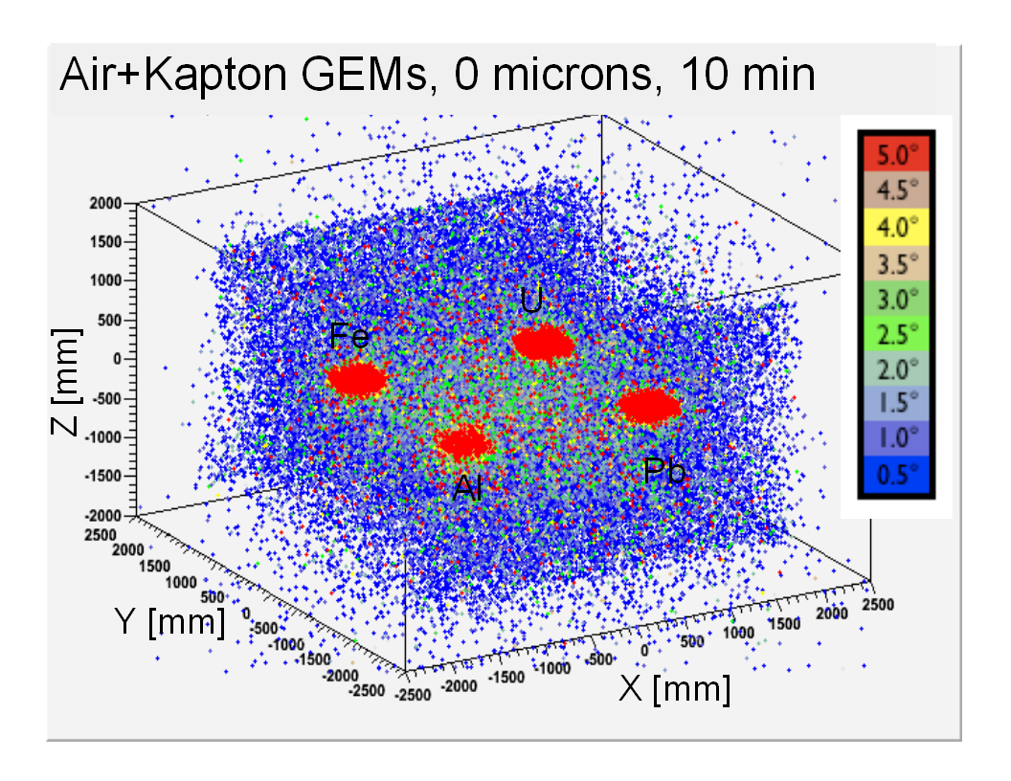
Fig. 19 Basic cosmic ray muon scattering scenario with four 40cm×40cm×10cm targets (Al, Fe, Pb, U) located at Z=0mm in a 4m×4m×3m MT station with lateral detectors (top left). 3D scatter plots of reconstructed POCA points with GEM material and station volume both set to vacuum to eliminate scattering by external materials and with perfect GEM resolution. Samples comprise 1M (top right), 4M (bottom left), and 10M (bottom right) events equivalent to 1, 4, and 10 min exposure time, respectively. POCA points are color-coded according to the associated reconstructed scattering angle; points with scattering angles Θ < 0.5º are suppressed for clarity.

Fig. 20 3D scatter plots of reconstructed POCA points for scenario from Fig.19 for 10min exposures and perfect GEM detector resolution, but with successively added external material: All vacuum (top left), station filled with air, but vacuum GEM material (top right), station under vacuum, but GEM material Kapton (bottom left), station filled with air and GEM material Kapton (bottom right). POCA points are color-coded according to the associated reconstructed scattering angle; points with Θ< 0.5º are suppressed.

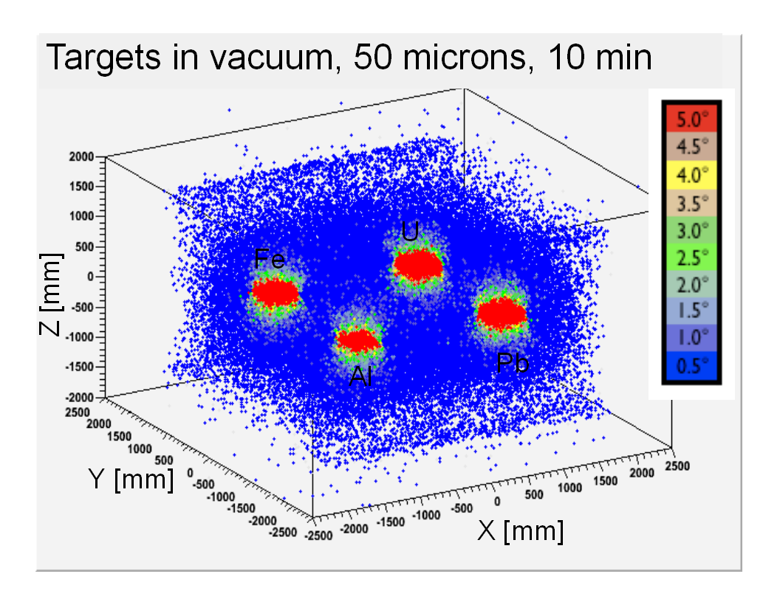
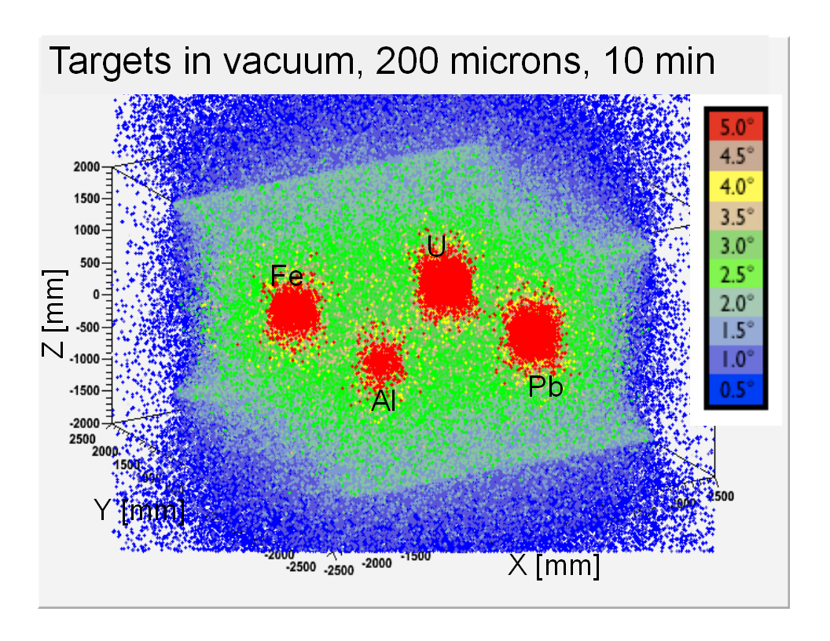
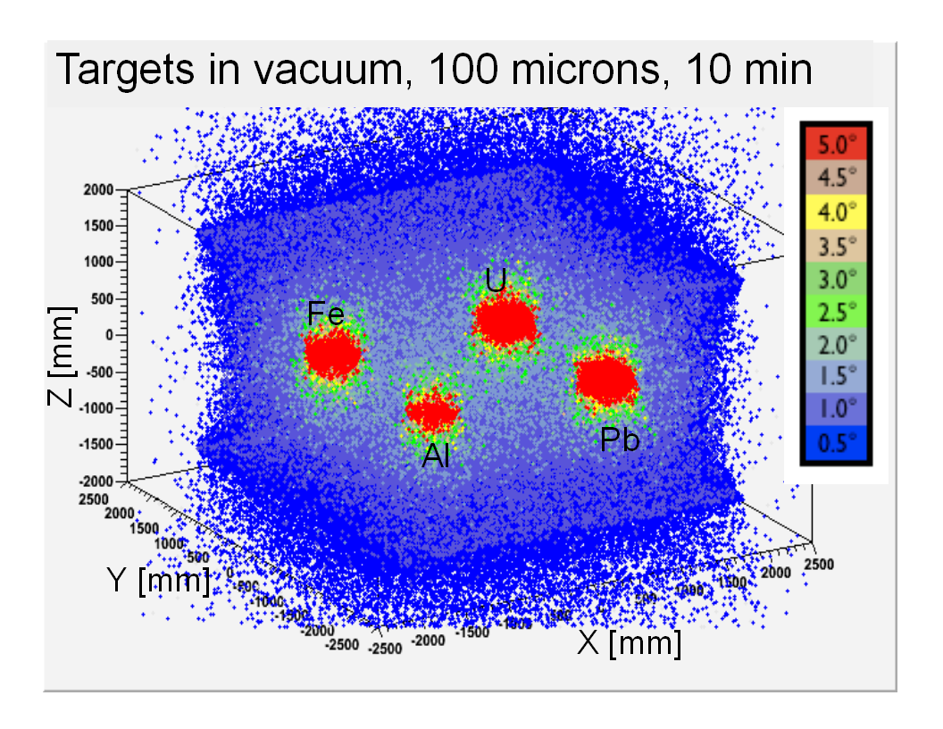

Fig. 21 3D scatter plots of reconstructed POCA points for scenario from Fig.19 for 10min exposure with station under vacuum and GEM material set to vacuum, but with successively worsening GEM detector resolution: Perfect resolution (top left), 50 microns resolution in each x and y coordinates (top right), 100 microns in each x, y (bottom left), and 200 microns in each x, y (bottom right). POCA points are color-coded according to the associated reconstructed scattering angle; points with Θ< 0.5º are suppressed.
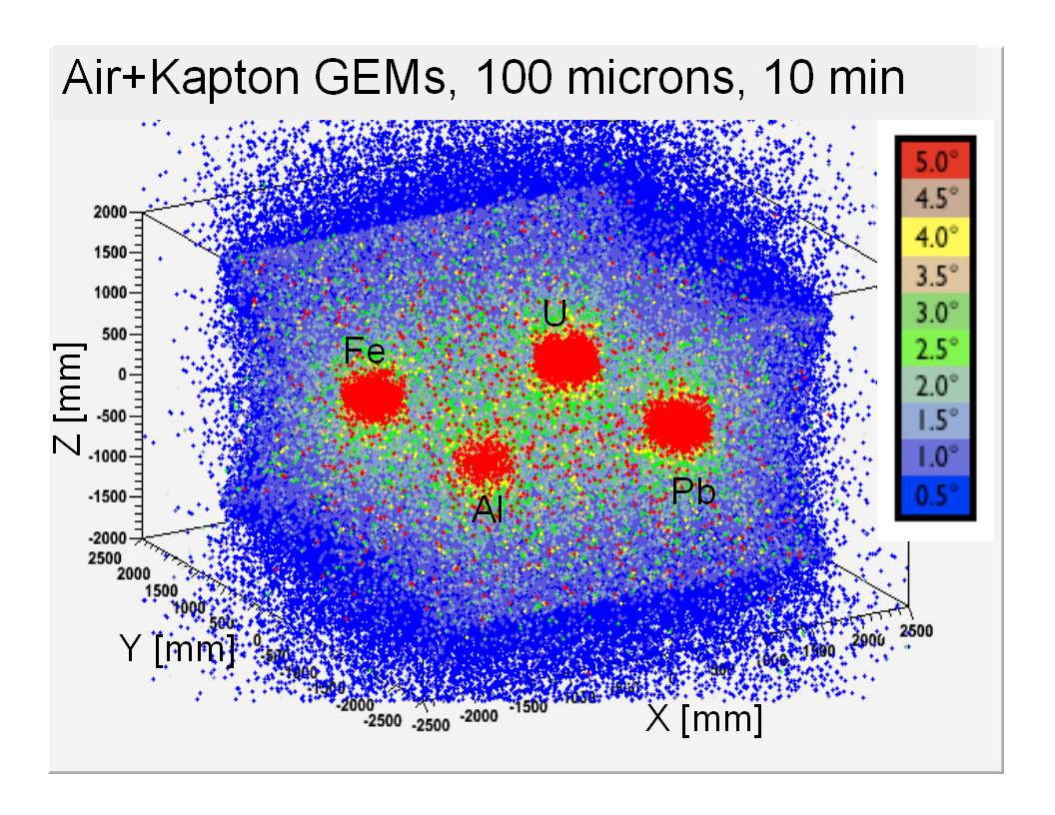
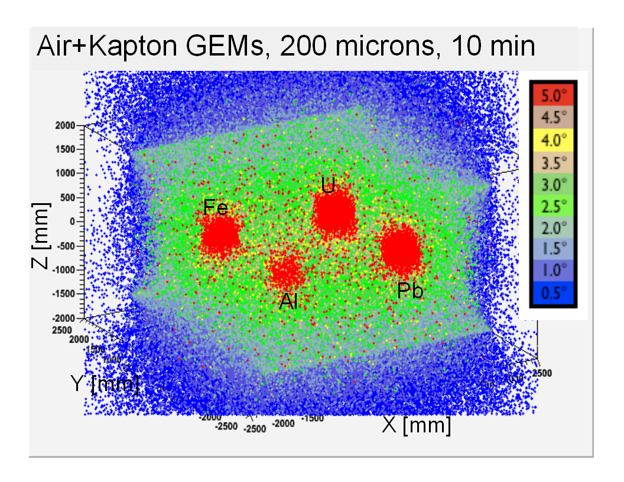
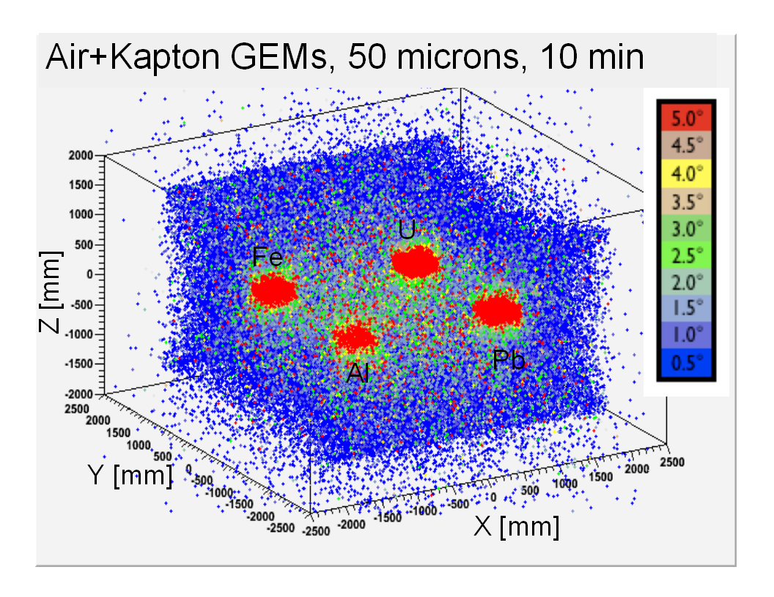
Fig. 22 Same as Fig.21, but with kapton as GEM detector material and with station volume filled with air. POCA points are color-coded according to the associated reconstructed scattering angle; points with Θ< 0.5º are suppressed.
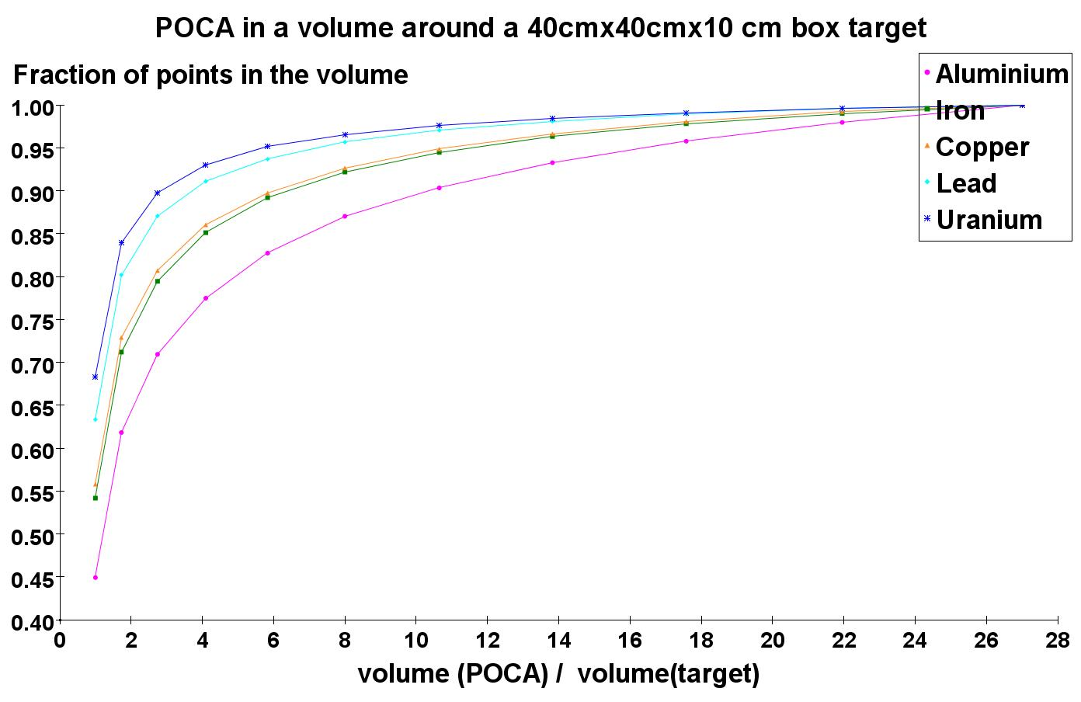
Fig. 23 Fraction of POCA points that are reconstructed within a rectangular volume containing a 40cm×40cm×10cm target at the center as a function of the ratio of that rectangular volume and the target volume for five different target materials and with perfect GEM resolution.

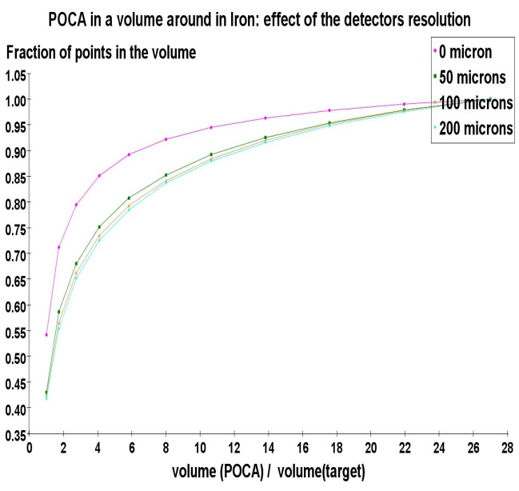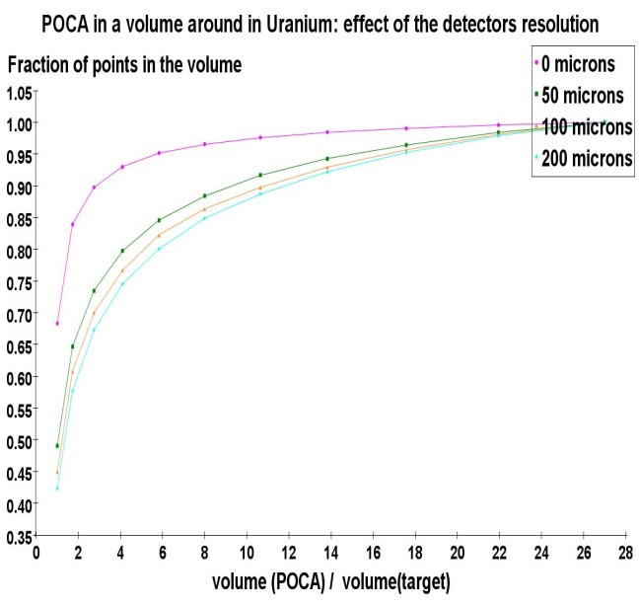
Iron
Uranium

Fig. 24 Fraction of POCA points that are reconstructed within a rectangular volume containing a 40cm×40cm×10cm target at the center as a function of the ratio of that rectangular volume and the target volume for different GEM resolutions.
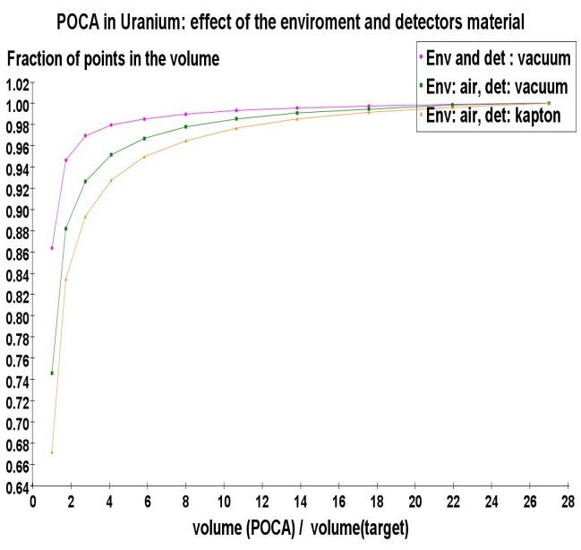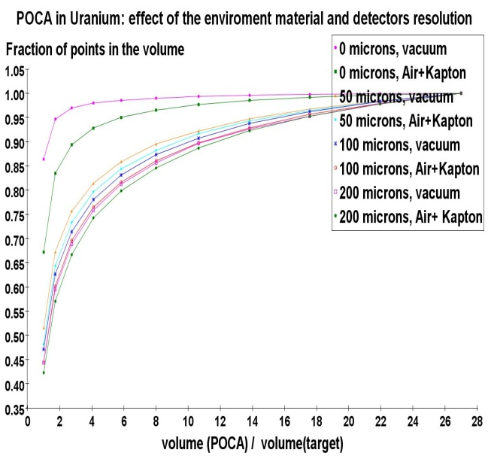

Fig. 25 Fraction of POCA points that are reconstructed within a rectangular volume containing a 40cm×40cm×10cm uranium target at the center as a function of the ratio of that rectangular volume and the target volume. Left: for different combinations of detector material and environmental material in the station volume for perfect resolution. Right: for different combinations of materials and detector resolutions.

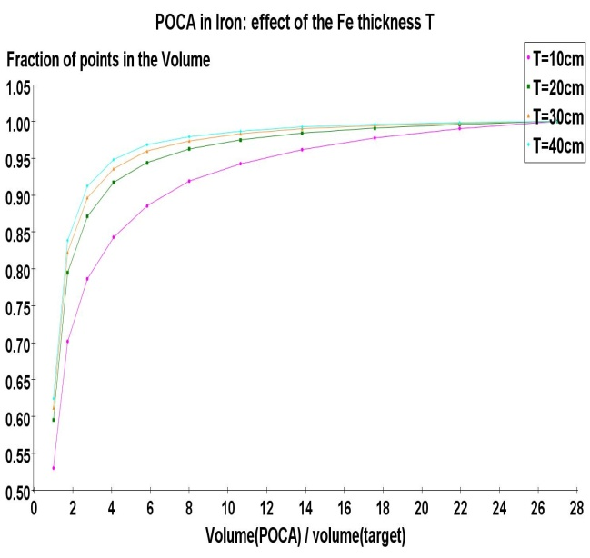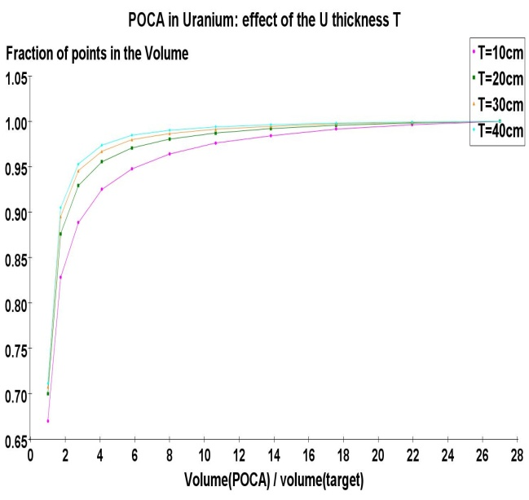
Iron
Uranium

Fig. 26 Fraction of POCA points that are reconstructed within a rectangular volume containing a 40cm×40cm×10cm target at the center as a function of the ratio of that rectangular volume and the target volume for different target thicknesses.

MH to continue editing here !

according to their corresponding scattering angle. Small angles are encoded by cooler blue colors and larger angles by warmer red colors. In each case we only plot points that hit both detector planes and that have scattering angles >0.5º to keep the plots free from clutter.
In the larger sample, the Pb target clearly stands out from its surroundings. For 0.17% of the 316k events that are reconstructed, the POCA points are actually contained within the physical 10 × 10 × 10 cm³ box. When we subdivide the target into 125 smaller 2 × 2 × 2 cm³ voxels we find that 94% of these voxels are occupied, i.e. contain at least one POCA point. We also calculate how many points are contained within larger cubes with sides of 20, 30, 40, and 50 cm centered on the target cube. The results shown in Fig.13 indicate that a cubic volume with sides three times larger (30 cm) than the physical cube contains close to 90% of all reconstructed points. However, this also implies that the simple POCA algorithm is smearing the “image” of the target object by a factor 2-3 compared to the actual target geometry.
In the Pb sample with 250k events (Fig.12), the presence of the target is less obvious, but upon close inspection a cluster of points with large scattering angles is visible by eye in the center of the volume. This result stresses the need for analyzing the clustering of POCA points with large scattering angles.

The validation tool was made for the purpose of checking how well the reconstruction algorithm maps the target object, or the accuracy of the former. This program takes the scattering points produced by POCA as input and determines how many of them are inside the predefined target volume that was used in the simulation. We have also studied how close the POCA points are to the target volume by counting the points over a larger volume around the actual target object.

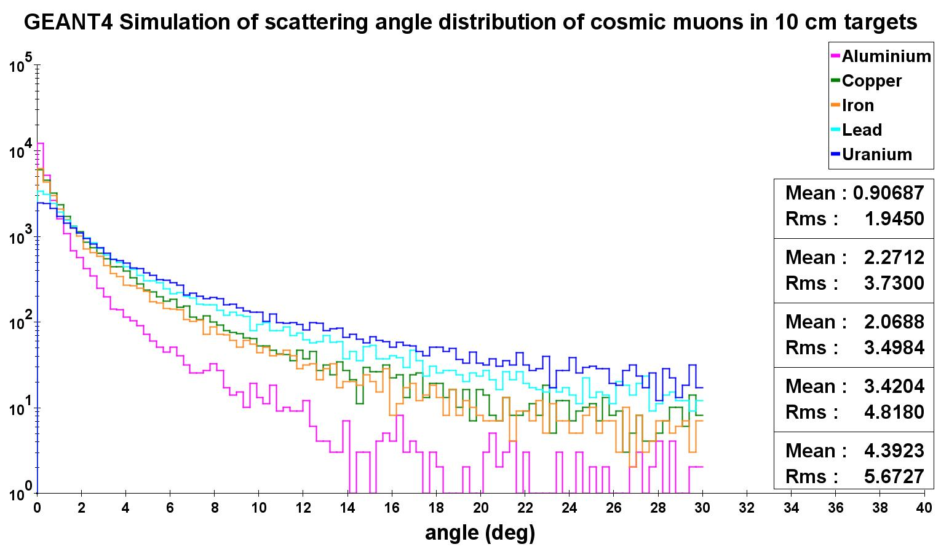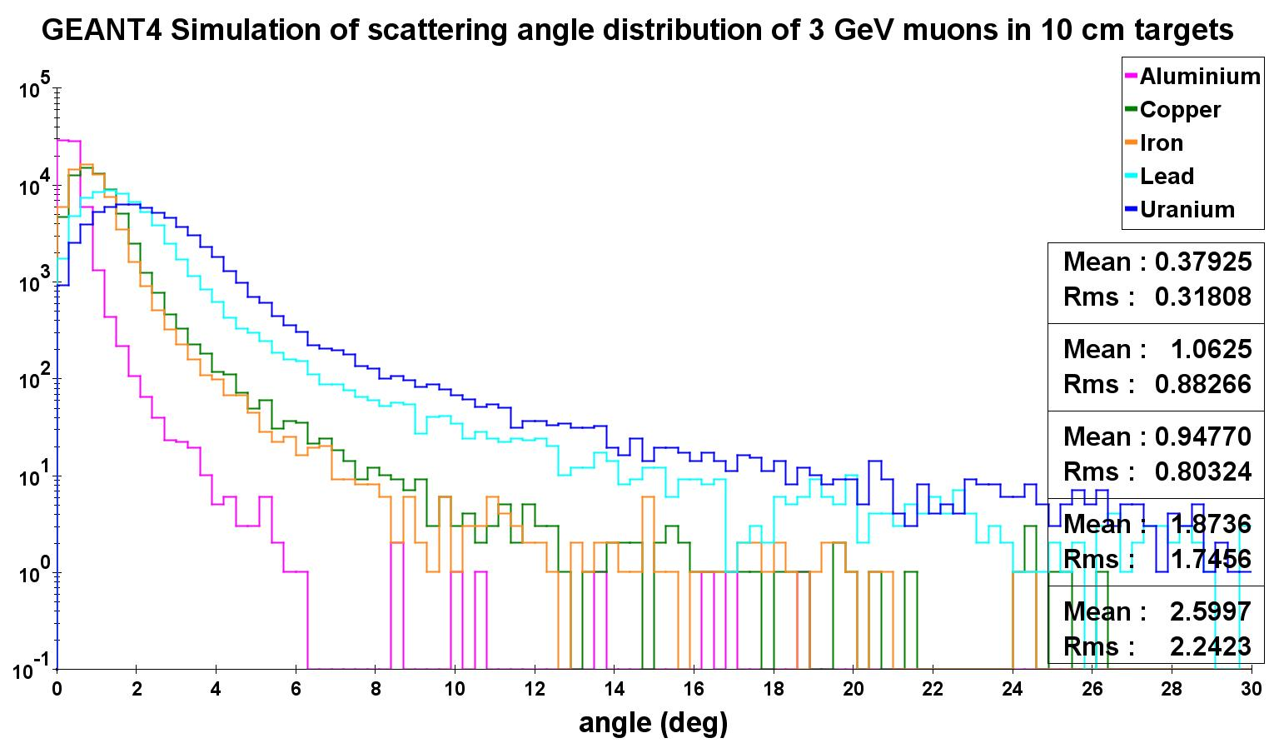
3 GeV muons
Cosmic ray muons

Fig.XXX Simulation results for scattering angles in 40cm x 40cm x 10cm targets for monoenergetic 3 GeV muons (left) and for cosmic ray muons placed in the center of a muon tomography station (right).

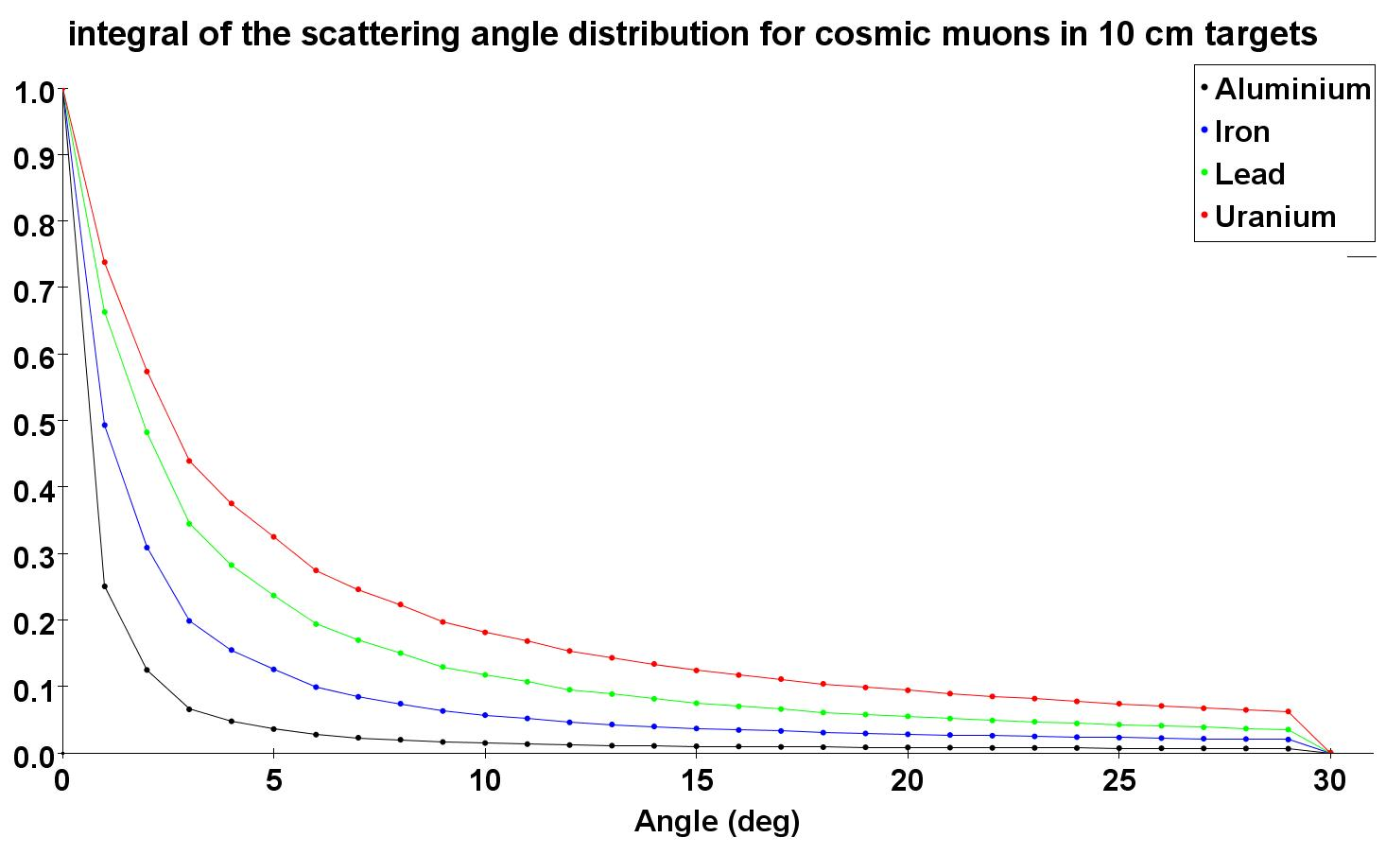
Cosmic ray muons
3 GeV muons

Fig. XXX Acceptances for events with scattering angles above a certain cut-angle vs. that cut-angle. Left: 40cm x 40cm x 10cm targets made of Al, Fe, Cu, Pb, and U using the monoenergetic 3 GeV muons. Right: For cosmic ray muons impinging on 40cm x 40cm x 10cm targets made out of the same materials. These plots are obtained by integrating the curves in Fig.? from the angle in question to infinity.

Scattering results for five targets of different Z

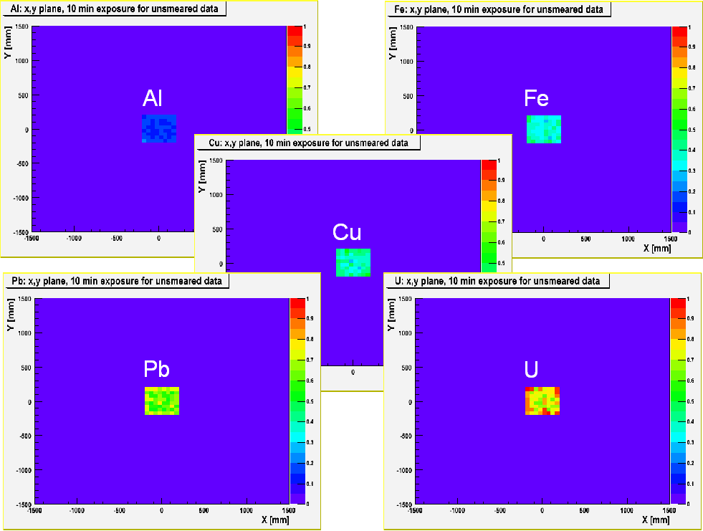

    - Signal significance

We do a first basic investigation of the problem of “false positives” by performing some simple statistical calculations on the signal significance for this case. As an example, 100 3 GeV muons impinging on 10 cm thick targets with 100 cm² area (equivalent to ~1 min cosmic ray muon exposure) would produce on the average 27 events with scattering angle >3º in the U target, ten such events in the Pb target, but only two events in the Fe target. The 27 events in the uranium cube have a statistical significance of S/√B = 27/√10 = 8.5σ relative to Pb background and S/√B = 19σ relative to Fe background. In either case, observing 27 events with scattering angles >3º would be highly significant.
Conversely, we can calculate how many cosmic ray muons N_{tot} have to be brought on target in order to achieve 5σ significance for a signal. Let R(θ) = S/B be the ratio of signal events to background events as a function of cut angle θ and let A_{signal}(θ) = S/N_{tot} be the acceptance for signal events as a function of θ as shown in Fig.7, e.g. 27% for U at θ=3º. The significance Signif is then given by
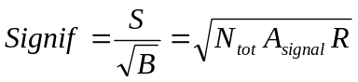 or 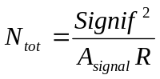.
To discriminate a U signal with 5σ significance against a Pb background, N_{tot} = 46 muons would need to be brought on target, but only N_{tot} = 5 muons would be needed for 5σ discrimination of a U signal against a Fe background. For 100 cm² targets this would correspond to ~28s and ~3s of exposure to cosmic ray muons, respectively, in this idealized case.
We note that the significance is proportional to √N_{tot} and that one needs to maximize the product A_{signal}(θ)⋅R(θ) of signal acceptance A_{signal}(θ) and signal-to-background ratio R(θ) as a function of the cut angle θ in order to maximize the signal significance. This corresponds to taking the product of the two curves at the bottom of Fig.7 for discriminating U vs. Pb with 3 GeV muons.

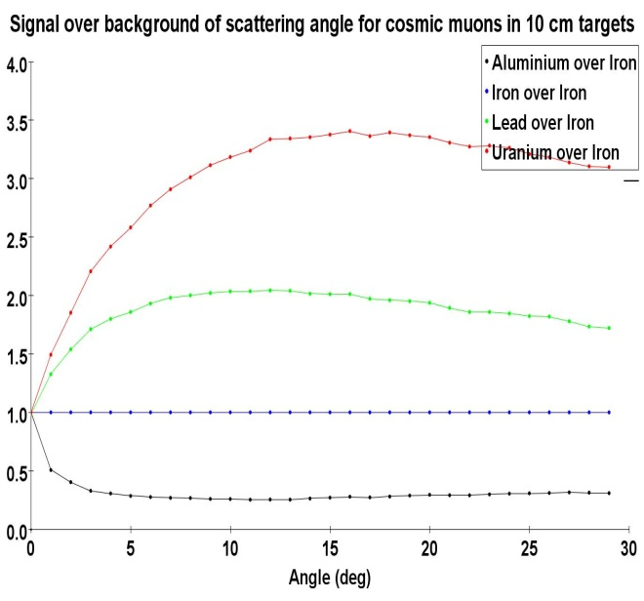
Cosmic ray muons
3 GeV muons

Fig. XXX Ratio of acceptances shown in fig.? above for events with scattering angles above a certain cut-angles vs. that cut-angle using Fe as the reference, i.e. as denominator in the ratios. Left: for 10 cm thick targets made of Al, Fe, Cu, Pb, and U using the monoenergetic 3 GeV muons. Right: For cosmic ray muons impinging on 10cm thick targets made out of the same materials. In both cases Fe is used as the denominator in the ratios

    - Detector resolution effects

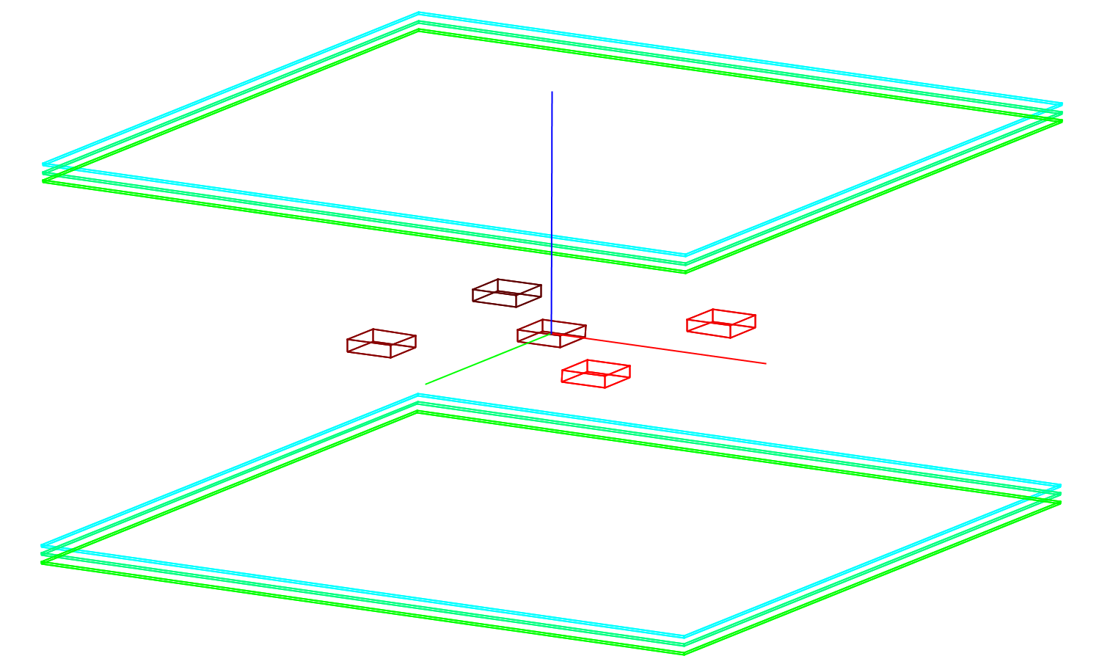
U
Cu
Al
Fe
Pb

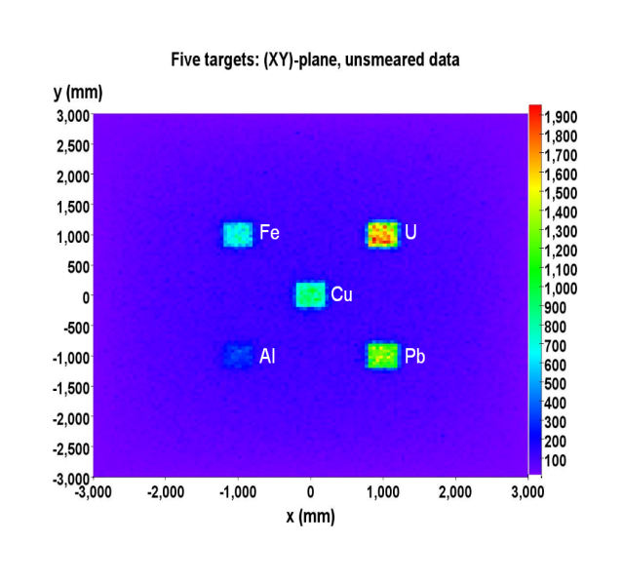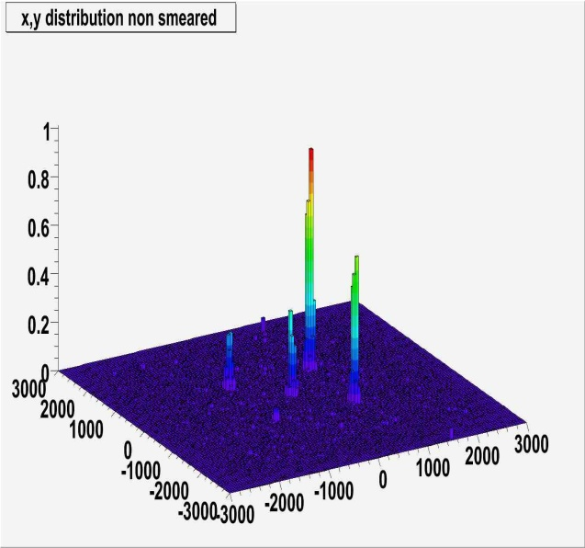

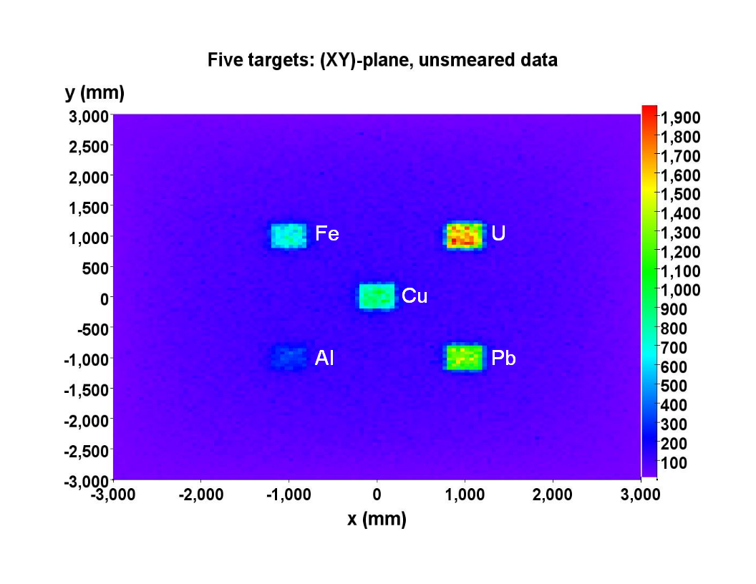
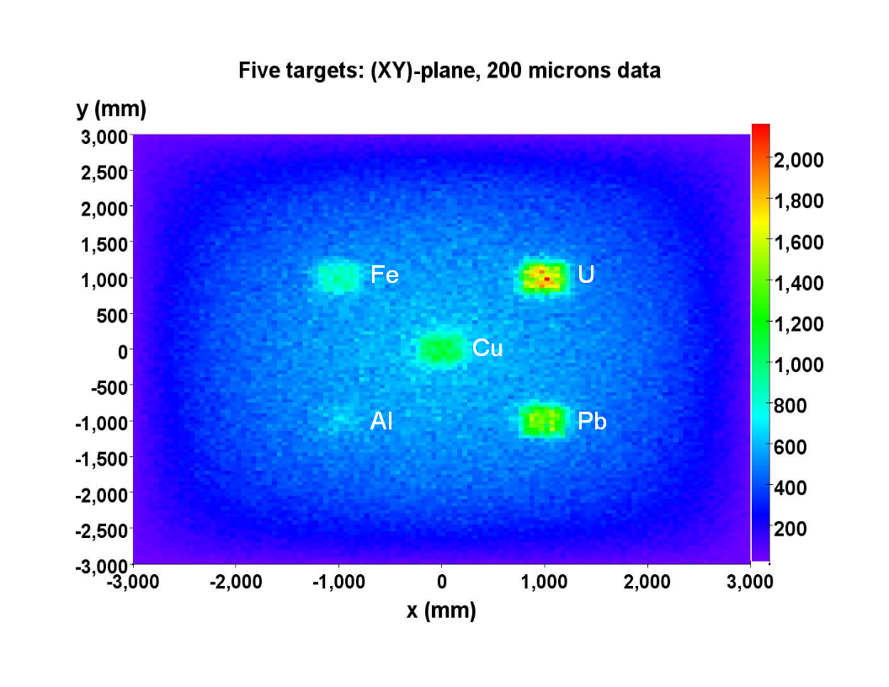

Fig. XXX Visualization of the total sum of all reconstructed scattering angles over all events for each voxel for 200μm GEM resolution. Entries for all voxels along the z-axis are summed together here (projected top view) and normalized. The data set comprises 10 million generated events corresponding to ~10min of exposure. Needs a color scale ! and axes labels

Fig. ? Collapsed top view.

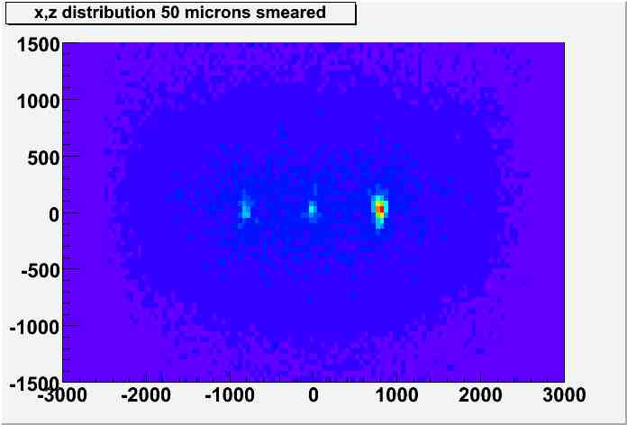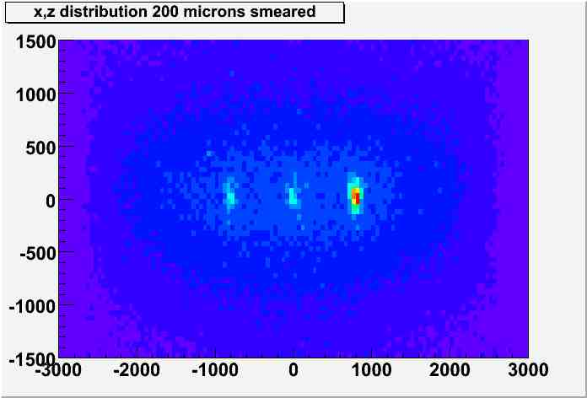

Fig. XXX Comparison of the total sum of all reconstructed scattering angles over all events for each voxel for 50μm (left) and 200μm (right) GEM resolution. Entries for all voxels along the y-axis are summed together here (projected side view) and normalized. The data set comprises 10 million generated events corresponding to ~10min of expoure. Needs a color scale ! and axes labels

Iron
Uranium

Iron
Uranium

U
Cu
Al
Fe
Pb

    - Scenarios of special interest

      - Shielded target scenarios

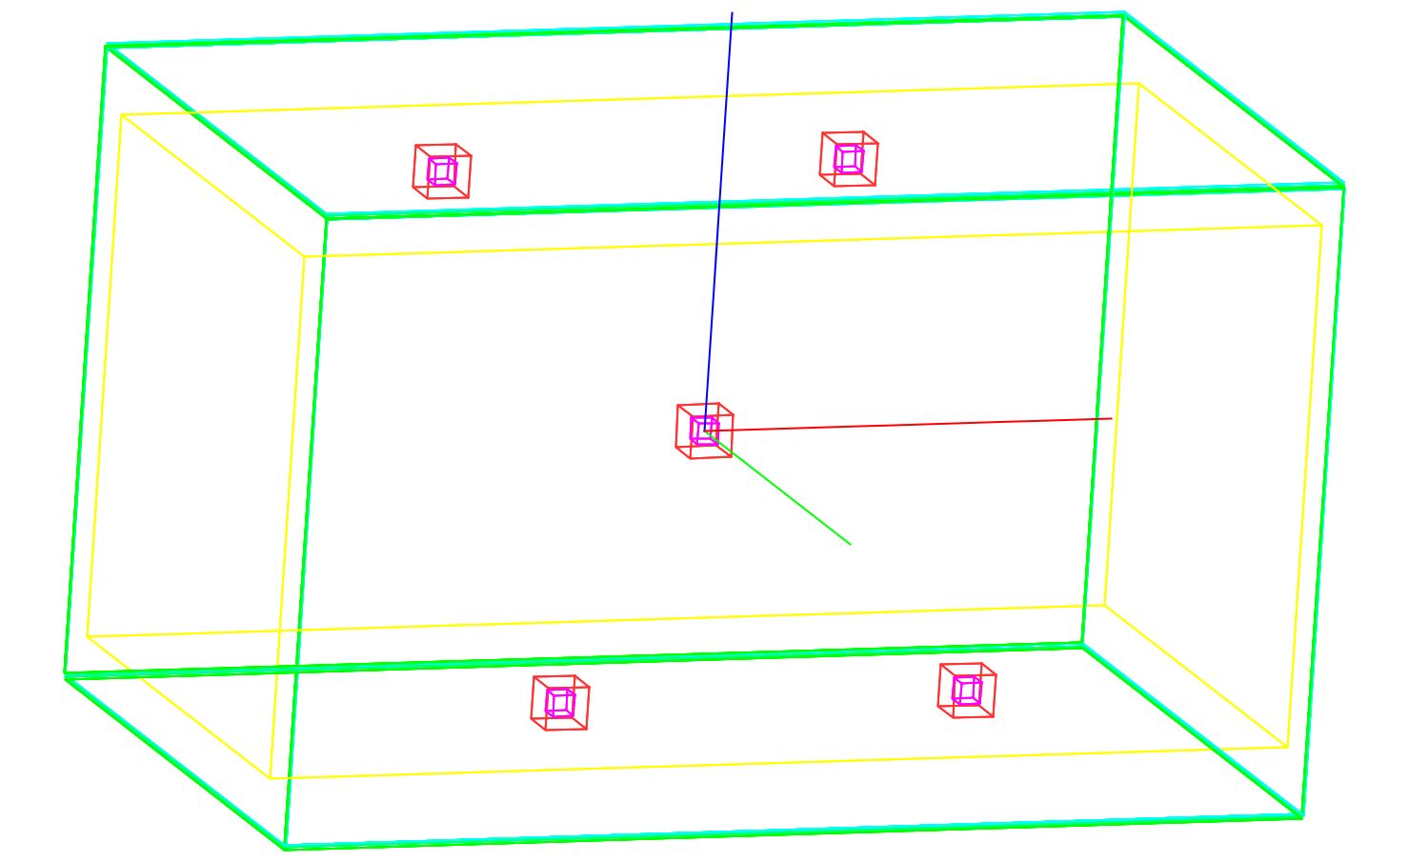
Z
X
Y

Fig.XXX GEANT4 geometry of a shielded target scenario using five liter-sized uranium
cores (purple) shielded on each of their six sides by 2.5cm of Pb. The targets are placed at coordinates (-1,-1,-1), (-1,-1,1), (0,0,0), (1,1,1), (1,1,-1) (all in m) within the muon tomography station.

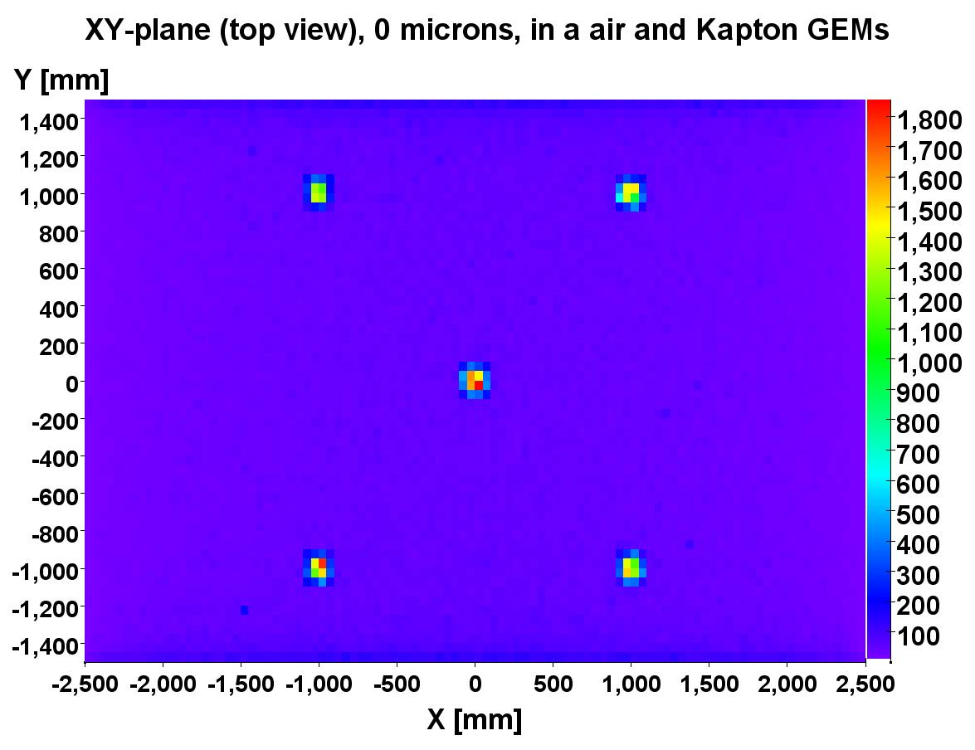

Fig. XXX Visualization of the total sum of all reconstructed scattering angles over all events for each voxel for the shielded target scenario and with perfect GEM resolution. Entries for all voxels along the z-axis are summed together here (projected top view) and normalized. The data set comprises 10 million generated events corresponding to ~10min of exposure. Needs a color scale !

      - Vertical clutter scenarios

U
Fe
X
Z

GEMs
GEMs

Fig. XXX Simple scenario with vertical clutter where a liter-sized cube made of material of interest (U) is placed underneath another liter-sized cube made of shielding material (Fe).
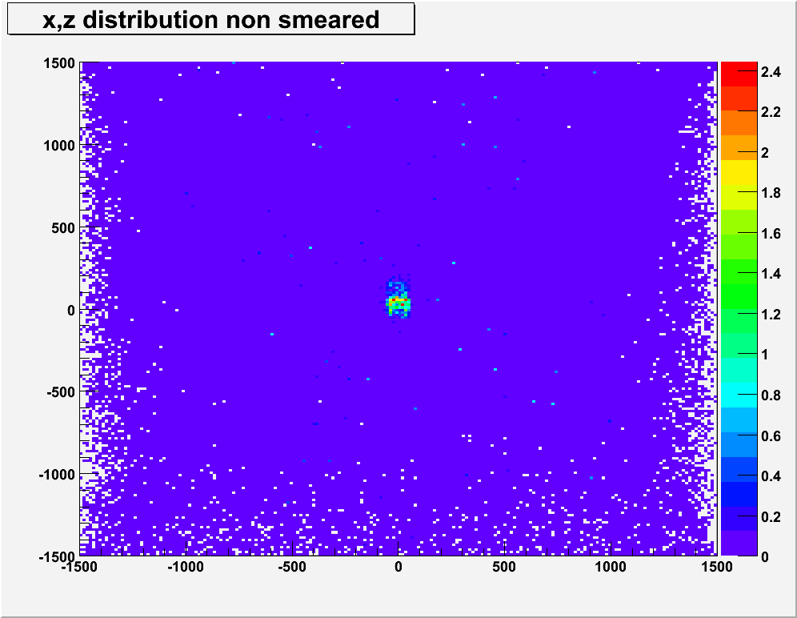
Fe over U
Fig. XXX Visualization of the total sum of all reconstructed scattering angles over all events for each voxel for the simple vertical clutter scenario of Fe over U and with perfect GEM resolution. Entries for all voxels along the y-axis are summed together here (projected side view) and normalized. The data set comprises 2.5 million generated events corresponding to ~10min of exposure. What’s the meaning of the scale?

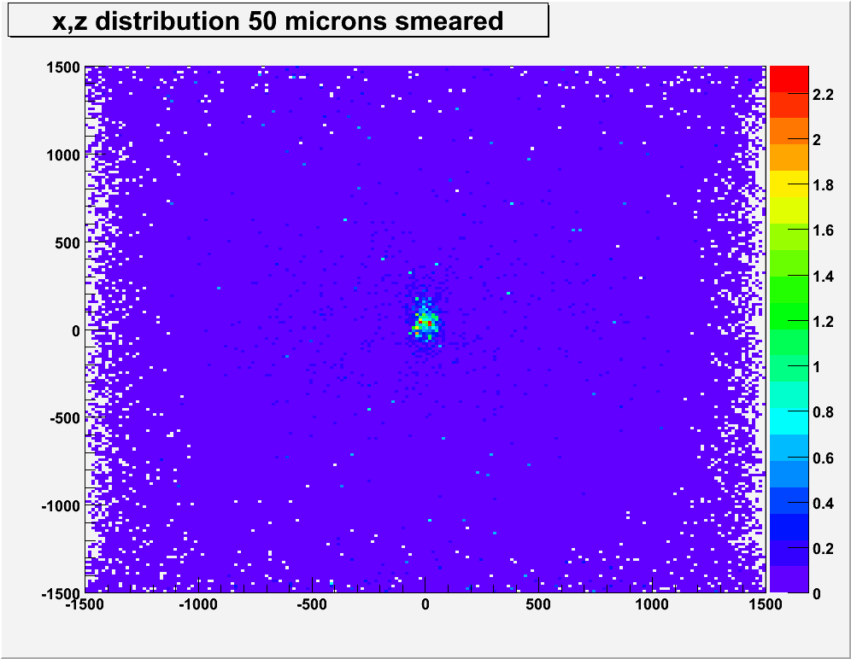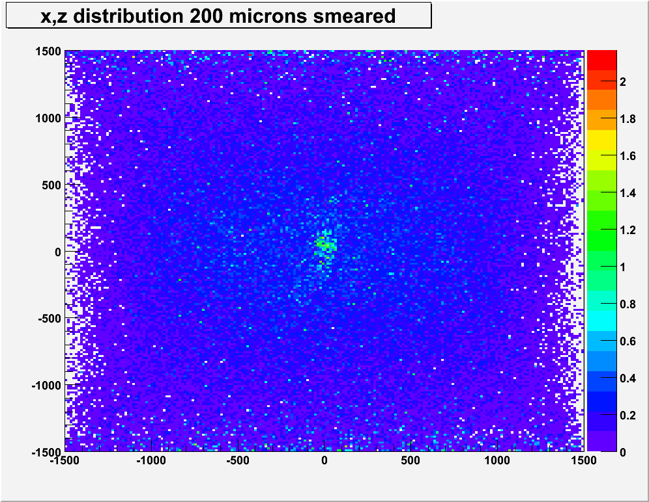
Fe over Uranium
200 microns
Fe over Uranium
50 microns
Fe over Uranium
200 microns
Fe over Uranium
200 microns
Fig. XXX Visualization of the total sum of all reconstructed scattering angles over all events for each voxel for the simple vertical clutter scenario of Fe over U for 50μm (left) and 200μm (right) GEM resolution. Entries for all voxels along the y-axis are summed together here (projected side view) and normalized. The data set comprises 2.5 million generated events corresponding to ~10min of exposure. What’s the meaning of the scale?

- Conclusions

- References

1. Dan Sunday, "Distance Between Lines and Segments with Their Closest Point of Approach," http://geometryalgorithms.com/Archive/algorithm_0106/algorithm_0106.htm, 2006.

2. Schultz, L.J. Blanpied, G.S. Borozdin, K.N. Fraser, A.M. Hengartner, N.W. Klimenko, A.V. Morris, C.L. Oram, C. Sossong, M.J. , "Statistical Reconstruction for Cosmic Ray Muon Tomography," IEEE Transactions on Image Processing, vol. 16 (8), pp: 1985-1993, Aug 2007.

3. H.A. Bethe, "Molière's Theory of Multiple Scattering," Physical Review, vol. 89(6), pp. 1256-1266, March 1953.

