Construction and Performance of Gas Electron Multiplier Detectors for Nuclear Contraband Detection using Muon Tomography

by

Amilkar Alejandro Quintero Segovia

Licenciado en Física
Universidad de Carabobo, Venezuela
2007

A thesis
submitted to
Florida Institute of Technology
in partial fulfillment of the requirements
for the degree of

Master of Science
In Physics

Melbourne, Florida
July, 2010

©Copyright 2010 Amilkar Quintero
All Rights Reserved

The author grants permission to make copies.

_________________________
We the undersigned committee hereby recommend
that the attached document be accepted as fulfilling in
part the requirements for the degree of
Master of Science in Physics.

“Construction and Performance of Gas Electron Multiplier detectors for nuclear contraband detection using Muon Tomography,” a thesis by Amilkar Alejandro Quintero Segovia

_____________________________ Marcus Hohlmann, Ph.D.  Associate Professor  Physics and Space Sciences | _____________________________ Debasis Mitra, Ph.D.  Professor  Computer Sciences
_____________________________ Joseph Dwyer, Ph.D.  Professor  Physics and Space Sciences | _____________________________ Terry D. Oswalt, Ph.D.  Professor and Head  Physics and Space Sciences

Abstract

Title: Construction and Performance of Gas Electron Multiplier Detectors for Nuclear Contraband Detection using Muon Tomography.

Author: Amilkar Alejandro Quintero Segovia

Advisor: Dr. Marcus Hohlmann

The construction of position-sensitive triple Gas Electron Multiplier (GEM) detectors of 30cm × 30cm active area is presented. These detectors are going to be used for a Muon Tomography station. The idea is to apply this technology in portal monitors at borders since the current techniques are not very sensitive to nuclear contraband, if these materials are well shielded to absorb emanating radiation. High voltage test of the GEM foils was performed to verify their quality. The foils are stretched and framed if they pass the first high voltage test. The drift cathode and the readout are glued onto honeycombs. Gas system test is done after the detector is assembled. The commissioning of the detectors was made using a Cu X-ray source and cosmic rays. The results show the energy spectrum of each source. The Cu X-ray spectrum shows an energy resolution ~20% (FWHM). The gas gain was ~10⁴ at 4 kV applied voltage. The Cu X-rays shows a rate plateau at 3.9 kV. These results are consistent with others triple-GEM detectors from different experiment. Similar studies have been made with two 10cm × 10cm active area GEM detectors. One detector has framed foils as the standard detectors. We used an ⁵⁵Fe X-ray source for commissioning. The spectrum for cosmic and ⁵⁵Fe (energy resolution ~60% FWHM) are reproduced. The rate plateau shows up at 4.05 kV and the gain was ~10⁵ at 4.3 kV applied voltage. We used honeycombs between non-framed GEM foils with the other detector, to avoid the stretching and gluing steps. The cosmic rays spectrum is reproduced. However this detector is very sensitive to vibration.
Table of Contents

Abstract iii
Table of Contents iv
List of Figures and Tables vi
Acknowledgments xi

Chapter 1 Introduction
1.1 Interaction of charged particles with matter 1
1.2 Gas Electron Multipier 5
1.3 Muon Tomography 8

Chapter 2 Construction of GEM detectors
2.1 GEM detectors assembly procedure 11
2.2 High voltage test of GEM foils 13
2.3 Frames for the GEM foils 16
2.4 Stretching and gluing process 17
2.5 Drift Cathode 21
2.6 Readout 23
2.7 Stack the foils 25
2.8 High voltage circuit board 28

Chapter 3 Commissioning the detectors
3.1 Gas distribution system 31
3.2 Initial tests 32
3.3 Detector Performance
3.3.1 Rate plateau 35
3.3.2 Charge sharing of the readout strips 36
3.3.3 Gain measurement 36
3.3.4 Uniformity measurements 39

Chapter 4 Small GEM detector
4.1 Construction 42
4.2 Results 43
4.3 Performance 47

Chapter 5 Conclusions and Summary 51

Reference 53
Appendix A : Landau Distribution 55
Appendix B : Computer Code to Save Oscilloscope Data in Excel 58

List of Figures and Tables

Figure 1.1: Mean energy loss rate in different media for muons, pions and protons (radiative effects for muons and pions, not included) [2]. 2
Figure 1.2: Contribution of different processes to the photon total cross-section as a function of energy in carbon and lead: σ_{p.e}. = photoelectric effect; σ_{Rayleigh} = Rayleigh scattering; σ_{Compton} = Compton scattering; κ_{nuc} = Pair production, nuclear field; κ_{e} = Pair production, electron field [2]. 4
Figure 1.3: Diagram of primary and secondary ionization due to incoming photons. 5
Figure 1.4: Magnified view of a GEM foil, hole diameter 70 µm and hole distances 140 µm [6]. 6
Figure 1.5: Different steps to make the holes in a GEM foil (left). Electron microscope view of a cross-section through one hole (right) [6]. 7
Figure 1.6: Triple-GEM configuration [9]. 8
Figure 1.7: The muon tomography concept. A muon passing through uranium has the potential to scatter more than one that passes through iron [10]. 9
Figure 1.8: Simulated cargo van scenario with Al, Fe, W, U, Pu targets (left). Mean angle reconstruction with POCA (right) [13]. 10
Figure 2.1: Exploded view of COMPASS triple GEM assembly [7].. 12
Figure 2.2 GEM foil under high voltage test in an airtight Plexiglas box under nitrogen at GDD-CERN lab (left). High voltage power supply and ammeter used for high voltage test of the foils at GDD-CERN lab (right). 13
Figure 2.3: Leakage current results for 24 foils tested at CERN, before (top) and after (bottom) framing. The figures show histograms of each sector result of all the foils tested. 14
Table 1: Result of the high voltage test for all the 24 foils before and after framing. 15
Figure 2.4: Raw frame delivered by the CERN workshop. The front one without extra material (left). Frame for the GEM foils being coated at the inner sides of the detector (right). 16
Figure 2.5: Bottom part of the stretching device (top left). Foil in the stretching device (top right). A foil ready to go into the oven for stretching (bottom). 18
Figure 2.6: Applying the glue with a needle to the inner part of a frame (top left). Framed foil in the thermal stretching device ready to go into the oven to cure the glue (top right). Three frames glued onto foils with the stretching device in the oven (bottom). 20
Figure 2.7: Gluing the drift cathode with a roller (top left). Gluing the honeycomb for the drift cathode with a roller (top right). Removing air bubbles (bottom left). Applying heavy weight during the curing process (bottom right). 22
Figure 2.8: Gluing process of the drift spacer. A small roller is used to glue the groove part in the frame (left). Placing the drift cathode spacer using the alignment pins (center). Complete drift cathode with its spacer (right). 23
Figure 2.9: Single-GEM diagram with a 2-D readout in a cross sectional view, top strips are X-axis and bottom ones Y-axis [6] (left). Magnified image of the readout used in the detectors; bright areas are gluing problems. 24
Figure 2.10: Gas outlet slit in the readout’s honeycomb (top left). Readout before gluing to the honeycomb (top right). Readout glued to the honeycomb with a Mylar foil (bottom left). Readout final shape (bottom right). 25
Figure 2.11: Applying the glue to the spacer to stack the first framed GEM foil (top left). With the alignment pins in position, the process is repeated for the three foils to stack them (top right). Heavy weight is applied until the glue cures (bottom). 26
Figure 2.12: Cutting the outer frame from the GEM stack (top left). Removing the outer frame of the chamber (top right). Gluing the GEM stack onto the readout (bottom left). Heavy weight to join the GEM stack and the readout (bottom right). 27
Figure 2.13: Triple-GEM detector with gas connectors and Panasonic connectors for the readout front end (left). Coating the detectors to prevent gas leak (right). 28
Figure 2.14: High voltage circuit. The electronic diagram updated by TERA group from COMPASS design. 29
Figure 2.15: Printed circuit board with resistors soldered in (top). HV board attached to a GEM chamber (bottom). 29
Figure 2.16: Test of the HV board. Ohmic behavior was confirmed, obtaining the same result for all the assembled board before (left) and after (right) coating. Error bars are much smaller than the points 30
Figure 3.1: Grooves for the gas system in the drift cathode spacer (top left). Small holes in frame strips (bottom left). Diagram of the gas system of the detectors (right). 31
Figure 3.2: Test of the HV board after being connected to the triple-GEM detector. Ohmic behavior was confirmed, obtaining the same result for all the assembled board. Note that this figure is not the same as figure 2.16. 32
Figure 3.3: Fully assembled detector with strips of the readout terminated for single channel data recording. Cu X-ray bench at GDD-CERN lab. 33
Figure 3.4: Single triple GEM detector channel measurement with Cu X-rays. The yellow scope trace is the actual pulse showing Argon escape peak and photo peak of Cu X-rays, the violet scope trace is the gate pulse for the ADC. 33
Figure 3.5: Pulse area spectrum showing a ~20% energy resolution (FWHM) for 8.04 keV Cu X-ray. The noise pedestal peak is at ~100 ADC, the escape peak at ~1000, and the photo peak at 1451 ADC. Gaussian fit (blue) to the photo peak.. 34
Figure 3.6: Corresponding pulse area distribution with fit to Landau curve (blue). 34
Figure 3.7: X-rays count rate plateau. 35
Figure 3.8: Charge sharing x - y strips for increasing HV with Cu X-rays. Error bars are much smaller than the points. 36
Figure 3.9: Gas gain of one of the triple-GEM detectors in Ar/CO₂ 70:30, obtained at CERN. 38
Figure 3.10: Absolute effective gain measured in two positions of a COMPASS chamber with extreme values [3], compared with the gain result measured from one of the assembled chambers (black). 38
Figure 3.11: The detector studied on the X-ray bench. Yellow lines represent the location of the strips inside the detector. The marks (red) are the areas studied, in centimeters from the 0 point. 39
Figure 3.12: X-ray spectra measured at different areas of the detectors. 40
Figure 3.13: Result showing the uniformity of the main peak positions in different areas of the detector studied. Error bars are much smaller than the points. 41
Figure 4.1: Spacers between foils inside the small GEM detector with plastic washers (left). Assembled small GEM detector with 2-D readout and aluminized Mylar as lid (right). 42
Figure 4.2: Non-framed foil with honeycomb placed on the top and a frame (left). Assembled small non-framed GEM detector with 1-D readout and honeycomb lid (right). 43
Figure 4.3: Test of the HV board disconnected from the small chambers (left). HV test with the board connected to the standard small chamber (right). Error bars are much smaller than the points. 44
Figure 4.4: Single channel measurement of a cosmic ray event (left). Corresponding pulse height distribution of cosmic rays with fit to Landau curve in blue (right). 45
Figure 4.5: Energy spectrum obtained for ⁵⁵Fe with the small standard detector. Energy resolution ~60% (FWHM). Gaussian fit for the photo peak in blue. 46
Figure 4.6: Pulse height distribution of cosmic rays using the honeycomb detector. 46
Figure 4.7: Count rate plateau for standard small detector. Error bars are much smaller than the points. 47
Figure 4.8: Pulse height average of the output pulse at different applied voltages, with an exponential fit (left). Linear interpolation to the three last points of the left figure (right). 48
Figure 4.9: Pulse height average of the output pulse using a calibration pulse, with a linear interpolation. 49
Figure 4.10: Gain result for the small standard detector (blue), using a calibration pulse of 20 ns width. Result for the big detector (red). 50
Figure 4.11: Grid array with the ⁵⁵Fe source and the sector name in red to perform a uniformity test (left). Uniformity results using the main peak position in different areas of the standard small detector with bottom strips of the readout (right). 50

Acknowledgments

All my gratitude to Dr. Hohlmann, for giving me the chance to work with him. During the entire program, I learned a lot of very important and interesting topics of physics from him. He was an excellent advisor.

Dr. Kondo Gnavo was a very important mentor during my time in Melbourne and Geneva. I appreciate all the knowledge that he shared with me. Also I want to thank him for his friendship and support.

Gas Detectors Development (GDD) lab at CERN, because I could not do all my work without their help. Especially I want to thanks Miranda van Stenis because she taught me how to assemble the detectors. Also thanks to TERA Foundation at CERN for their help with the construction.

To all my partners in the HEP lab A, especially to the graduates: Himali, Samir, Lenny and Mike; and the undergraduates: Nick, Mike and Alfred.

Finally to the Department of Homeland Security specifically Domestic Nuclear Detection Office, for the grant 2007-DN-077-ER0006-02, that supports most of my degree program.

I want to dedicate this thesis to God, my parent, all my family and in particular to my wife for all the support that she gave me in this country.

Chapter 1 Introduction

1.1 Interaction of charged particles with matter

Any particle passing through matter interacts with that medium in different ways like electromagnetic, gravitational or nuclear forces. Suppose a rocket going into space. The forces interacting with the rocket, due to its size, are gravitational and drag force. These forces enable an observer to see the contrail of the rocket during its journey to space. In this case the rocket acts like a particle and the atmosphere represents the medium.

The same reasoning is applied to subatomic particles; however, electromagnetic interactions are dominant at this level. Strong or weak interactions are less probable to occur so they are unnecessary to detect particles. Coulomb interactions between the electromagnetic fields of the incoming charged particles and the medium produce ionization and excitation of the atoms of the medium. These two processes are the most important to the total energy loss of the incoming particles. Other electromagnetic processes (Bremsstrahlung, Cherenkov and transition radiation) are negligible in gas detectors [1].

While charged particles are passing through any medium the average loss energy per unit length due to Coulomb interaction is given by the Bethe-Bloch equation [2]:
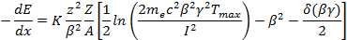

Where: -T_{max} is the maximum kinetic energy that can be imparted to a free electron
in a single collision.
- 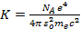 a constant.
- z and β are the charge and velocity (β = v/c) of the particle.
- Z and A are the atomic number and mass of the medium.
- δ(βγ) is the density effect correction of the medium.
- γ is the Lorentz factor.

The Bethe-Bloch equation depends only on the velocity β of the particle. Figure 1.1 shows a fast decrease dominated by the β⁻² term in the equation, reaching a minimum value around βγ = 1.2 and a slow increase for βγ → ∞ (relativistic rise) [5]. Most relativistic particles, like cosmic rays, have mean energy loss rate close to this minimum so they are called minimum ionized particles or MIP.
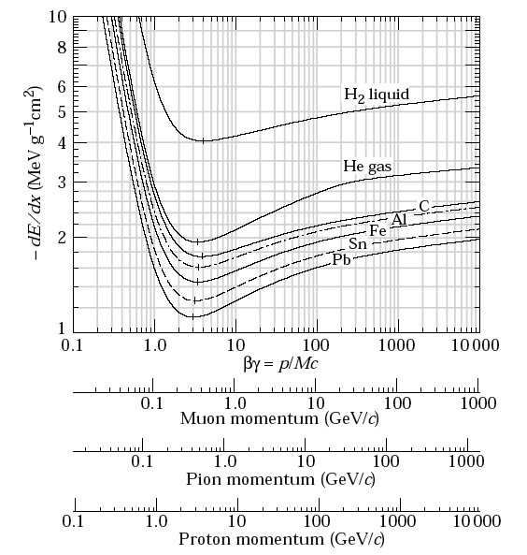
Figure 1.1: Mean energy loss rate in different media for muons, pions and protons (radiative effects for muons and pions, not included) [2].

The variation of the energy loss around the mean energy loss value is an asymmetric distribution called the Landau distribution [3], which is given by:
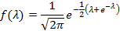

Where λ is the normalized deviation from the most probable energy loss Δ_{mp}:

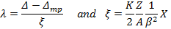

Where Δ is the actual energy loss, ξ the average energy loss given by the first term in the Bethe-Bloch formula, and X is the area density of the medium (appendix A).

Although photons do not have charge, electromagnetic interaction is also used to detect them but with a different treatment of charged particles. The probability of adsorption can be written in terms of the mass attenuation coefficient μ, or the cross section σ of a beam of photon traversing a medium of thickness x with a number molecules per unit volume N:

The cross section of the photon depends on its energy. This energy determines the mechanics of interaction (see figure 1.2). Atomic photoelectric effect for low energy, incoherent scattering or Compton scattering for medium energies, and pair production for high energy; all contribute to the total cross section of the photons. Other mechanisms such as Rayleigh (coherent) scattering, photonuclear interactions (very high energy, the nucleus broke up), also contribute.

The atomic photoelectric effect is very important for gaseous detectors development since X-rays isotopes (~keV) are commonly used to test these detectors. Also X-ray detection is used in many applications [1].
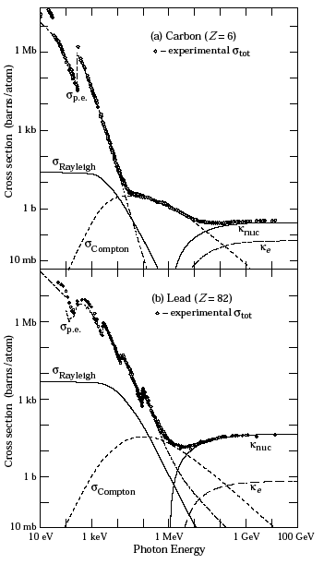
Figure 1.2: Contribution of different processes to the photon total cross-section as a function of energy in carbon and lead: σ_{p.e}. = photoelectric effect; σ_{Rayleigh} = Rayleigh scattering; σ_{Compton} = Compton scattering; κ_{nuc} = Pair production, nuclear field; κ_{e} = Pair production, electron field [2].

The energy loss by ionization and excitation starts with a certain number of primaries interacting with the atoms of the medium. These atoms liberate ion-electron pairs. Some of the electrons are trapped in a different energy level. This event produces other X-rays that have enough energy to further ionize other atoms of the medium, producing secondary ion-electron pairs. The sum of the two contributions is called total ionization [1]. Sometimes the resulting ion-electron pairs from the primary ionization do not produce secondary ionizations, so the electron escapes the medium and it is detected. These electrons produce the called “escape peak”. Figure 1.3 presents a diagram of this process. In an energy distribution spectrum, the discrepancy between the primary and secondary ionization is always constant since the total ionization posses the contribution of the primary ionization.
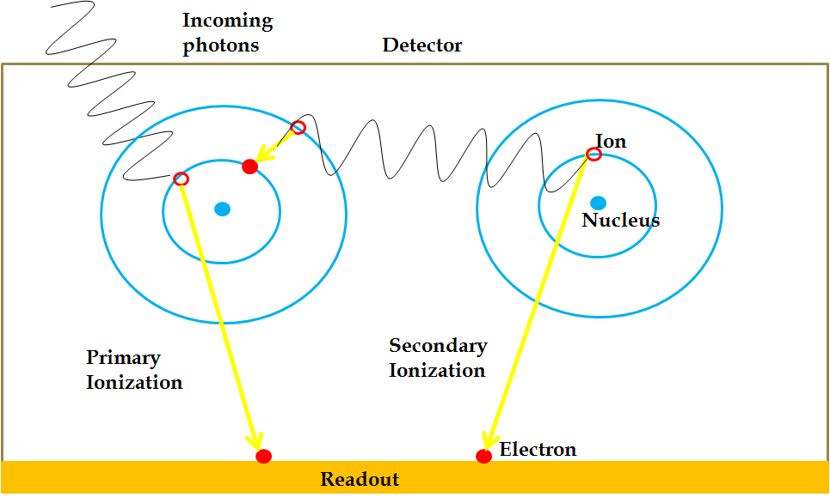
Figure 1.3: Diagram of primary and secondary ionization due to incoming photons.

1.2 Gas Electron Multiplier

A new generation of gaseous particles detectors, using precision photolithographic technologies, is called Micro-Pattern Gas Detectors (MPGD). The first of this type was the Micro Strip Gas Chamber. These detectors have better performance than classical multi-wire detectors. However they are not reliable and get seriously damaged by accidental discharges. Other detectors such as Micro-dot, Micromegas and Gas Electron Multiplier are generally sturdy enough to withstand discharges, have higher reliability and can be produced at low costs [4].
The Gas Electron Multiplier (GEM) detector is a Micro-Pattern Gas Detector that uses a thin foil of Kapton coated with copper layers on both sides and pierced by a regular array of chemically etched holes, typically 140 μm apart (see figure 1.4). High voltage is applied across a GEM foil to produce high electric field that creates an avalanche of electrons through the holes. These electrons are collected by a suitable device. GEM detectors provide good efficiency and good spatial resolution. These advantages make this detector good instrument for research in high energy physics experiments and other applications [5].

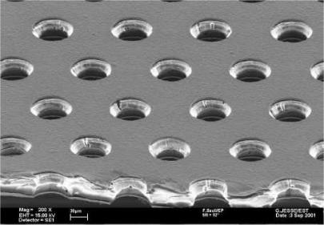
Figure 1.4: Magnified view of a GEM foil, hole diameter 70 µm and hole distances 140 µm [6].

The GEM foils production was developed by CERN-EST-DEM workshop. The holes on the copper are formed by conventional photolithography techniques using a mask pattern of the holes, in which proper alignment of the two sides is very important. The shape of the holes is done by etching chemically the Kapton on both sides of the foil (see figure 1.5) [7].
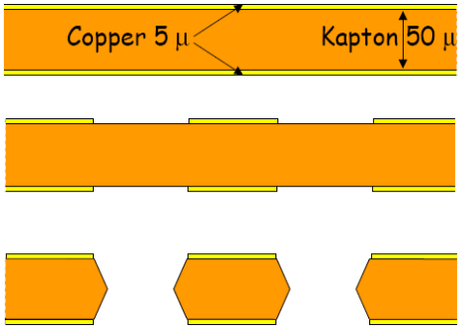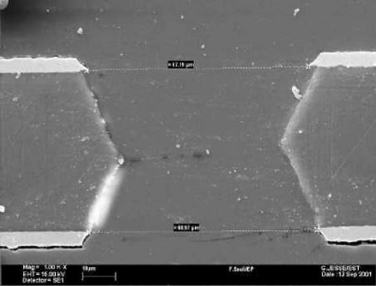
Photolithography Etching
Chemical Etching
Figure 1.5: Different steps to make the holes in a GEM foil (left). Electron microscope view of a cross-section through one hole (right) [6].

Holes shape plays an important role in determining the performance of the detector. To achieve higher gain, the potential difference between electrodes can be increased or the hole diameter can be reduced. The pitch plays no role in the gain however the hole diameter and the pitch affect the collection efficiency of electrons. The foil pattern and the geometry of the hole are determined by the necessities of the experiment [4].

To avoid using excessive potential across the GEM and to obtain good performance, it is necessary to operate the detector with the proper gas mixtures. The gas mixture of Argon and CO₂ in the volume proportion 70:30 has been the most used gas mixture in many experiments with GEM detectors. Although this is not the best for obtaining the highest gain, it has the advantage of being nonflammable, chemically stable and with a fast electron drift velocity. It is also intrinsically non-aging under heavy avalanche conditions and provides stable gain under high rate long-term exposure to radiation [8].

Another configuration to avoid applying high voltage between GEM foils is to use a set of two (double-GEM detector) or three (triple-GEM detector) foils, powered with a suitable potential difference between each foil [5]. The triple-GEM configuration (figure 1.6) is the most popular one, allowing GEM foils to hold less voltage and providing low discharge probability. The triple-GEM configuration is very reliable in long term trials.
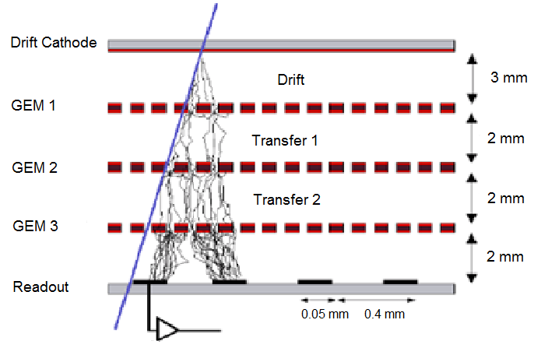
Figure 1.6: Triple-GEM configuration [9].

1.3 Muon Tomography

Muon Tomography (MT) technique has been proposed to detect high Z material in cargo, when such materials are well shielded. Due to their large mass and high energy, muons can pass through many meters of material without being absorbed; also they are easily detectable. All this features make muon useful in distinguishing between certain materials [10].

Muons are charged elementary particles with mass 105.7 MeV/c² and get produced in the upper atmosphere by primary cosmic rays. The muon flux at sea level is ~10000 per minute per meter square, at an average energy of 4 GeV, which makes them almost 200 times more massive than electrons. They have a lifetime of 2.2μs which makes it the second longest living unstable subatomic particle [6]. Muons are produced when a cosmic ray strike an atmosphere molecule and produce a shower of particles, one of which is the muon.
Although the energy loss for muon due to electromagnetic interactions with the medium (see section 1.1) is still present, it is not enough to stop them in many cases. Muons possess another electromagnetic interaction with the medium that is Multiple Coulomb Scattering. When muon passes near an atomic nucleus, the muon can be deflected from its initial path if the electric field of the nucleus is strong enough. Since the muons are passing through a medium, several of these deflections happen during the muons’ path. Coulomb scattering depends on density and atomic number Z of the material traversed because it is the interaction between two charged particles [2]. A technology that applies this principles has been proposed as a noninvasive technique which can be used for homeland security, due to the fact that nuclear materials have large atomic number Z (see figure 1.7) [10].

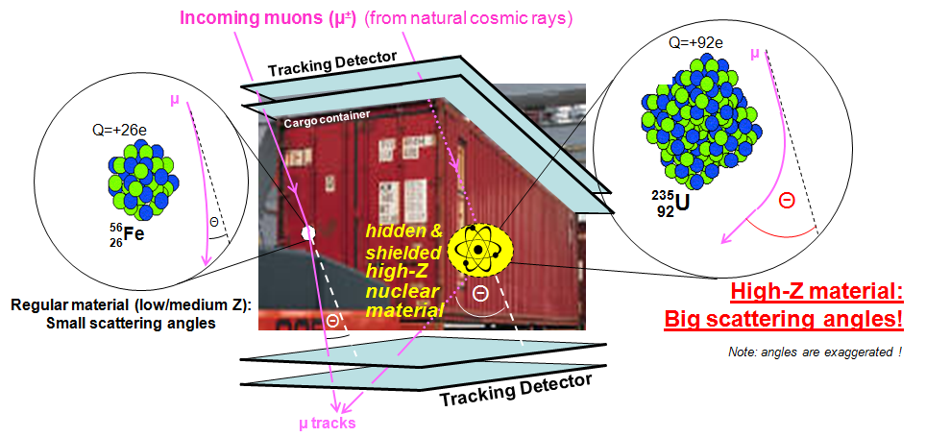
Figure 1.7: The muon tomography concept. A muon passing through uranium has the potential to scatter more than one that passes through iron [10].

Computer simulations have shown that cosmic rays muon tomography can discriminate sensitive high Z nuclear material such as uranium against iron or steel background with high statistical significance in four to ten minutes of exposure if the detectors have good spatial resolution (~100 μm). Monte Carlo simulations were used to model the effectiveness of various MT station configurations, which is primarily determined by the time required to produce an accurate and precise Point-Of-Closest-Approach (POCA) reconstruction. POCA reconstructions provide the locations where and by how much muons have been scattered. Computer simulation data are used to choose practical and effective detector configurations. Data from real-world detectors will be used to validate these simulations [11] [12].
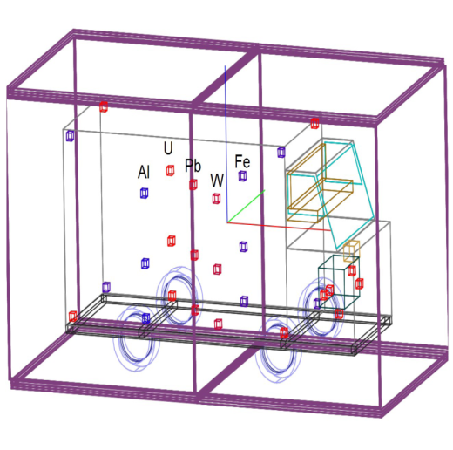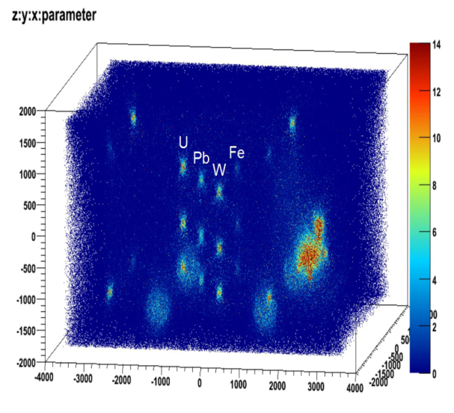
θ
Figure 1.8: Simulated cargo van scenario with Al, Fe, W, U, Pu targets (left). Mean angle reconstruction with POCA (right) [13].

These simulations have shown that the detector spatial resolution is a crucial parameter for the quality of discrimination and target imaging achievable by a compact cosmic ray muon tomography station. Also the multiple scattering effects in the detector material itself are found to be non-negligible [11] [12]. GEM detectors match these requirements since they have resolution of ~50 μm, so they can reproduce results obtained for simulation with perfect resolution. Also the material used for construction of the detectors is minimized not only to avoid multiples scattering in the detector itself but also to maintain the low cost of the detectors.

Next, we present the construction and commissioning of several GEM detectors as the first steps for the development of a muon tomography station for detecting nuclear contraband.

Chapter 2 Construction of GEM detectors

2.1 GEM detectors assembly procedure

We used 30cm × 30cm GEM foils based on an upgraded version of the original foils used by the COMPASS experiment at CERN [3], but with the central foil area also sensitive to traversing particles because COMPASS original design possessed a separate area in the center that serve as beam killer. This updated design was originally proposed by the TERA Foundation for a medical application [14]. Each GEM foil, one electrode is divided into twelve sectors in order to reduce discharge probability; the electrode in the other side is not divided [3].

All components used for the GEM detector construction material and the readout electronics have been selected to minimize the mass and consequently multiple scattering in the GEM detectors themselves. Each detector is fabricated by gluing together a set of thin frames holding the three foils, in a similar procedure to that used for the assembly of COMPASS [3] and TERA [14] GEM detectors. Some small improvements were made in the assembly techniques. Mechanical stiffness and gas tightness are provided by two low-mass outer honeycomb supporting plates. One on the top for the drift cathode and the other honeycomb pasted under readout board (see figure 2.1). The distances between the drift and first GEM foil is 3 mm, while all other spaces are 2 mm (see figure 1.6).

COMPASS configuration use 50 μm Kapton foils coated with 5 μm copper, with holes arranged in a triangular pattern, ~70 μm in diameter and 140 μm pitch [7] [15]. To reduce both energy and propagation probability of discharges, COMPASS have subdivided one side of each GEM foil into twelve sectors, separately connected externally to the voltage supply through high value resistors.
The separation between sectors is 200 μm, sufficiently narrow to induce only a small perturbation in the uniformity of response of the detector. Different configurations will produce different performance, other choices (such as smaller hole diameter and pitch or a thinner metal layer), may be more efficient but current production facilities are not capable of achieving a better pattern for foils [7].

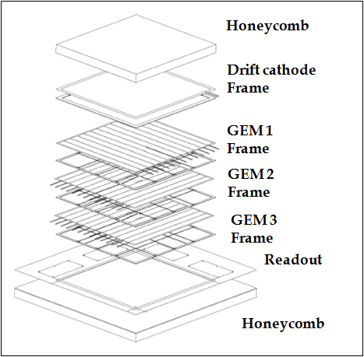
Figure 2.1: Exploded view of COMPASS triple-GEM assembly [7].

All the steps of the assembly process that require handling GEM foils must be carried out in a class 1000 clean room, with controlled temperature and low moisture levels (~40%) and using the appropriate attire like facial masks, gloves and suit.
2.2 High voltage test of GEM foils

The acceptance criterion for a GEM foil requires the foil to hold 500 V under nitrogen gas with a leakage current less than 5nA in each of the 12 sectors. These tests are made in a class 1000 clean room and are performed before and after framing the foils (figure 2.2). The tests are performed in an airtight Plexiglas box with nitrogen flowing at a rate of five volume exchanges in three hours, to reduce moisture levels. A high voltage power supply (CAEN N471A) and an ammeter (Tabor Electronics DMM4030) are used for the current measurements.
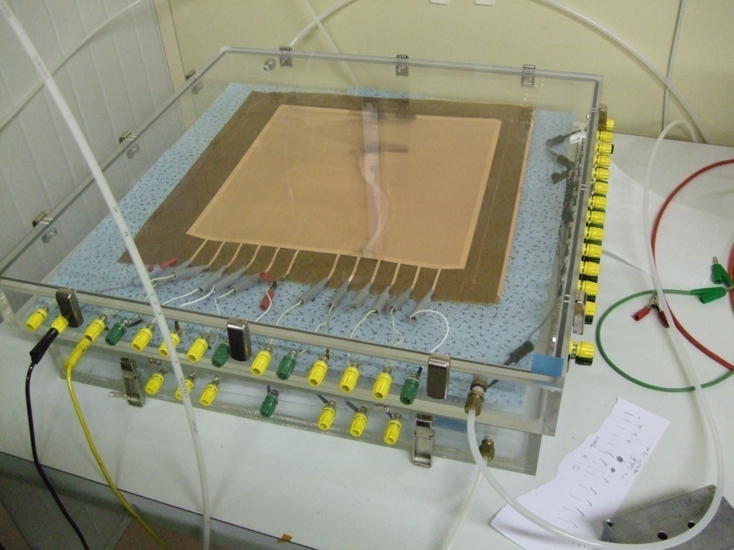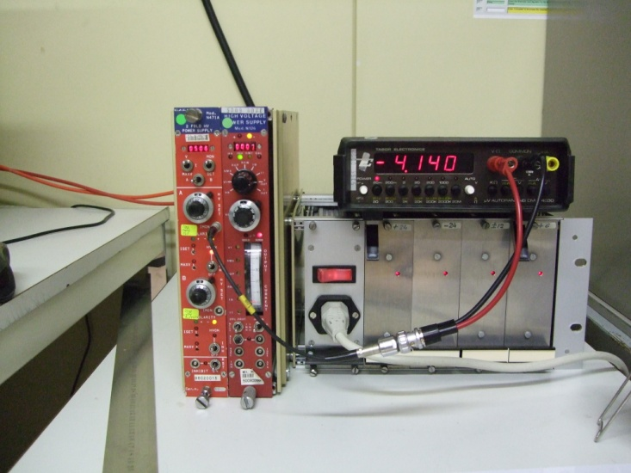
Figure 2.2 GEM foil under high voltage test in an airtight Plexiglas box under nitrogen at GDD-CERN lab (left). High voltage power supply and ammeter used for high voltage test of the foils at GDD-CERN lab (right).

Due to the fragility of the foils, this part of the process must be done with extreme caution in the handling since any large wrinkle or cut will cause an irretrievable damage. These foils are like a piece of paper so any hard movement could cause damage. It is important to avoid contact with the active area.

The foils must be carefully flushed with a low flow of nitrogen to remove dust particles before putting it in the Plexiglas box for the test. This flushing must be made parallel to the foils, to avoid direct contact of the nitrogen with the foils and cause damage. During high voltage test, the time for the leakage current to stabilize fluctuates randomly in each sector; two minutes with stable value of current and without sparking is necessary to approve a sector. Sometimes the stabilization of the current could take more that fifteen minutes or could be faster than two minutes. If the test fails the first time, it is necessary to perform second or third tests. Usually foils improve with second tests because the moisture level improves. In case of sparking, the ramp-up is stopped but resumed immediately. Most of the time sparks are produced because of dust particles in the foil that burn up when the high voltage is applied. If the spark remain in the same location, increase the voltage until 800 V and the current until 4 μA systematically (the manufacturer suggested these maximum voltage and current values), to burn up this dust particle that could be altering the result; this procedure improves the quality of the foils considerably. Although all the foils are individually inspected and tested by the production workshop at CERN, sparking is very common in the foils.

A total of 30 foils were delivered by the CERN PCB workshop. Only 24 were tested, all of which passed the high voltage test before framing (see figure 2.3), with an average leakage current of 2.0 nA. The other six foils will be tested at Florida Tech.

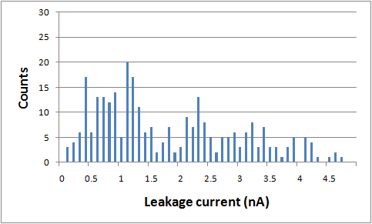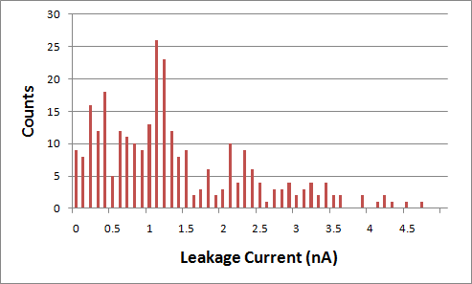
Figure 2.3: Leakage current results for 24 foils tested at CERN, before (top) and after (bottom) framing. The figures show histograms of each sector result of all the foils tested.
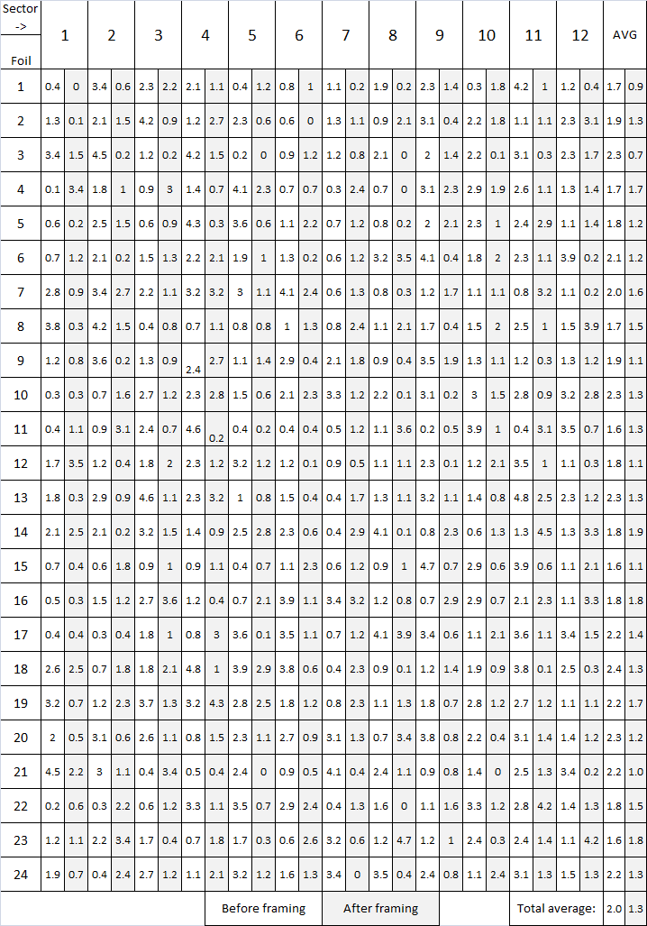
Table 1: Result of the high voltage test for all the 24 foils before and after framing.
2.3 Frames for the GEM foils

The frames or spacers provide the mechanical tension to the foils and their thickness is used to separate the foils to obtain the required electric fields. As in the standard CERN triple-GEM detector design, we are using a 3mm spacer for the drift cathode to establish the distance between drift cathode and first GEM; and 2mm spacers between the GEM foils (see figure 1.6).

The frames come from the CERN PCB workshop with two areas of extra material. The outer one is the periphery of the FR4 plate used to make the frames. It is removed before working with the frames (figure 2.4). The middle area allows for alignment pins. It is designed to be relatively wide so that strong adhesion of the foil to the frame and good foil flatness during the stretching process can be guaranteed. This design is an improvement in the GEM framing process.

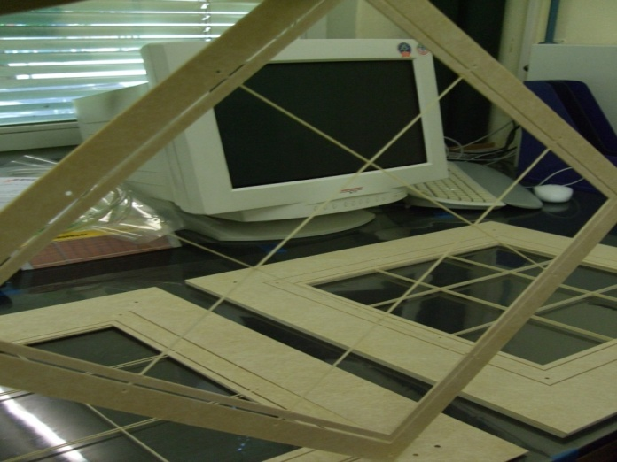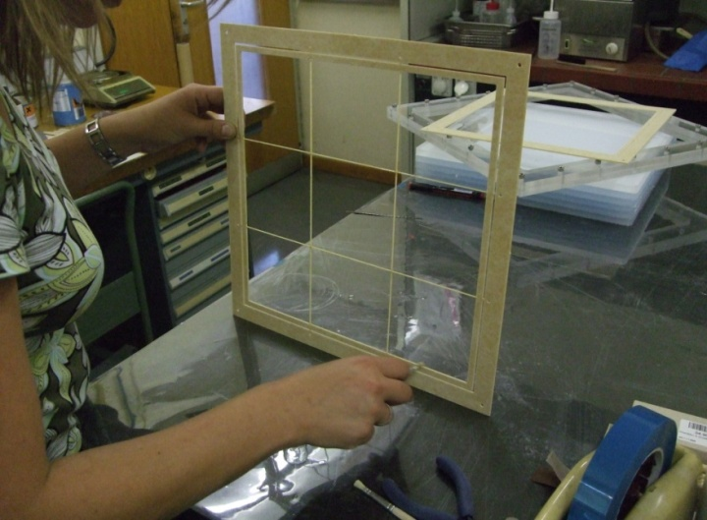

Figure 2.4: Raw frame delivered by the CERN workshop. The front one without extra material (left). Frame for the GEM foils being coated at the inner sides of the detector (right).

The frames also have a grid of thin strips within the active area to maintain the gap in the middle sections of the foils. This grid is machined from the same plate as the frame. The grid structure of the frame and the inner sides of the frames are sanded down, then coated with two component polyurethane Nuvovern LW of Walter Mader AG to prevent dust particles from the frame itself to get on the GEM foils (see figure 2.4). It is not necessary to clean the outer parts. The drift spacer (3mm thick) does not have this grid structure however it has a grove to distribute the gas uniformly through the chamber. This groove must be coated the same way as the frames and taking special care not to obstruct the groove with the coating.

To prepare the coating, use 3 grams of Nuvovern per 1 gram of Durcisserur, this is enough to coat at least six frames. With a small brush, coat the inner parts already cleaned. Do not apply very much coating to avoid bumps. If there are some bumps that can affect the thickness of the frame, clean the bump with a tissue before the coating cures. This is to avoid gas leaks after the stacking of the framed foils. To reduce curing time and assure good polymerization the coated frames are placed in oven per twelve hours at a temperature of 45 ºC.

2.4 Stretching and gluing process

We use a thermal method for tensioning the GEM foils. This method uses thermal expansion of Plexiglas to stretch the foils. A Plexiglas frame was made to accommodate a foil. This device consists of two frames much bigger than the active area; they are attached to each other by screws. The inner parts of these Plexiglas frames are also used in the stretching process (see figure 2.5). This stretching device must be clean because it is in direct contact with the foils. Methanol is used to clean the device since isopropanol or ethanol degrades Plexiglas and then flush it with nitrogen.
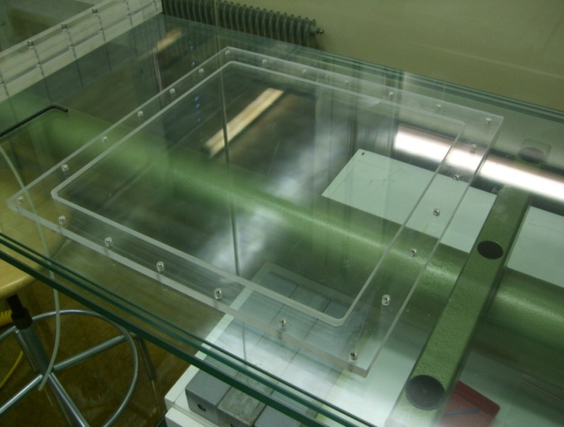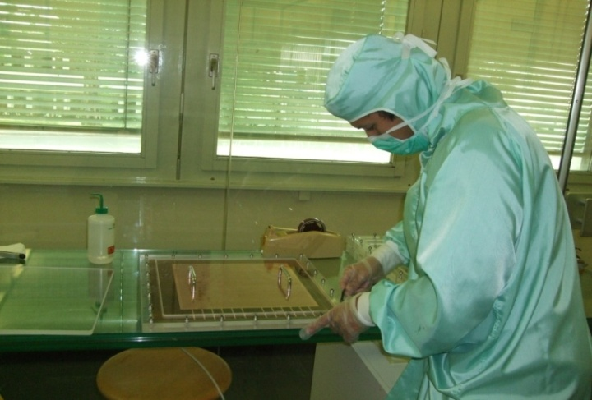
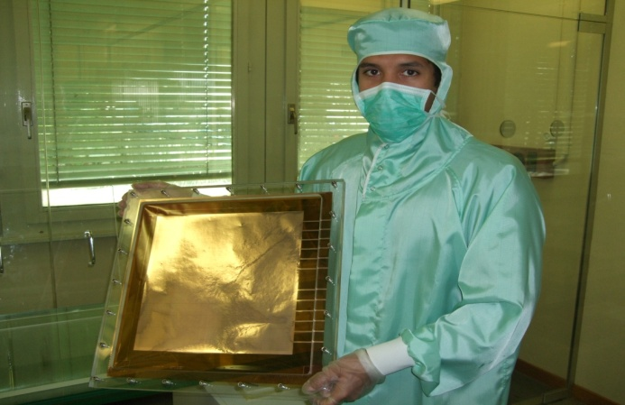
Figure 2.5: Bottom part of the stretching device (top left). Foil in the stretching device (top right). A foil ready to go into the oven for stretching (bottom).

The stretching process starts by placing the foil on the bottom part of the stretching device (frame and inner part). Lay down the foil in the center of the inner part so the foil frame could fit without problems. Place the other Plexiglas plane (handles were attached to this part to facilitate removing it from the device) to hold the foil flat. Then put the other frame, tighten slightly the screws of the frames and remove the top and bottom Plexiglas planes. Put it in the oven at 45 ºC; the foil should be stretched approximately twenty minutes. Sometimes foils are not well stretched in one or two corners because of incorrect placement so repeat the stretching process but unscrew only the problematic corner and stretch it by hand.

The thermal method has been used for 10cm × 10cm detectors. We are the first to use this method with this foils size. The results obtained were very good, the foils were well stretched and the method proved to be very easy and fast to use.

We used ARALDIT AY103+HD991 (ratio 5:2) from CybaGeigi to glue a frame onto the tensioned foil. This product is a good electrical insulator and it is convenient for its handling properties (density and viscosity) [7]. To prepare the epoxy, use 30 grams and 12 grams; this quantity is more than sufficient to glue three frames but the spare glue is used as a sample to make sure that it had crystallized. In all the assembly process steps that involve using the glue, a test sample was used. The glue must not be used after one hour.

Flush the coated frames with nitrogen to remove all dust particles before gluing them to the foils. The epoxy is applied with a needle in a syringe to enable the application of a very thin strip of glue on the frame. After the glue is on the frame bring the stretched foil from the oven. It is very important to cut the outer part of the frame from the inner part, but only in one side for the strips of the foil; so all these outer frames can be removed after stacking the framed foils.

The most critical step in the whole assembly process is to glue the frame onto the foil. The frame must be glued on the side opposite to the twelve electrode strips. Place one side of the frame with the glue, close to the active area and touching the Kapton. Holding the center of that side with one hand while using the other hand keep the opposite side in the air (the frame must not be held in the corners). Fit the frame with the active area. There is no reference for to fit the frame, make sure that the active area is in the center of the frame. When the frame is lined up, drop the frame (see figure 2.6). If is not lined up, the frame can be moved no more than three or four millimeters, so the glue does not touch the active area. Put the foil with the frame, still in the stretching device again into the oven at 45 ºC to maintain the tension until the glue is cured (~12 hours). For each chamber, there must be one frame with a gas slit in GEM 3. This slit must be on the same side of the electrode strips (details about the gas systems in section 3.1). The spare Kapton sides are cut with a scalpel, and high voltage test is repeated.

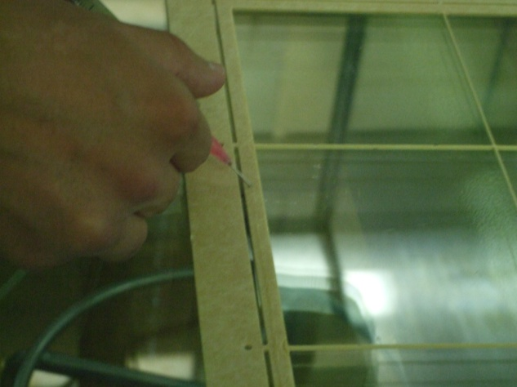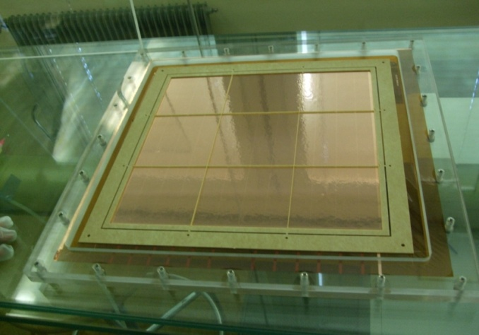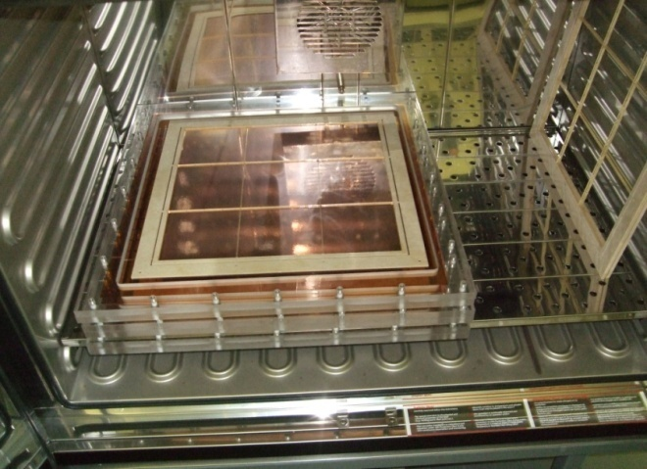
Figure 2.6: Applying the glue with a needle to the inner part of a frame (top left). Framed foil in the thermal stretching device ready to go into the oven to cure the glue (top right). Three frames glued onto foils with the stretching device in the oven (bottom).

Out of twenty-four framed foils, eighteen passed the high voltage test with an average of 1.3 nA (see figure 2.3). Five foils showed unacceptably large currents due to problems during the gluing process but were successfully recovered with an ultrasonic bath in ethanol at CERN PCB workshop. One foil was lost due to a cut in the active area. The performance of the foils improved after the framing process, probably because of the reduction in moisture levels after hours in the oven.

2.5 Drift Cathode

The drift cathode is made of a single-sided metal-coated Kapton foil 50 μm thick, with the 5 μm copper layer patterned to cover only the active part of the detector in order to prevent edge problems. The mechanical rigidity of the detectors is provided by two honeycomb plates, one supporting the readout plane and the other supporting the drift cathode. A copper-clad Kapton strip permits the application of voltage. It extends from the electrode and is offset with respect to the GEM contacts. The frame used for the drift is 3mm thick and 7mm wide. It is glued onto the Kapton electrode and defines the sensitive volume of the drift region. A groove in this frame distributes the gas input through narrow slits along two sides of the chamber [7].

To glue the drift cathode onto the honeycomb plate, clean and flush the Kapton side before applying the glue. The drift cathode can be glued outside the clean room without any special clean room equipment. This facilitates the assembly procedure but still it is necessary to maintain the clean standards.

Since there is no reference to align the honeycomb and the drift cathode, draw marks the drift cathode so it is placed in the center of the honeycomb. The glue is applied uniformly to the Kapton side of the drift cathode with a roller, keeping the drift cathode extended with tape in the table. The honeycomb for the drift has two sides, clean the darkest side and use the roller to spread the glue in this side. Place the honeycomb onto the drift cathode. Air bubbles between the honeycomb and the drift must be removed using a roller, rolling from the center to the edges, before putting heavy weights onto the assembly. A rubber sheet must be placed first to keep the weight distribution uniform and then a rigid plate. Put heavy weights to glue the drift cathode. Keep this setting per 12 hours for the glue to cure (see figure 2.7).
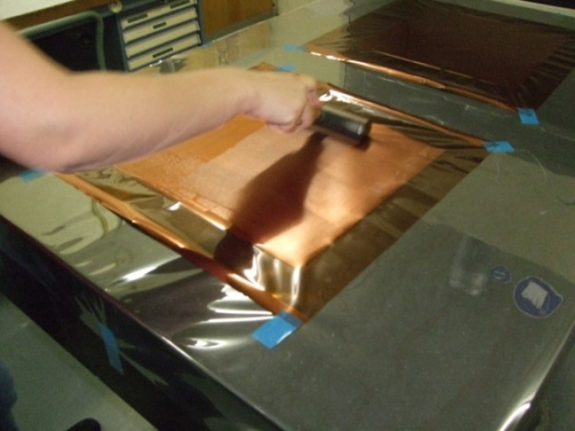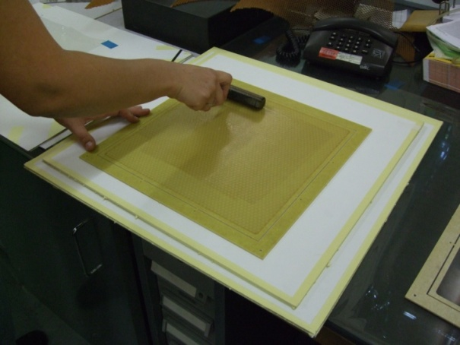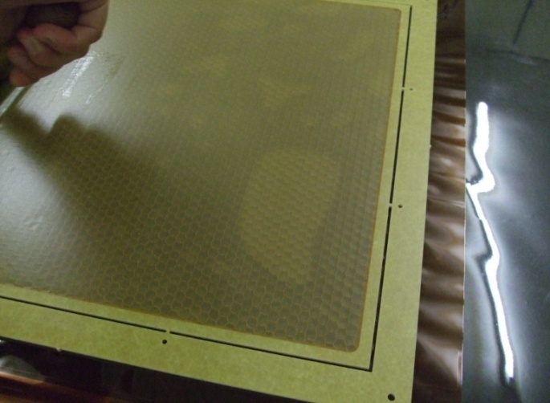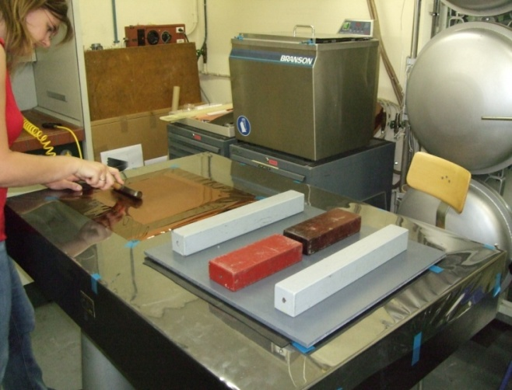
Figure 2.7: Gluing the drift cathode with a roller (top left). Gluing the honeycomb for the drift cathode with a roller (top right). Removing air bubbles (bottom left). Applying heavy weight during the curing process (bottom right).

After 12 hours the glue is cured so the extra Kapton parts must be removed using a scalpel. Before gluing the spacer of the drift (3mm thick), check again that the groove for the gas is not blocked and with no dust or big particles. Flush this frame before gluing it onto the drift cathode with the honeycomb. The frame or spacer between the drift and the first GEM foil is glued onto the drift cathode using the alignment pins in the outer frame. Use a needle to apply the glue in the frame and use a small roller to apply the glue in the sides of the frames with the gas grooves (see figure 2.8). Care must be taken not to obstruct the grooves and the gas inlet (on top of the drift cathode strip). Also do not glue the high voltage strip with the outer frame (where the alignment pins are placed), because it is possible to cut that strip when this outer frame is removed. Finally take out the pins, put something rigid on the spacer and put heavy weight on it for 12 hours. The most important issue in this process is not to scratch or spill glue on the drift cathode because it can cause serious damage to the whole detector.

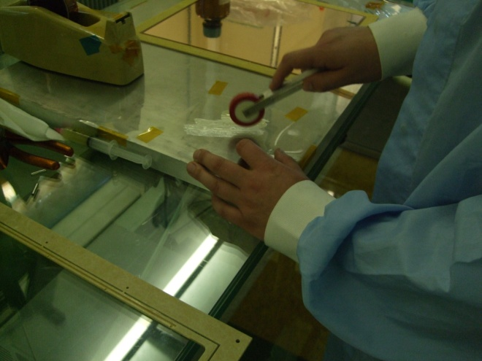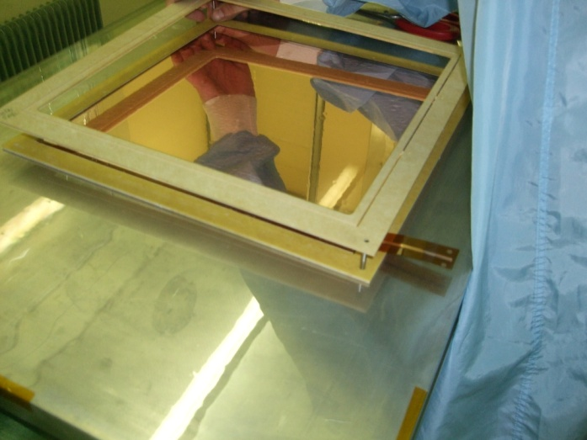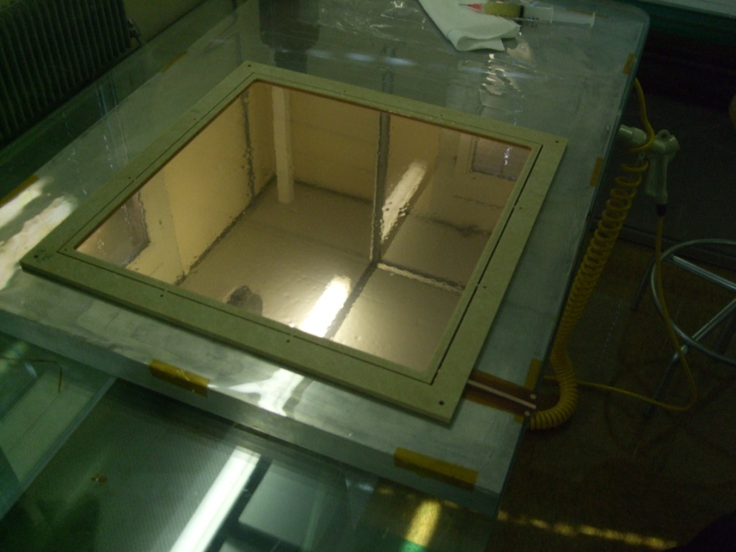
Figure 2.8: Gluing process of the drift spacer. A small roller is used to glue the groove part in the frame (left). Placing the drift cathode spacer using the alignment pins (center). Complete drift cathode with its spacer (right).

2.6 Readout

The two-dimensional printed circuit board (PCB) readout consists of two layers of perpendicular copper strips at 400 μm pitch, the two layers being separated by 50 μm thick Kapton ridges (see figure 2.9). Each coordinate has 768 readout strips, divided into six sectors. The method of fabrication is similar to the one used for GEMs [7].

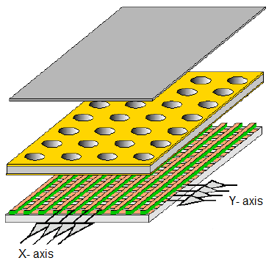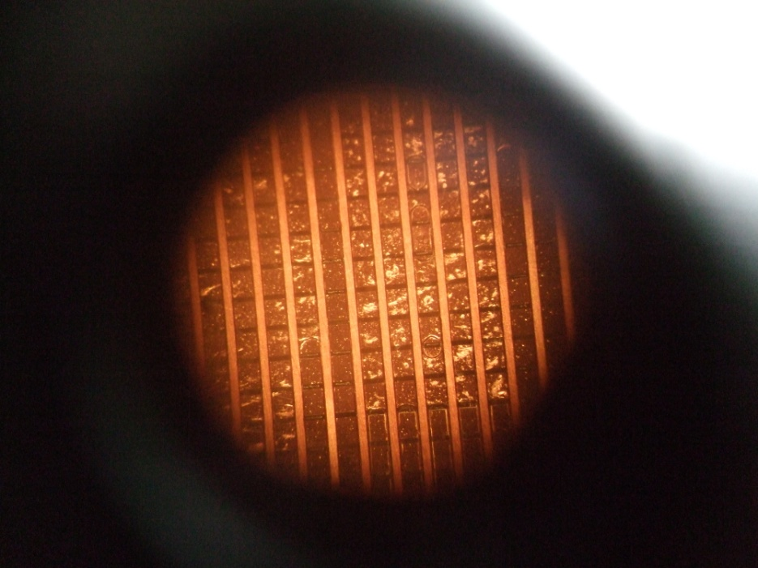
Figure 2.9: Single-GEM diagram with a 2-D readout in a cross sectional view, top strips are X-axis and bottom ones Y-axis [6] (left). Magnified image of the readout used in the detectors; bright areas are gluing problems.

The gluing of the readout foil works the same way as for the drift cathode, but the honeycomb structure of the readout has the gas outlet of the chamber so it must be glued in a specific way.

Clean the Kapton side of the readout before applying the glue. The readout, like the drift cathode, can be glued outside the clean room. Use tape to fix the readout to the table so it will not move; spread the glue uniformly with the roller. The honeycomb for the readout has two sides, clean the darkest side and use the roller to apply the glue in this side (the gas outlet must be in this side). Tape the honeycomb to the table so it will not move and spare the glue with the roller. The readout must be glued onto the honeycomb, whereas with the drift cathode, the honeycomb goes onto the drift. Use the reference holes of the honeycomb and readout (provided by manufacturer); this will fit the gas outlet in the correct position (special care must be taken to not close this slit with the glue). Place clean Mylar foil on the readout and with a clean roller take out all air bubbles, rolling from the center to the edges. To finish put weight on the readout and wait until the glue is cured.

After gluing, the readout goes to the machine shop to be cut so it gets its final shape and room to place the high voltage circuit board (see figure 2.10).

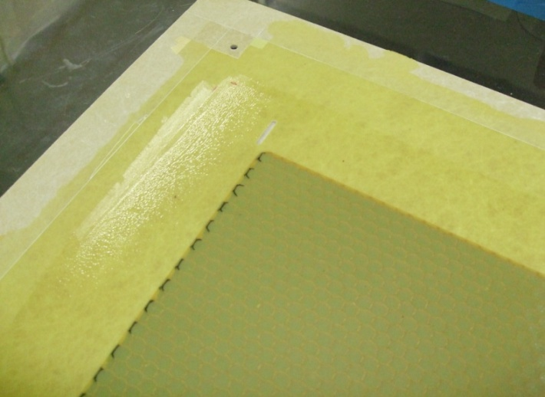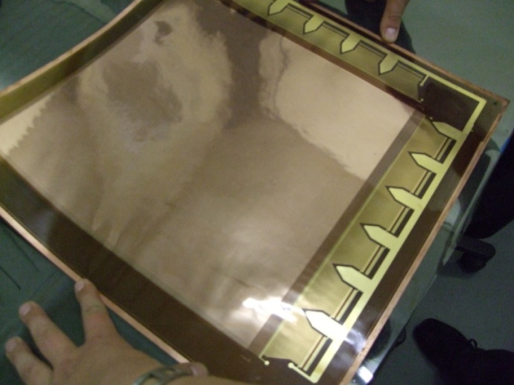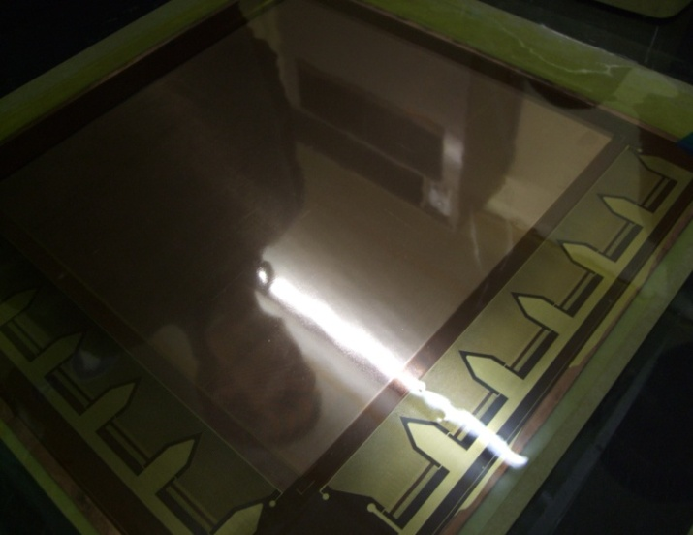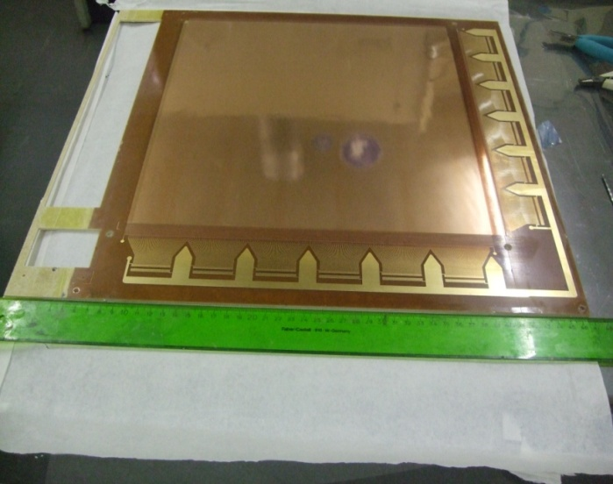
Gas outlet groove
Figure 2.10: Gas outlet slit in the readout’s honeycomb (top left). Readout before gluing to the honeycomb (top right). Readout glued to the honeycomb with a Mylar foil (bottom left). Readout final shape (bottom right).

2.7 Stacking the foils

The final steps of the assembly of the chamber must be done inside the clean room, since the foils are exposed to the environment. A last and very exhaustive flush must be done to the framed foils before gluing since they are going to be sealed. Using the alignment pins on the drift cathode, the glue is applied with a needle into the spacer. The first framed GEM foil is placed using the pins. Glue is applied to the frame of the first GEM and the second framed GEM foil is placed on top. This is repeated for the third GEM (this one must have the slit for the gas outlet). All the foils must be glued in the same side, with the drift facing the ceiling and the sides of multiple strips facing the floor. Heavy weights are placed on the entire assembly stack while the glue cure, without taking out the alignment pins (see figure 2.11).

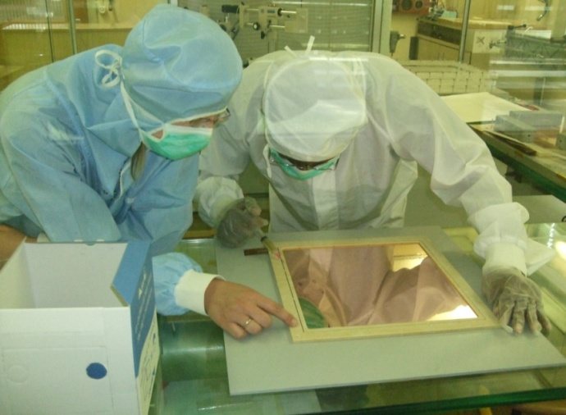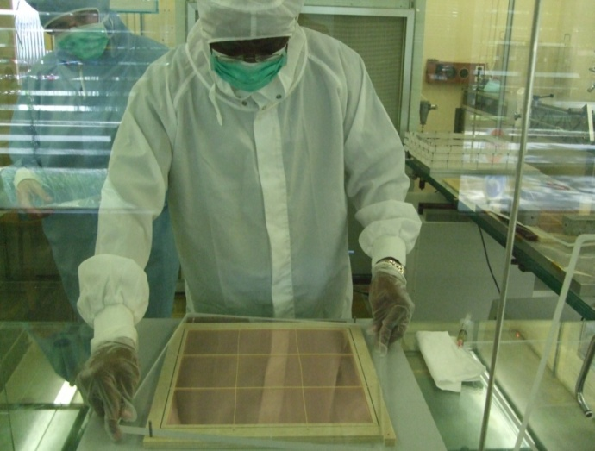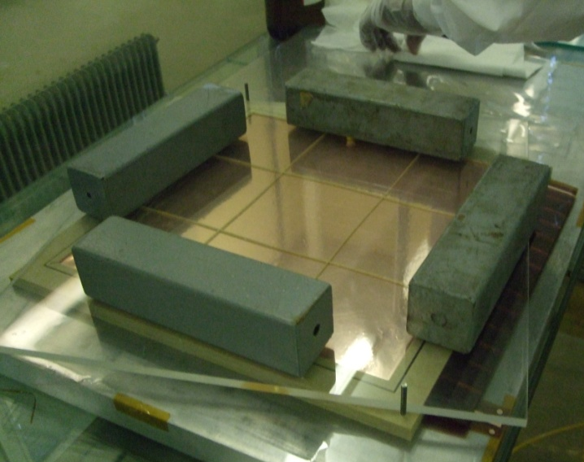

Figure 2.11: Applying the glue to the spacer to stack the first framed GEM foil (top left). With the alignment pins in position, the process is repeated for the three foils to stack them (top right). Heavy weight is applied until the glue cures (bottom).

The outer alignment frames are removed from the GEM stack, removing these frames one by one; the sides with the strips of the foils must be already cut (before framing the foils). The readout must be cleaned before gluing the GEM stack, using ethanol (isopropanol can be used) and clean room tissues. Swipe the tissue in the direction of the upper strips of the readout to avoid damages. With a needle, apply the glue on the frame of GEM 3 without blocking the slit for the gas outlet but making sure that corner will be glued. Glue the stack onto the readout plane using the reference marks. Place heavy weight for 12 hours for the glue to cure (figure 2.12).

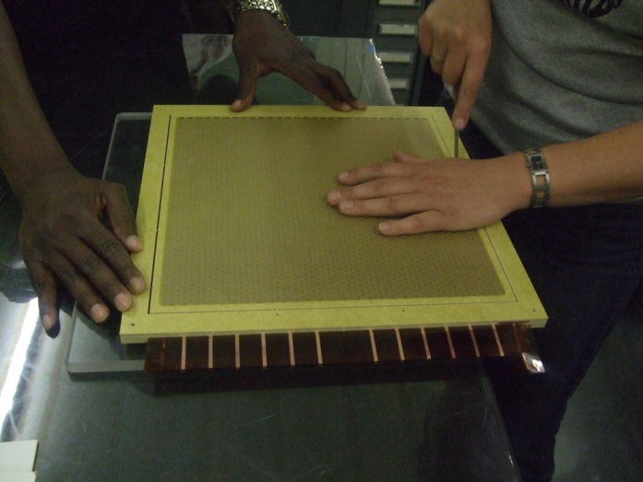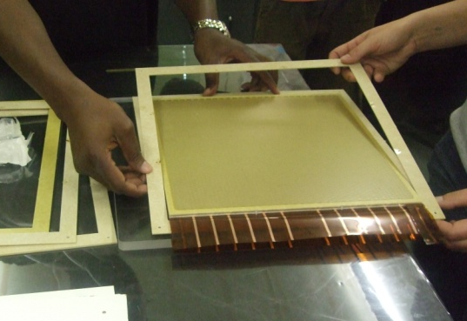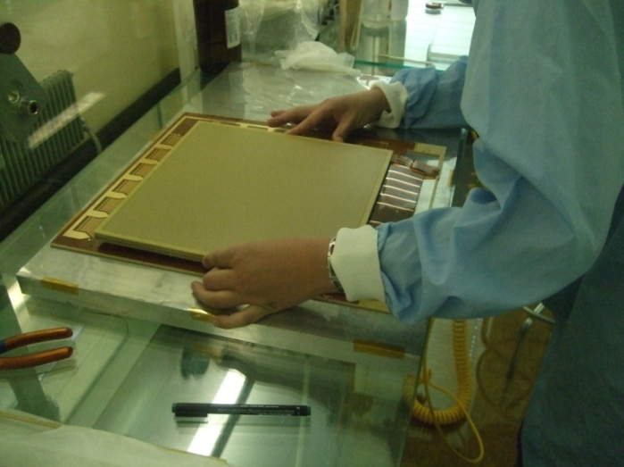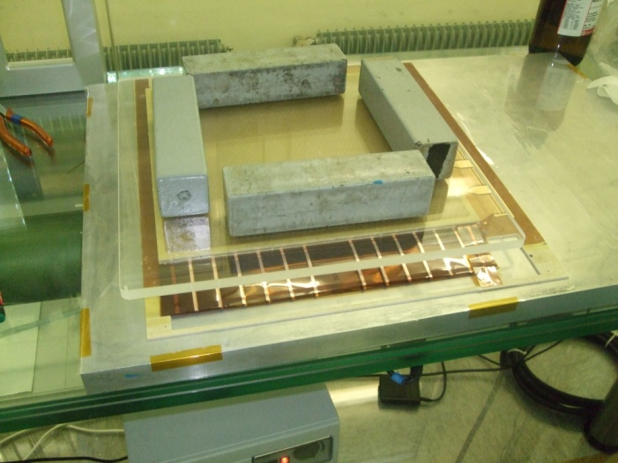
Figure 2.12: Cutting the outer frame from the GEM stack (top left). Removing the outer frame of the chamber (top right). Gluing the GEM stack onto the readout (bottom left). Heavy weight to join the GEM stack and the readout (bottom right).

Gas connectors are glued into the frames and the edges of the detector assembly are sealed with conformal coating to prevent gas leak. Each side must be coated one at a time since this coating material cures in four hours. The detector is taken to the machine shop to solder twelve 130 pin Panasonic AXK6SA3677YG connectors onto the periphery of the readout plane to provide connectivity to the x-y strips (see figure 2.13).

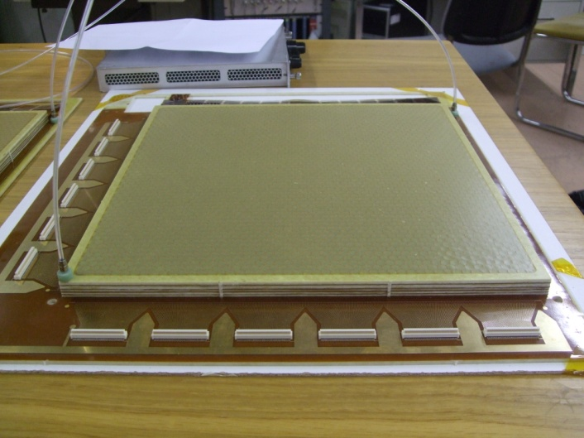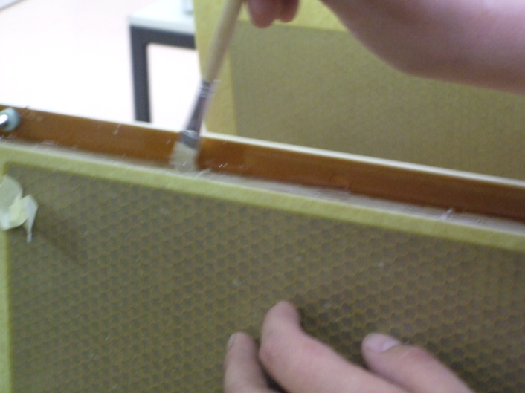

Figure 2.13: Triple-GEM detector with gas connectors and Panasonic connectors for the front end electronics (left). Coating the detector edges to prevent gas leaks (right).

The first test that has to be made is to the gas system. Connect gas (CO₂) to flow through the chamber. The gas must get in and go out without any problems, if this is not the case, the detectors must have gas leaks or the gas system is obstructed. We assembled a total of seven triple-GEM and one double-GEM (one foil was lost during the process); all of them passed the initial gas test without any problem.

2.8 High voltage circuit board

The design of the high voltage (HV) circuit is basically a simple voltage divider. Since the GEM foils have 12 separate sectors, the high voltage circuit has 12 separate sections for each foil (see figure 2.14). The original design was developed by COMPASS [7]; however, some minor improvements to this board were made by TERA [14].
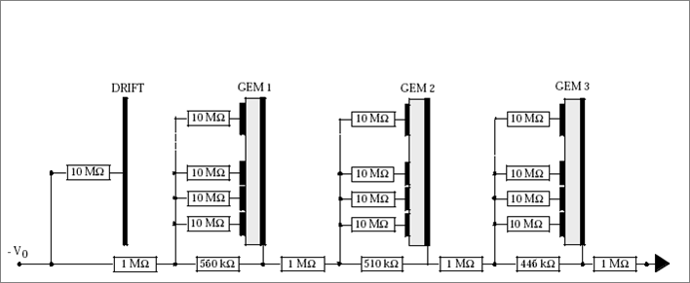
Figure 2.14: High voltage circuit. The electronic diagram updated by TERA group from COMPASS design.

We are using a HV board designed for the TERA Foundation GEM detectors. The circuit board is manufactured by the CERN PCB workshop and the resistors are manually soldered onto it (see figure 2.15).

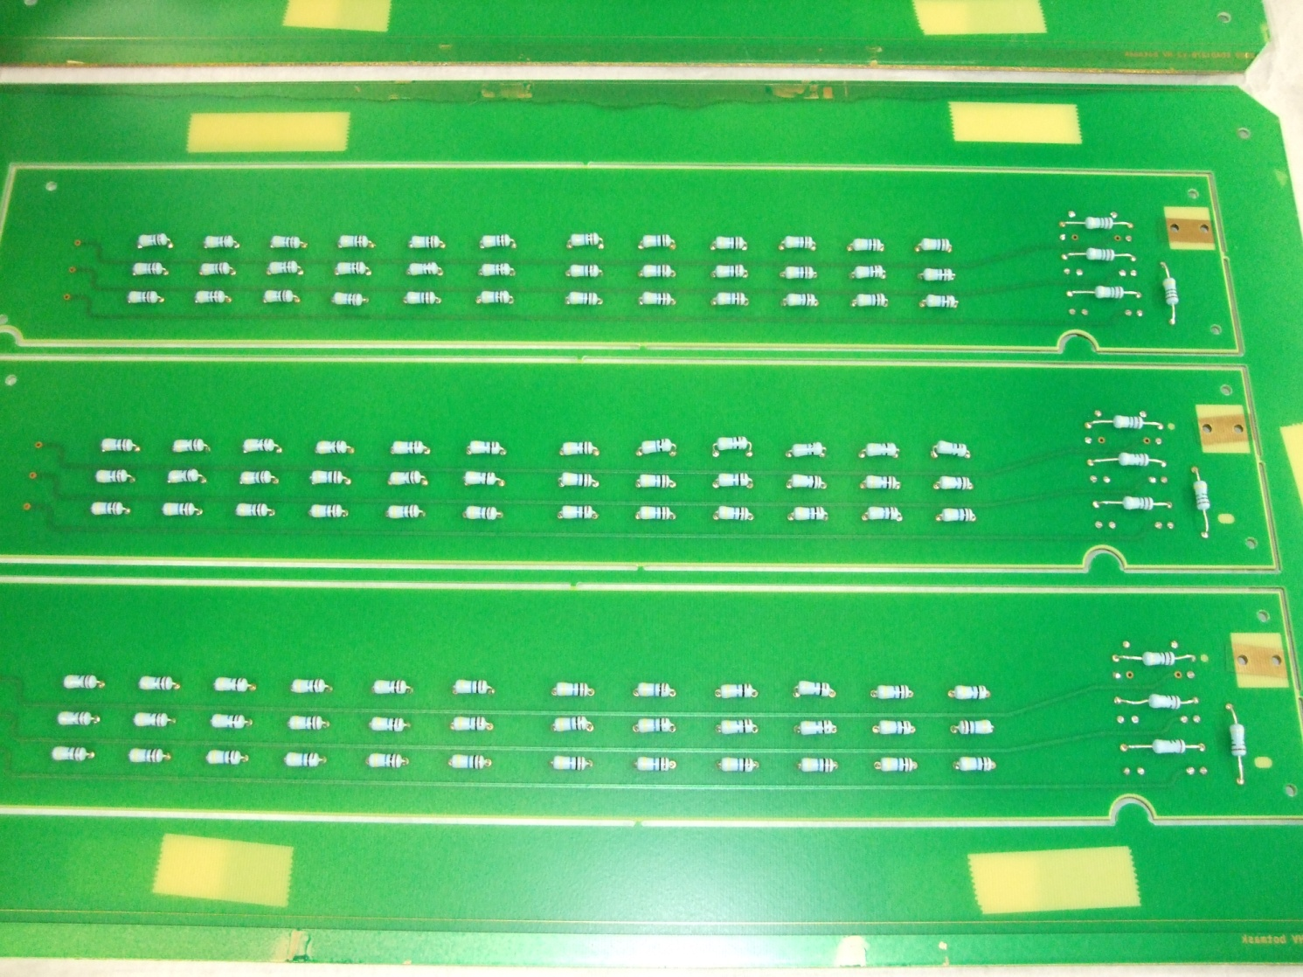
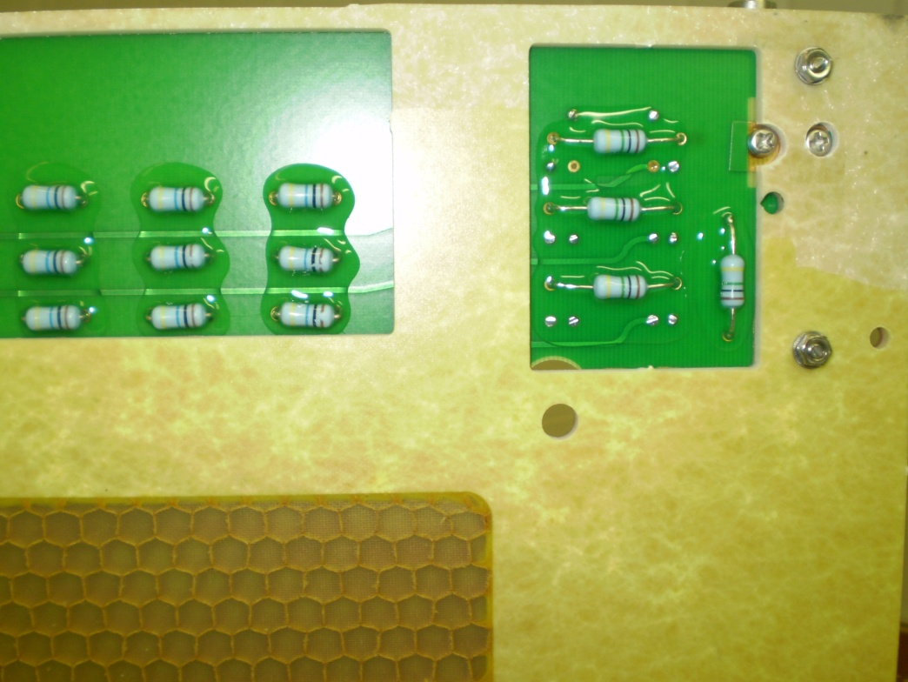
Figure 2.15: Printed circuit board with resistors soldered in (top). HV board attached to a GEM chamber (bottom).
Before mounting it to the detector, the boards are tested by taking the main supply voltage (V₀) up to 4 kV and measuring the bias current to verify that the boards have proper Ohmic behavior. The equivalent resistance of the HV board is 5.42 MΩ. The assembled boards are cleaned with acetone and ethanol, then coated (Dow Corning), and tested again.

We assembled seven HV boards in this way and all of them passed the tests without problems (see figure 2.16). The last step of the assembly is to attach the HV board to the honeycomb base plate and to solder the strip electrodes of the GEM foils to the HV board.

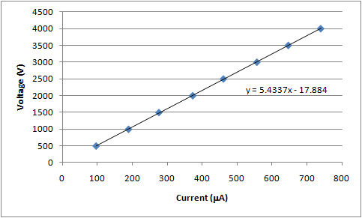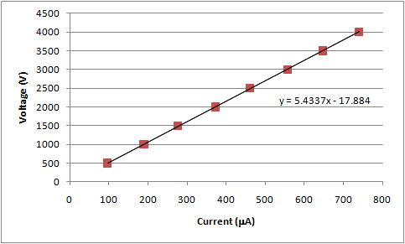
Figure 2.16: Test of the HV board. Ohmic behavior was confirmed, obtaining the same result for all the assembled board before (left) and after (right) coating. Error bars are much smaller than the points.

Chapter 3 Commissioning the detectors

3.1 Gas distribution system

The first test that the detectors must pass is a simple gas test. CO₂ is flushed through to determine if the gas system of the chamber is working properly. A small flow of the gas is applied (~50 ml/min) and it must flush out. The spacer of the drift is not only used as a spacer. It also has grooves with slits of different sizes to distribute the gas uniformly through all the active area. The smaller slits are closer to the gas inlet. The gas is distributed in the drift region, goes through the GEM holes and gets out through the slit in the GEM 3 frame connected to the outlet of the readout. Also, the frame strips have small slits in them to assure that the gas is distributed uniformly in the transfer regions (see figure 3.1).
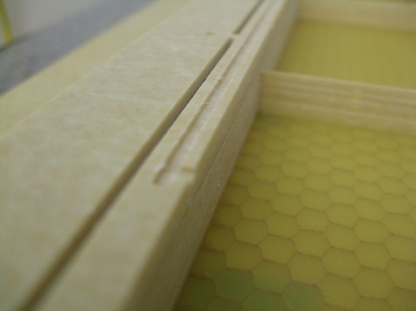
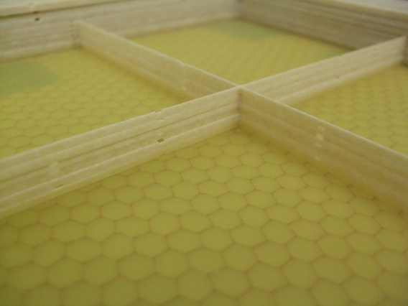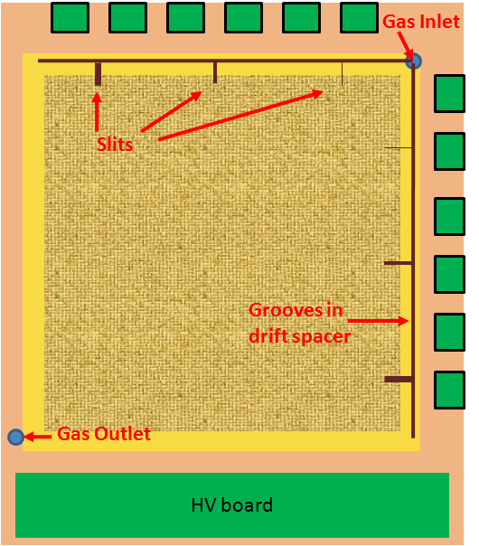
Grooves
Slits
Figure 3.1: Grooves for the gas system in the drift cathode spacer (top left). Small slits in frame strips (bottom left). Diagram of the gas system of the detectors (right).

3.2 Initial tests

The detectors were first tested under HV with pure CO₂, to prevent any undesirable signal amplification during the test. The gas was flushed for several hours (usually 12 hours) to guarantee entire diffusion of the gas through the detector. The results obtained were similar to those of the HV boards disconnected from the chambers. Seven of the assembled triple-GEM detectors where tested with this procedure, only one showed a problem in one sector, while the others showed the same behavior as expected (see figure 3.2).
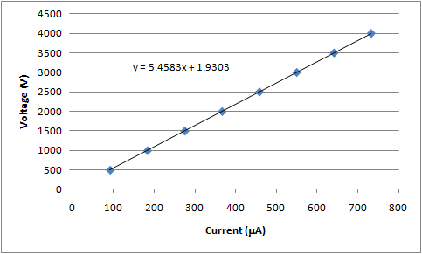
Figure 3.2: Test of the HV board after being connected to the triple-GEM detector. Ohmic behavior was confirmed, obtaining the same result for all the assembled board. Note that this figure is not the same as figure 2.16.

After passing the HV test, the detectors were operated with an Ar/CO₂ 70:30 counting gas mixture. One of the detectors was placed on a Cu X-ray test bench in the GDD lab at CERN. The readout strips of each sector of the detector are connected together and grounded, except the sector that is going to collect the signal. With this setting, it is obtained a single pulse from all the group of strips (128 channels) per sector. With a total bias high voltage of 3.8 kV, signal pulses become visible (figure 3.3).
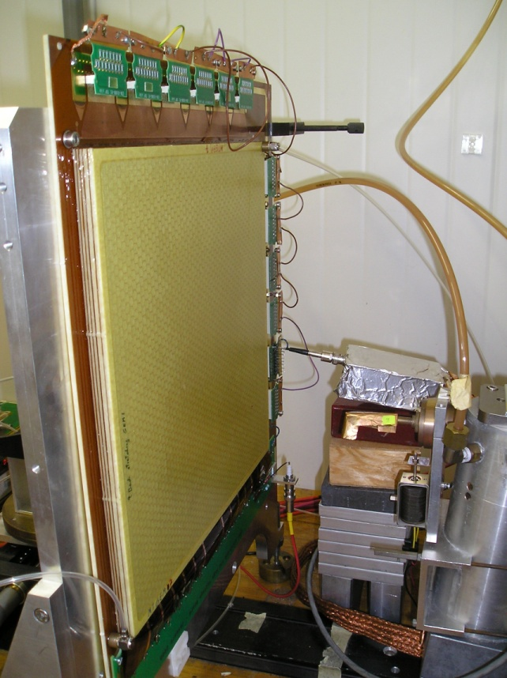
Figure 3.3: Fully assembled detector with strips of the readout terminated for single channel data recording. Cu X-ray bench at GDD-CERN lab.

A low-noise charge-sensitive amplifier (450 Ortec) with a preamplifier (142PC Ortec) coupled to ADCs permit recording of the signals. A typical pulse height spectrum was obtained with the GEM detectors exposed to 8.04 keV X-rays (figure 3.4). Six detectors were tested with this procedure and all of them showed similar behavior. Not a single spark was observed during any of the tests and the signal was acquired with low electrical noise for the assembled detectors.
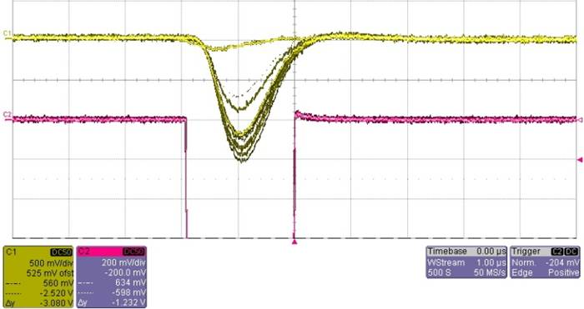
Argon escape
Photo peak
Gate pulse of ADC
Figure 3.4: Single triple-GEM detector channel measurement with Cu X-rays. The yellow scope trace is the actual pulse showing Argon escape peak and photo peak of Cu X-rays, the violet scope trace is the gate pulse for the ADC.
The Cu X-rays spectrum was obtained as expected. Three peaks can be distinguished from figure 3.5. The main or photo peak at 1451 ADC corresponding to the energy value of the Cu source, 8.04 keV. The escape peak at ~1000 ADC is due to the secondary X-rays ionization in the gas, which value is 4.84 keV for Ar (discussion about this mechanism in section 1.1). The peak at ~100 ADC is the noise pedestal of the electronics used.
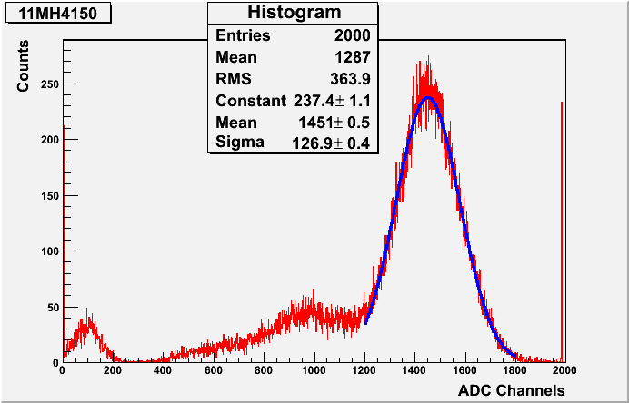
Figure 3.5: Pulse area spectrum showing a ~20% energy resolution (FWHM) for 8.04 keV Cu X-ray. The noise pedestal peak is at ~100 ADC, the escape peak at ~1000, and the photo peak at 1451 ADC. Gaussian fit (blue) to the photo peak.

Cosmic ray muon data were also collected with one of the detectors. Around 100,000 muon events were recorded using one sector of the total active area for five hours. The pulse height spectrum is shown in figure 3.6. We expect ~45,000 counts at sea level, but since Geneva is at 373 m above sea level, more cosmic ray particles are detected.
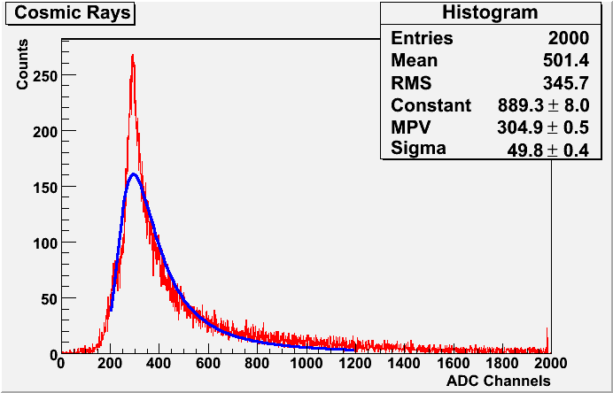
Figure 3.6: Corresponding pulse area distribution with fit to Landau curve (blue).
3.3 Detector performance

3.3.1 Rate plateau:
The rate of pulses was studied varying the high voltage applied to the chamber. The Cu X-ray source was used for this test. The rate of counted X-rays shows a plateau at 3.9 kV.

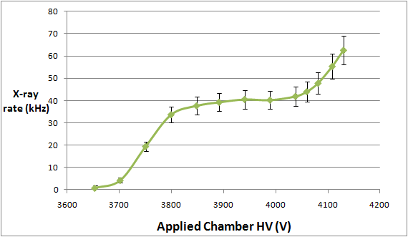
Figure 3.7: X-rays count rate plateau.

Notice that figure 3.7 is not the real chamber efficiency plateau curve since we are only counting the recorded X-ray events; this does not directly measure the efficiency. However, this curve indicates that the triple-GEM chamber becomes efficient for X-rays around 3.9 kV. The actual efficiency must be measured with an independent trigger either from scintillators or another GEM [7].

After 4.2 kV, the curve started increasing again because this is the point where the first transfer gap starts becoming efficient for X-rays, so that you get some pulses from a "double GEM" detecting X-rays on top of the "triple-GEM" pulses.

3.3.2 Charge sharing of the readout strips:
The charge sharing between horizontal (top) and vertical (bottom) strips is defined by:
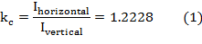

This result was calculated using a linear fitting to the values obtained by taking the current of both strips at certain applied voltage (see figure 3.8).

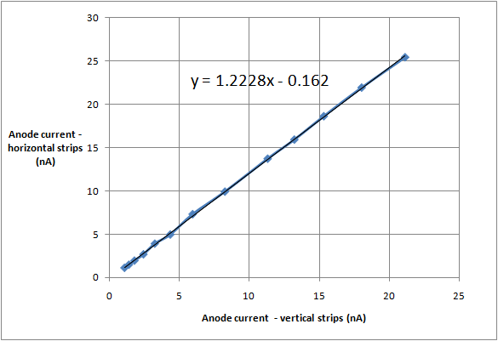
Figure 3.8: Charge sharing x - y strips for increasing HV with Cu X-rays. Error bars are much smaller than the points.

3.3.3 Gain measurement:
The gain of the detectors is the ratio of the primary charges to charges collected with the readout. The procedure consists by measuring the collected current and knowing the radiation flux. This relation is given by:

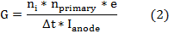
Where: - G is the gas gain.
- n_{i} is the number of incoming rays entering the detector, e.g. X-rays.
- n_{primary} is the number of primary electrons to ionization.
- e is the electron charge.
- Δt is the time of the current measurement.
- I_{anode} is the current collected with the readout.

The anode current I_{anode} is the sum of the current recorded with the horizontal and vertical strips of the readout, so we can express this current in terms of the charge sharing factor and the current of one axis of the readout:

Inserting equation (3) in (2), and using the rate of primaries entry to the detector, Rate = n_{i}/Δt, the gain is:

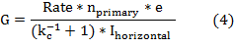

We used an 8.04 keV collimated X-ray generator to measure the gain of one of the six detectors made. Since the gas used for all detectors is Ar/CO₂ 70:30, the number of primary electrons n_{primary} gained per Cu X-rays is:

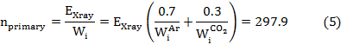

Where W_{i} is the effective average energy to produce one ion-electron pair. The values for the gas mixture are:
- Ar: = 25 eV
- CO₂: 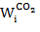= 34 eV (see table 28.6 in Ref. [2]).

We obtain the gain by inserting the rate of X-rays 41.03 kHz at the plateau and the values from equations (1) and (5), into equation (4). An exponential behavior with a gas gain up to 2 × 10⁴ was obtained as expected (see figure 3.9).
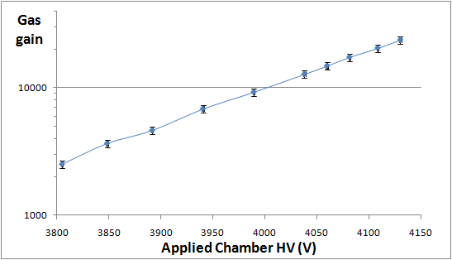
Figure 3.9: Gas gain of one of the triple-GEM detectors in Ar/CO₂ 70:30, obtained at CERN.

Figure 3.10 shows the gain results of COMPASS detectors, adding the result obtained with our chamber.
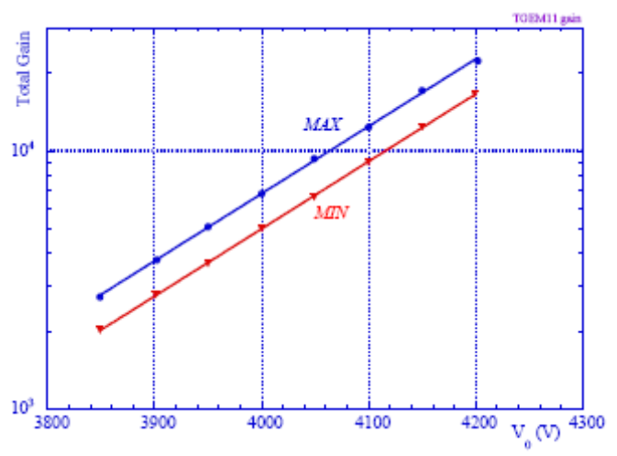
This measurement
Figure 3.10: Absolute effective gain measured in two positions of a COMPASS chamber with extreme values [7], compared with the gain result measured from one of our assembled chambers (black).
3.3.4 Uniformity measurements:
Studying the uniformity of the detector we can know the variation of the output signal in different positions of the readout. The procedure consists of shooting the X-ray source at different areas of the detectors, take the spectrum and localize the maximum value of the photo peak. If the detector has good uniformity, the photo peak value should be the same for different areas, since we are using the same Cu X-rays source. Figure 3.11 shows the areas where the X-ray impinged on the chamber to study uniformity.

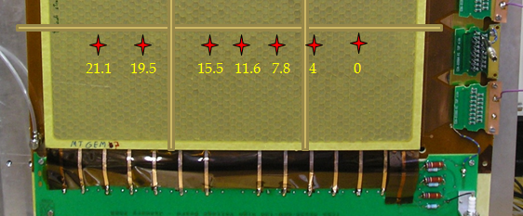
Figure 3.11: The detector studied on the X-ray bench. Yellow lines represent the location of the strips inside the detector. The marks (red) are the areas studied, in centimeters from the 0 point.

The spectrum results for the studied areas are shown in figure 3.12. We supposed that the position of the frame strips would interfere with the result of the uniformity gain. However no major differences were observed, in particular at the “4 cm” point since the strips are almost on the same place. Due to the reduced space in the lab, only seven randomly selected locations were studied, for the same readout sector (see figure 3.12).
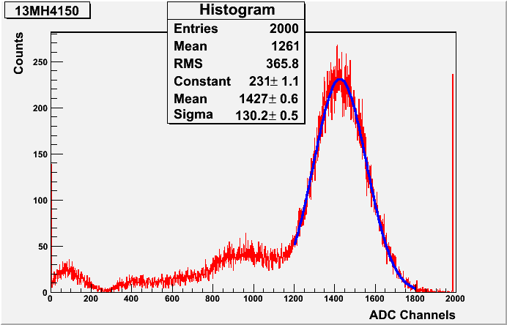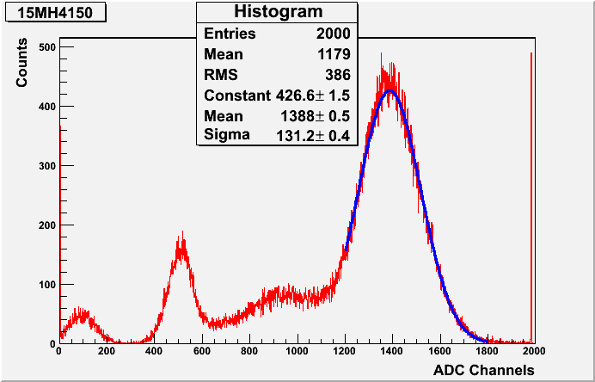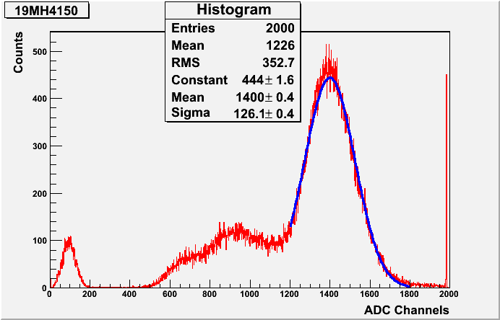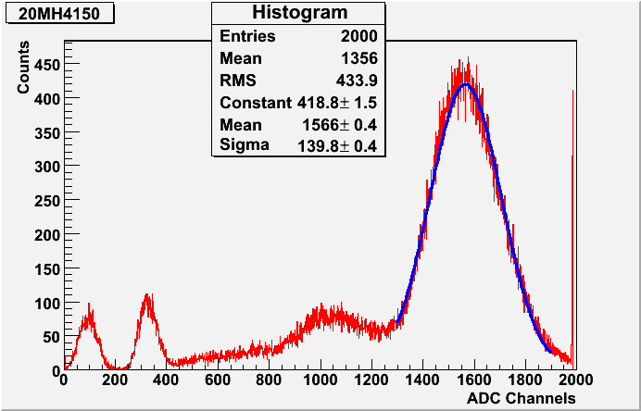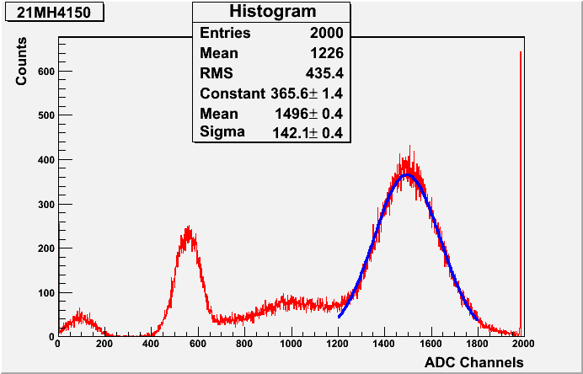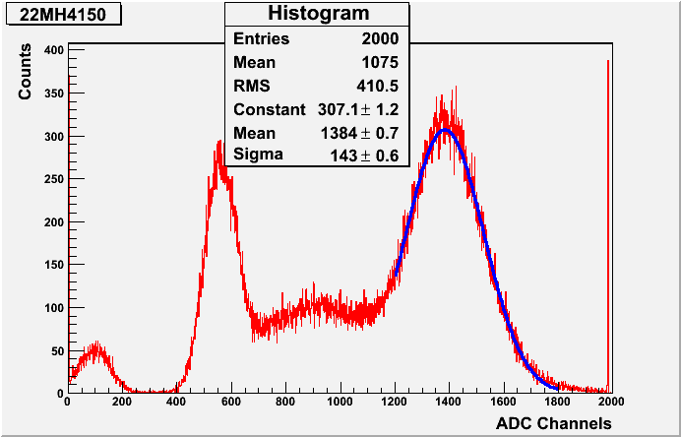
x = 0 cm
x = 4 cm
x = 7.8 cm
x = 11.6 cm
x = 15.5 cm
x = 19.5 cm
x = 21.1 cm
Figure 3.12: X-ray spectra measured at different areas of the detectors.

The average ADC position for the main peak is 1444 for all the measurements. Figure 3.13 shows the relation between the peak value and the studied area. The RMS of the result is 1445 and the RMS of the mean is 100%.
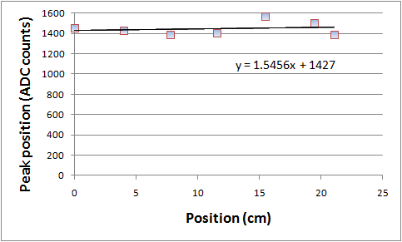
Figure 3.13: Result showing the uniformity of the main peak positions in different areas of the detector studied. Error bars are much smaller than the points.

Chapter 4 Small GEM detector

4.1 Construction

The PCB workshop at CERN also produced a 10cm × 10cm active area GEM detector that we are using for research and development purposes. We acquired two of these small chambers with different settings. The first one is a standard triple-GEM detector, with 2-D readout and aluminized Mylar lid (see figure 4.1). It is used aluminized Mylar to reduce the probability of diffusion of moisture to the chamber; the probability with only a Mylar layer is much larger. PCB workshop delivers the foils and drift already framed at CERN, so the construction process is very straightforward; all parts of the detector must be placed together soldering the electrodes of the foils to the readout (the readout has the bias to apply high voltage). The same gaps between foils for the 30cm × 30cm detectors are used for the small detectors. As before, care has to be taken to assemble these small chambers since the foils are very fragile. The assembly also was performed in a clean room.
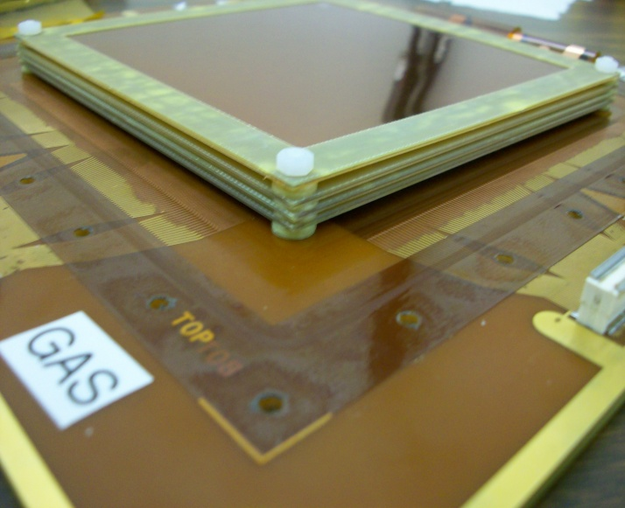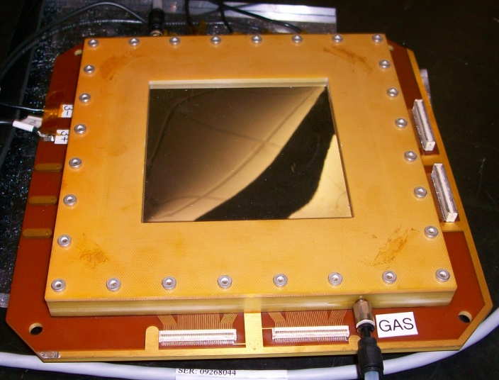
Readout
Drift Cathode
Spacers
FR 4 frame
Figure 4.1: Spacers between foils inside the small GEM detector with plastic washers (left). Assembled small GEM detector with 2-D readout and aluminized Mylar as lid (right).
With the second small chamber, we use non-framed foils, so honeycombs are placed between the foils to maintain the gap. This detector has a 1-D readout and a honeycomb lid. There is no technical reason to use this lid and readout with this honeycomb detector. The lid and readout are interchangeable in both small chambers. This honeycomb detector uses frames to obtain the desired gap between the foils and to prevent the honeycomb from moving outside the active area (see figure 4.2).
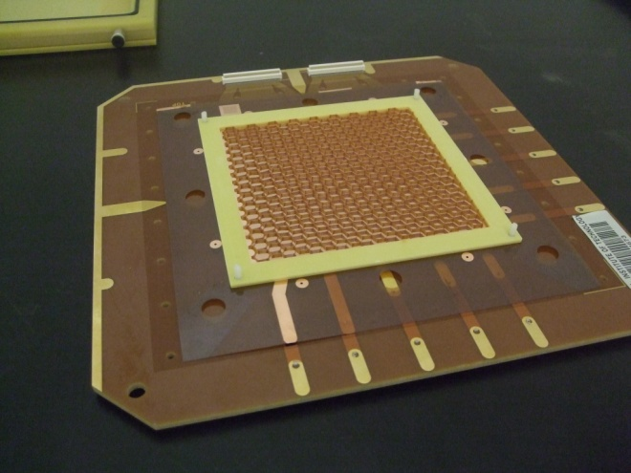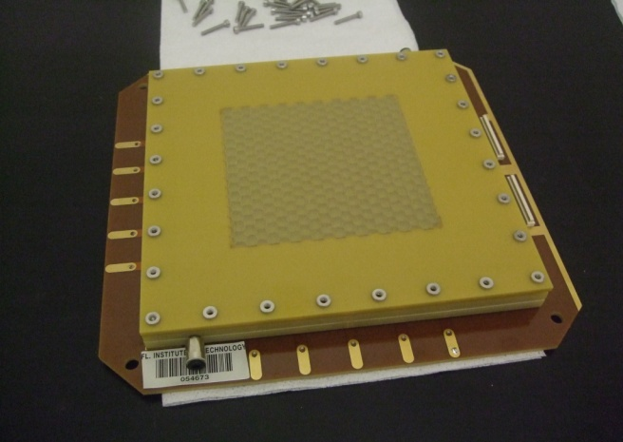
Readout
Honeycomb
GEM foil
FR 4 frame
Figure 4.2: Non-framed foil with honeycomb placed on the top and a frame (left). Assembled small non-framed GEM detector with 1-D readout and honeycomb lid (right).

The same HV board of the 30cm × 30cm detectors is used since the small detectors have the same configuration, however these small foils do not have the twelve sector configuration per foil (only one sector). We left open the connection for 11 sectors of the board and used only one sector (see figure 2.14).

4.2 Results

We followed the same commissioning procedure of the 30cm × 30cm detectors. Both small chambers were placed under CO₂ and a high voltage test was performed. Similar results to those of the 30cm × 30cm active area GEM detectors were obtained. Figure 4.3 shows the high voltage test results of both small chambers, before and after connecting to the HV board. Notice that the bias current obtained in figure 4.3 for both small chambers is slightly lower (~ 2 nA) than the results obtained with the big chambers (see figure 2.16).
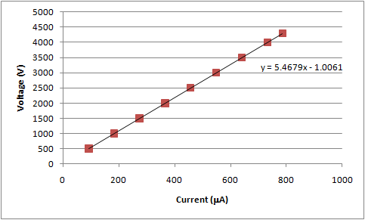
Figure 4.3: Test of the HV board disconnected from the small chambers (left). HV test with the board connected to the standard small chamber (right). Error bars are much smaller than the points.

With the standard chamber, pulses from cosmic rays become visible at 3.5 kV (figure 4.4). Using ⁵⁵Fe as an X-ray source, the signal starts to show at 3.9 kV using the strips on the top of the readout; using the bottom strips the signal is shown at 4.05 kV. The difference between applied voltage to detect cosmic and X-rays is because the energy of the source is not strong enough to go through the separation between where the source is placed and the drift region of the detector. The attenuation coefficient of this gap must be so big that the rays cannot reach the drift region. The transmission of rays is ~90% using the Mylar lid at 2cm from the source (a Geiger counter was used to test the source). We cannot go above 4.3 kV because this is the recommended limit of high voltage; also 2cm is the minimum distance to place the source on the detector. For the honeycomb lid the ⁵⁵Fe transmits less than 5% of the rays so the honeycomb lid is only used to take cosmic rays data.
As before we ganged all the readout strips together to get single channel measurements and terminated the other sectors of the readout. The signal travels through a preamplifier (142PC Ortec) and an amplifier (TC202BLR Tennelec) then it is connected directly to the oscilloscope (Lecroy W wave Runner 104Xi-A). We develop a computer code to save large sample of data since our oscilloscope cannot record more than one thousand events (see appendix B).

Around 40 counts per minute cosmic events were collected, using a sector of the readout (10cm × 5cm) with operational voltage of 4.3 kV. This result is very close to the theoretical value for this area (50 counts per minute). It is shown the Landau distribution (section 1.1) for cosmic muons as it was expected (figure 4.4).

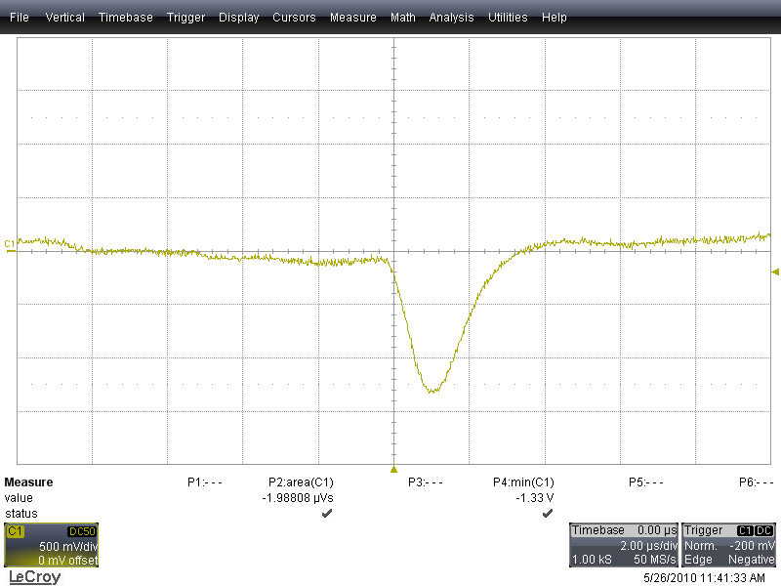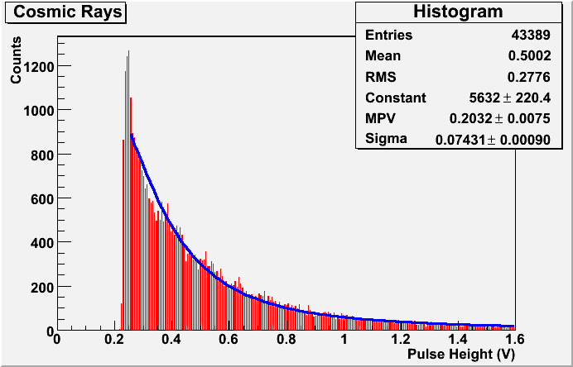
Figure 4.4: Single channel measurement of a cosmic ray event (left). Pulse height distribution of cosmic rays with fit to Landau curve in blue (right).

We obtained the spectrum of the ⁵⁵Fe source, with 4.3 kV of applied high voltage using the small standard chamber. The result shows the same behavior as the spectrum of the Cu X-ray source used with the 30cm × 30cm detector results (see figure 3.5). The photo peak at ~1.1 V μs correspond to the Manganese K_{α} line 5.9 keV; the escape peak at ~0.7 V μs, for Ar the value is 2.9 keV; and the noise pedestal of the electronics used was ~0.2 V μs.
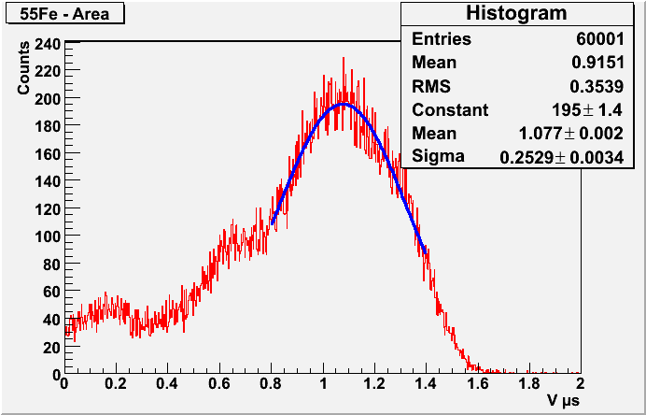
Figure 4.5: Energy spectrum obtained for ⁵⁵Fe with the small standard detector. Energy resolution ~60 % (FWHM). Gaussian fit for the photo peak in blue.

The results for cosmic rays using the honeycomb detector show the corresponding Landau curve (see figure 4.6). However the noise level for this detector is very high so high trigger threshold was set to eliminate this noise. One of the causes of the high noise level is because the honeycomb detector is very sensitive of vibration of the test bench (microphonic effect).

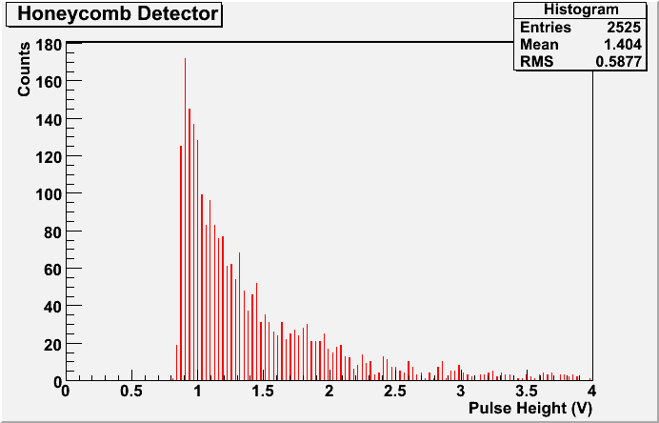
Figure 4.6: Pulse height distribution of cosmic rays using the honeycomb detector.
The rate obtained for several trials was ~20 counts per minute, using one readout sector (10cm × 5cm) with operational voltage of 4.3 kV. This value shows that we are losing more than half of the cosmic rays. The reason is because we need to use the trigger threshold higher due to the noise, so we are missing a significance number of the cosmic. The trigger used for the standard detector was 0.25 V (see figure 4.4), and for the honeycomb detector was 0.8 V (figure 4.4, left). However the Landau distribution is shown for this honeycomb detector too.

The microphonic effect is also present with the standard detector; however, it is not as extreme as the honeycomb detector. We did not make any test to measure the incidence of mechanical vibrations to the electric noise, but it can be seen easily that the honeycomb detector detects any small knock in the work bench while the standard detector does not detect them. This behavior can be intuitive since the foils are not stretched so there must be some small movement in them.

4.3 Performance

The rate test was performed, using the standard small GEM detector with the Mylar lid and the ⁵⁵Fe source. The rate plateau appears at 4.05 kV (figure 4.7).
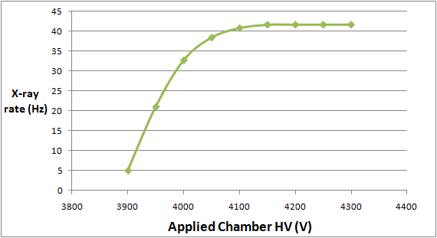
Figure 4.7: Count rate plateau for standard small detector. Error bars are much smaller than the points.
The result of the rate is completely atypical for triple-GEM detectors. The plateau should start close to the value of the 30cm × 30cm detectors (see figure 3.6), even if the source is different. One of the hypotheses that can explain this strange behaviour is that the gas used is not Ar/CO₂ 70:30; however we are not able to test the quality of gas. The holes shape could be another issue that is affecting the performance of the small detector. We do not know if the 10cm × 10cm foils have the same hole pattern than 30cm × 30cm foils.

The electric field between foils have been continuously tested to check if bad electric field or bad connection is the reason of the shift in the plateau. However no problems with the electric connections were found.

Another issue that could be affecting the result is that the energy of the source is not strong enough so most of the X-rays are not being detected at a lower applied voltage. The output pulse height average becomes very small at 4.1 kV (see figure 4.8). Also if we increase the gain of the amplifier, the noise also increased so it is impossible to distinguish small pulses from noise.

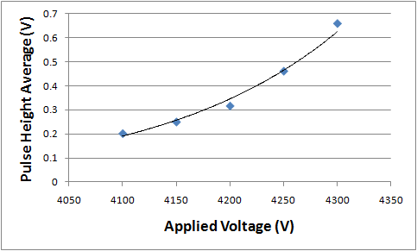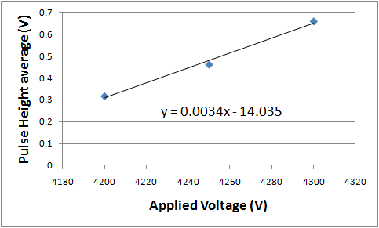
Figure 4.8: Pulse height average of the output pulse at different applied voltages, with an exponential fit (left). Linear interpolation to the three last points of the left figure (right).
This problem affects the calculation of the gain of the detector, since the anode current is very small to be recorded with our electronics. The gain calculation was performed taking a calibration signal using a pulse generator (see figure 4.9). We are using a preamplifier Ortec 142PC; it is an integrator amplifier with a capacitance of 1 pF. We need to simulate an input signal, similar to the one that is obtained with cosmic rays or X- rays. We use short pulses 20 ns and vary the input pulse voltage (from the pulse generator) to correlate the input charge and the output pulse height obtained with all the electronic (pre amplifier and amplifier).
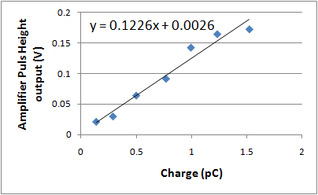
Figure 4.9: Pulse height average of the output pulse using a calibration signal, with a linear interpolation.

Figures 4.8 and 4.9 relate the pulses height average of the real signal obtained with ⁵⁵Fe source and the calibration signal. We can obtain the charge deposited on the readout using the interpolation from both figures. The gain (see figure 4.10) can be calculated using:

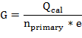

Where: - Q_{cal} is the charge obtained from calibration.
- e electron charge.
- n_{primary}= 217 using ⁵⁵Fe source.
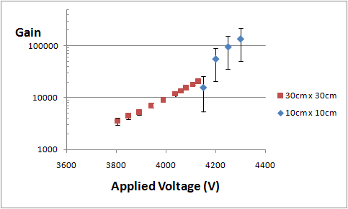
Figure 4.10: Gain result for the small standard detector (blue), using a calibration pulse of 20 ns width. Result for the big detector (red).

The results presented in figure 4.10 seem to agree with the result of the 30cm × 30cm detectors; however, the uncertainty of the calibration charge is large.

The uniformity of the gain was studied for the standard detector using the bottom strips of the readout. The procedure was the same as with the big detector. The ⁵⁵Fe was impinged to 16 different sector of the active area (see figure 4.11). The average pulse area for the main peak was 0.433 V μs for all the measurements made for the studied detector.
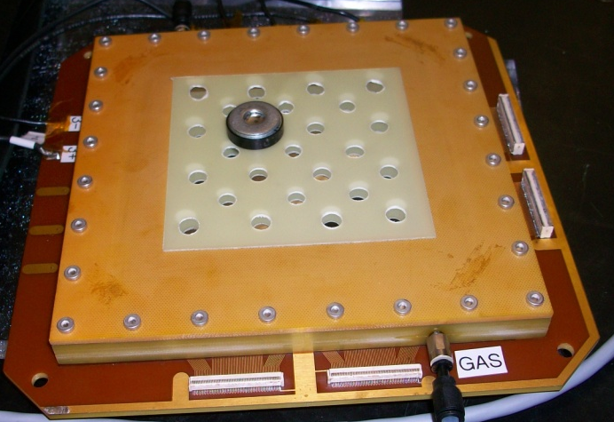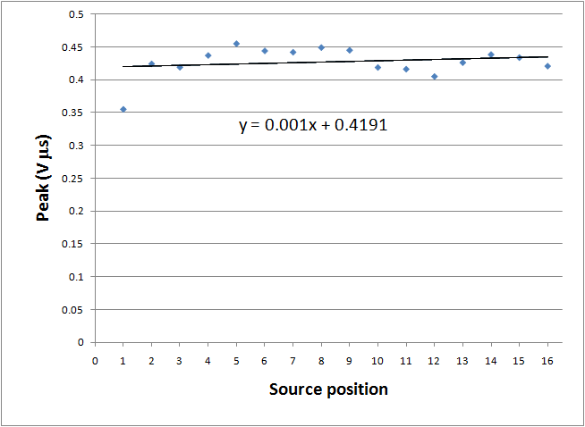
1
16
13
4
Figure 4.11: Grid array with the ⁵⁵Fe source and the sector name in red to perform a uniformity test (left). Uniformity results using the main peak position in different areas of the standard small detector with bottom strips of the readout (right).
Chapter 5 Conclusions and Summary

A total of seven 30cm × 30cm active area triple-GEM detectors were successfully constructed at the GDD lab at CERN. The assembly was made following COMPASS procedures [7], however some improvements were made. Our group was the first one to use the thermal method to stretch 30cm × 30cm foils; the results obtained were satisfactory. The design of the foil frames was modified to be adapted to the thermal method. The frames’ extra material part is wider to keep the frame stable in the stretched foil during gluing; also we put alignment pins in this region. The thermal method for stretching allow us to glue the frames on three foils at the same time (we have three stretching devices and the oven used can accommodate the three foils), this reduces the time expended to perform the high voltage test of the foils before and after framing. The alignment pins in our wider extra material frame permit to stack the three foils to the drift cathode in one day with a very good precision. Previous groups using the same active area detectors (COMPASS [7], TERA [14]), needed one entire day to frame and test only one foil and they stack the foils one by one (around one night for the glue to cure). A triple-GEM detector can be assembled in less than four days following the procedures of this work. We improve the time of construction by three or four days without compromising the quality.

Of the seven constructed detectors, six passed the high voltage test without a single spark. Only one sector of one detector failed the test; however, this was expected since we were experimenting with the gas system so we pierced a hole in one corner of a foil. The gas system works properly for all seven chambers. These two tests showed the cleanliness level and carefulness of handling throughout the procedure, both of which are very important to assure the good quality of the detectors.

The six detectors that passed the basic HV test were tested in single channel mode (ganging all the strips of a readout sector together) with Cu X-rays. All of them showed the expected energy spectrum. Cosmic ray muon data was recorded with two detectors, showing satisfactory results with pulse heights following a Landau distribution as expected. Preliminary performance tests with Cu X-rays for one detector showed good behavior for gain, rate plateaus, charge-sharing among readout strips, and uniformity. Our gain measurement shows improvement comparing this result with COMPASS results [7] (see figure 3.8). This improvement must be related to progress of the production techniques of the manufacture, not necessarily with the assembly procedure. Tests for all the detectors could not be done due to the lack of time available to use the X-ray bench and electronics at CERN.

The work done with the 10cm × 10cm detectors at Florida Tech was done mostly to reproduce the results of the 30cm × 30cm detectors at CERN. Cosmic and ⁵⁵Fe spectrum are reproduced with the standard detector. The rate plateau result shows problems with this small detector since the plateau should start close to the same voltage than the big chamber.

Initial studies have been started to avoid the framing and gluing steps in the assembly process. We used honeycombs between non-framed foils to maintain the separation between foils. Results for this prototype are inconclusive, although cosmic rays spectrum has been reproduced. Two drawbacks thus far are the electronic noise level for the honeycomb detector is very high and the detector is very sensitive to vibration.

References

[1] F. Sauli: “Principles of Operation of Multiwires Proportional and Drift Chambers,” Lectures given in the academic training program of CERN, 1977.

[2] Particle Data Group: “Review of Particle Physics,” Physics Letters B, vol. 667, issue 1-5, p. 1-6., 2008.

[3] L.D. Landau, J.Exp.Phys. (USSR), vol. 8, pp. 201, 1944.

[4] F. Sauli and A. Sharma: “Micropattern Gaseous Detectors,” Ann. Rev. Nucl. Part. Sci., vol. 49, pp. 341, 1999.

[5] F. Sauli: “GEM: A new concept for electron amplification in gas detectors,” Nucl. Instr. and Meth. A, vol .386, pp. 531, 1997.

[6] CERN Gas Detectors Development (GDD) web page: http://gdd.web.cern.ch/GDD, 2010.

[7] C. Altunbas et al.: “Construction, Test and Commissioning of the Triple GEM Tracking Detector for COMPASS,” Nuc. Ins. Met. A, vol. 490, pp. 177–203, 2002.

[8] S. Bachmann, A. Bressan, A. Placci, L. Ropelewski and F. Sauli: “Development and test of large size GEM detectors,” IEEE Trans. Nucl. Sci., NS-47, pp.1412, 2000.

[9] Murtas, F.: “Development of a gaseous detector based on Gas Electron Multiplier (GEM) Technology,” http://www.lnf.infn.it/seminars/talks/
murtas_28_11_02.pdf, 2002.

[10] M. Hohlmann, P. Ford, K. Gnanvo, J. Helsby, D. Pena, R. Hoch, and D. Mitra: “GEANT4 Simulation of a Cosmic Ray Muon Tomography System With MicroPattern Gas Detectors for the Detection of High Z Materials,” IEEE Trans. Nucl. Sci., vol. 56, no. 3, pp. 1356-1363, 2009.

[11] K. Gnanvo, P. Ford, J. Helsby, R. Hoch, D. Mitra, and M. Hohlmann, “Performance Expectations for a Tomography System Using Cosmic Ray Muons and Micro Pattern Gas Detectors for the Detection of Nuclear Contraband,” Proc. IEEE Nucl. Sci. Symp., pp. 1278-1284, 2008.

[12] R. Hoch, D. Mitra, K. Gnanvo, and M. Hohlmann, “Muon Tomography Algorithms for Nuclear Threat Detection,” Proc. 22 nd International Conference on Industrial, Engineering & Other Applications of Applied Intelligent Systems; published in Lecture Series in Computational Intelligence, no. 214, pp. 225-231, Springer Verlag, 2009.

[13] Gnanvo, K. et al.: “Large Area GEM Detectors for Muon Tomography: Application to Nuclear Material Contraband Detection,” 1st International Conference on Micro-Pattern Gaseous Detectors, 2009.

[14] D. Watts, N. Malakhov, L. Ropelewski, F. Sauli, and J. Samarati: “Performance of MPGDs with portable readout electronics,” Proc. IEEE Nucl. Sci. Symp., 2008.

[15] S. Bachmann, L. Bressan, L. Ropelewski, F. Sauli, A. Sharma, D. Mormann: “Charge amplification and transfer processes in the gas electron multiplier,” Nucl. Instr. and Meth. A, vol. 438, pp. 376, 1999.

Appendix A: Landau Distribution

Suppose that the energy loss of a particle with initial energy E₀ passing through a layer of thickness x, losing an amount of energy between Δ and Δ+dΔ, is unknown distribution function. The probability of energy loss ε of the incoming particle is ω(ε). The change of the distribution function on a length dx, is given by:

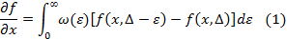

The Laplace transformation for the variable Δ is:

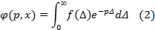

The inverse Laplace transformation is:

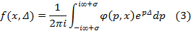

Rearranging equation (1) in terms of the Laplace transformation in equation (2), the result is given by:

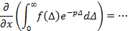
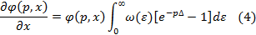

Integrate equation (4), knowing that :

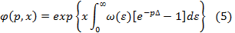

Inserting equation (5) in (3) we obtain the solution of the problem in general case:

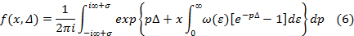

The probability of energy loss ε of the incoming particle is ω(ε) is given by:

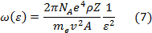

Where ρ is the density of the material.

Suppose an energy ε₁ p << 1, so the integration of (5), using e^{-pε} ≈ 1 –pε, is:

The solution of equation (8) multiplied by x is:

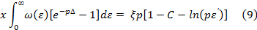

Where ε’ is the initial energy loss of the particle that depends of the ionization potential of the atoms in the medium.

Inserting (9) in (6), we obtain the solution:

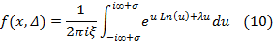

Where u = ξ p and:

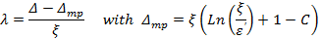

Solving the integral of equation (10), we obtain the Landau Distribution:

These calculations have been made following Ref. [3]

Appendix B: Computer Code to Save Oscilloscope Data in Excel

' Visual Basic code
Sub Button1_Click()
' Connect to the Oscilloscope Lecroy W wave Runner 104Xi-A
Set app = CreateObject("LeCroy.XStreamDSO")
' Set the start time
Cells(1, 3).Value = app.Utility.DateTimeSetup.CurrentDateAndTime

' Set number of events to record (Excel max value 65535)
For i = 1 To 1999 Step 1
' P4 minimum and P2 area of the signal
' Set these parameters in the oscilloscope
Cells(i, 1).Value = app.Measure.P4.Out.Result.Value
Cells(i, 2).Value = app.Measure.P2.Out.Result.Value
If Cells(i, 2).Value < > Cells(i + 1, 2).Value Then
Do While Cells(i, 2).Value = app.Measure.P2.Out.Result.Value
Cells(i + 1, 2).Value = app.Measure.P2.Out.Result.Value
Cells(i + 1, 1).Value = app.Measure.P4.Out.Result.Value
Loop
End If
Next i
' Set the end time
Cells(2, 3).Value = app.Utility.DateTimeSetup.CurrentDateAndTime
'Disconnect the oscilloscope
Set app = Nothing
End Sub

Trade name of Du Pont Co., Wilmington DE, USA
12577 Dow Corning

