Analysis of Quarknet Summer Outreach Data
with University of Chicago Cosmic Ray e-Lab

Julie M. Slanker

December 12, 2005
Between June 21 and July 21, 2005 cosmic ray muon events were captured at the Florida Institute of Technology using five scintillation detectors, as part of the Quarknet Summer Outreach Program. One hundred and eighteen individual data files were uploaded to the University of Chicago Cosmic Ray e-Lab throughout the program and targeted data analysis began in September. The procedure of analysis included the following steps:
- Upload correct detector geometry to the e-Lab
- Analyze each individual data file using the e-Lab performance function and bless appropriate data
- Run an e-Lab air shower analysis for each day and isolate events that are possible cosmic ray air showers
- Investigate any unexpected data
- Reevaluate the parameters of the air shower analysis and make appropriate changes
- Re-run the e-Lab air shower analysis for each day and isolate events that are possible cosmic ray air showers

Over the course of this semester, all but the last step has been completed; leaving the true discovery of multiple air shower events to those who continue the analysis in the spring.
In the beginning of the summer outreach program four cosmic ray detectors were set up in a rectangular array, with one detector at each corner, and towards the end of July a fifth detector was added. The GPS information from the data acquisition card, along with the relative geometry of each detector to its GPS receiver was uploaded to the e-Lab when detection began. However, between the end of the summer outreach program and the beginning of the analysis, the e-Lab was modified and all of the geometry information became invalid. It was necessary to convert the existing geometry into the new system of units, before the analysis could continue. Thankfully, the e-Lab modification also made it easier to update geometry, and the task was completed without much trouble. A sample portion of the new geometry page is shown below:

Detector 9
 | Dec 7, | 2005 | @ 9:33 | AM
 | Nov 28, | 2005 | @ 2:05 | PM
 | Jul 12, | 2005 | @ 1:17 | PM
 | Jun 19, | 2005 | @ 12:00 | AM
 | Apr 29, | 2005 | @ 2:22 | PM

Each detector is listed, followed by the date that the detector was moved and new geometry was necessary. With a click, the user can either edit the existing geometry for that day or delete the entry all together. In order to edit the geometry, the user would click on the pencil icon and the following table would appear:

Edit Detector 9: Jul 12, 2005 @ 1:17 PM
 |  |  | Cable  Length (m) |  | Area (cm²) |  | E-W (m) | N-S (m) | Up-Dn (m)




 |  | Orientation
GPS Location
Latitude:  e.g., 47:39.2347 N | Longitude:  e.g., 122:18.68 W | Altitude (m):

The user can then easily make the necessary changes and commit the geometry. Only data uploaded to the e-Lab by Florida Tech after June 19, 2005 has been changed to the new system of units. The website administrators promised to provide a “behind the scenes” conversion to all of the geometry uploaded before that date but this change has not yet been delivered. None of the data with bad geometry has been blessed, nor should it be until the change has been made.
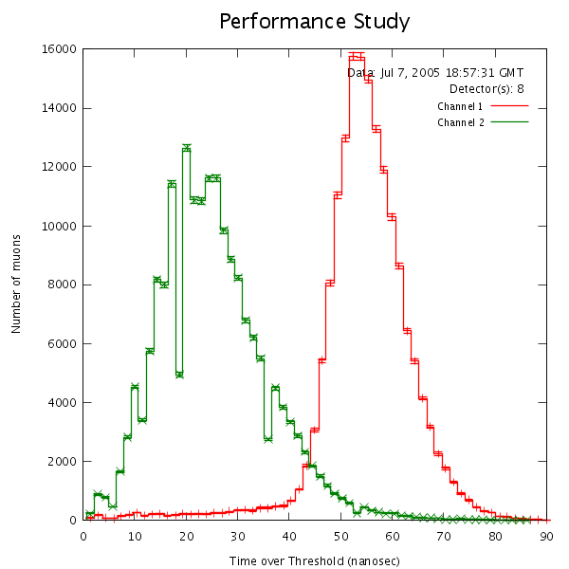
When a data set is blessed, it means that the detector’s performance has been analyzed and is deemed appropriate for use in further investigations. In the case of scintillation detectors, performance is analyzed by creating a histogram of time over threshold for all of the events in the data set. The data acquisition card can not directly measure the energy of each particle that causes scintillation in the detector, but it can measure the time that each pulse spends above a certain minimum potential called the threshold. More energetic particles produce more scintillation which gives a bigger pulse that spends more time above the threshold potential. The time over threshold histogram for Detector 8 on July 7, 2005 is shown below:

For a scintillation detector, the histogram should be roughly Gaussian, as shown. The histogram peaks at a maximum value above 10 nanoseconds and tapers off relatively evenly on both sides of the peak. This data set was blessed. If there are too many low energy events, the curve will look like a falling exponential, with the maximum well below 10 nanoseconds. This would mean that the detector was picking up more background noise than cosmic ray muons. The data set would not be useful in analysis and would therefore not be blessed. It is beneficial to run a performance analysis each time data is uploaded to the e-Lab. If the analysis is run and it is found that the data can not be blessed, the data acquisition card should be immediately recalibrated to filter out more of the background noise. Once all of the appropriate data has been blessed, those sets may be used in further analysis.
Including only the blessed data from the summer outreach, analysis was performed using the air shower function on the e-Lab. For an air shower to be detected there must be coincidence events in at least two separate detectors at nearly the same time. A coincidence event is one that occurs in both scintillation panels of the same detector at nearly the same time. Many high energy particles can cause scintillation in a single panel, but cosmic ray muons are energetic enough to cause scintillation in one panel and continue on to cause scintillation in the second. For this reason, only coincidence events are used when searching for muons from cosmic ray air showers. Because of the wave front geometry of a cosmic ray air shower, it is possible that its particles would only interact with a single detector, so muon events that do not occur in two separate detectors should not be completely discounted. However for the sake of a first pass through the data, those events were excluded. The event gate, or maximum time allowed between events, is 100 nanoseconds. This is the default gate on the analysis portal and was not changed during the first pass through the data. The plot of a possible air shower event is included below along with its data table:

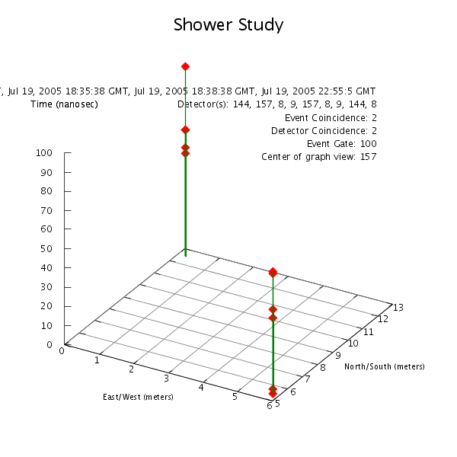
East/West | North/South | Time | Detector | Channel
(meters) | (meters) | (nanosec) | Detector | Channel
5.8 | 5.5 | 0 | 9 | 1
5.8 | 5.5 | 2.2 | 9 | 2
5.8 | 5.5 | 39 | 9 | 1
5.8 | 5.5 | 43.5 | 9 | 2
0.2 | 12.6 | 53.2 | 8 | 1
0.2 | 12.6 | 56.2 | 8 | 2
5.8 | 5.5 | 62.2 | 9 | 1
5.8 | 5.5 | 63 | 9 | 2
0.2 | 12.6 | 65.3 | 8 | 1
0.2 | 12.6 | 65.3 | 8 | 2
0.2 | 12.6 | 98.2 | 8 | 1

The information included in the data table is, from left to right:
- The East-West position of the detector in which the event occurred, relative to an origin determined by the analysis
- The North-South position of the detector in which the event occurred
- The time of the event relative to the first event in the 100 nanosecond gate
- The detector in which the event occurred
- The channel on the data acquisition card corresponding to the panel of the detector in which the event occurred.
The same analysis settings were used for each day data was collected in the summer outreach program. There were three possible shower events identified in the first pass, all of which took place in July.
The possible shower identified on July 11, 2005 displayed some unusual results, along with the expected coincidence events. In the data table shown below, there are multiple events that occur only in channel 2 in both detectors.

East/West  (meters) | North/South  (meters) | Time  (nanosec) | Detector | Channel
5.8 | 5.5 | 0.0 | 9 | 2
1.5 | 5.5 | 3.8 | 144 | 2
5.8 | 5.5 | 6.8 | 9 | 1
1.5 | 5.5 | 31.5 | 144 | 1
5.8 | 5.5 | 32.3 | 9 | 2
5.8 | 5.5 | 49.5 | 9 | 2
1.5 | 5.5 | 54.8 | 144 | 2
5.8 | 5.5 | 80.3 | 9 | 2
1.5 | 5.5 | 99.0 | 144 | 2

Since the data acquisition card is set up to only record coincidence events, these data points should not have been included in the analysis. They should have been filtered out by the card’s logic function. A closer analysis of the specific data files found that, in both detectors, there are three seconds of data starting at 19:51:52 GMT where events are only recorded in channel 2. All of the other data for that day includes only coincidence events. It is unknown what caused the unexpected events or why they were not filtered out by the coincidence settings on the data acquisition card, so there can be no further analysis that includes those three seconds of data.
There were two other issues with the first air shower analysis: the 100 nanosecond event gate and the coincidence gate on the data acquisition card. As stated above, 100 nanoseconds is the default event gate in the e-Lab. For the detector array used during the summer outreach program, the maximum distance between two detectors was about 21 feet and the speed of light is roughly one foot per nanosecond. Since the air shower front moves at a high percentage of the speed of light, if the air shower was horizontally incident it would take no more than 25 nanoseconds to pass through the entire array. Also, four of the detectors were set up so that the stacked panels were separated by one foot. Because of the size of the scintillation material, it would take a cosmic ray muon no more than six nanoseconds to pass from one panel to the other. The coincidence logic on the data acquisition board is set to allow events that are 24 nanoseconds apart. This is four times too long. In the future the data acquisition board should be set to only record as coincidence events that occur within 6 nanoseconds.
Since the data from July 19, 2005 gave a possible air shower in the first pass, it was chosen as the test date for the new air shower parameters. The plot of a possible air shower event is included below:

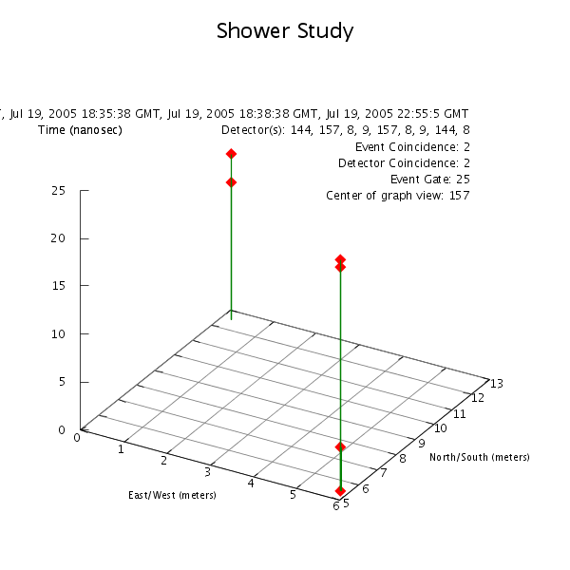
East/West  (meters) | North/South  (meters) | Time  (nanosec) | Detector | Channel
5.8 | 5.5 | 0.0 | 9 | 1
5.8 | 5.5 | 4.5 | 9 | 2
0.2 | 12.6 | 14.2 | 8 | 1
0.2 | 12.6 | 17.2 | 8 | 2
5.8 | 5.5 | 23.2 | 9 | 1
5.8 | 5.5 | 24.0 | 9 | 2

From the information given in the data table, it seems that the shower front passed through detector 9 first and then moved to detector 8. Since the coincidence between channels in both detectors is within six nanoseconds, it can be said that both events were caused by cosmic ray muons. The second coincidence event in detector 9 may have come later because of scattering within the shower front, or it may be due to an unrelated muon. This is a strong cosmic ray air shower candidate and merits further study in the spring.
The July 19 event above shows that the data collected during the summer outreach program could yield interesting information about cosmic ray air showers. The new event gate parameter should be applied to air shower analysis for the rest of the 118 data files and any air shower candidates should be studied.

