Instructions for Installation of Muonic
- Launch Linux on your computer. If you do not have Linux, you can get Unbuntu Linux from here: http://www.ubuntu.com/download/desktop/create-a-usb-stick-on-windows and instructions for how to install it are here: http://www.ubuntu.com/download/desktop/install-ubuntu-desktop.
- Once Linux has launched, you will need to download muonic. You can download the .tar file here: https://pypi.python.org/pypi/muonic
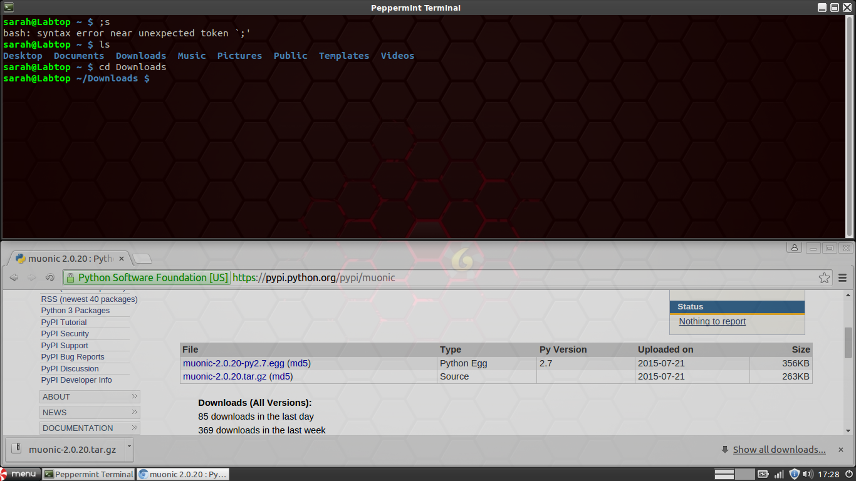
- Now, once you’ve downloaded the file, open Terminal. Then use the “cd” command to change the directory to where you downloaded the file (Example: cd Downloads).

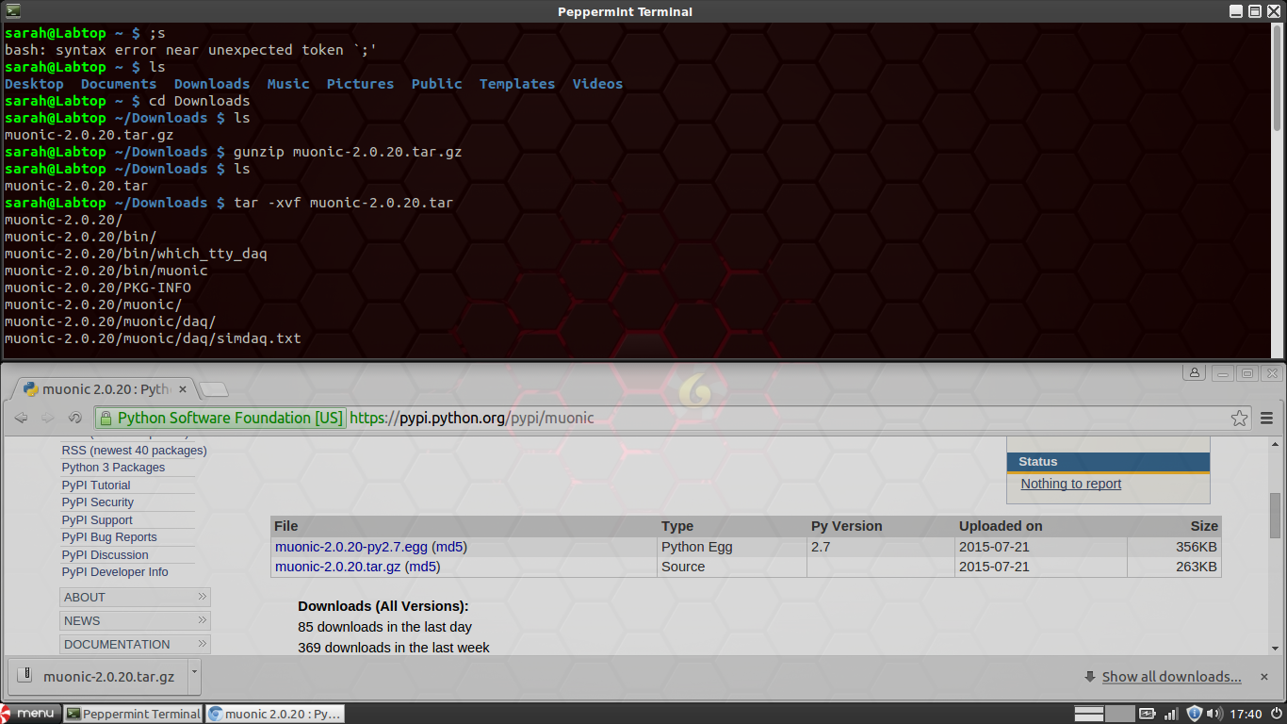
- Once you’ve reached the directory that holds the file (double check with the “ls” command), use the following command to unzip the file: “gunzip (insert file name here)”. Once you've done that use this command to extract the .tar: “tar -xvf (insert tar file name here).

- Now you will need to change directory (“cd”) into the new folder you've just created. Then you will use “python (file name, usually setup.py) install” (if it gives you an error about permissions, then put “sudo” before the command and it will make you enter your password). Then you’ll want to put in the command “sudo muonic.” If everything works and it asks for two letters, congrats! You're nearly done! If it gives an error, you will need to do the following step.
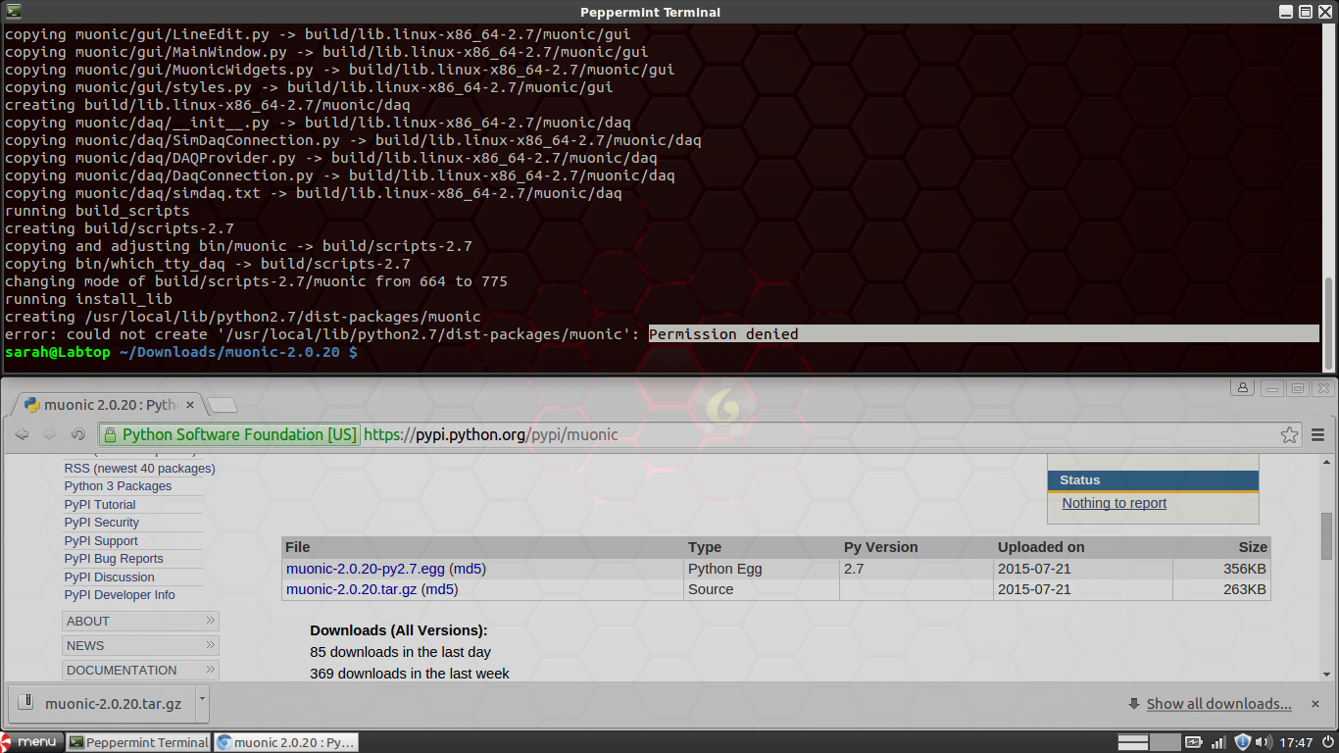
- If the terminal gives you an error saying that a certain module is not installed, then you will need to install it using the “apt-get” command. But first, you will want to search for the proper name of the package using “apt-cache search” (Example: apt-cache search pyqt4). Here is a list of some common packages that usually need to be installed before installing muonic (there may be more):
  - scipy
  - matplotlib
  - numpy
  - qt4
  - serial
Once you find the proper name for each package, use “sudo apt-get install (file name)” and repeat this process until step 5 works for you.

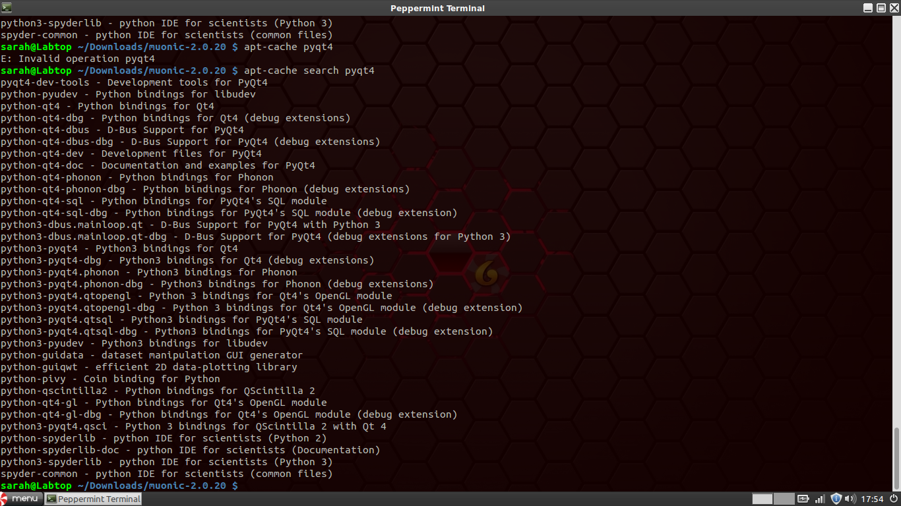

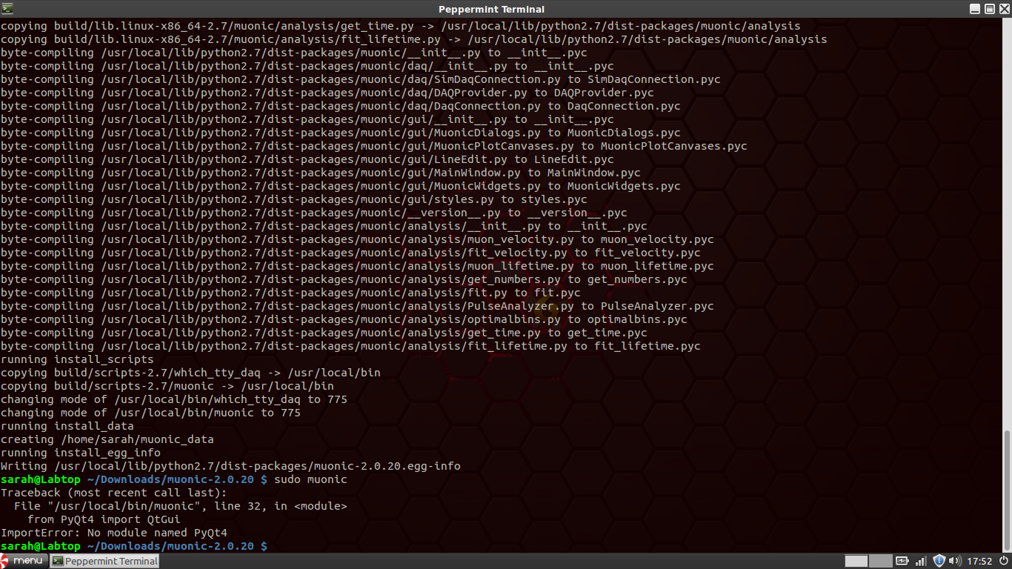
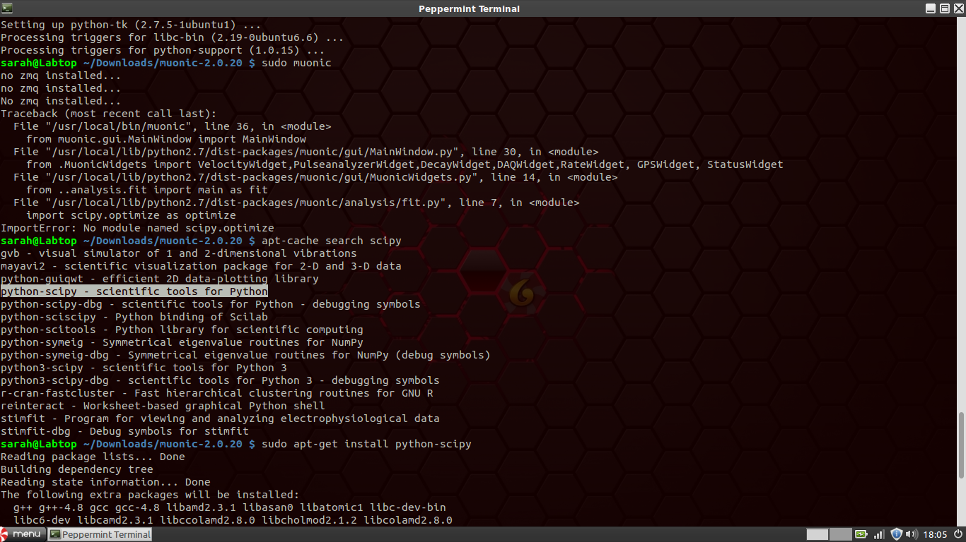
7. Once it says muonic has installed, simply type into the terminal “sudo muonic xy”, where “xy” are two letters of your choice (initials are recommended). This will launch muonic, and now you have a program to control the DAQ card!

How to Use Muonic
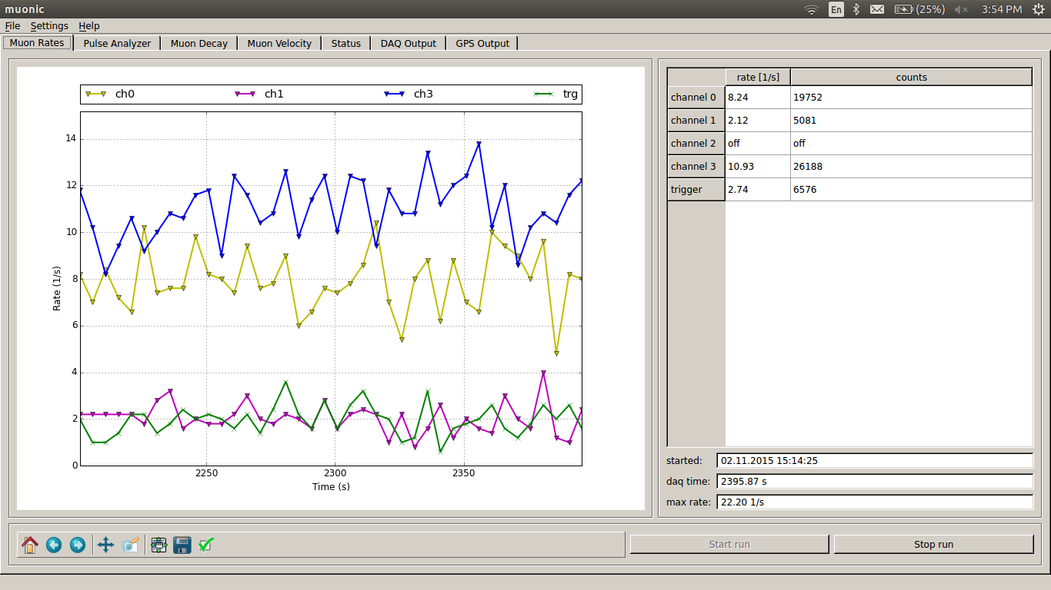
- When you launch muonic, you will be greeted by a window with a lot of tabs and buttons. It may look confusing, but it is really simplistic. The primary window displays the rates of the hits of the muons on the scintillators in counts per second. Once you have scintillators connected to the DAQ card, hit the “Start Run” button. The table will then say “Measuring” for several seconds then start displaying measurements. Once you are done measuring, press the “Stop Run” button.

- If you go to Settings -> Channel configuration, a window will pop up with several options. If you wish to disable certain channels for counting, uncheck the channels you wish to disable. You can also change under what condition the “coincidence trigger” will count. Single fold means that the trigger is set off anytime any one of the channels gets a hit, and two fold means that the trigger is set off anytime any two of the channels gets a hit, etc.
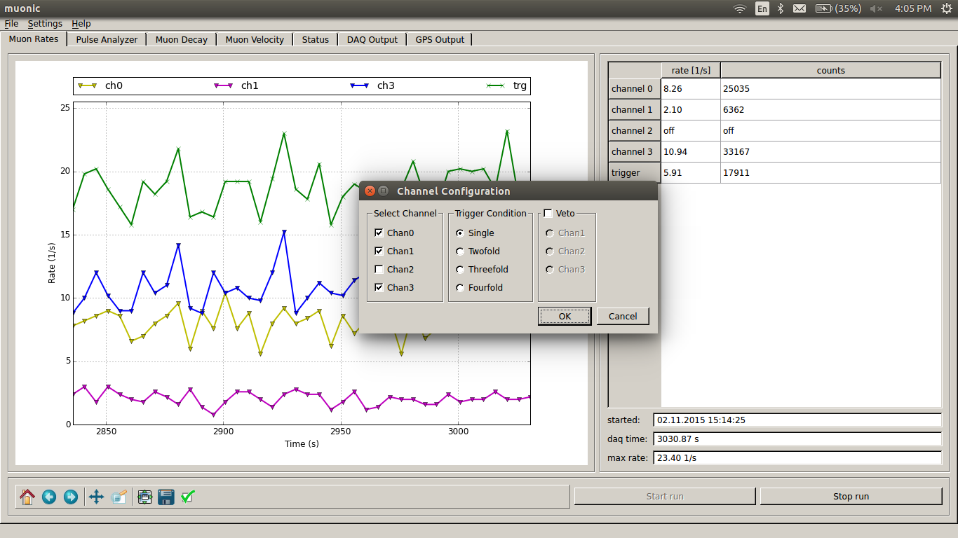

- The DAQ output tab can be used for a variety of tasks. It allows you to send direct commands to the DAQ card. Here are some of the more important ones:
  - TL (channels) (new threshold) - sets the threshold for the channel specified, or if you put in 4 for the channels, it will change all of them. If you leave out the parameters, then it will just display current threshold levels.
  - DG - displays information pertaining to the GPS
  - ST (number) (time) - this command will cause the DAQ card to output counts every (time) minutes. For the (number) parameter, it is suggested to just use 3.
  - DS - This displays the counts for each channel, or rather known as “scalars.” It outputs the counts in hexadecimal, so you will need to convert accordingly.
  - RB - This manually resets the scalars.
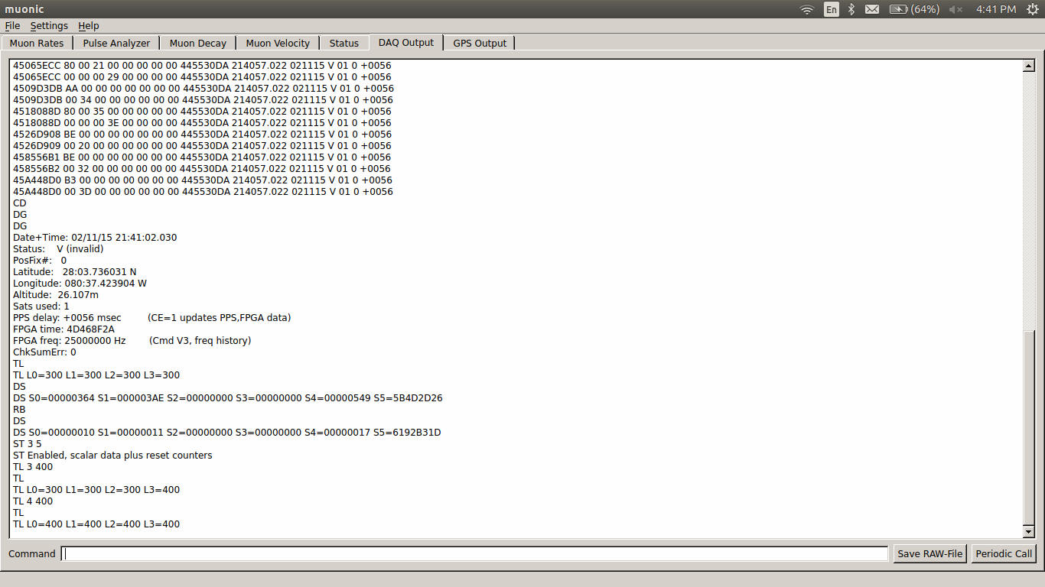
  - CD - you will want to do this pretty much as soon as you start using the DAQ output. It disables the sounds being streamed into the DAQ output. It will still count, but it will just do it in the background.

