Thermal Stretching of Large-Area GEM Foils Using an Infrared Heating Method

Michael Staib*, Bryant Benson, Kondo Gnanvo, Marcus Hohlmann⁺, Amilkar Quintero
Department of Physics and Space Sciences
Florida Institute of Technology
150 W. University Blvd
Melbourne, FL 32901
USA

March 20, 2011

Abstract
As GEM foils continue to increase in size, traditional methods of stretching and framing become more cumbersome and costly. We have developed a low-cost method of foil stretching based on a modified thermal technique using Plexiglas frames and infrared heat lamps. An overall temperature variation of not more than 5º C across a 1.2 m x 0.7 m stretching frame is observed. We have applied this scalable technique to stretch and mount several 30 x 30 cm GEM foils for use in a muon tomography station and to stretch a 1 m x 0.5 m drift foil for the prototype of the CMS high-η muon detector upgrade. Two 30 cm x 30 cm triple-GEM detectors were successfully constructed from foils stretched by this method. Potential future improvements to this method and one other potential low-cost method of thermal stretching of large-area GEM foils are also discussed.

Introduction
One of the challenges presented as GEM foils continue to grow in size is the ability to stretch and frame the GEM foils for assembly into a detector. The stretching is usually performed using mechanical or thermal methods [1, 2]. The use of unframed foils in final detector assembly using honeycomb spacers is also being investigated [3]. Here we present an adaptation of the thermal method that we have used to stretch two different foil geometries including one large foil (1 m x 0.5 m).
Traditionally, thermal stretching of GEM foils is performed by placing the GEM foil in a large Plexiglas frame which is placed inside a low temperature clean room oven. The Plexiglas frame has a higher coefficient of thermal expansion (7.2 x 10⁻⁵ ºC⁻¹) than the kapton foil (1.7 x 10⁻⁵ ºC⁻¹). As the temperature increases, the Plexiglas frame expands more than the kapton, tensioning the foil. This process is pictured in Figure 1.
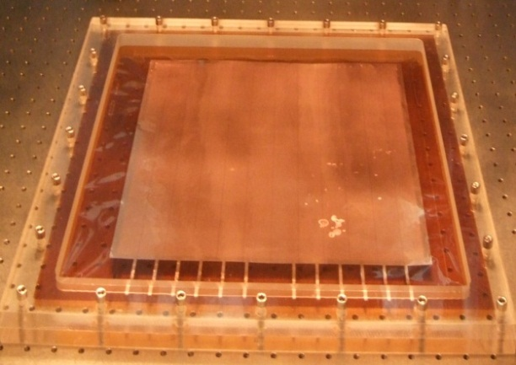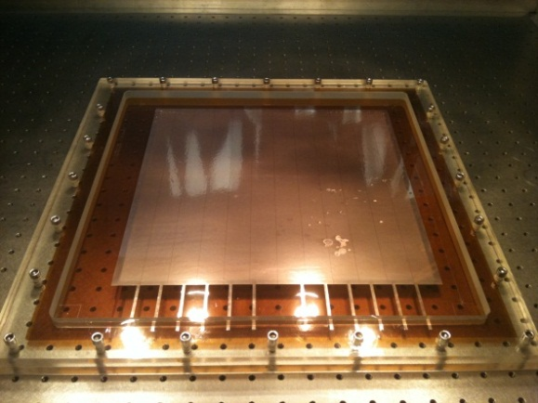
Figure 1: 30 cm x 30 cm GEM foil at room temperature (left) and tensioned at ~45º C (right).

The original motivation for this development was to build two 30 cm x 30 cm GEM detectors without the substantial investment in a clean room oven. These detectors are for use in a muon tomography station [4] being designed, constructed, and tested by Florida Tech with the help of the RD51 collaboration. Considering that the required temperatures for stretching are quite low (35-50º C), we decided that a large oven might not be necessary. After discussing various heating methods, we decided to attempt to use infrared lamps to directly heat the stretching frame.
IR Array for Stretching 30 cm x 30 cm GEM Foil
The design for our infrared array to stretch 30 cm x 30 cm GEM foils was constructed to minimize cost and maximize the use of readily available materials. We first investigated the different low-cost IR bulbs available. We found some minor variations in the construction of the bulbs from different manufacturers and decided to use 250-Watt straight-filament bulbs. The profile of the light intensity from these bulbs was well suited to our application, with the highest-intensity light being cast out fairly uniformly along a line. Other filament shapes, e.g. c-shaped filaments, were rejected because the intensity profile was too non-uniform. A 40 cm x 40 cm frame was built out of ¾” L-bar extruded aluminum. Eight light sockets were secured to the frame, two on each side. These lights were placed equidistant from the centers of each frame side with a 24 cm pitch. This rack was suspended above a 2 x 1 m² optical bench. The bulbs were
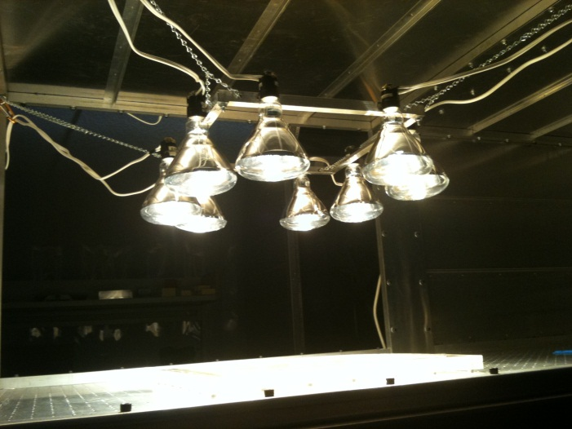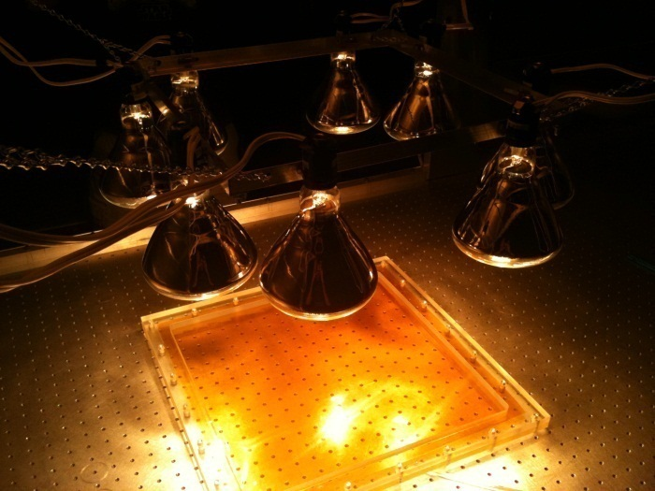
Figure 2: First IR array for stretching of 30 cm x 30 cm GEM foils on an optical bench.

then placed in the sockets and were adjusted such that the highest intensity light was directed at the Plexiglas frame. Each pair of bulbs was wired through a common household dimmer switch in order to control the current and consequently the temperature. This IR heating array is shown in Figure 2.

The lights were then raised to a height of 45 cm above the top of the stretching frame. Before our array was used to actually stretch a foil, measurements of the frame temperature during the heating process were recorded. Results in Figure 3 show a temperature variation of ~4º C along one side of the 48 cm x 48 cm Plexiglas frame of 2.5 cm thickness. This variation in temperature appears to be acceptable and does not affect the stretching process. By inspection, the foils tensioned by the IR heating method appeared very uniformly stretched in the active area (see Fig. 1, right).
The small array required about 90 minutes to reach a steady temperature. Once thermal equilibrium was reached, the temperature stayed constant with a variation of less than 2 ºC for several hours (Fig. 4) which is essential for gluing the FR4 frame to the GEM foil, in particular for curing the glue. This consistent temperature is likely a result of the optical bench serving as a large heat bath. Also, this highly thermally conductive base helps to distribute the temperature evenly and prevents large temperature fluctuations throughout the frame, in particular on the underside of the Plexiglas.
In order to stretch our 30 cm x 30 cm foils, we used a temperature of 45-50 ºC which corresponded to roughly 185 Watts per pair of bulbs. The exact wattages used were slightly different for each set of bulbs and were determined experimentally by repeated measurements. The GEM foil was sandwiched in the Plexiglas frame and placed under the IR array for one hour. Glue was carefully applied to the FR4 frame and the frame was then placed onto the stretched GEM foil. The framed GEM was placed back under the lamps to allow the glue to cure overnight. After curing, the framed foil was removed from the Plexiglas frame and the excess kapton trimmed away. The resulting framed GEM foil appeared very uniformly stretched to the naked eye.
We repeated this procedure for the remaining foils and two 30 cm x 30 cm detectors [5] were fabricated from foils stretched by our IR method. Characterization of the detectors is still ongoing. Initial results do indicate some non-uniformity in the gain in one particular corner for both detectors. It is unclear if this defect is caused by the minor temperature variations. This problem is currently under investigation. Spectra from minimally ionizing cosmic ray muons as well as from an ⁵⁵Fe x-ray source obtained from the central region of our detectors are shown in Figure 5.
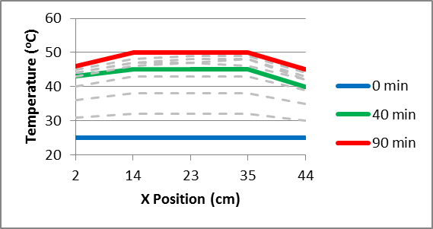
Figure 3: Temperature profile along one side of the Plexiglas stretching frame for 30 cm x 30 cm GEM foil using 185 W per pair of bulbs measured at different times during the heating-up process.

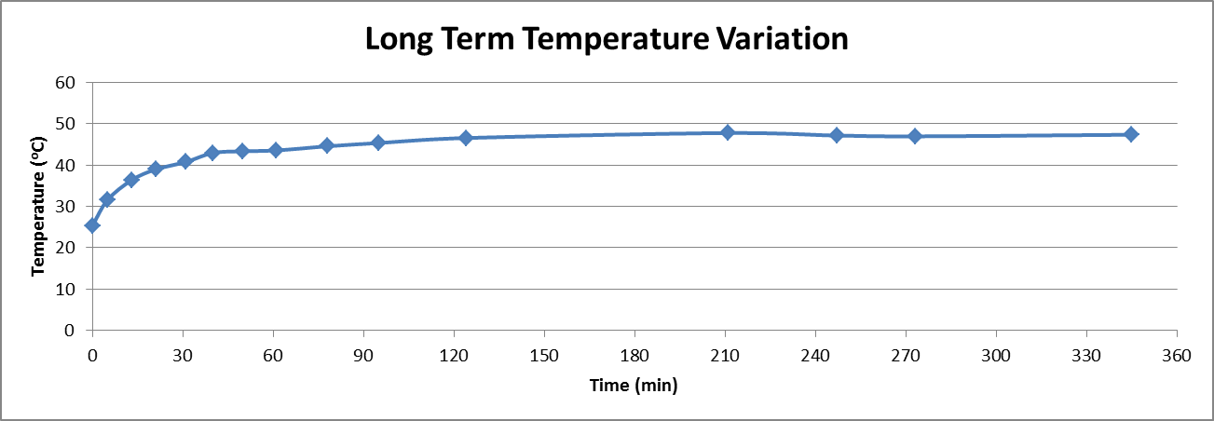
Figure 4: Long-term, single location temperature measurement on surface of Plexiglas frame. Error on temperature reading is ± 1.5º C and is smaller than the marker.

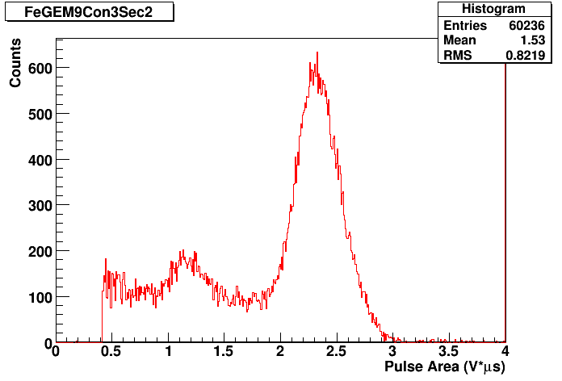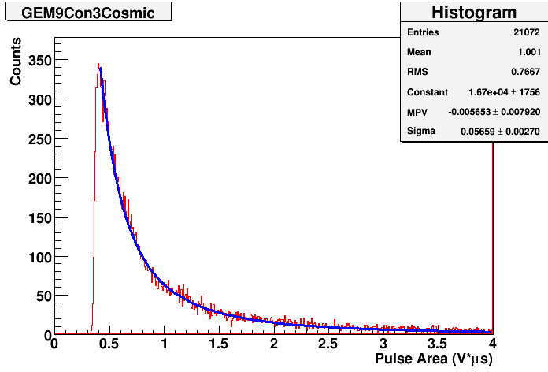
Figure 5: Spectra obtained in the central region of 30 cm x 30 cm triple-GEM detector fabricated with IR method for ⁵⁵Fe source (left) and for cosmic ray muons (right) for the same gain conditions.
IR Array for Stretching 50 cm x 100 cm GEM Foil
We scaled up our original IR array in order to test if our method could be used to thermally stretch larger GEM foils. As a verification of our method, we have thermally stretched a wedge-shaped drift foil of approximately 0.5 m x 1 m. This is the proposed foil geometry for a possible upgrade in the CMS high-η region using triple-GEM detectors [2].
The new IR array was built in a similar fashion as the first array. As before, the aluminum support frame for the light bulbs was built such that the rectangular light profile of the IR bulbs was oriented along the 115 x 66 cm² Plexiglas stretching frame. For the scaled-up version of our design, 16 bulbs were used. There were eight dimmer switches that controlled the power supplied to the bulbs in pairs. Initially, the large number of dimmer switches proved somewhat problematic. The class CC fast-acting fuses that were installed in the electrical outlets were burning out regularly making the array inoperable. This problem was fixed by switching these outlets to a time-delay fuse. The time-delay fuses are much better suited to handle the large current spikes associated with the fast voltage switching of a common household dimmer switch.
An image of the scaled up array is shown in Figure 6. A typical temperature profile for the scaled-up IR array measured with an IR thermometer is shown in Figure 7. The temperature variation is similar to what we observed with the smaller array, showing a temperature variation of ~5º C over the full surface of the Plexiglas frame. This variation is largely due to hotspots where the light profile is irregular. There are some inconsistencies in the manufacturing of these low cost bulbs and the light profile of each is slightly different, making it difficult to produce better temperature uniformity using this direct lighting technique.
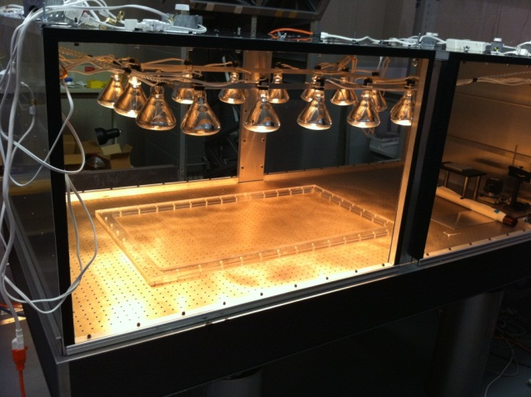
Figure 6: IR array for stretching 100 cm x 50 cm GEM foil for proposed CMS upgrade.

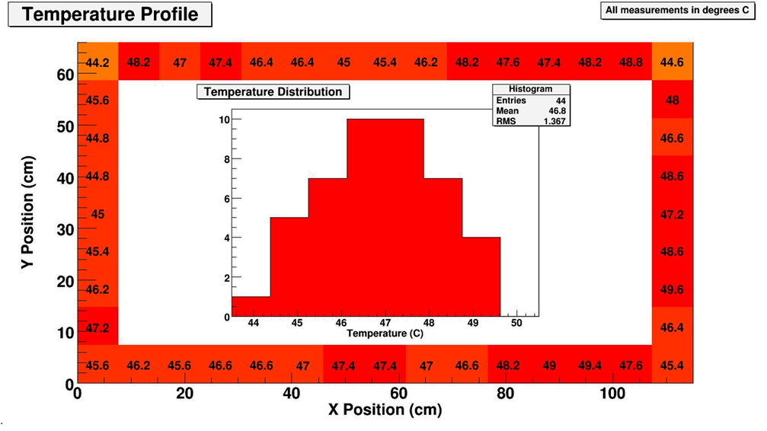
Figure 7: Temperature profile and overall temperature distribution on the surface of the Plexiglas stretching frame for scaled-up IR array measured with an IR thermometer.
Once we were satisfied with the performance of our heating array, the large drift foil was sandwiched inside the Plexiglas frame. This was then placed under the IR lights and heated. The resulting thermal stretching appeared again very uniform to the naked eye (Fig. 8), similar to our results with the smaller foil. This result shows that our method is easily scaled to larger foil sizes. This is the only thermal stretching of a foil of this size performed entirely inside a clean room to-date. The clean room oven required to stretch large foils of this size is extremely expensive in comparison to our method.
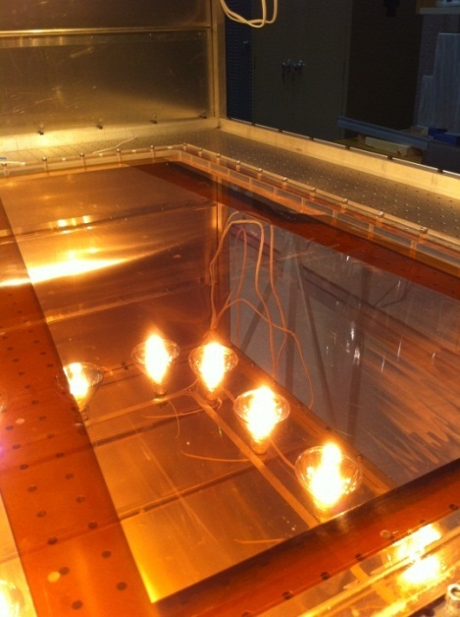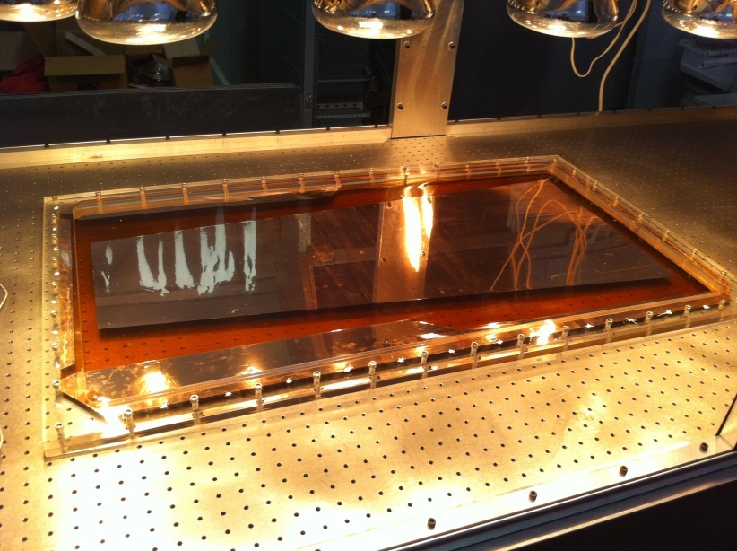
Figure 8: Large trapezoidal drift foil (50 cm x 100 cm) stretched by IR method.
Conclusion and Recomendations
It is important to note that one of our goals for this project was to create the lowest-cost solution possible out of materials readily sourced at our local institution. There are many improvements to the design that could be made at a moderate investment while still retaining a much lower price point than with a clean room oven. There are IR bulbs better suited for this application, with much more regular light profiles that are available at a higher cost. One could also develop a feedback mechanism so as to monitor the temperature and adjust the light levels accordingly for even better temperature uniformity. It may be possible to improve the performance by moving to an indirect infrared heating solution. This would effectively mitigate the problems caused by hotspots in the light profile of the IR bulbs. It is recommended that lower wattage bulbs are used for similar arrays in the future because it is difficult to achieve steady temperatures less than 45º C using 250 Watt IR bulbs in this configuration. The power output appears to be less steady when the bulbs are operated only at a small fraction of their maximum output. We note that using the 250W bulbs, we were able to reach temperatures of up to 80º C, far beyond the temperature required for this application.
We also plan to investigate the use of an electrical heating element directly embedded into the stretching frame itself. This is another attractive option that eliminates some of the bulk associated with our method. By heating the frame only, we should be able to operate at slightly lower temperatures to achieve the same amount of stretching since the foil itself will not be heated. This option also enables the use of other materials for the stretching frame. By using a material with a lower coefficient of thermal expansion we would have even greater control of the tension applied. Integrated heating is also a potential option for non-planar foil geometries.
Infrared GEM foil stretching is clearly a viable low-cost method for a variety of GEM-detector assembly applications. It should be possible in the future to completely eliminate the need for a clean room oven from the thermal GEM framing procedure. This will lower the cost for small institutions such as ours to construct large-area GEM detectors, hopefully leading to new advances in this field.
References
[1] G. Bencivenni, “The GEM detector activity at the Frascati Laboratory,” Nucl. Phys. A 827 (2009) 614C.
[2] D. Abbaneo et al., “Construction of the ﬁrst full-size GEM-based prototype for the CMS high-η muon system,” Proc. of the IEEE Nuclear Science Symposium 2010, October 30 - November 6, 2010, Knoxville, TN, arXiv: 1012.1524 [physics.ins-det], CERN RD51-Note-2010-008, 2010.
[3] D. Abbaneo et al., “Characterization of GEM Detectors for Application in the CMS Muon Detection System,” Proc. of the IEEE Nuclear Science Symposium 2010, October 30 - November 6, 2010, Knoxville, TN, arXiv:1012.3675 [physics.ins-det], CERN RD51-Note-2010-005, 2010.
[4] K. Gnanvo, et al., “Detection and Imaging of High-Z Materials with a Muon Tomography Station Using GEM Detectors,” Proc. of the IEEE Nuclear Science Symposium 2010, October 30 - November 6, 2010, Knoxville, TN, arXiv:1011.3231 [physics.ins-det], CERN RD51-NOTE-2010-004, 2010.
[5] M. Hohlmann, et al., “Design and construction of a first prototype muon tomography system with GEM detectors for the detection of nuclear contraband,” 2009 Proc. IEEE Nuclear Science Symposium, pp. 971-975, Orlando, FL, USA, arXiv:0911.3203 [physics.ins-det], 2009.

