Testing and Optimization of the 3-GEM Detector
at Florida Institute of Technology

Georgia Karagiorgi

Undergraduate Research Report – Fall Semester 2004

Introduction

During this stage of the GEM detector development conducted by the High Energy Physics Group at Florida Institute of Technology, a 3-GEM detector setup was tested, which was designed and built during the spring and summer 2004 semesters in the Detector Development Laboratory (DDL), and the Machine Shop at Florida Institute of Technology. During the testing, some alterations and additions were been made to the original design for improvement purposes, such using a different amplifier (developed, manufactured and provided by the PHENIX Group, at BNL), as well as shielding of the circuit board, detector, and preamp setup employing coax cables and a Faraday box. The results showed relatively small improvement; no acceptable signal was observed, and leakage current measurements were inconclusive. Further changes need to be made to the detector design, and new GEM foils need to be used, as the ones that are currently being used do not seem to be working properly.

Method

The basic design of the 3-GEM detector assembly used is shown in Figures 1 and 2.

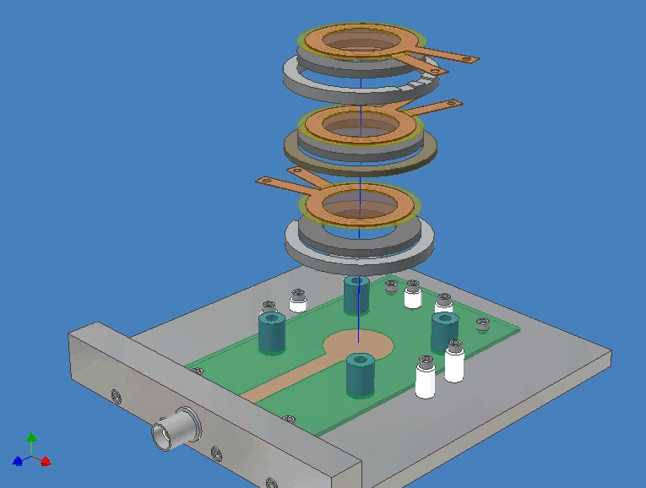
GEM 1
GEM 2
GEM 3
Output signal
Figure 1: 3-GEM Detector Setup [Exploded view]²
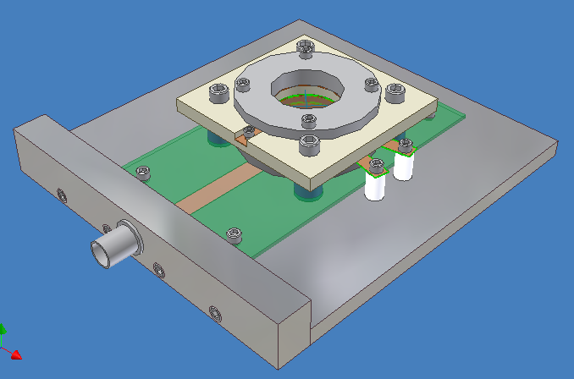
Mylar window
Figure 2: 3-GEM Detector Final Assembly²

The initial task was to verify that the setup was working properly, by observing output signals from a 5μCi Fe-55 γ-source, using three TechEtch, 1 inch-diameter GEM foils. Two series of trials were conducted; the first one using a Fujitsu preamp card that had previously been used during the single GEM testing, and the second one using a new preamp provided by the PHENIX Group, led by Dr. Craig Woody, at Brookhaven National Laboratory (BNL).
Both tests were run using the same basic experimental setup, displayed in Figures 3 and 4. The only variation was the different power supplies used to power up the two different preamps used. The Fujitsu preamp card required a single constant operating input voltage of 3.4V; this voltage was provided by the same power supply used for powering the DC-DC converters in the HV circuit (see Figure 4): Power Designs Inc, Precision DC Source 0-20V. The BNL preamp required five separate constant input voltages (GND, +6V, -6V, +12V, and -12V) for its operation. It was powered using three separate power sources: Power Designs Inc, Power Supply 2005P (S.R. 108336); Power Designs Inc, Power Supply 2010 (S.R. E6652); and NIM Crate ORTEC 401A (S.R. 11745). Appendix A provides a reference for input connection specifications.

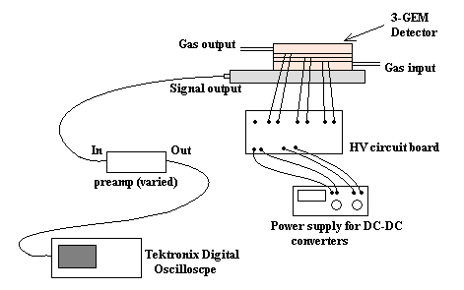
Figure 3: Experimental Setup for Signal Testing

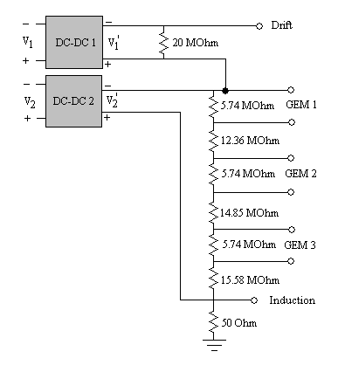
Figure 4: 3-GEM HV Circuit Board

The settings below were followed during the experimental setup that was used for signal testing:
DC-DC converters settings:
The voltage on the DC-DC converter 1 was set to:
V₁ = 2.7 V = constant during test
The voltage on DC-DC converter 2 was set to:
V₂ = 10-12 V = constant during (corresponding to V_{GEM} = ~300-330V)
[Note: Calibration measurements for DC-DC converter 2 were performed in a later stage, and the results are presented in Plots 1 and 2 of the Results section.] (See Appendix B for DC-DC converter specifications.)
Gas flow settings:
The Ar/CO₂ (70:30) flow was always set to ~75 kPa on the pressure gauge, and 80 scale units on the flowmeter scale (corresponding to 10 L/hr, according to flowmeter calibration data provided). Before any signal testing, gas was usually allowed to purge though the detector for 1-3 hrs.
[Note: An additional Ar/CO₂ (70:30) bottle was ordered and installed in September 2004. The name and address of company that provided the bottled gas is given in Appendix C.]
Data observation:
Data was observed using a Tektronix Digital Oscilloscope.
A second stage of investigation was the leakage current measurement for the GEM foils that were used. The experimental setup is shown in Figure 5.

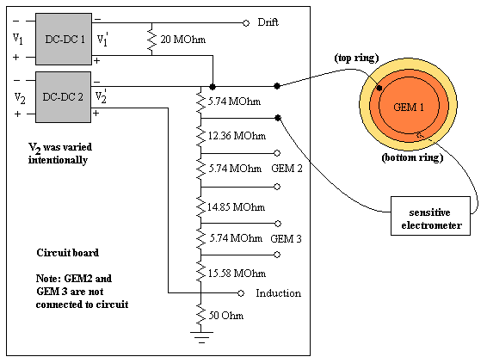
Figure 5: Experimental Setup for Leakage Current Measurements (Shown here: test for GEM 1)

The leakage current was measured using a Keithley 616 Digital Electrometer. The measurement was repeated after cleaning the GEM foils with isopropyl-alcohol. The test was conducted in order to determine the impedance of each GEM foil, as well as to investigate any charging up effects or strange behavior that the GEM foils showed. It was conducted both in Ar/CO₂ (70:30) and air, both inside and outside the detector. For the air test outside the detector, the GEM was supported in such a position that its plane was perpendicular to the horizontal plane, in order to prevent any particles from depositing on the active area while the test was running. It was supported using alligator clips, which also acted as electrodes, with one of their sides being insulated with mylar foil. The results of these tests are presented in Plots 3 to 5 of the Results section.
The basic procedure followed for cleaning GEM foils was suggested by Bob Azmoun, a researcher in the PHENIX Group at Brookhaven National Lab, via email correspondence. (See Appendix D.) The procedure, which is done under a laminar flow hood, is outlined below:
- Spray down the foils (always at “grazing incidence”) with dry N₂
- Spray down the foils with ethyl-alcohol until foils are completely drenched, using a
Windex-type dispenser spray
- Before the ethanol has a chance to air dry (which could absorb particulate deposits from the
air onto the GEM surface), quickly spray down the foils again with dry N₂ (again, always at
“grazing incidence”)
One should keep in mind that after this process the GEM impedance should drop dramatically, due to the conductivity of the remaining alcohol. However, usually after 5hrs of purging with dry gas, the impedance returns to its original value.
The procedure that was actually followed in the lab was slightly different: it was not done under a laminar flow hood, and pressured Ar/CO₂ (70:30) gas at 100 kPa was used instead of dry N₂, since the later was not available in the lab. In addition, isopropyl-alcohol was used instead of ethyl-alcohol, which is not as good a solvent as ethyl-alcohol. However, this was the only type of solvent available at the time. Methanol is an even better solvent than ethyl-alcohol that could have been used; however, it is much more dangerous, since it can cause blindness if ingested, so it was avoided.

Results

The tests performed with the first (Fujitsu) preamp in order to see whether a good signal could be obtained with the 3-GEM setup were unsuccessful; no expected results were obtained. Periodic signals, as well as random noise were observed on the oscilloscope; at specific occasions sparking was observed, both between the circuit board and the plexiglass box, and inside the GEM detector.
The tests performed with the second (BNL) preamp had the same results concerning the noise levels and sparking effects, even though this time the test was performed at a slightly lower V_{GEM} = 320V. The power supplies were tested to see if the noise signals were coming from those, but the noise levels remained unchanged. Another test was run with no HV supplied, but the noise signal persisted. In addition, during one of these tests, charge accumulation was observed on one of the four large, metal screws (shown in Figure 2) located on the top cover plate of the detector.
It is possible that sparking occurred due to bad contact between the O-rings (electrodes) and the GEM foils. Figure 6 shows how the detector electrodes were designed to fit inside the grooves of the spacer; however, in the actual design, the O-rings had a smaller outer diameter, therefore they could easily be displaced while or after assembling the detector as they were piled up, sometimes even covering a fraction of the active area of the GEM foil.

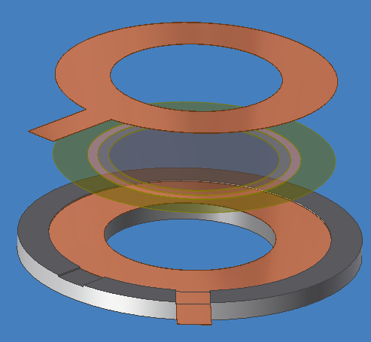
Figure 6: Placement of GEM Foil and Brass O-Rings (Electrodes) in the Detector²

After this point, the GEM foils were cleaned using the procedure outlined above, in the Methods section. While assembling the detector component parts back together after the cleaning procedure, the gas input was found to be clogged, possibly with glue. This problem was solved using fishing wire sent through the gas tubes; this was double-checked by sensing the gas flow both in the gas input and gas output points of the detector setup.
One hour after cleaning the GEM foils, and after assembling the detector, the GEM foil impedances were measured directly between electrode points using the Keithley 616 Digital Electrometer, and they were all found to be above 10 GΩ.
After the cleaning procedure, the leakage current measurements were conducted. First, a calibration curve for the DC-DC converter 2 (used to provide V_{GEM}) was obtained to be used as a reference. Plots 1 and 2 show the behavior of the converter with respect to input voltage. (See Appendix E for raw data.)

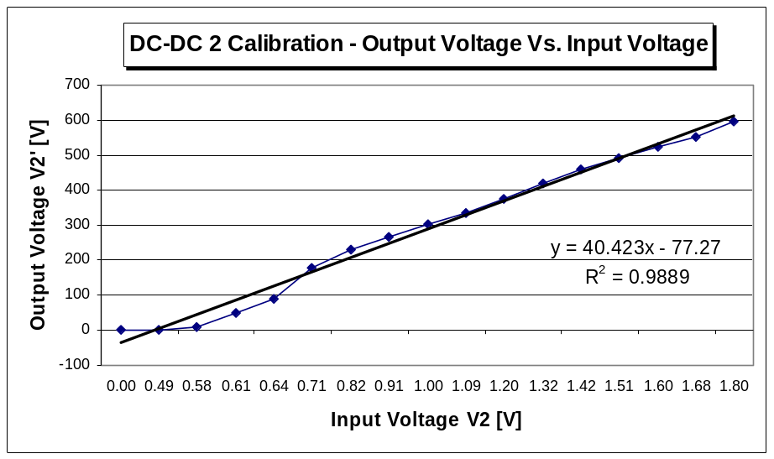
Plot 1: DC-DC Converter 2 Calibration – Output Vs. Input Voltage

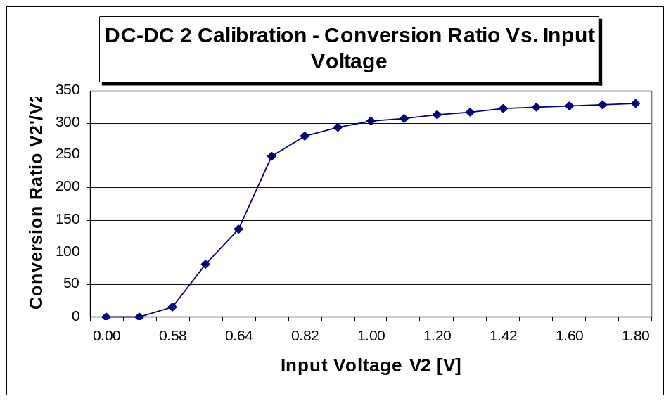
Plot 2: DC-DC Converter 2 Calibration – Conversion Ratio Vs. Input Voltage

The leakage current measurements were first conducted in air, while the GEM foils were in the detector; however, sparking was observed at V_{GEM} = ~330V, possibly due to moisture accumulation after cleaning the GEM foils with alcohol (the detector had not been purged with Ar/CO₂ gas yet, since the cleaning).
When the procedure was repeated in Ar/CO₂ (after 1.5hrs of gas purging), higher potential differences were reached across the foils. Occasionally, as the potential increased, sparking was observed momentarily; as the potential was lowered soon after sparking was observed (in order to prevent foil damage) and then raised again (slowly), sparking was not disappeared. This was probably an effect due to tiny particles being sparked off of the GEM foil. In addition, the leakage currents observed to have some time dependence; their magnitude decreased with time. Also, for GEM 1, negative currents were obtained. This discrepancy might have been due to wrong polarity of the electrometer, or false grounding. The results for GEM 1 and GEM 2 are shown below, in Plots 3 and 4 (GEM 3 was not tested). (See Appendix E for raw data.)

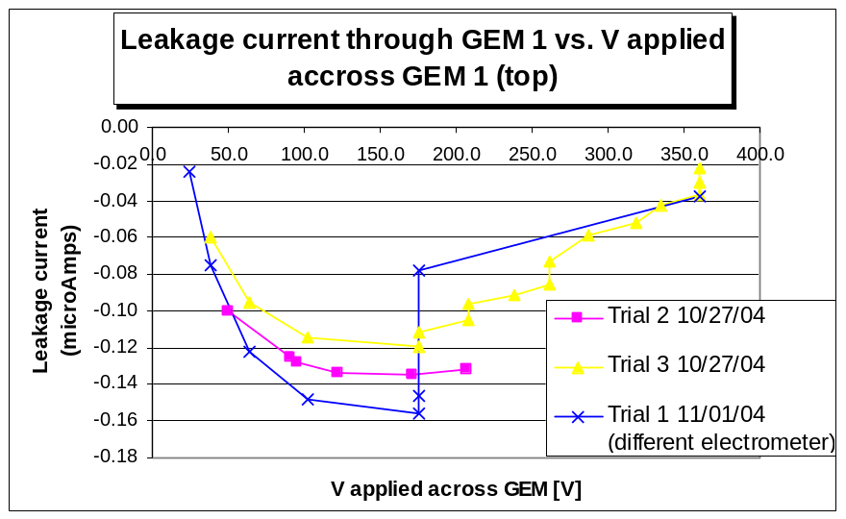
Plot 3: Leakage Current Measurement in Ar/CO₂ (70:30) for GEM 1 (in the detector)
*Note: steep vertical line steps are due to time dependence shifts in current

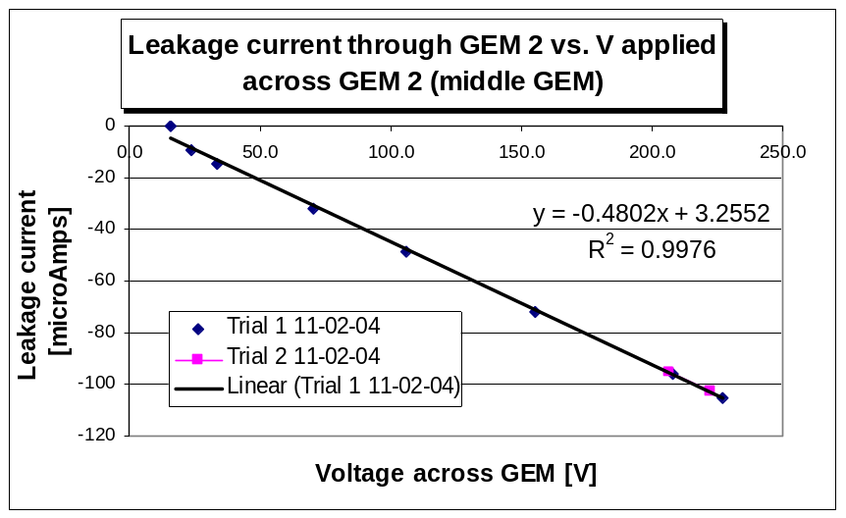
Plot 4: Leakage Current Measurement in Ar/CO₂ (70:30) for GEM 1 (in the detector)

Note that, even though GEM 2 showed stability with time, the leakage current values obtained were orders of magnitude greater than a few nA, which is what should be expected for this type of measurements¹. In addition, the low impedances implied by the large currents were inconsistent with the previous leakage current measurement.
After this test, all the connections on the HV circuit board were soldered again, where the solder seemed to be fatigued. When GEM 1 was retested, it showed a similar behavior as before.
As a final test, GEM 1 was tested outside the detector, in air. The results are shown below, in Plot 5. (See Appendix E for raw data.)

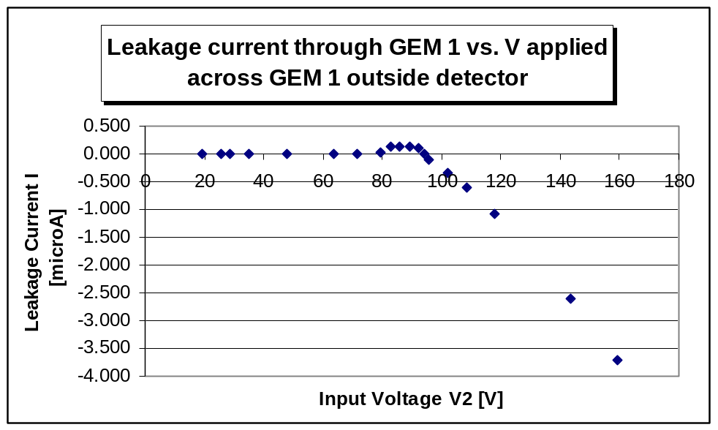
Plot 4: Leakage Current Measurement in Ar/CO₂ (70:30) for GEM 1 (in the detector)

Conclusions

The experimental results were not satisfactory since they did not meet the expectations for a successfully operating 3-GEM detector. The leakage current measurement was inconclusive; the most probable scenario is that the GEM foils have been worn out, or permanently damaged during testing, which implies the need for their replacement. In addition, the initial design for the 3-GEM detector that was developed and tested was found to be impractical and flawed. A new 3-GEM detector setup needs to be developed, this time to employ 10x10cm² GEM foils. Improvements need to be made for better shielding the circuit board, the connection points between wires and electrodes on the 3-GEM detectors assembly, as well as for better gas sealing.

References

¹B. Azmoun, G. Karagiorgi, C. Woody. A Comparative Study of GEM Foils from Different
Manufacturers.
<http://www.phenix.bnl.gov/WWW/TPCHBD/GEM_foil_comparison.pdf>

²J. Slanker, G. Karagiorgi, M. Hohlmann. Prototypes for Particle Detectors Employing Gas
Electron Multipliers. FAS 68th Annual Meeting, Orlando, FL. March 12-13, 2004.
< http://www.fit.edu/hep/FAS_2004_GEM_Julie.ppt>

Appendix A

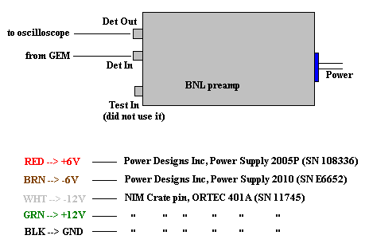
Figure 6: Reference for Connection Specifications for BNL Preamp

Appendix B-1

DC-DC Converter Specifications

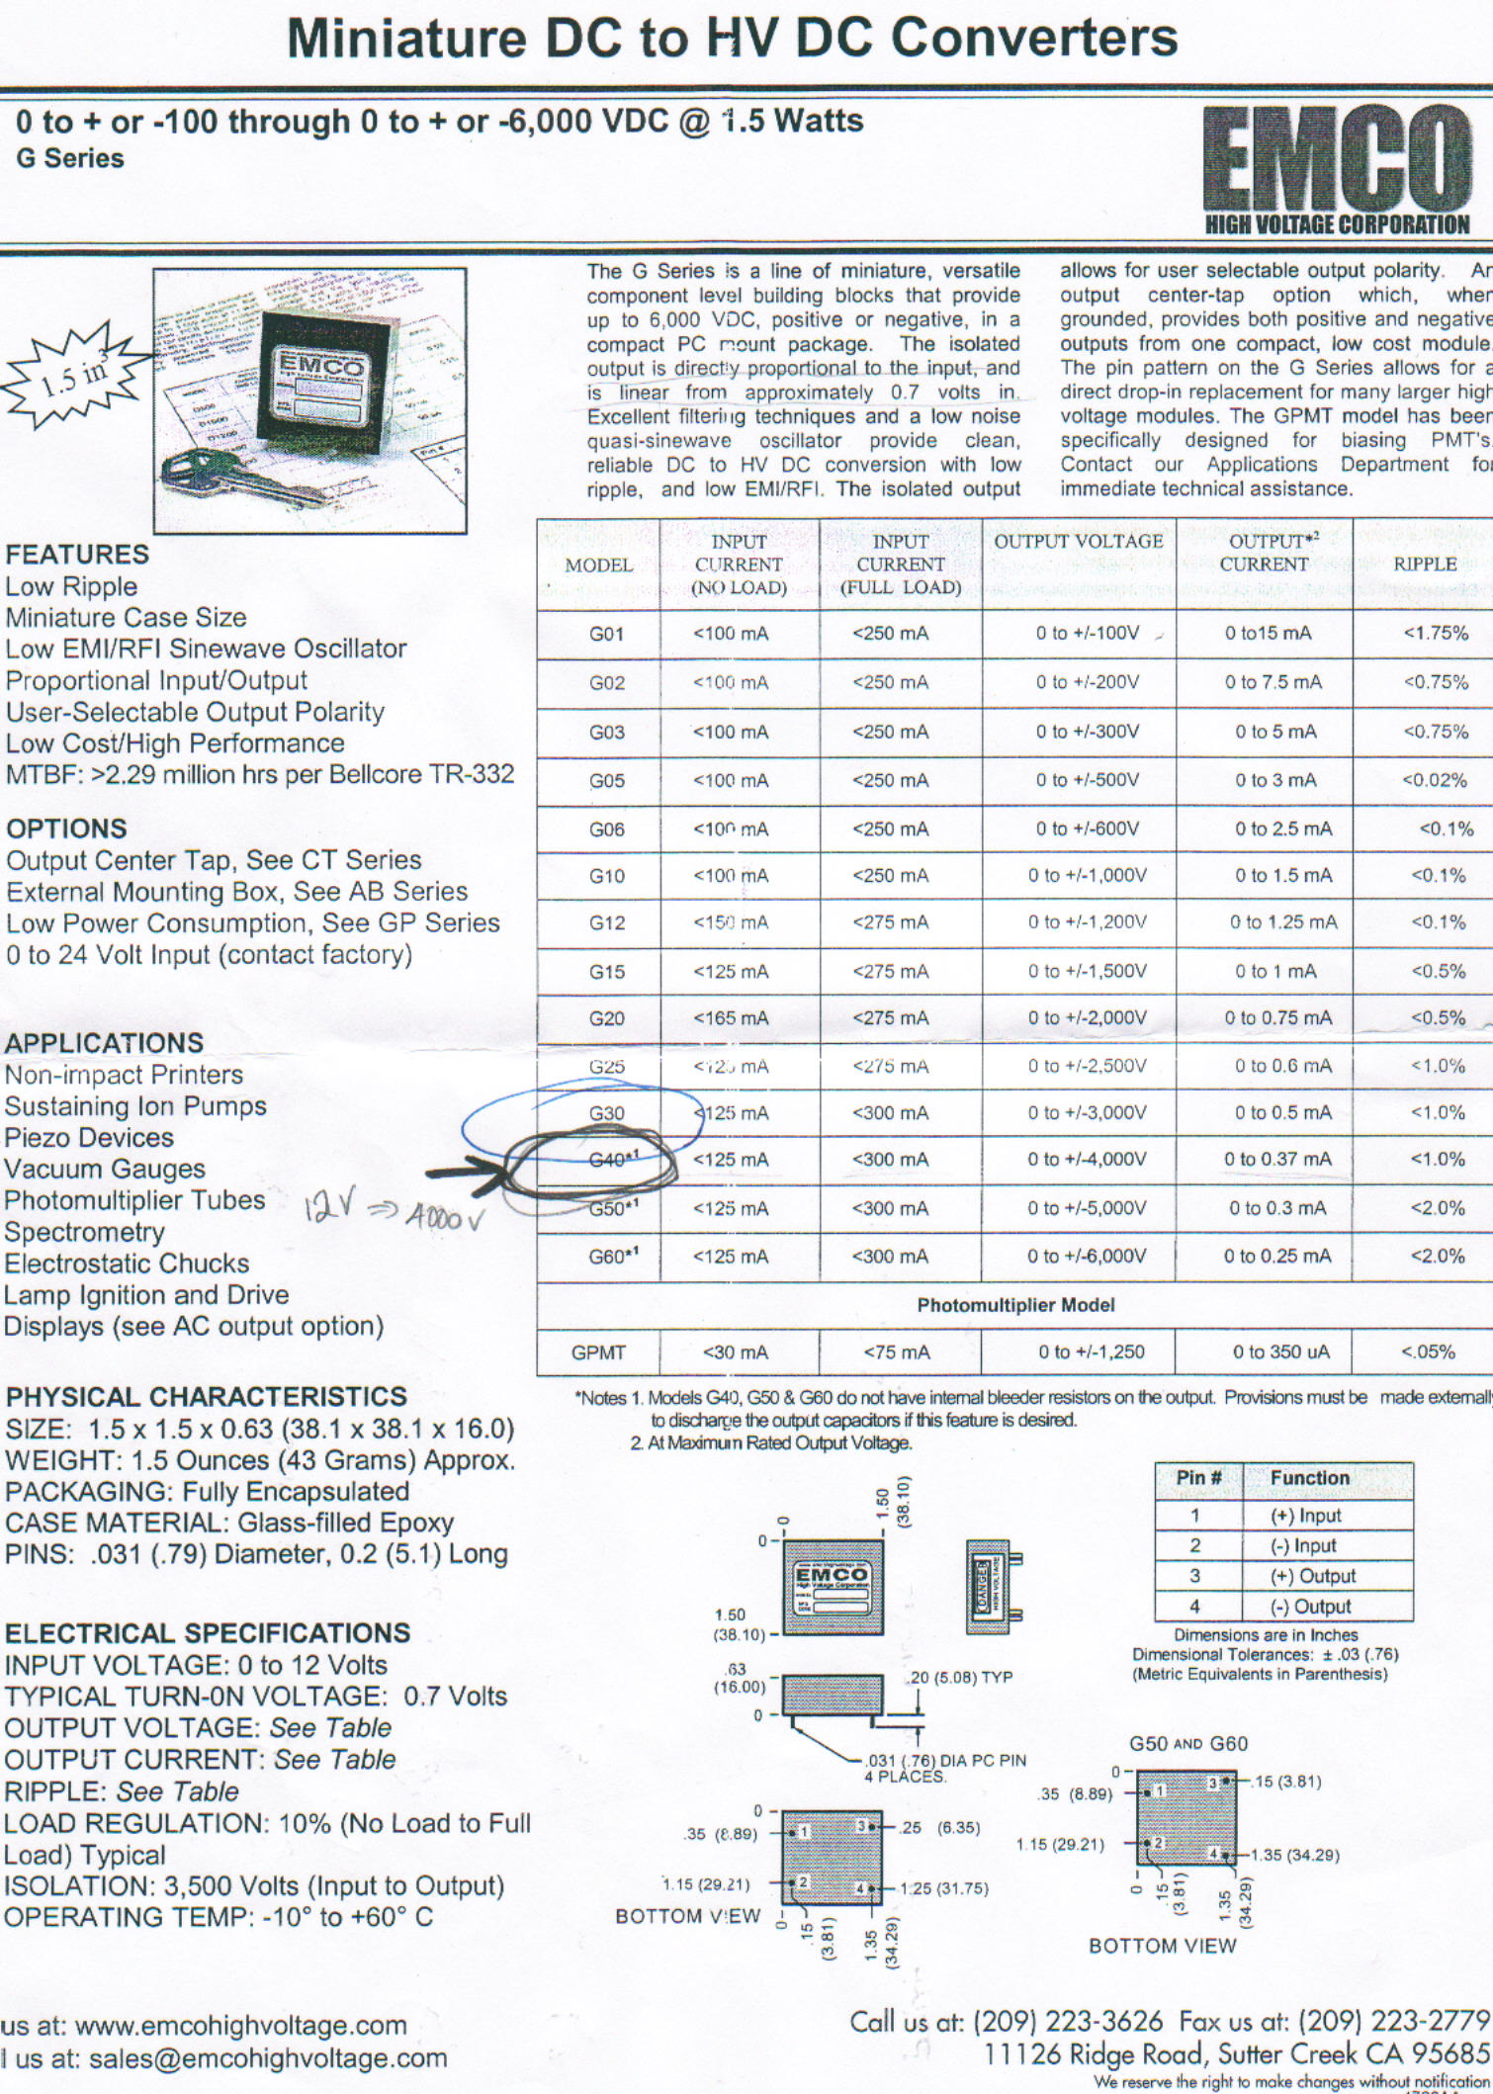

Appendix B-2

Table 1: DC-DC 2 Calibration Raw Data
Input V (V2) | Output V (V2') | Conversion Ratio = V2'/V2
[V] | [V]
0.000 | 0.000 | 0.00
0.485 | 0.005 | 0.01
0.580 | 8.500 | 14.66
0.613 | 50.500 | 82.38
0.640 | 87.000 | 135.94
0.711 | 177.300 | 249.37
0.818 | 229.600 | 280.68
0.909 | 266.300 | 292.96
1.000 | 303.300 | 303.30
1.087 | 333.700 | 306.99
1.202 | 376.000 | 312.81
1.316 | 417.000 | 316.87
1.424 | 459.000 | 322.33
1.514 | 492.000 | 324.97
1.602 | 523.000 | 326.47
1.684 | 553.000 | 328.38
1.804 | 595.000 | 329.82

Appendix C

Type of gas ordered:
Compressed Ar/CO₂ (70:30)

Name and contact information of gas provider company:
Boggs Gases
620 Main St.
Titusville, FL 32796
Tel. (321) 267 4110

Appendix D

Email correspondence with Bob Azmoun, PHENIX Group, BNL – Regarding cleaning procedure for GEM foils.

From | "B. Azmoun" <azmoun@bnl.gov>
Subject | Re: Cleaning GEM foils
Date | Sat, November 6, 2004 4:54 pm
To | "Georgia Karagiorgi" <gkaragio@fit.edu>
Hi Georgia,
Nice to hear from you! All is well here, except very busy writing papers and such.

As far as cleaning is concerned, I can't remember whether you actually saw me clean any foils. In any case, I first spray down the foils with dry N2 at "grazing incidence" (as you saw), then I spray down the foils with Ethyl alc until the foils are completely drenched (I use a Windex-type dispenser spray). BTW, this is all done under the laminar flow hood that’s in the lab. Before the alc has a chance to air-dry (which could adsorb particulate deposits from the air onto the GEM surface) I quickly spray down the foils again with dry N2 quite a bit, beyond the point where the foils are apparently dry--again at grazing incidence. One thing to keep in mind is that after this process, the impedance of the foils goes down dramatically due to the conductivity of the remaining alc on the foils. Usually after
5hrs of purging with dry gas, the impedance returns to its original value.
Hope this helps. Let me know if you have other questions.

Bob

----- Original Message -----
From: "Georgia Karagiorgi" <gkaragio@fit.edu>
To: "B. Azmoun" <azmoun@bnl.gov>
Sent: Thursday, October 07, 2004 3:21 PM
Subject: Cleaning GEM foils

> Hi Bob,
>
> How are you? I hope your research is going well.
>
> I have a question about the cleaning procedure of the GEM foils and I was wondering if you could help me. I am trying to clean the 3-GEM detector we have here in our lab, and Dr. Marcus Hohlmann has mentioned to me that GEMs can be cleaned with alcohol; I couldn't remember if we did that for any of the GEM foils that we used during the summer (at BNL), so I don't know if this is actually true. If so, do you happen to know what exactly the process includes?
>
> Thank you.
>
> ~Georgia Karagiorgi
>

From | "B. Azmoun" <azmoun@bnl.gov>
Subject | Re: Cleaning GEM foils
Date | Mon, October 18, 2004 12:36 pm
To | "Georgia Karagiorgi" <gkaragio@fit.edu>
Hi Georgia,
Sorry for the late response, I was out of town the past week. I suppose isopropyl alc is Ok, but I don't think it's as good a solvent as ethyl alc. Methanol is even better than ethyl alc, but it's more dangerous--methanol is the alcohol that causes blindness if ingested...if possible, go with ethyl alc.

Regards,
Bob

----- Original Message -----
From: "Georgia Karagiorgi" <gkaragio@fit.edu>
To: "B. Azmoun" <azmoun@bnl.gov>
Sent: Wednesday, October 13, 2004 11:48 PM
Subject: Re: Cleaning GEM foils

> Hi Bob,
>
> I would like to ask you for one more thing about the cleaning of GEMs. Do you happen to know if there is or could be any reason why one could clean the GEMs using Ethyl-alcohol and not Iso-propanol?
>
> ~Georgia
Appendix E

*Note: For the following tests, the output voltage was approximated using a conversion factor of 333 for simplicity reasons, even though during the DC-DC converter 2 calibration it was found that at low input voltage this linearity breaks. Consult Plot 2 for more accurate values.

Table 2: Leakage Current Raw Data for GEM 1 in Ar/CO2 (70:30) - inside detector
10/27/2004 | V2 | V2'=V2(333)(5.74/60) | Leakage I
 | [V] | [V] | [microA]
Trial 1 | 1.27 | 40.5 | -6.26
 | 2.28 | 72.6 |  | sparking!
Trial 2 | 1.58 | 50.3 | -0.100
 | 2.85 | 90.8 | -0.125
 | 3.00 | 95.6 | -0.128
 | 3.84 | 122.3 | -0.134
 | 5.35 | 170.4 | -0.135
 | 6.50 | 207.1 | -0.132
 | 6.50 | 207.1 | -0.114 | 2 min later
Trial 3 | 1.20 | 38.2 | -0.060
 | 2.00 | 63.7 | -0.095
 | 3.20 | 101.9 | -0.115
 | 5.50 | 175.2 | -0.119
 | 5.50 | 175.2 | -0.112 | 2 min later
 | 6.54 | 208.3 | -0.105
 | 6.54 | 208.3 | -0.096 | 2 min later
 | 7.50 | 238.9 | -0.091
 | 8.20 | 261.2 | -0.086
 | 8.20 | 261.2 | -0.073 | 2 min later
 | 9.00 | 286.7 | -0.059
 | 10.0 | 318.6 | -0.052
 | 10.5 | 334.5 | -0.042
 | 11.3 | 360.0 | -0.037
 | 11.3 | 360.0 | -0.030 | 2 min later
 | 11.3 | 360.0 | -0.022 | 2 min later

Table 3: Leakage Current Raw Data for GEM 1 in Ar/CO2 (70:30) - inside detector
11/1/2004 | V2 | V2'=V2(333)(5.74/60) | Leakage I
 | [V] | [V] | [microA] | *Using different electrometer
Trial 1 | 0.75 | 23.9 | -0.024
 | 1.20 | 38.2 | -0.075
 | 2.00 | 63.7 | -0.122
 | 3.20 | 101.9 | -0.148
 | 5.50 | 175.2 | -0.156
 | 5.50 | 175.2 | -0.146 | 2 min later
 | 5.50 | 175.2 | -0.078 | 40 min later
 | 11.3 | 360.0 | -0.038 | after 10 min at 11.3V
Table 4: Leakage Current Raw Data for GEM 2 in Ar/CO2 (70:30) - inside detector
10/27/2004 | V2 | V2'=V2(333)(5.74/60) | Leakage I
 | [V] | [V] | [microA]
Trial 1 | 0.50 | 15.9 | -0.04
 | 0.75 | 23.7 | -9.37
 | 1.06 | 33.8 | -14.4 | *values are stable after ~2min
 | 2.20 | 70.1 | -32.0
 | 3.32 | 105.8 | -48.6
 | 4.88 | 155.5 | -71.7
 | 6.53 | 208.0 | -96.0
 | 7.12 | 226.8 | -105 | sparking!
Trial 2 | 6.48 | 206.4 | -95.3
 | 6.98 | 222.4 | -102.6
 | 7.12 | 226.8 |  | sparking!

Table 4: Leakage Current Raw Data for GEM 1 in Air - outside detector
11/16/2004 | V2 | V2'=V2(333)(5.74/60) | Leakage I
Trial 1 | [V] | [V] | [microAmps]
 | 0.6 | 19.1142 | 0.004
 | 0.8 | 25.4856 | 0.0033
 | 0.9 | 28.6713 | 0.002
 | 1.1 | 35.0427 | 0.001
 | 1.5 | 47.7855 | 0.0007
 | 2 | 63.714 | 0.006
 | 2.25 | 71.67825 | 0.0108
 | 2.5 | 79.6425 | 0.017
 | 2.6 | 82.8282 | 0.127
 | 2.7 | 86.0139 | 0.132
 | 2.8 | 89.1996 | 0.13
 | 2.9 | 92.3853 | 0.1
 | 2.95 | 93.97815 | 0.003 | Fluctuates a lot between
 | 3 | 95.571 | -0.1 | -0.1 and 0.5 microAmps
 | 3.2 | 101.9424 | -0.35
 | 3.4 | 108.3138 | -0.6
 | 3.7 | 117.8709 | -1.09
 | 4.5 | 143.3565 | -2.6 | For V2=4.5V, high-f sound
 | 5 | 159.285 | -3.7 | coming from DC-DC converter, but no change in curent

