**Investigation of In-flight Preamplifier Ripple**

High Energy Physics Group

Aerospace, Physics & Space Sciences Dept.

Florida Institute of Technology

May 13, 2020

Mike Luntz, Devon Madden

# Introduction

The In-flight detector is connected to a high voltage source through a low pass filter. During testing a periodic ripple noise on the preamp input and output has been observed when the detector and preamp are connected. It was postulated that this ripple, which can limit detector sensitivity, may be related to ripple on the HV supply. To check this possibility the HV filter insertion loss at ripple frequencies was analyzed. The conclusion, based on large filter insertion loss, is that ripple on the HV is unlikely to cause ripple on preamp input. The cause of this ripple is still unknown. Determination of its cause requires further investigation.

# In-flight Detector Setup

Figure 1 is a simplified block diagram of the test setup. The In-flight detector is connected to an Ortec 142PC preamplifier through a short (approximately 20 cm) coaxial cable. The preamplifier has a pair of identical outputs, one of which is connected to an amplifier and the other directly to an oscilloscope. In addition to the normal input, the preamplifier also has a test input which is connected to a pulse generator for testing the system.

The high voltage required by the detector is supplied by a CAEN 1470 high voltage power supply which is connected via coaxial cables to the detector through a cascade of 3 low-pass filters whose function is to reduce any ripple on the high voltage.

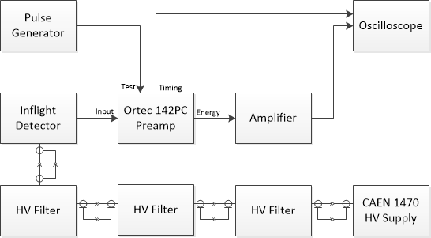

Figure 1. In-flight Detector Test Setup

# Observed Ripple in Preamp

When the preamp and amplifier were tested without the detector connected, no significant noise was observed in the preamp output as seen in Figure 2(a) below. But when high voltage was applied to the detector and the detector connected to the preamp, what appeared to be a periodic ripple was observed on the preamp output as seen in Figure 2(b). In Figure 2 the blue scope trace is the pulse generator input, the green trace is the preamplifier output and the yellow trace is the amplifier output. It should be noted that a similar ripple was detected on the preamp output in 2019[1]. The frequency content of this ripple has been analyzed and found to consist of a 100 kHz sinusoid and its harmonics, primarily 200 kHz. Although there was no significant ripple observed in the amplifier output, there was concern that this ripple would limit the sensitivity of the detector.

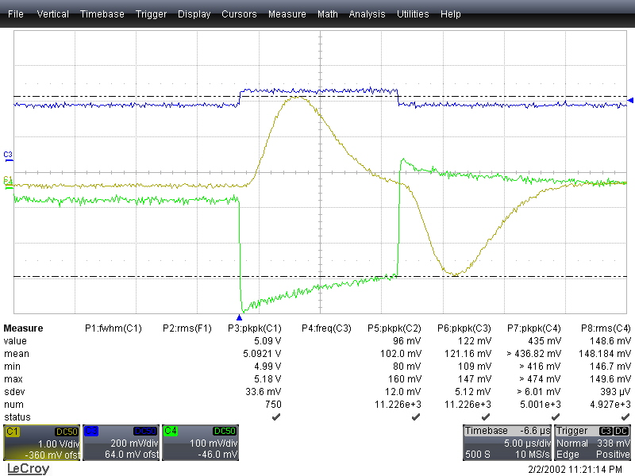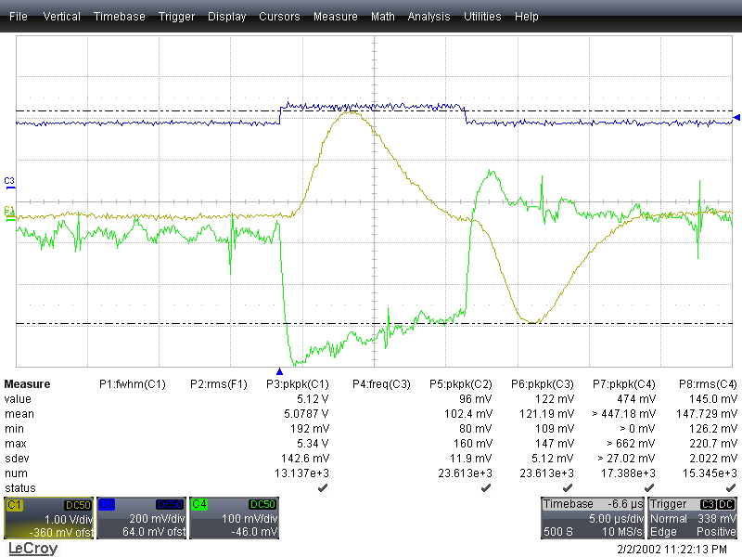

(a) Detector Disconnected (b) Detector Connected

Figure 2. Impact of Connecting Detector to Preamp on Observed Nosie

# Impact of Filtering on the High Voltage Detector Input

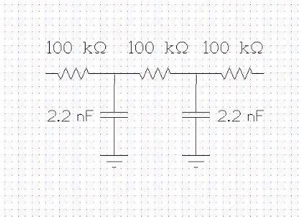Because of the apparent lack of randomness in the preamp ripple output it was thought that this ripple was possibly the result of insufficient filtering of ripple due to a switching regulator in the HV supply. For this reason, the HV filters were analyzed to compute their insertion loss at the ripple frequencies. The commercial program Orcad Capture and PSpice were used in this analysis. Figure 3 is a circuit diagram of one of the 3 cascaded filters used to filter the high voltage. A circuit diagram of the cascade of three of these filters is shown in Figure 4 below. In this diagram, which was used in PSpice to compute the insertion loss versus frequency, the parasitic capacitance of the cables connecting the 3 filter sections, assumed to be equal to 10 pf, is included. Figure 5 shows the results of this analysis. It can be seen from Figure 5 that even 1 volt of ripple at 100 kHz would be reduced to significantly less than 1 V (120 dB insertion loss) at 100 kHz. To ensure that parasitic capacitance in the 100 k resistors did not impact this result, a 0.2 pf capacitor was placed across each filter resistor and another frequency response computed with negligible impact on the insertion loss results.

Figure 3. HV Filter Circuit

Figure 4. Schematic Diagram of HV Filter Cascade Analyzed

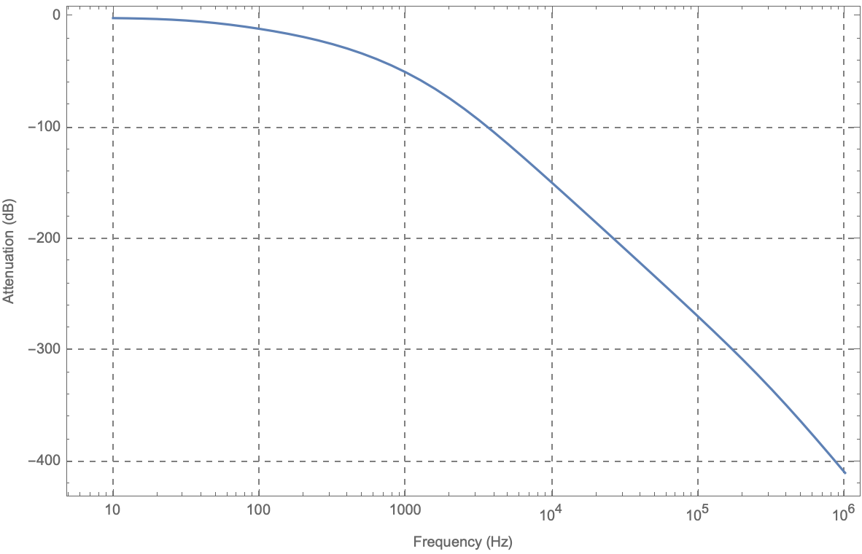  
Figure 5. Insertion Loss of Cascaded HV Filters

The filter attenuation values computed using PSpice are closely approximated by the simple equation $$L\left(f\right)=10 {\text{log}}_{10}\left[\frac{1}{{\left(1+\frac{f}{f_{b}}\right)}^{4n}}\right]$$

where $f_{b}$ is a break frequency and $n$ is the number of filters cascaded. For a single filter, the break frequency is 720 Hz and for the cascade of 3 filters the break frequency is 525 Hz. Plots shown in figure 6 comparing the approximate attenuation with the attenuation computed using PSpice, provide justification for using this simple equation to estimate the attenuation at any frequency.



3 Filter Cascade Single Filter  
 Figure 6. Comparison of Approximate Equation with PSpice Results

# Conclusions

Based on the calculations described above it seems clear that ripple in the high voltage power supply is not the source of the ripple on the preamp output voltage and its cause is still unknown. If the sensitivity of the detector amplifier combination with this ripple is determined to be inadequate to the In-flight mission, then additional investigation into its source is recommended. If the sensitivity is adequate, then no additional investigation is necessary.

1. Zachary Paul, "**In-Flight Radiation Detector Testing**," Spring 2019, Internal Report