ORTEC 142 PC Preamp Response Analysis

High Energy Physics Group

Aerospace, Physics & Space Sciences Dept.

Florida Institute of Technology

June 4, 2020

Mike Luntz

Table of Contents

Introduction 2

In-flight Detector Setup 2

Preamplifier Analysis Model 3

PSpice Results 6

Approximate Analysis 7

Comparison of PSpice and Approximate Analysis Results 8

Comparison of Approximate Model and Measured Results 9

Approximation Model Response to Particle Detection 11

Conclusion 12

Appendix 1 Test Input Analysis 13

Appendix 2 Detection Input Analysis 17

List of Figures

Figure 1. In-flight Detector Test Setup 2

Figure 2. Preamplifier Circuit Diagram 3

Figure 3. Analysis Model for Particle Detection 5

Figure 4. Analysis Model for Test Stimulation 5

Figure 5. Comparison of Simulated and Experimental Result 6

Figure 6. Comparison of AD825 and AD845 Test Pulse Response 7

Figure 7. PSpice Calculated Preamp Response to Particle Detection 7

Figure 8. Ideal Op-Amp Model 8

Figure 9. Good Correlation Between Approximate and PSpice Analysis Results 9

Figure 10. Comparison of Approximate Analysis with Measurements 10

Figure 11. Assumed Output Circuit 10

Figure 12. Comparison of Modified Analysis Amplifier Output with Measured Output 11

Figure 13. Predicted Output Due to Particle Detection 12

# Introduction

This note documents the attempt to predict the In-flight detector ORTEC 142PC[1] preamplifier response to a detected photon produced by a Cd-109 source. Prediction is necessary because photons have not yet reliably produced detections.

The analysis of the preamplifier is based on the circuit diagram in the preamplifier manual. This circuit was initially modeled using a trial copy of PSpice, but a PSpice model of an active amplifier with sufficient bandwidth could not be found so an approximate analysis was developed. Using this analysis, the bandwidth of the active amplifier in the preamp was adjusted until the response to a pulse on the test input matched the experimental results. Once a match was obtained with a test input, the response to a particle detection was computed.

# In-flight Detector Setup

Figure 1 is a simplified block diagram of the test setup. The In-flight detector is connected to the ORTEC 142PC preamplifier through a short (approximately 20 cm) coaxial cable. The preamplifier has a pair of identical outputs, one of which is connected to an amplifier and the other directly to an oscilloscope. In addition to the normal input the preamplifier also has a test input which is connected to a pulse generator for testing the system.

The high voltage required by the detector is supplied by a CAEN 1470 high voltage power supply which is connected via coaxial cables to the detector through a cascade of 3 low-pass filters whose function is to reduce any ripple on the high voltage.

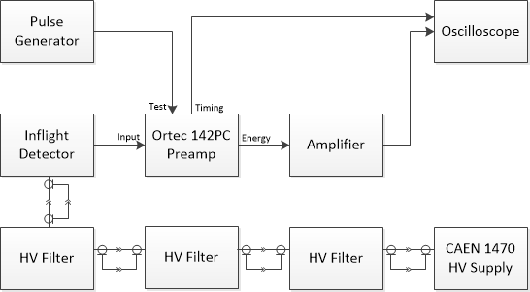

Figure 1. In-flight Detector Test Setup

When the system is working properly, particles impinging on the detector ionize gas molecules in the detector. Electrons released in this ionization, after multiplication in the detector, eventually reach readout strips in the detector producing a pulse at the preamplifier input port. This input signal is amplified by the wide bandwidth preamplifier whose output is further amplified by a narrower bandwidth amplifier. The output of both the preamplifier and the amplifier can be displayed on an oscilloscope.

There is a test input in addition to the normal input port that can be used to test the preamplifier and since, unfortunately, particles from a radioactive source have not yet been detected, the test input has been used to stimulate the preamp and the output waveform with this stimulation has been observed on an oscilloscope.

The preamp circuit has been modeled and the model response to a test pulse input has been compared with the observed response. The aim of modeling the preamplifier circuit is to eventually predict its output in response to a particle detection.

# Preamplifier Analysis Model

A simplified circuit diagram of the preamplifier, extracted from the ORTEC 142PC manual is shown in Figure 2 below. Unfortunately, this diagram provides no detail for the active component of the circuit (the amplifier with an open loop gain of 40,000). This amplifier is apparently constructed of discrete parts. There was only a statement in the manual that the amplifier had an FET front end.

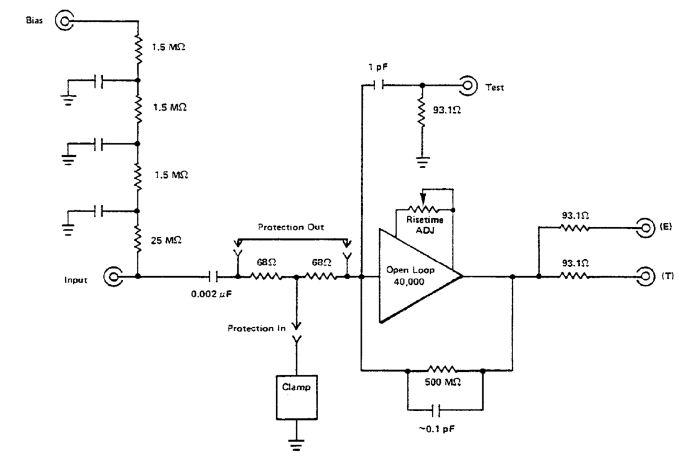

Figure 2. Preamplifier Circuit Diagram

This circuit was modeled using a trial version of the commercial circuit analysis program PSpice. Figure 3 shows the circuit used to analyze the response due to a particle detection using PSpice. This diagram is essentially the circuit shown in Figure 2 with the following exceptions:

1. A 0.1 pF parasitic capacitance on the unused test input is assumed.
2. A 20 pF capacitor is connected to the input emulating the capacitance of a detector readout strip.
3. A 1 M resistor to ground is connected to the input. This resistor emulates the 29.5 M resistance in the bias network. **Note: If bias is not required the ORTEC manual instructs users to short the bias input to ground.**
4. The event of a particle detection is modeled as a current pulse applied to the 20 pF capacitor representing the readout strip. The pulse is assumed to be 10 ns in duration with a 50 A amplitude. This amplitude is based on an average of 300 electrons released in the detector due to a Cd-109 radioactive decay photon. These electrons are multiplied by an assumed GEM gain of 10,000 so that 3 x 106 electrons are collected on the readout strip. The charge associated with these electrons is 1.6 x 10-19 x 3 x 106 = 4.8 x 10-13 coulombs. To assemble this charge in 10 ns requires a current of 48 A which has been rounded to 50 A.

Because of the lack of detailed information on the active components within the preamplifier circuit, a commercial integrated circuit amplifier having an FET front end was used in the PSpice analysis model. The part chosen for this amplifier was an Analog Devices AD845/AD[2]. The specifications for this amplifier initially appeared consistent with the active amplifier in the preamp. It has an FET front end, a 100 V/s slew rate, a 12.8 MHz unity gain bandwidth, and a 350 ns settling time to .01%. In addition to the functional connections, this amplifier has connections to adjust for DC offset in the output, but these connections were not used in this analysis resulting in an offset voltage in the computed output. But, as will be discussed later, this amplifier did not have sufficient bandwidth to reproduce test observations.

Attempts to find an amplifier with higher bandwidth and to use it to replace the AD845/AD were only partially successful. An Analog Devices AD825[3] amplifier with slightly higher bandwidth was found, but this amplifier did not have sufficient bandwidth either and the trial period ran out before it could be completely evaluated. Attempts to find additional amplifiers with significantly higher bandwidth were unsuccessful.



Figure 3. Analysis Model for Particle Detection

The analysis model for a test pulse input is shown in Figure 4. In place of the current pulse, the preamp is stimulated by a voltage pulse from a pulse generator with a 50  source impedance (the source impedance is not shown in this diagram). Note that only a small capacitor, C3, is required to couple the pulse generator to the amplifier while a large capacitor, C2, is required to couple the detector. A large value of C2 is required to insure the preamp doesn’t impact the detector readout. The amplitude and pulse width of the voltage pulse used in the analysis was selected to emulate values in the lab. Results were also computed when the active amplifier in this figure was replaced by an Analog Devices AD825. This amplifier has a greater bandwidth than the AD845/AD, but the results with this amplifier were roughly the same as with the AD845 part.



Figure 4. Analysis Model for Test Stimulation

# PSpice Results

In Figure 5 the output voltage of the preamp when stimulated by a 13 s pulse at the test input and computed using the AD845 part is displayed alongside the experimental result. In the experimental result shown on the right, the blue trace is the test input voltage from the pulse generator and the green trace is the output voltage of the preamplifier. The yellow trace is the output voltage of an amplifier attached to the preamplifier, however the amplifier response was not part of this evaluation. The left-hand figure shows the output voltage of the preamplifier computed using PSpice. This figure should be compared with the green trace in the experimental results. This comparison shows a significant difference between the computed and experimental results, primarily in the rate of output voltage transitions. Slow transitions in the computed response have been attributed to insufficient bandwidth of the AD845 amplifier relative to the actual bandwidth of the amplifier in the preamp. The voltage offset in the PSpice calculation is the result of the uncompensated offset built into the PSpice model of the amplifier. It should also be noted that in both the computed and experimental results the output voltage of the preamplifier is inverted from the input voltage. An inverting amplifier is necessary to enable the negative feedback that is required to stabilize the amplifier.

An AD825 amplifier with somewhat higher bandwidth was found and substituted for the AD845. The calculated result with this amplifier is compared with that for the AD845 in Figure 6. The AD825 amplifier is internally compensated for offset so for the purposes of comparison the offset of the AD845 was removed in this figure. Although the increased bandwidth reduced the transition times of the pulse response, the transition time is still significantly slower than that observed in the lab. It does, however, indicate that the amplifier bandwidth likely plays a dominant role in determining the transition times in the preamp circuit.

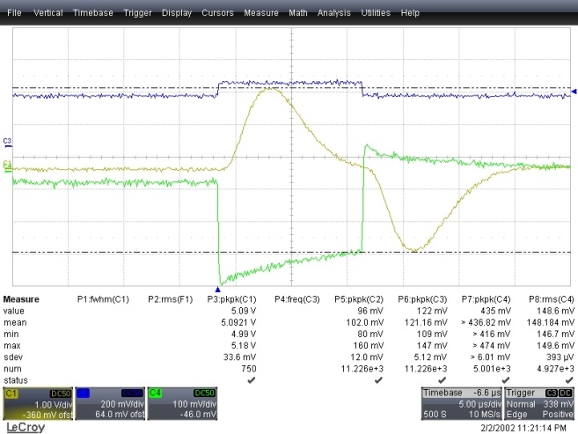Measured Scope Traces: green-preamp out, blue-test in, yellow-amplifier out

Figure 5. Comparison of Simulated and Experimental Result



Figure 6. Comparison of AD825 and AD845 Test Pulse Response

Unfortunately, the trial period of PSpice expired before the response of the preamp to a particle detection using the AD825 amplifier could be computed. The response computed using the AD845 amplifier is shown in Figure 7 below. The slow transition of the leading edge of this output reflects the insufficient bandwidth of the AD845 amplifier.



Figure 7. PSpice Calculated Preamp Response to Particle Detection

# Approximate Analysis

Because the detailed circuit of the active amplifier as part of the preamp circuit was unknown and the PSpice program required identifying a specific part for the active amplifier, an analysis capable of specifying the amplifier bandwidth was developed in an attempt to better predict the response of the preamp to a particle detection.

A reasonably accurate model the open loop gain of commercial operational amplifiers with FET inputs consists of an amplifier with high DC gain, infinite input impedance and zero output impedance that rolls off in frequency with a first order roll-off with the roll-off starting at a low break frequency. A circuit diagram illustrating this model is shown in Figure 8. In this figure the ideal amplifiers have infinite input impedance, zero output impedance and a given voltage gain. The roll-off break frequency is determined by the RC time constant of the low-pass filter between the 2 ideal amplifiers.

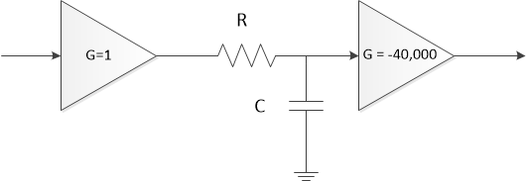

Figure 8. Ideal Op-Amp Model

For this approximation the circuit model of the active amplifier was defined to have a gain of −40,000 (the negative sign to account for the inverting nature of the amplifier) with a single pole low-pass filter having a 3-dB break frequency that can be specified.

The approach to analyzing the circuit was to describe the circuit as combinations of series and parallel impedances (specified as their Laplace transforms) and to combine these equivalent impedances in such a way as to cause the input voltage to the active amplifier component to be just a voltage division of the input voltage resulting from 2 impedances in series, with the output voltage to be the active amplifier transfer function times its input voltage. The step response (for the test input) or impulse response (for the detector input) was then found by computing the Inverse Laplace transform of the output voltage using Mathematica. The Mathematica scripts performing these calculations are shown as appendices 1 and 2.

## Comparison of PSpice and Approximate Analysis Results

This approximation approach, when the amplifier approximation bandwidth has been adjusted to match that of the PSpice part model, yields a reasonably close match to the results provided by PSpice. Figure 9 shows a comparison between the results from a PSpice calculation with an AD825 active amplifier and those of the approximate model. In each case the input to the preamp was a 100 mv pulse with a pulse width of 13 s. The main difference between the PSpice calculation and the approximate model calculation results is in the slight difference in pulse amplitude.

The results in this figure were computed with the 3 dB break frequency at an open loop gain of 40,000 set to 650 Hz. This is equivalent to a unity-gain bandwidth product of 26 MHz. This value was selected because the data sheet of the AD825 indicates a typical unity-gain bandwidth of 26 MHz.



Figure 9. Good Correlation Between Approximate and PSpice Analysis Results

The similarity of this approximation result to that of the PSpice model provides significant justification to using the approximate model for further predictions.

## Comparison of Approximate Model and Measured Results

Now that it has been shown that the approximate model does a reasonably good job of calculating the same results as the PSpice program, there is still a question as to how well the approximate model predicts the actual hardware performance. The answer to this question was evaluated by adjusting the break frequency of the active amplifier in the approximate model to match the transition times measured when a voltage pulse was applied to the test input of the preamp. The predicted and measured output waveforms could then be compared. A break frequency value of 3.5 kHz resulted in a good match with the measured results. This break frequency for the open loop gain of 40,000 is equivalent to a unity-gain bandwidth product of the active amplifier of 140 MHz.

Figure 10 shows the computed result overlaid on the oscilloscope trace. In this figure the green trace is the measured output voltage of the preamp, the yellow trace is the output voltage of the Mechatronics 519 Dual Amplifier which was not involved in this analysis, and the blue trace is the test input voltage. The red trace (it looks slightly orange in the figure) which generally follows the green trace is the computed value of the preamp output voltage. The main difference between the measured and predicted voltage is the overshoot and slow decay on the leading and trailing edges of the output pulse. This overshoot was not predicted by either the PSpice analysis or the approximate analysis and is likely part of a rise time compensation circuit in the amplifier that was mentioned in the preamp manual and whose adjustment is shown in the circuit diagram of Figure 2.

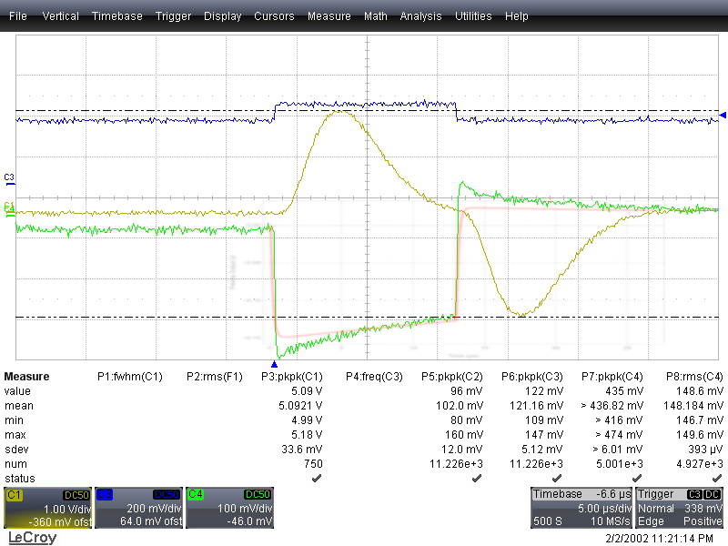  
Signal Traces: green-preamp out, blue-test in, yellow-amplifier out, red-computed result

Figure 10. Comparison of Approximate Analysis with Measurements

To attempt to understand if a simple modification of the active amplifier circuit could account for the difference in the computed and measured results, the amplifier output was connected to the circuit shown in Figure 11 and the response (compensated for a gain difference) of the modified circuit to the test pulse was compared to the measurements. Although it is doubtful that the actual circuit in the amplifier is the same as what was used in this computation, the response, shown in Figure 12, provides some justification for thinking that the shape of the measured test pulse response could be due in part to the rise time compensation circuit.

Figure 11.   
Assumed Output Circuit

Although not a perfect match to the measurements, the result is close enough to the measured results that there is a reasonable expectation that slight tweaking of the output circuit parameters would provide a closer fit of the computed output to the measurements. It bears repeating here that there is no reason to assume that the amplifier actually incorporates this output circuit. This circuit has been postulated merely to show that a simple modification of the amplifier circuit from that of an ideal operational amplifier is capable of producing the measured results.

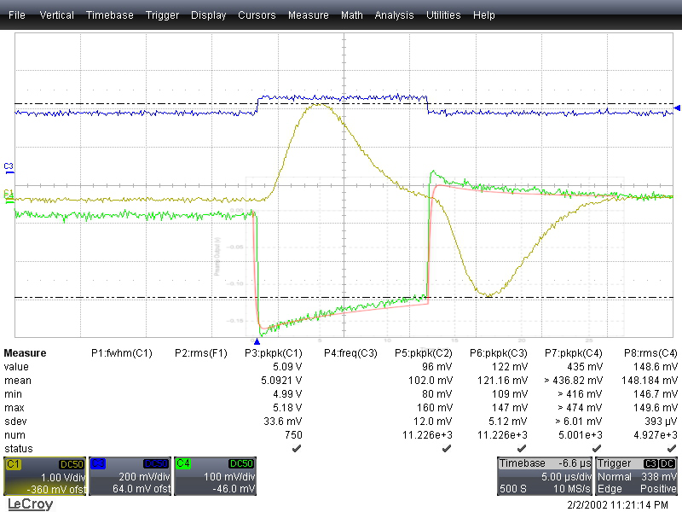  
Signal Traces: green-preamp out, blue-test in, yellow-amplifier out, red-computed result

Figure 12. Comparison of Modified Analysis Amplifier Output with Measured Output

# Approximation Model Response to Particle Detection

The primary motive of this analysis has been to predict the response of the preamplifier to a detected particle. The predicted response was computed using the circuit model described in Figure 3 above but with the active component replaced by the approximate amplifier model. Figure 13 shows the anticipated waveform out of the preamp, as modified by the output circuit of Figure 11, due to a detection and compares that with the predicted output had the circuit not been tweaked to more closely match the measured test input response. Other than a slight overshoot on the leading edge of the output pulse the two responses are pretty much identical. The 10% to 90% rise time of the leading edge of the output pulse is computed to be about 330 ns independent of whether the circuit of Figure 11 is included.



Figure 13. Predicted Output Due to Particle Detection

# Conclusion

A model capable of relatively accurately predicting the response of the preamplifier to a test pulse has been developed. Determining the accuracy of this model in predicting the response to a particle detection will be determined when particles are observed with the detector.

# Appendix 1 Test Input Analysis

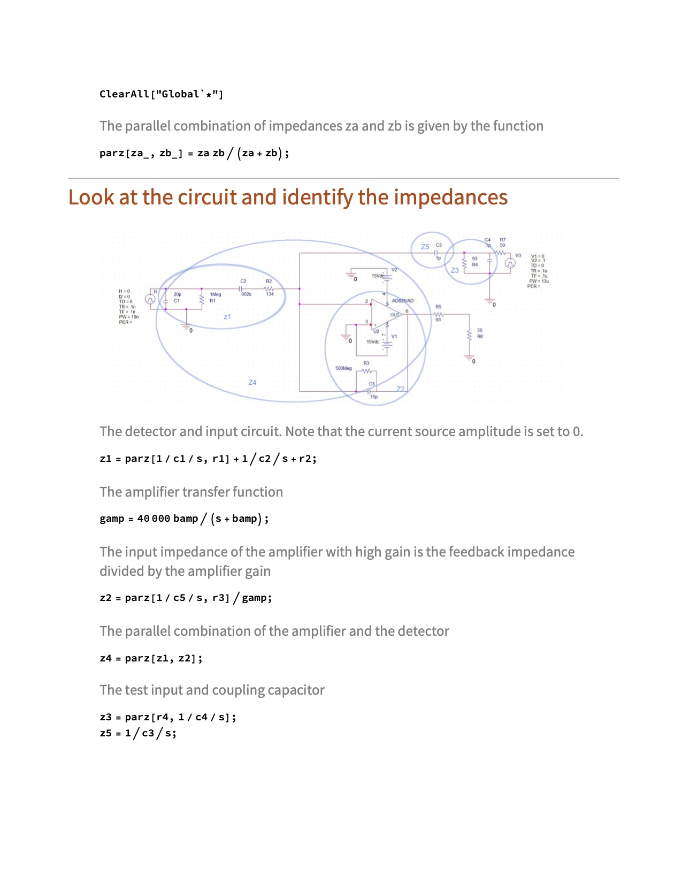

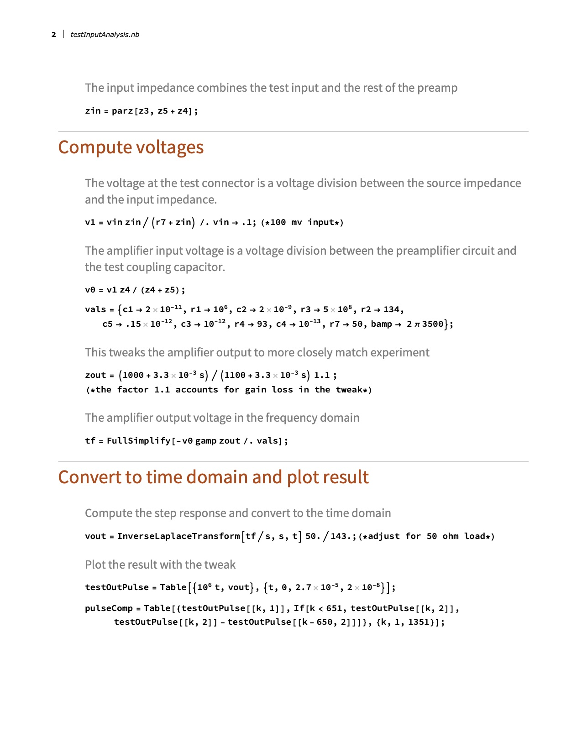

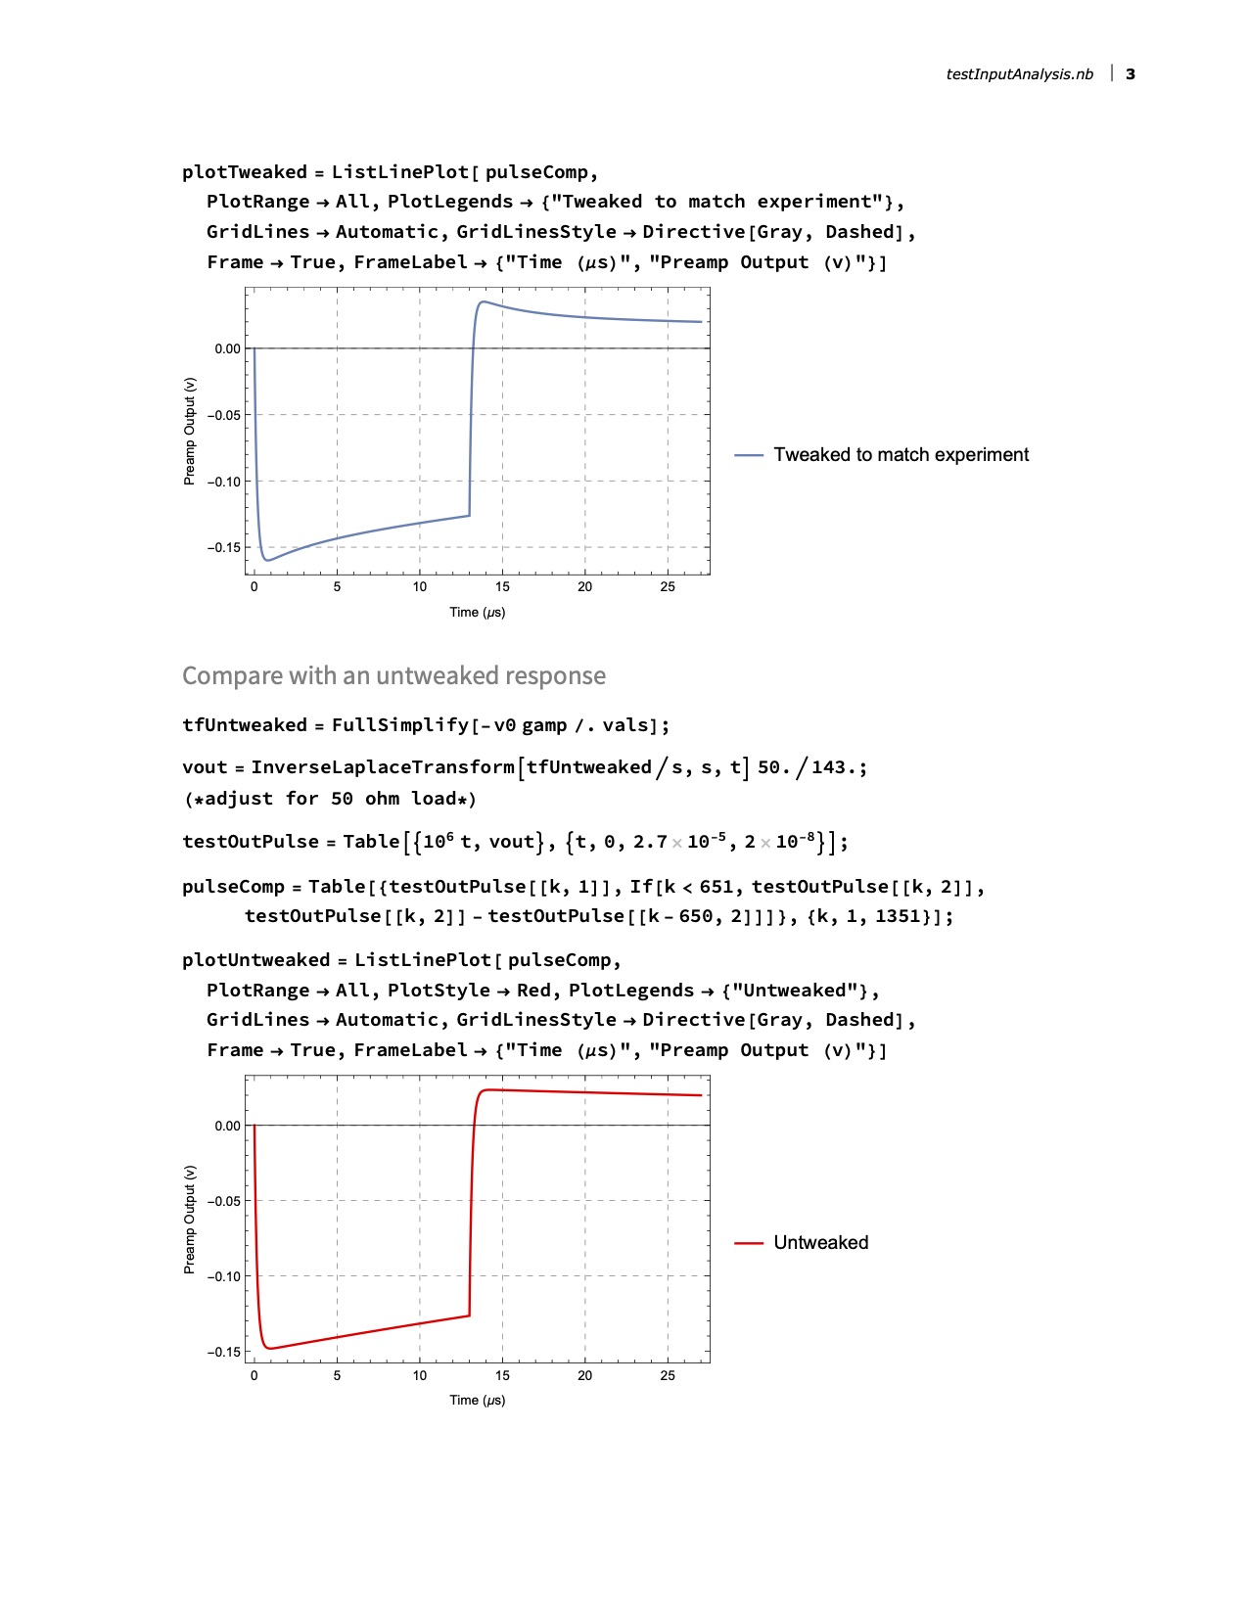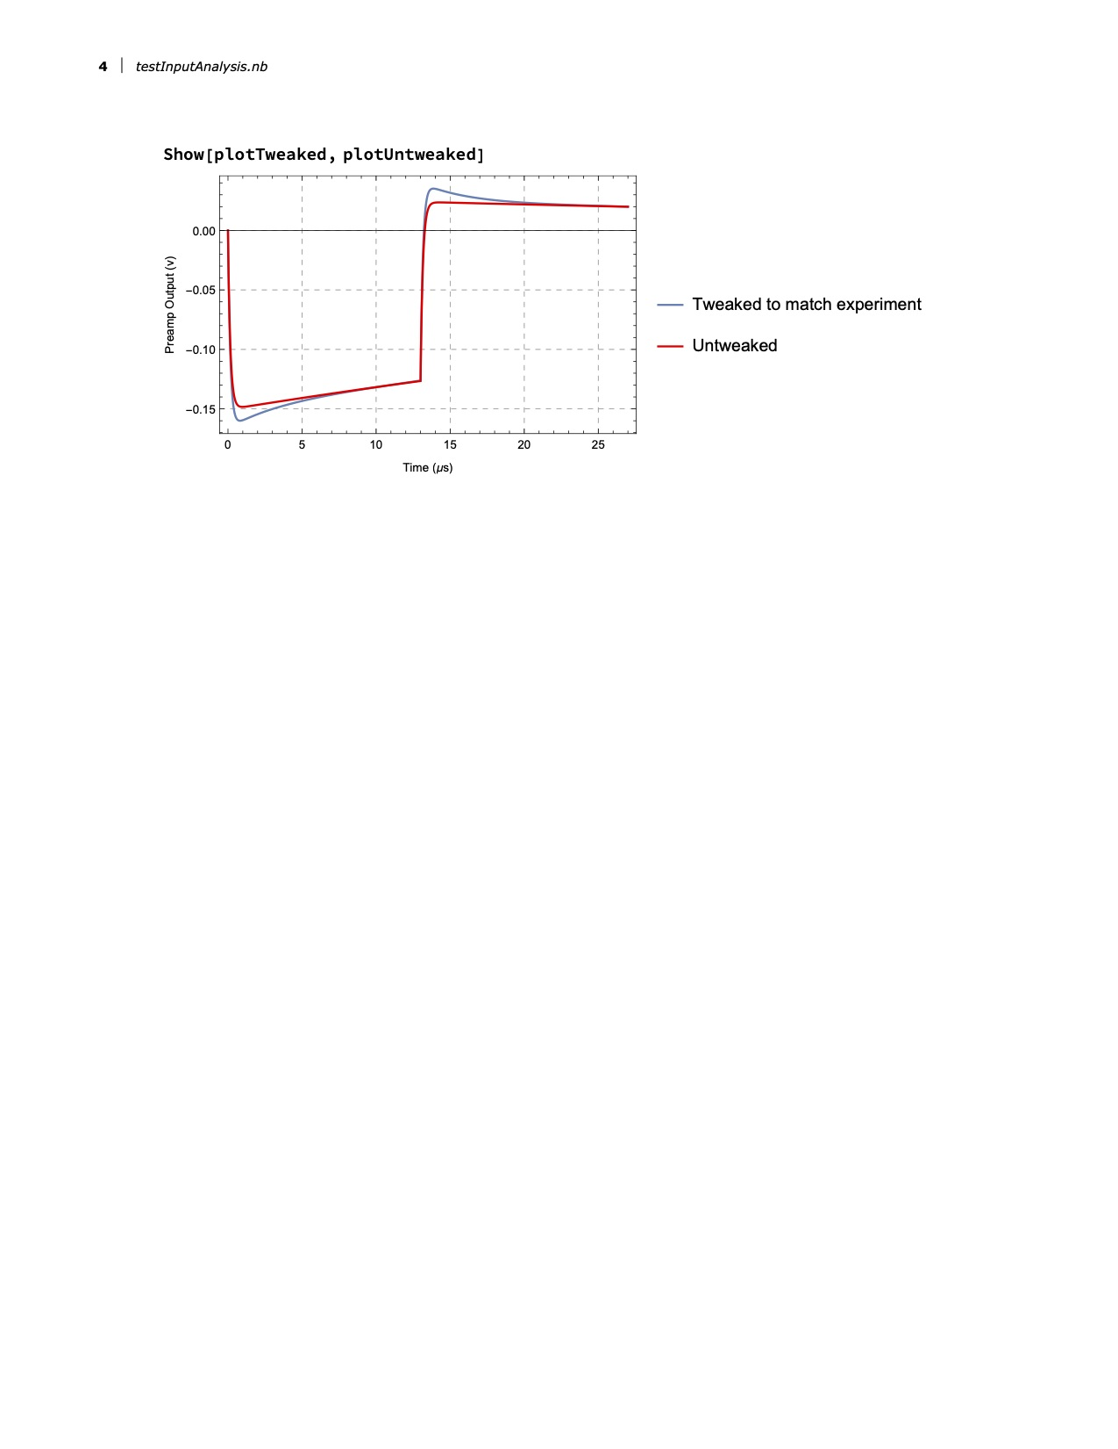

# Appendix 2 Detection Input Analysis

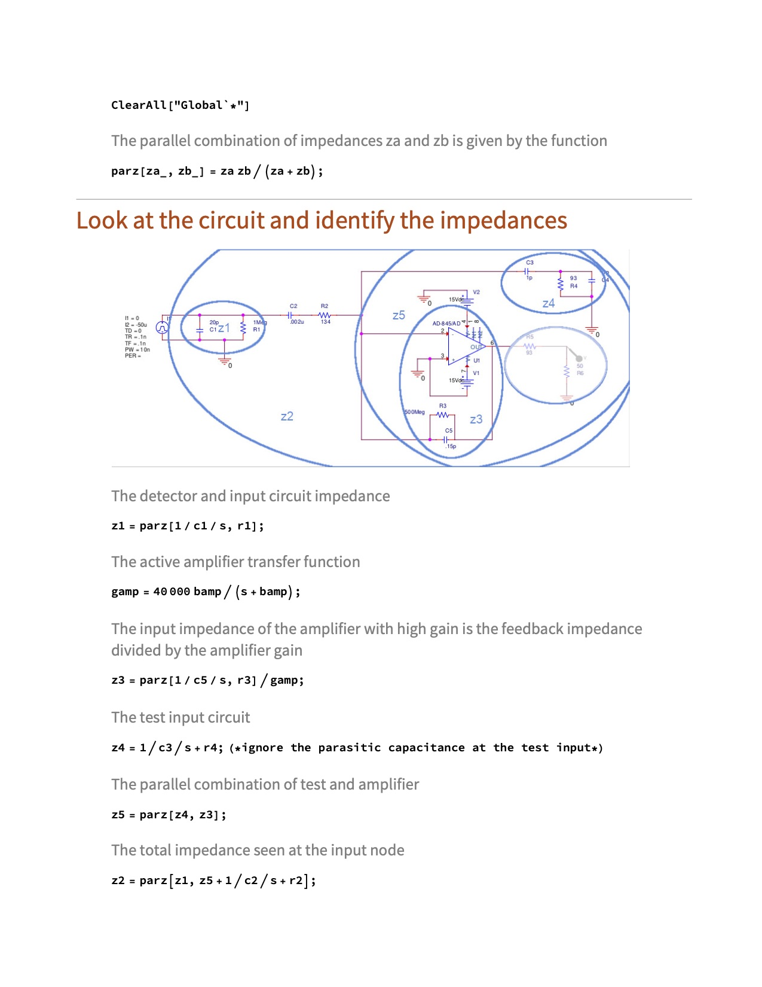

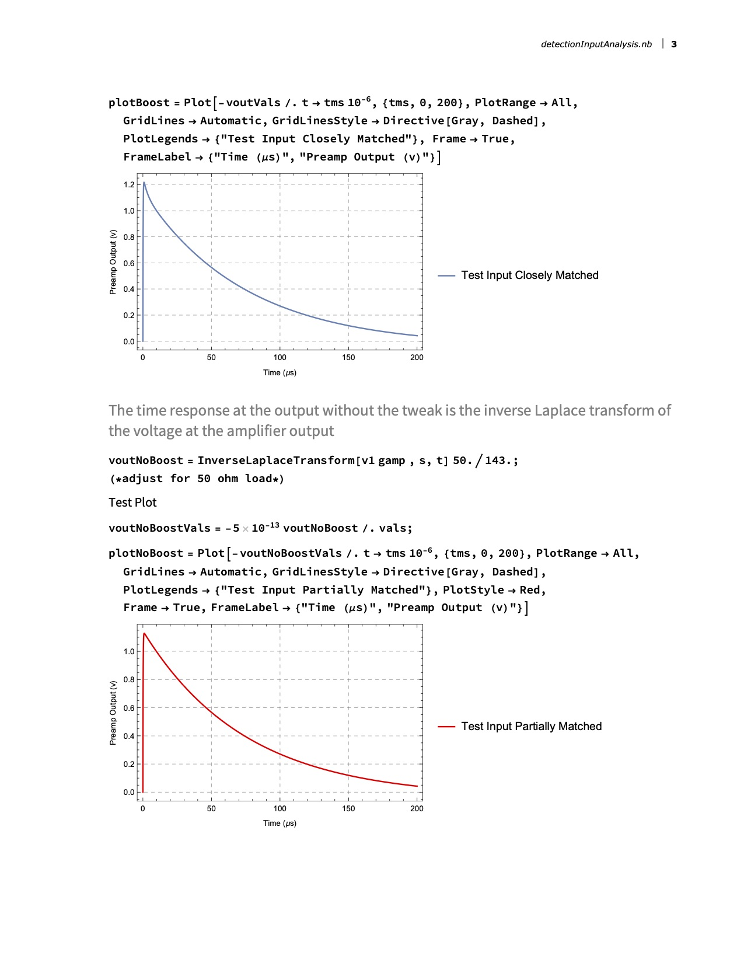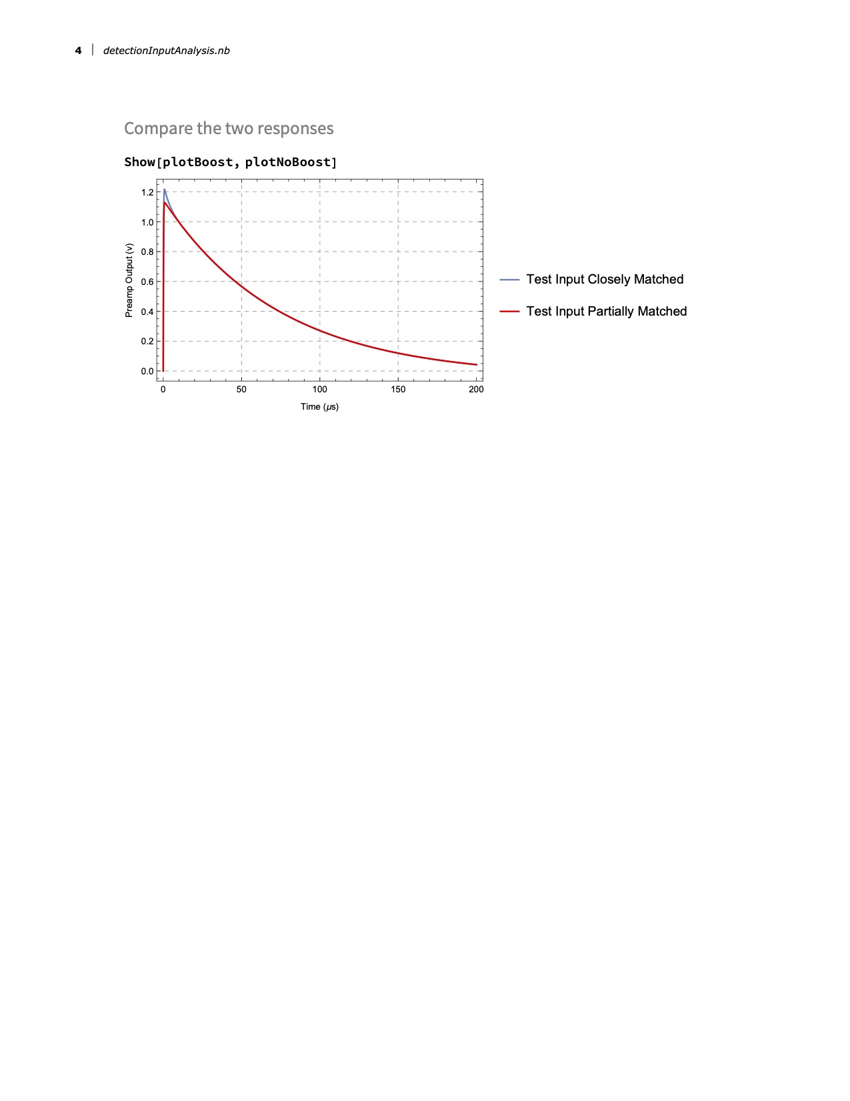

1. Model 142PC Preamplifier Operating and Service Manual, https://www.ortec-online.com/-/media/ametekortec/manuals/142pc-mnl.pdf
2. https://www.analog.com/media/en/technical-documentation/data-sheets/AD845.pdf
3. https://www.analog.com/media/en/technical-documentation/data-sheets/AD825.pdf