Zachary Paul
Dr. Hohlmann
In-Flight Radiation Detector
May 3, 2019
In-Flight Radiation Detector Testing
Introduction:
This current semester is a continuation of the project that had begun last semester, throughout the semester many issues were faced with noise masking signals on the scope throughout the semester. The issue was successfully resolved allowing for a more proper testing of Quality Control test 5. Before the noise was successfully reduced and the divider was confirmed to evenly distribute the voltage too each foil, effective gain measurements were tested though unsuccessful.

Discussion:
When testing first began with the effective gain measurement the tests were moving along successfully. After testing was finished for the day, Jerry had needed to use the LEMO cable as he also needed it for his own testing. Once done with his testing Jerry reconnected the cable back up to the In-Flight, though it no longer gave a reading on the scope; no discernable sinusoidal waves could be seen giving off the idea that something within the electronics was no longer working. An insulating polymer to see if it would reduce the electrical discharge that was also being seen on the scope reaching a level of up to 10 volts. While this issue has yet to be resolved it would seem that it does not cause any damage as the detector works properly and shows no physical signs of appearing as it has yet to be heard or seen especially since it has such a high rate of appearance it should have been noticed at least once. While waiting for the for the polymer three new stations were created for the other detectors as all the groups were reaching the same point of testing and too much clutter would be created if only one station was usable. The insulating polymer did not work but it was noticed that the possible noise issue may be due to the BNC cable was being used as that is the type of connection used for the pre-amp that was taken from the X-ray box that was being used for the In-Flight detector. After switching the connection to an SHV the noise (fig 1&2) was reduced significantly to a threshold of about 120mV. Testing for effective gain measurement was commenced in the final week of school, while some sinusoidal waves seemed to appear they were not at a high enough rate as they should have been even though the Strontium-90 source is perfectly fine. It was decided that stronger source would be needed to do get better results in effective gain measurement.

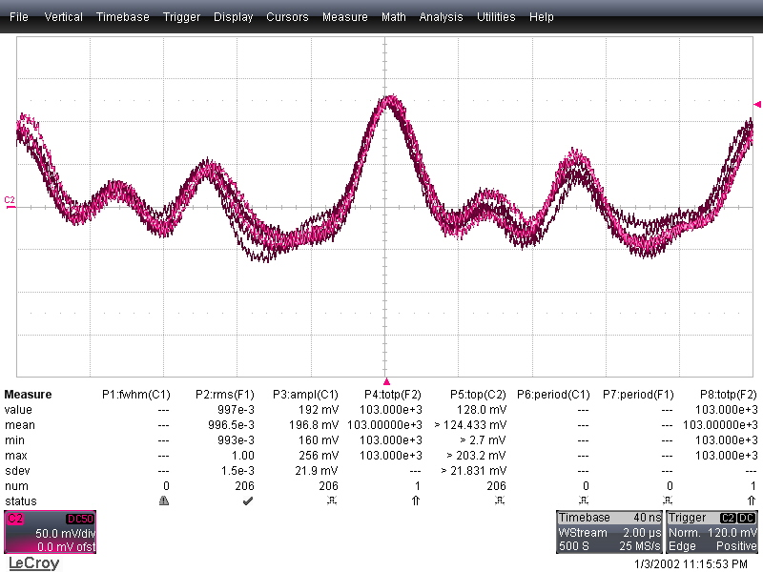
Figure 1: Reduced noise after switching to SHV

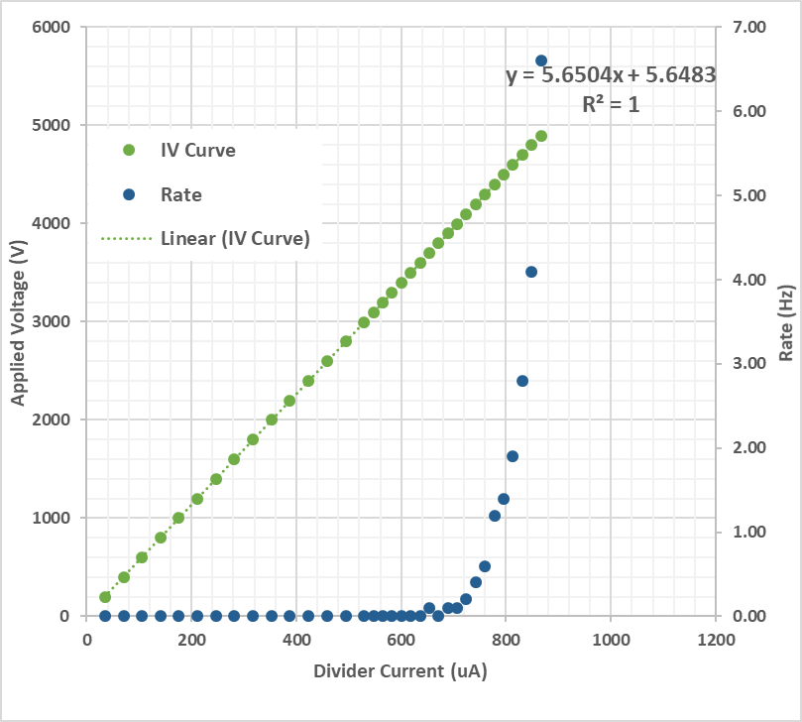
Figure 2: QC 4 test with SHV cable

