Restoring MTS Functionalities and Imaging Bone

Abstract:
This semester’s work is a continuation of the project to image bone. The main goals of this project were to restore the Muon Tomography Station (MTS) to working condition, confirm functionality by imaging a lead block that had been imaged several years ago in the MTS, and then to image bone. Previously, a routing error and power supply issues had been resolved, and the online processing issue had been determined to be a routing issue.
During a hiatus in the project, the power supply had been borrowed and a gas leak had developed. This semester, that power supply was reconnected to the MTS, the gas leak was fixed, and progress was made on the online processing. Plots were acquired, but an attempt to calibrate the Quarknet DAQ card was made to get better results. Difficulties with the EQUIP program and Raspberry Pi used to calibrate lead to this step being not yet being completed.
Future work should focus on finishing the calibration of the DAQ card and restoration of the MTS, then move onto the confirm functionality and imaging bone phases.

Background:
The work in this report is a continuation in the Imaging Bone with a Muon Tomography Station research in the Florida Tech Showcase. The objective of that research has been to return the Muon Tomography Station (MTS) to working condition, confirm the station was operational by imaging a lead block that had previously been successfully imaged, then image bone. Prior to this semester, some progress had been made in repairing the MTS, but that phase was not completed. A routing error with the Front-End Converters (FECs) had been resolved along with a hardware issue with the power supply, and the online analysis problem had been narrowed down to a potential routing error. During a semester of inactivity, the power supply had been borrowed and had its polarity reversed and the gas output failed to increase with gas input, indicating a leak. As a result, the tasks in the repairing the MTS included:
- Repair the gas leak.
- Returning the power supply to working form.
- Resolving the online processing problems.
- Reintegrate the oxygen-meter into the tubing.
If these tasks got resolved, the intension was then to move onto the stages of confirming functionality and imaging bone.

Progress:
- Repair the gas leak.
The potential reasons for no gas output were either a snag in the tubing or a leak somewhere. To check for a snag, the tubing was visually checked, and the GEMs were observed to see if there was any bulging. After no snags or bulging was located, it was determined that there had to be a leak. The connections in the tubing between the inflow meter and the MTS as well as the tubing between the outflow meter and the MTS were undone and retightened. After this was done, the inflow was set to 53mL/min and the outflow eventually reached 19mL/min. While 64% of the air was still leaking, there was a significant outflow.
- Returning the power supply to working form.
The CAEN power supply was located, and the polarity was returned to normal. The supply was then returned to the power crate. After pumping gas through the MTS and ramping up to a low voltage of 2V, the polarity switch was confirmed. Prior to checking the voltage, Minicom (the program used to control the voltage) was not able to communicate to the power supply. This issue was resolved by plugging in the connection to the DATE PC, which had Minicom, into a different USB port, then reducing the BPS being used to communicate. In case of a similar issue in the future, the procedure to reduce the BPS was added to the Grand Procedures List on the DATE PC.

- Resolving the online processing problems.
Using the procedures written in the Grand Procedures List, a successful attempt to obtain plots was made. It is not clear why previous attempts failed, because they had in theory been using the same procedures. The plots, which can be seen in figures 1-6, were not the best quality.
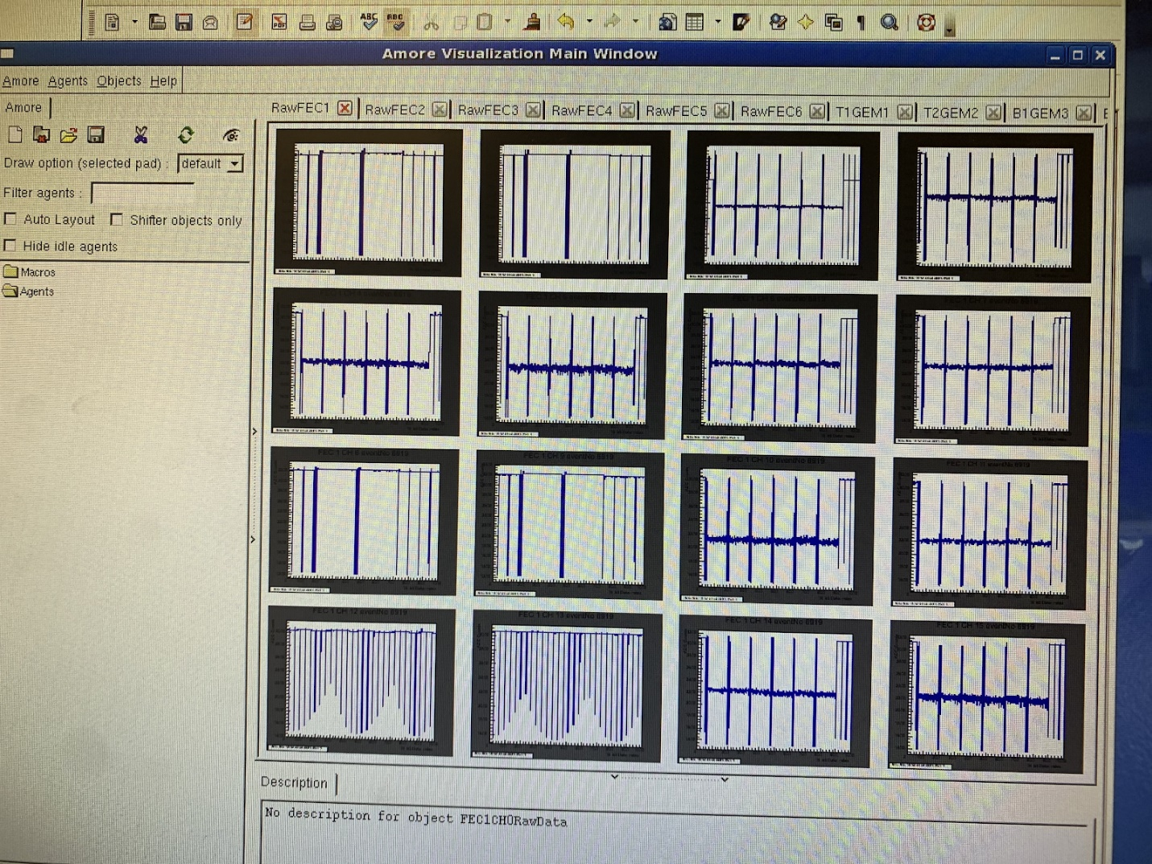
Figure 1: A picture of pedestal plots from FEC 1.
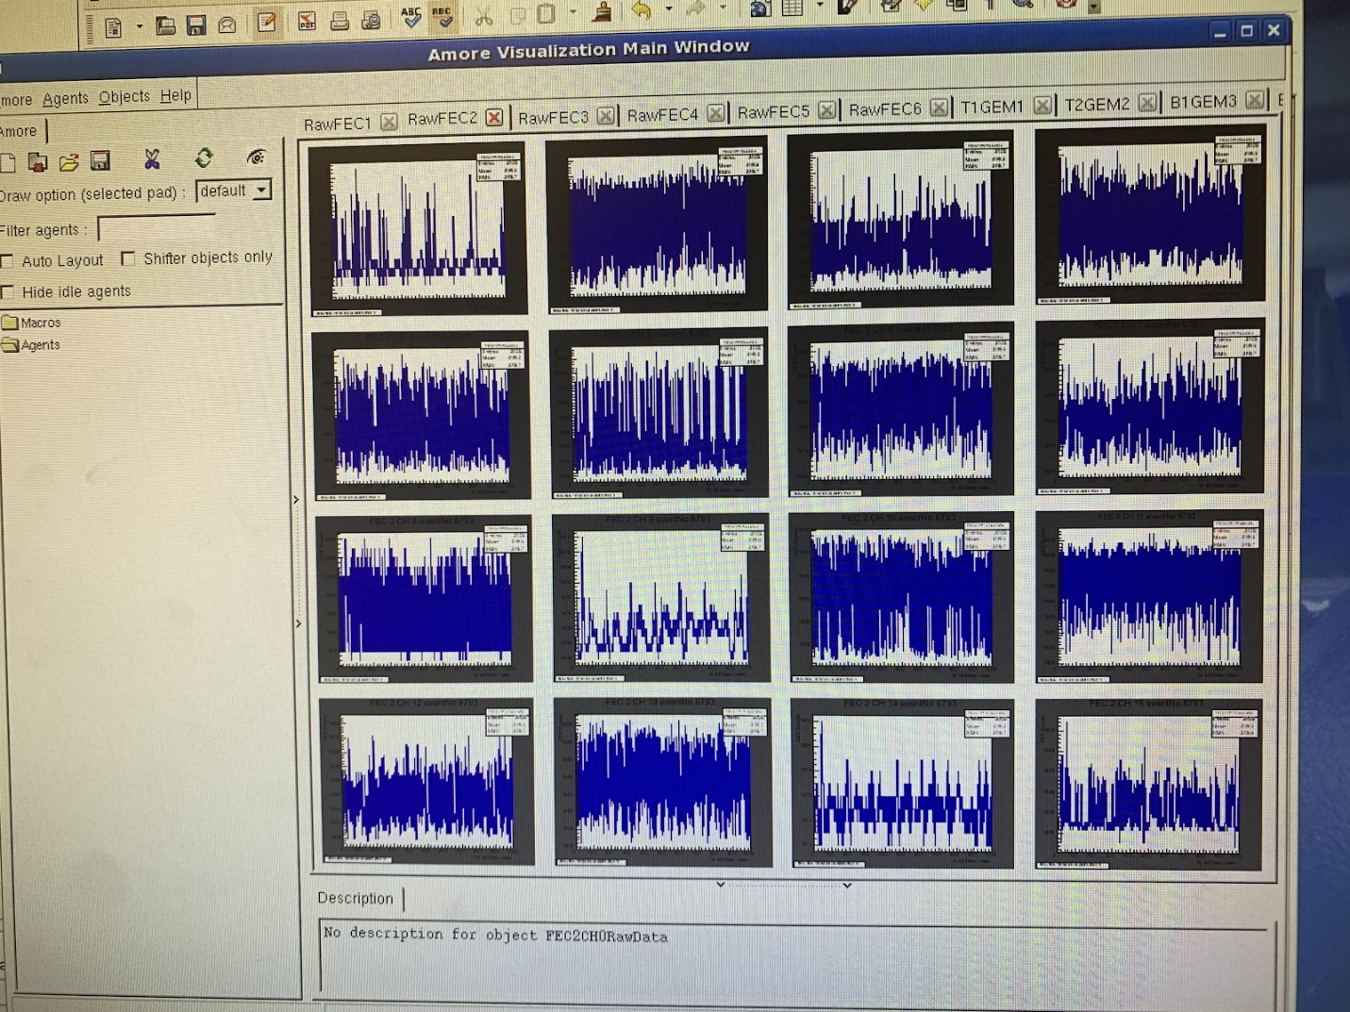
Figure 2: A picture of pedestal plots from FEC 2.
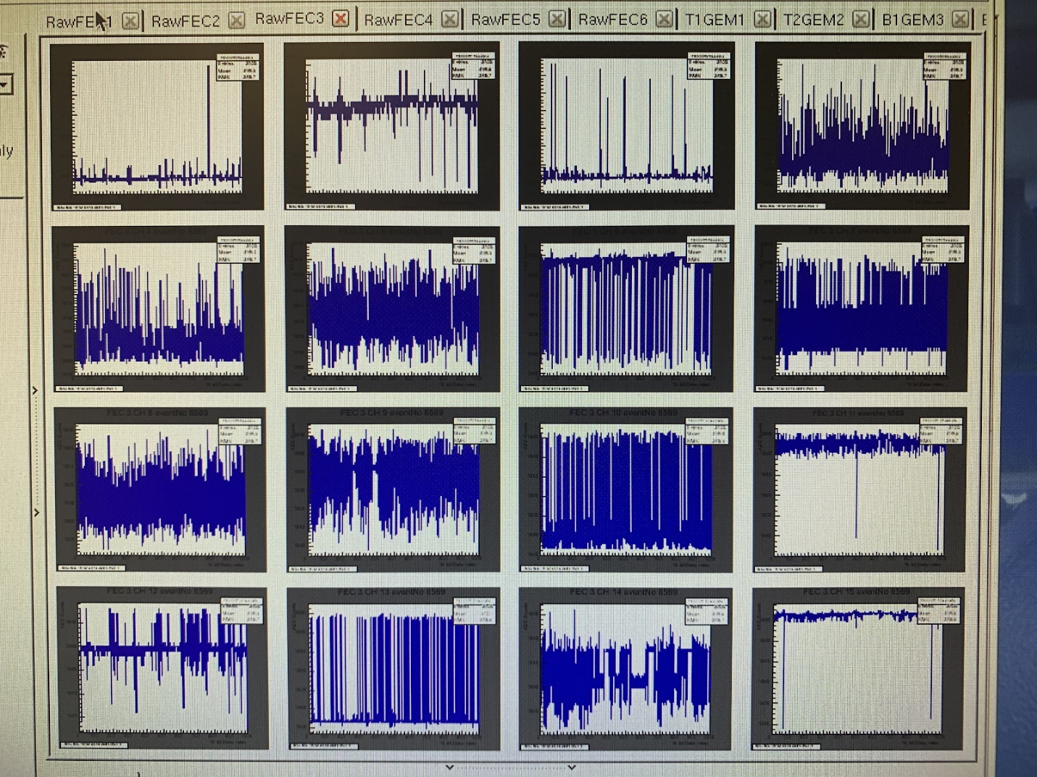
Figure 3: A picture of pedestal plots from FEC 3.
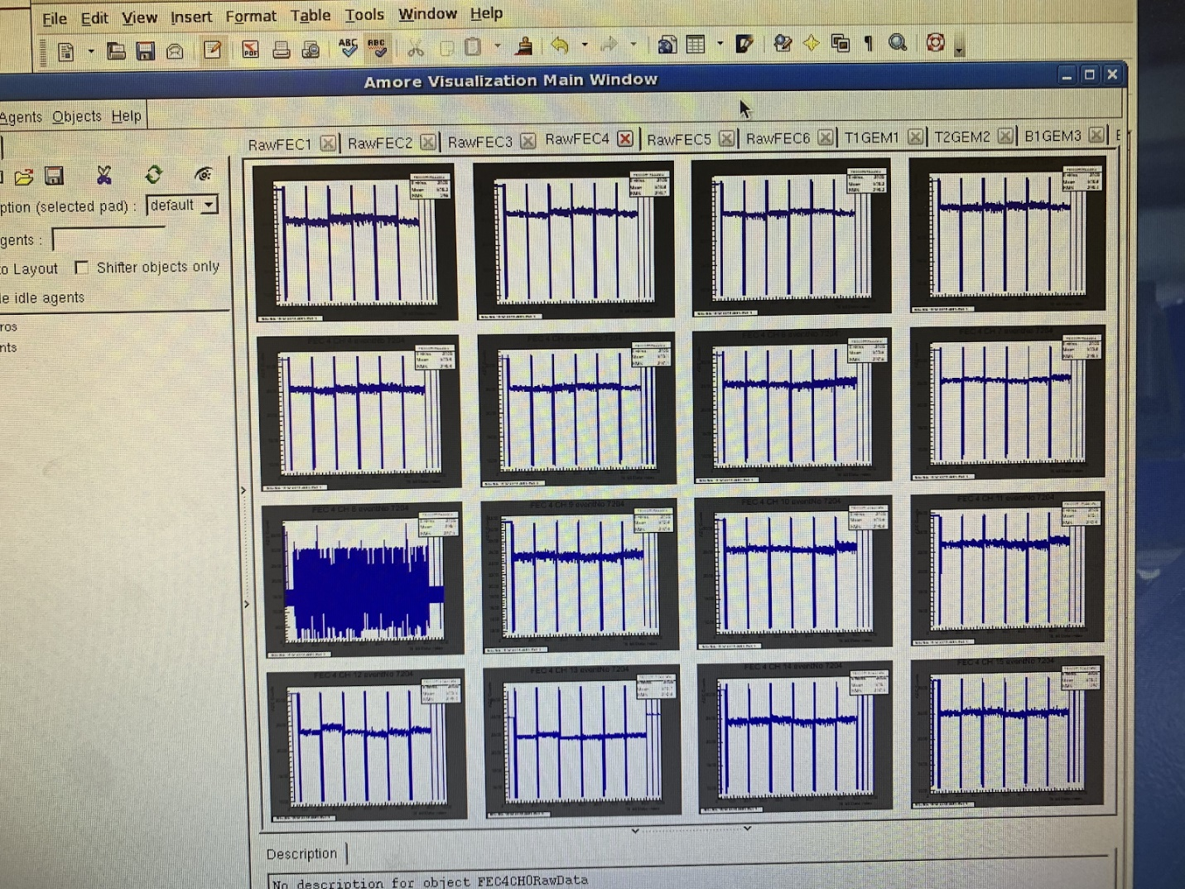
Figure 4: A picture of pedestal plots from FEC4.
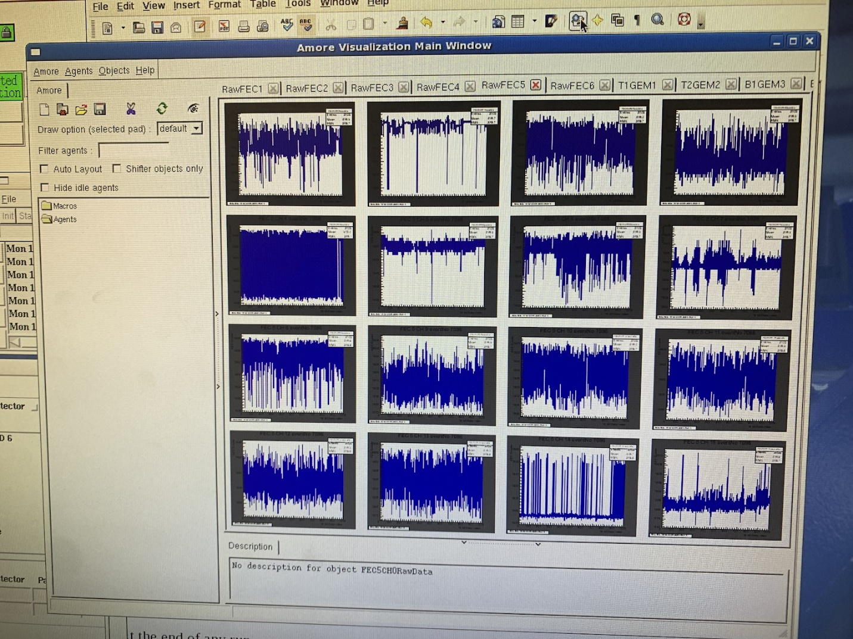
Figure 5: A picture of pedestal plots from FEC5.
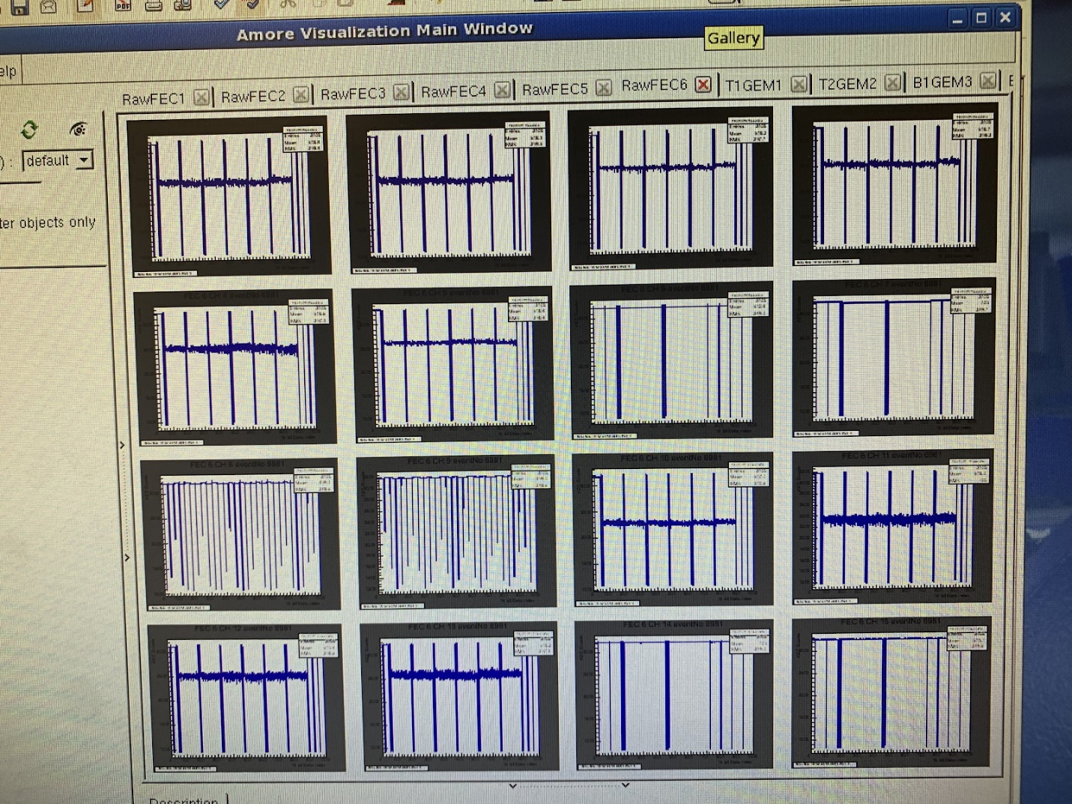
Figure 6: A picture of pedestal plots from FEC6.

As a result, an attempt to calibrate the Quarknet DAQ card was made. After some difficulty finding the procedure to start EQUIP (a program required in the calibration process), the program was successfully started, and procedures were added to the Grand Procedures List. However, to calibrate, the rates for each channel are needed from EQUIP, and the rates and coincidences were not showing. The Raspberry Pi stated that there is an issue with the COM port connection, and the DAQ card was not attached to a GPS receiver. Either of these factors could be responsible for the issue.

- Reintegrate the oxygen-meter into the tubing.
Not a lot of progress was made towards this task, but the core for the oxygen-meter was determined to be dead.

Future Work:
Most of the future work that should be done is in returning the MTS to a working condition. This should be done by reconnecting a GPS to the Quarknet DAQ card, solving the COM port error on the Raspberry Pi, and resolving the rate display issue with EQUIP. After this has been completed, the DAQ card should be calibrated, and new plots should be taken and analyzed to see if they are good.
After the restoration of the MTS to working condition, the next step would be to image a lead block to demonstrate functionality, and then to image bone.

