EMU COCOA ALIGNMENT

SLM 2-5 geometry and DCOPS data analysis

By Gyongyi Baksay

Florida Tech
December 9, 2006

This is a brief summary of the work that incorporates:

1) Geometry for ME+2 SLM 2-5
2) Cocoa fits for MTCC2 B=0T and B=3.8 T data
3) CMSSW and COCOA related information

The goal was to compare COCOA fitted values to theoretical and measured Photogrammetry (PG) coordinates in the CMS coordinate system to validate COCOA geometry and transformations. Preliminary results for ME+2 SLM 2-5 DCOPS data from MTCC2 at B=0 T and B=3.8 T are also provided.

Geometry for ME+2 SLM 2-5

The current setup uses DCOPS sensors (Figure 1) to measure displacements of the ME+2 chambers (CSCs) in CMS Z and RPhi directions.

The nominal coordinates of the SLM objects are provided from CAD drawings. These are introduced by hand in the COCOA System Description File (SDF) file; see Appendix A. There are two important considerations that one must take into account:

  - coordinates must be provided in the appropriate local reference frames
  - one must understand coordinate transformations from one local reference frame to another

- Hierarchical local reference frames (also called parent reference systems) used in the SLM 2-5 COCOA setup are:

CMS, SLM line, Transfer Plate, Long Chamber ME+2-(2), Short Chamber ME+2-(1)

COCOA objects (“children”) defined in these parent reference frames are shown in Table 1 and Figure 2. The old COCOA System Description File was modified according to up-to-date CAD drawings; see Appendix B. New objects included in the system hierarchy are in blue and italics.

Notations for chambers:
ME+2 =YE+2 disk (there are a total of 8 EMU disks, 4 on the positive and 4 on the negative side of the Z_{CMS} axis)
    - = inner chamber
    - = outer chamber
14, 04, 27, 08 are the chamber numbers on SLM 2-5.

There are two DCOPS and two alignment pins defined on each chamber. At the two ends of the SLM line (point 2 and point 5) there are two transfer plates. On each transfer plate there are 2 DCOPS: reference and transfer. Transfer DCOPS geometry is included to make connection with the other transfer line DCOPS sensors. These will be integrated at a later phase of the program development. In the current setup transfer DCOPS (on the transfer plate) do not affect COCOA measurements. The lasers are also defined on the transfer plates.

Chamber positions in the SLM reference frame are defined by chamber centers. This point is defined on the centerline connecting the two alignment pins (A-pins); see Figure 3.

An example for coordinate system transformations from ME+2(1)-10 to SLM 1-4 and from CMS to SLM 1-4 is shown in Figure 4. The reason for showing SLM 1-4 instead of SLM 2-5 is simply because it was easier to illustrate. Rotations of all the SLM lines (SLM 1-4, SLM 2-5, SLM 3-6) are the same around X_{CMS} (-90 deg) and Y_{CMS} (0 deg). They differ only in their rotations around the Z_{CMS} axis. SLM 1-4, SLM 2-5, and SLM 3-6 rotations around Z_{CMS} are 15 deg, 255 deg, and 135 deg, respectively. DCOPS coordinate system and readout vector orientations are also shown at the bottom right hand corner of Figure 4. This is discussed in more details in section 2).

Alignment pins:

In COCOA alignment pins (A-pins) are defined as points on the surface and the centerline of the CSC cathode strip panel. The CSC is treated as a rigid object. A-pin center coordinates (0, 0, Z_{CSC}) are referenced to the CSC coordinate system with origin in the CSC center. The distances from the chamber center to the two A-pins are not equal. Outer and inner alignment pin Z_{CSC} coordinates (Reference 9) for outer and inner chambers are:

Outer pin ME+2(2) Z_{CSC} = +1655.191 [mm] Inner Pin ME+2(2) Z_{CSC} = -1635.887 [mm]
Outer pin ME+2(1) Z_{CSC} = +988.187 [mm] Inner Pin ME+2(1) Z_{CSC}= -968.883 [mm]

A-pin coordinate system and CSC reference system orientations are the same. To compare COCOA fitted values to PG theoretical (CAD) coordinates the distance from the top surface of the CSCs to the top of the alignment pins (Y_{CSC} coordinate) has to be measured and included in the COCOA system description file, Reference [2]. This was not determined yet because there were small discrepancies between different CAD drawings that must be understood first.

PG measurements provide coordinates for the position of PG targets at varying distances from the surface of the CSCs. The reason for this variation is the following: Alignment pins have a snap ring, which registers against the bottom (of seven) panels that make up a chamber. So it is the bottom face (against the iron) that has a very precise relation to the END of the alignment pin that sticks out the TOP of the CSCs (8.70 inches). There is some variation in CSC stackup thickness so there is some variation between the top of the pin and the top of CSCs, Reference [9].

PG target measurements are referenced to the center of the YE+2 disk positioned at 8820.00 mm along the CMS Z axis. ME+2(2) outer and inner A-pins and ME+2(1) outer A- pins have a 20 mm long extension plus a 3 mm PG target mounted to the TOP pins. Inner A-pins on ME+2(1) chambers have only a 3 mm PG target (without extensions). An example is shown in Figure 5.

An example for coordinate system transformations from Transfer plates (at Point 2 and 5) to SLM 2-5 is shown in Figure 6.

COCOA objects can be defined “fix”, “calibrated” or “unknown” in the SDF.

Fix coordinates: are those that do not depend on any other coordinates.
An example in the current setup is the SLM line center coordinates. In COCOA these coordinates are defined fix, because this is the reference system that does not depend on the movement of any other objects from the system tree.

Calibrated coordinates: For COCOA, calibrated value means that center and angle coordinates can be moved within calibration errors. Examples are the DCOPS. The origin of the DCOPS reference system is the dowel pin in the chamber reference system, Figure 7. The first pixel of each CCD is at a certain distance from the reference dowel pin, Table 2. This distance must be introduced as an additional parameter (“entry parameter”) in COCOA. This parameter will be added to the distance of the reference dowel pin from the chamber center. Calibration uncertainties also have to be introduced. In general every time a new measurement is available this has to be updated or added to the system description file.

Unknown coordinates: are those that are determined from the COCOA fits. Examples are the chamber center positions and angle between crosshair-laser axes.

The lasers were defined on the transfer plates to take into account movements of this object together with the transfer plate. The transfer plate and the laser positions are both calibrated quantities. This means that the laser is basically moving only within the errors that are provided as calibration errors.

The chamber is a rigid object. When DCOPS move (CCD reading changes) then also the chamber center moves. For the present DCOPS analysis I used the laser as a reference (calibrated coordinates) so we can compare movements of the chamber centers for B=0T data (Appendix C) and B=3.8 T data (Appendix D) relative to the ideal laser center position 14.329 mm (Appendix E).

Nominal coordinates for COCOA objects (CSC center, DCOPS reference dowel pins, alignment pins, transfer plate center) are provided by D. Eartly. Coordinates for transfer plate objects were obtained from Transfer Plate drawings, Reference [3]. All of these coordinates are included in the COCOA SDF file, Reference [2].

2) Results from COCOA fits for B=0T and B=3.8 T data

The first step was to run COCOA on ideal measured values (laser center considered at the center of each CCD at 14.329 mm). In the measurement section of the COCOA SDF file CCD laser positions and uncertainties are read in a certain order. Notations in the COCOA SDF “measurement” section are:

U laser position error
D laser position error
L laser position error
R laser position error

U=Up, D=Down, L=Left, R=Right

CERN conventions for CCD names are CCD1, CCD2, CCD3 & CCD4 (and CCD0, CCD1, CCD2, CCD3). One must know the correspondence between these CCD names.

The conclusion from Figure 7, Reference [4], and [5] is that:

CCD1 =U
CCD3 =D
CCD4 =L
CCD2 =R

J. Bellinger (Univ. of Wisconsin) provided laser center positions in pixels. These are converted to [mm] (using 1 pixel =14.0 μm without applying calibrations for individual DCOPS). The number of pixels on a CCD is 2048 pixels =28672 μm. For bad CCD readings (negative or zero values) zero values are introduced for the laser center positions. Uncertainties are made equal to the distance form the first to the last pixel of the CCDs (28672 μm).

These DCOPS data in COCOA text format are shown in App.C (B=0T taken on Oct 31, 2006) and App.D (B=3.8T taken on Oct 25, 2006).

To get COCOA fits with ideal laser center positions (this will be called “simulation” from here on) the following measured values are introduced for each CCD, Reference [6]:

CCD laser center [mm] uncertainty [μm]

U 14.329 14.
D 14.329 14.
L 14.329 14.
R 14.329 14.

Fit results

a) Fits using ideal laser center positions (simulation)

With the correct nominal CAD values and coordinate transformations COCOA fits should provide global CMS coordinates that are comparable (or equal) to theoretical CMS CAD coordinates (CMS coordinates taken directly from CAD drawings, by D. Eartly); see comparison in Table 3. COCOA fitted values are provided for both chamber centers and alignment pins. Theoretical CAD coordinates are provided only for the alignment pins; these were not measured for chamber centers. In general differences between COCOA fits for ideal laser center values (Appendix E) and Theoretical CAD coordinates are very small. All the fitted COCOA values correspond to theoretical CAD values except for 2 alignment pins: apin_inner+22_27 and apin_inner+22_08 (red color). Although these coordinates do not affect the validity of COCOA geometry and its transformations these “two” alignment pin coordinates shall be verified. (Note: Z_{CSC} for apin_inner+22_27 and for apin_inner+22_08 are the same; one CAD drawing was used to measure the inner a-pin position on the long chamber ME+2(2), Reference [9])

b) Fits using MTCC2 data

Measured laser center positions and their associated errors for B=0 T and B=3.8 T are in Appendix C and D. These are measurements provided by 10 DCOPS (2 reference and 8 chamber DCOPS) on the SLM 2-5 line with two crosshair lasers pointing towards the DCOPS from the two ends of the SLM. CCD1 (Up) and CCD3 (Down) measure along the RPhi_{CMS} direction and CCD2 (Right) and CCD4 (Left) measure along the Z_{CMS} direction, see Figure 1. To obtain COCOA fitted values from these measurements one has to run COCOA with the same nominal CAD geometry (already used for the simulation) and replace ideal laser positions (Appendix E) with real measured values (Appendix C and D).

Figure 8 shows projections of fitted chamber center positions in the SLM X-Y plane. Uncertainties on these positions for B=0 T & B=3.8 T data are ~ 0.4 mm in Y_{SLM} ( = Z_{CMS}) direction. Laser center positions on CCDs for both (inner and outer) DCOPS on ME+2(2)-08 (at X_{SLM} = 5225.85 mm) for B=0 T data have large uncertainties as shown in Table 4. COCOA could not provide a good fit in this case. The error bar for the B=0T data point (for ME+2(2)-08 center) reflects only the uncertainty for the displacement in the Y_{SLM} direction (Y_{SLM}=-82.275 ± 0.505 mm). The rotations and corresponding uncertainties are shown below:

ME+2(2)-08 rotations:

Cocoa fitted value [deg] ± [μrad] Initial value [deg] ± [μrad] COCOA fitted – Initial [deg]
X_{SLM} = -29.114249 ± 14542.414 0 ± 100 DIFF= -29.114
Y_{SLM} = -83.791479 ± 889.24428 -85 ± 100 DIFF= 1.208
Z_{SLM} = 28.848719 ± 14463.329 0 ± 100 DIFF= 28.848

These rotations are not fully understood yet. They might be also caused by the large uncertainties on measured laser center positions.

In the COCOA file chamber centers (nominal values) are defined at a distance of Y_{SLM} = –93.35 mm from the SLM line center, see Figure 8. COCOA simulation shows that these points are all aligned; the laser line goes straight through the centers of the DCOPS. The projection of chamber centers in SLM X-Y plane is along a straight line. This is shown also in Figure 9.

Displacements from the ideal (nominal) positions can be observed for both B=0T and B=3.8 T data. COCOA shows that the real positions (at B=0T) of the chamber centers are shifted from the Y_{SLM}= –93.35 mm positions. B=0 T data can be understood only if Table 3 will be completed with the Z_{CMS} coordinate (Y_{SLM} direction). Also, if the various sizes of shims will be introduced in the simulation one will get a more realistic picture about placement of the chambers. B=3.8 T data shows displacements in the negative Y_{SLM} (Z_{CMS} direction). The center of the disk is pushed outward and the edges pulled inward. This kind of behavior is expected when the magnetic field is turned on.

Figure 10 shows projections of chamber center positions in the SLM X-Z plane (RPhi_{CMS} plane) with uncertainties of ~ 0.2 mm. Short (inner) chamber center nominal value (ideal laser position) is Z_{SLM} =118.164 mm. Long (outer) chamber center nominal value is Z_{SLM}=157.202 mm. Real positions are represented by B=0T data. When the magnetic field is turned on (B=3.8 T) an unexpectedly large movement in Z_{SLM} direction relative to B=0T data is seen. The reason for this displacement must be further investigated.

Comparison of COCOA fitted values for B=0T data with PG measured values (B=0T) are shown in Table 5. The discrepancies between the two value sets are evident. The cause for this discrepancy should be further investigated.

Comparison of COCOA fitted values for B=0T data and B=3.8T data in the CMS coordinate system is shown in Table 6. ME+2(2)-08, apin_inner+22_08, apin_outer+22_08 and apin_inner+22_07 center values cannot be trusted for reasons described before.

Summary of things that should be done to get a more complete picture about B=0 T and B=3.8 T measurements:

- Introduce shim sizes into the COCOA SDF file;
- Check inner alignment pin Z_{CSC} position for ME+2(2);
- Measure alignment pin Y_{CSC} coordinate (i.e. Z_{CMS}) in the CSC coordinate system;
- Compare COCOA fitted alignment pin Z_{CMS} coordinates (nominal) with theoretical CAD CMS coordinates;
- Compare COCOA fitted alignment pin Z_{CMS} coordinates (B=0T) with PG measured (B=0T) CMS coordinates;
- Analyze at least one more set of B=0 T and B=3.8 T data with better CCD readings than the one used in the present work (smaller errors on laser center positions);
- From 4) derive an error analysis of laser center positions. One has to know how much are chamber center positions affected by laser center uncertainties. This should also help to understand results from Table 4.

References
[1] http://home.fnal.gov/~maeshima/alignment/COCOA/sample_scripts/me2-2_dist.txt
[2] http://research.fit.edu/hep/documents/ME2_SLM25.txt
[3] ftp://www-ppd.fnal.gov/cms_ftp/CMSEMUalign/Dave2004/ME2,%20ME3%20TP%20Assy/
[4] http://cmsdoc.cern.ch/cms/MUON/alignment/software/COCOA/doc/basic_objects.html
[5] http://research.fit.edu/hep/documents/RLee_Thesis.pdf
[6] http://research.fit.edu/hep/documents/slm_simu.txt
[7] http://research.fit.edu/hep/slm25_b0t_data.txt
[8] http://research.fit.edu/hep/slm25_b4t_data.txt
[9] Dave Earty (Fermi National Laboratory), private communication
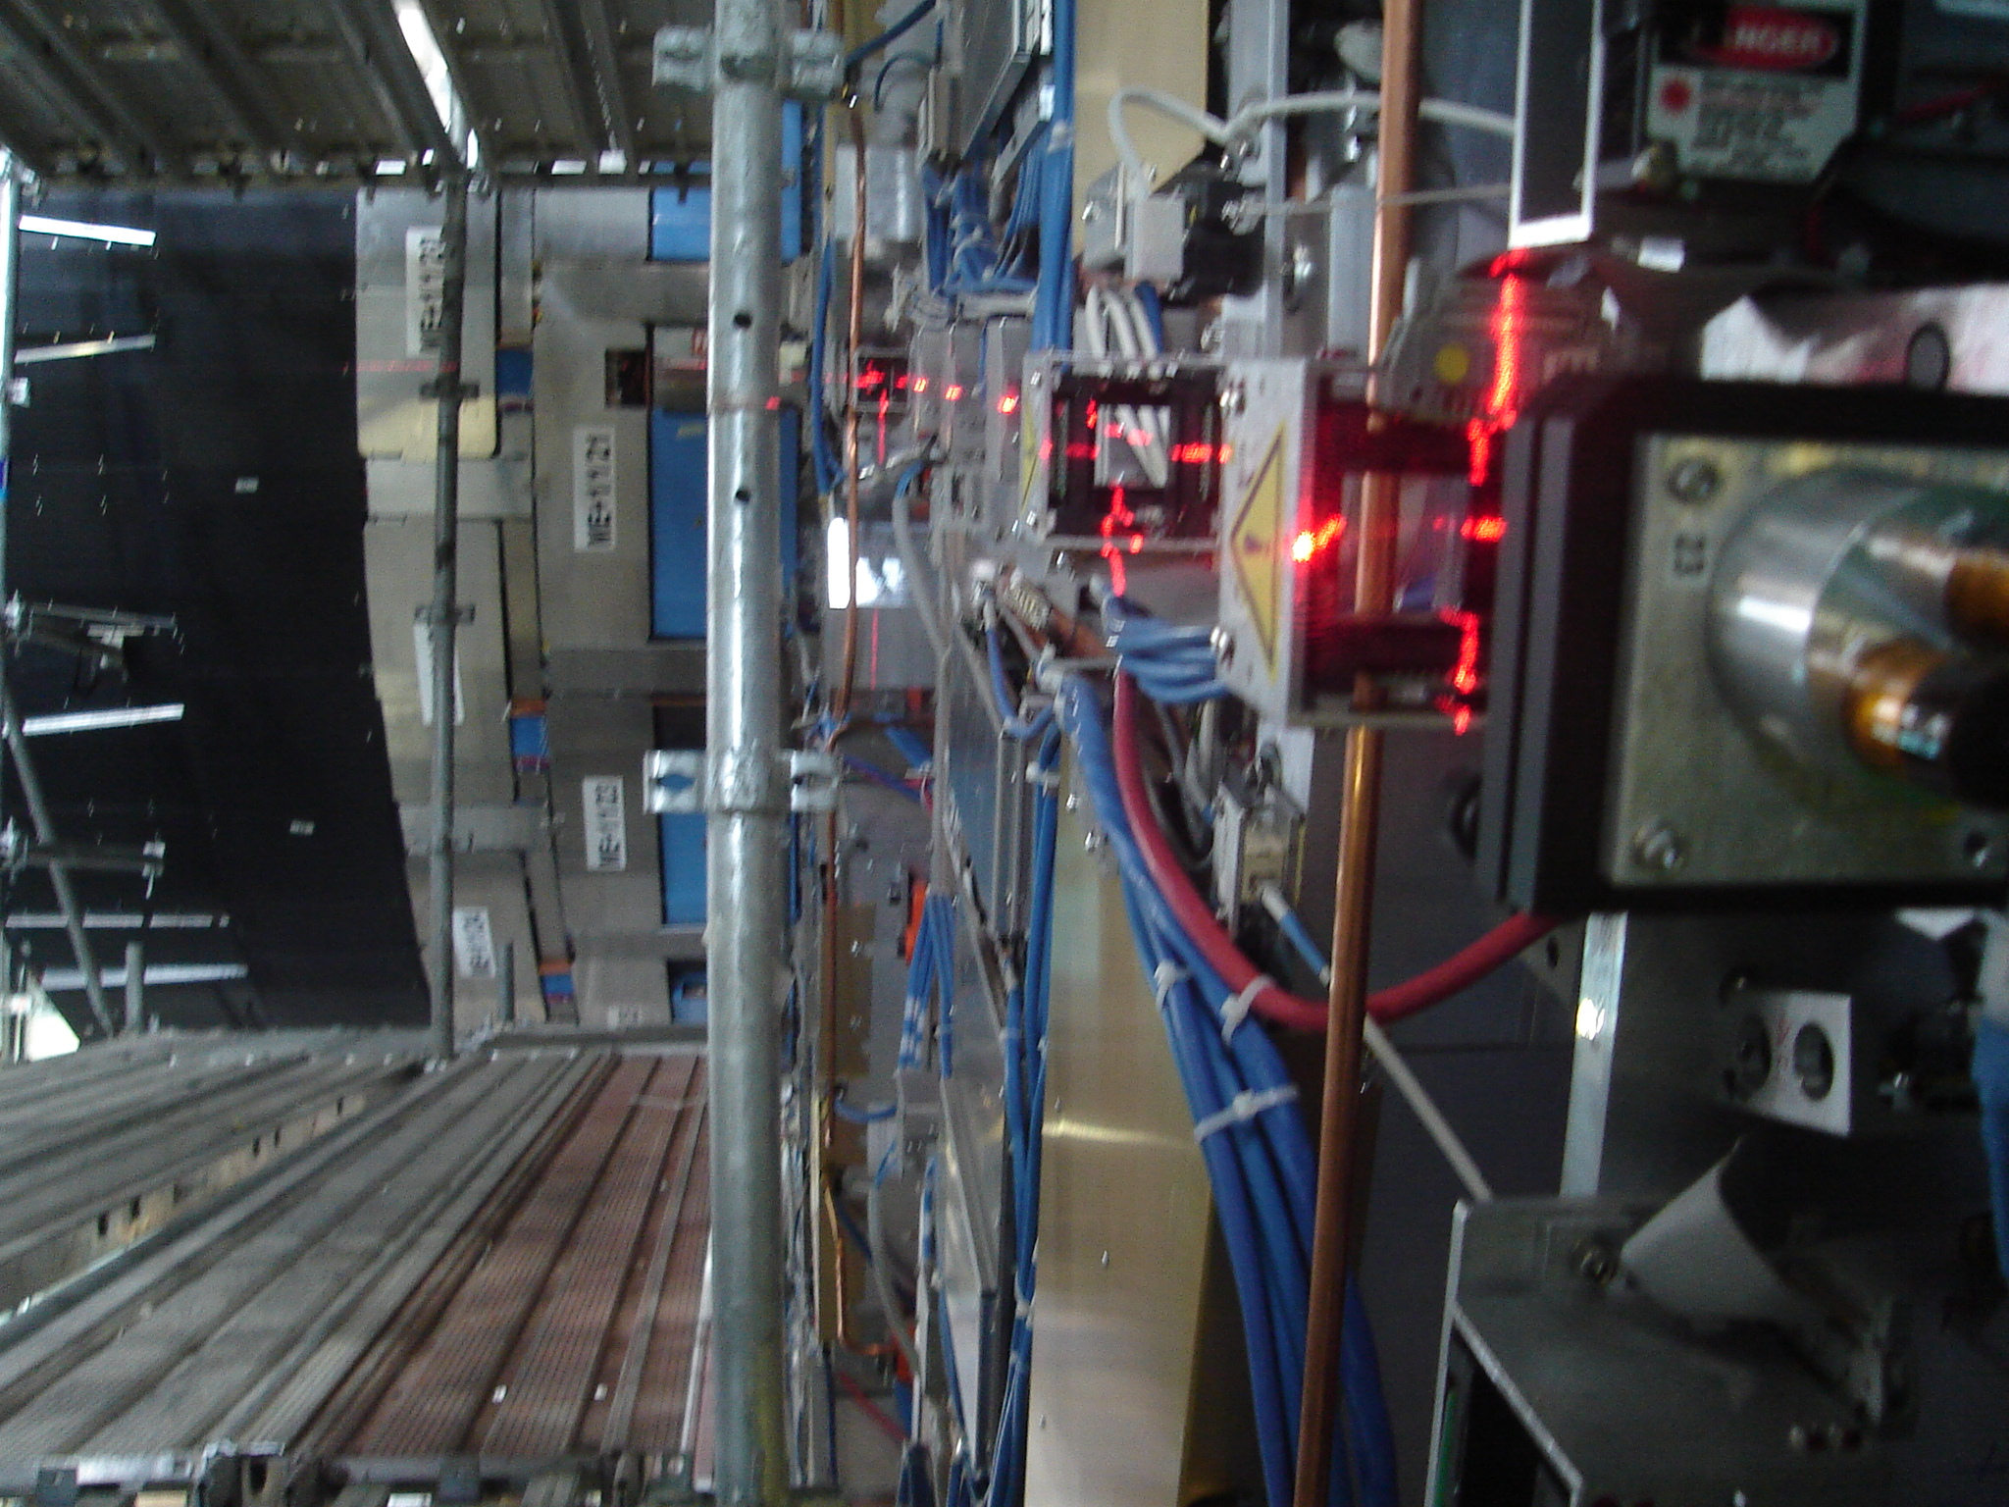

DCOPS Sensor

Laser
Z_{CMS}

CCD2

CCD3

CCD1
Rphi_{CMS}

CCD4

Figure 1 DCOPS sensor with laser

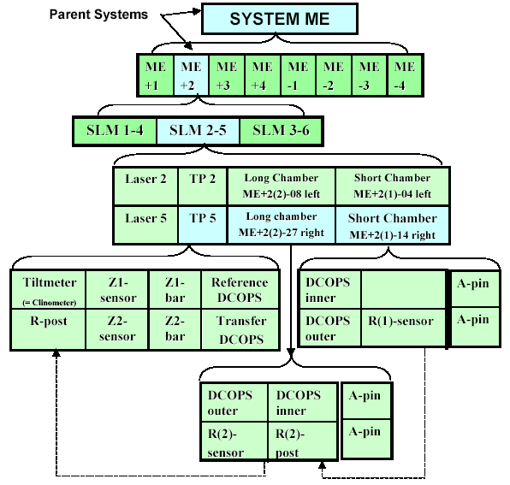

Figure 2 Full COCOA system hierarchy for ME+2 SLM 2-5 line
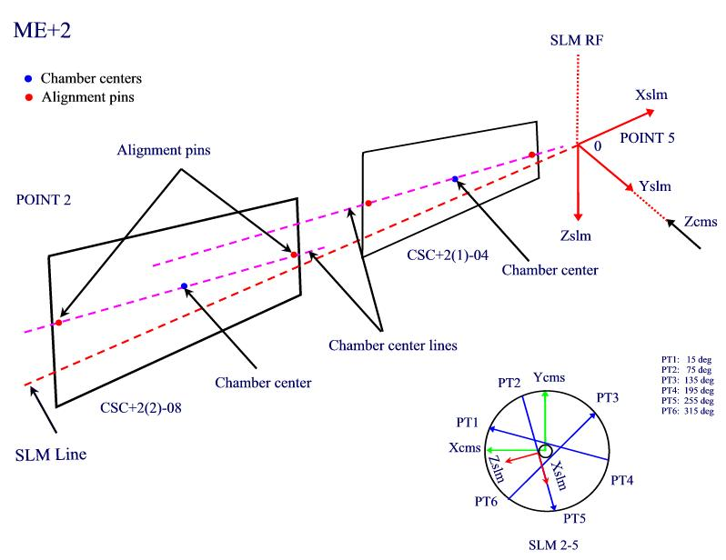

Figure 3 COCOA chamber centers and alignment pins
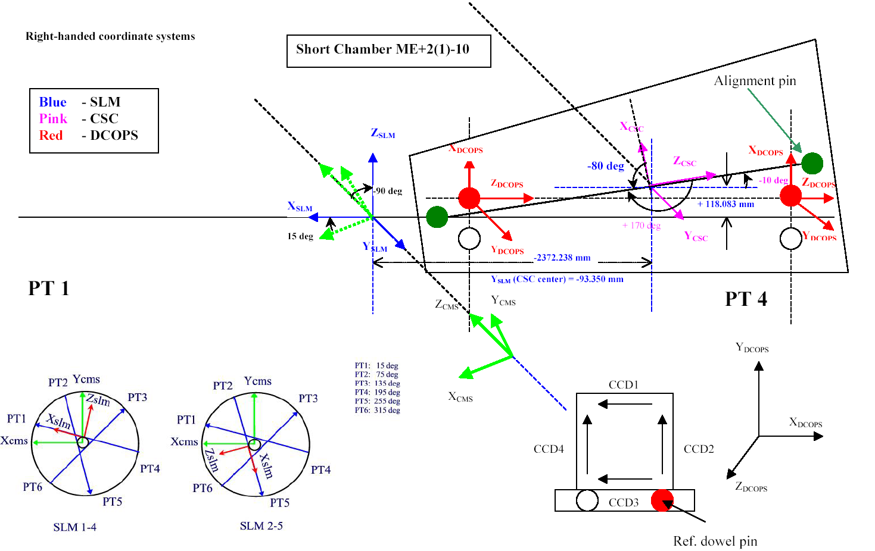

Figure 4 Coordinate transformations from Short Chamber ME+2(1)-10 to SLM 1-4 and from CMS to SLM 1-4

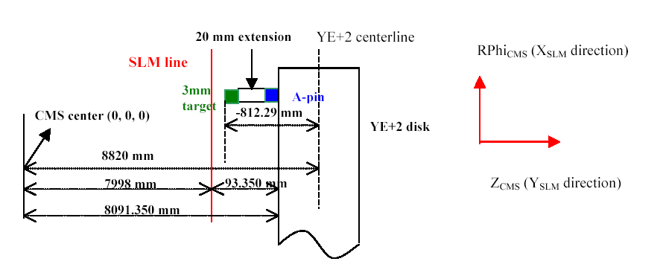
Figure 5 A-pin, PG target and extension on one of the ME+2(2) chamber
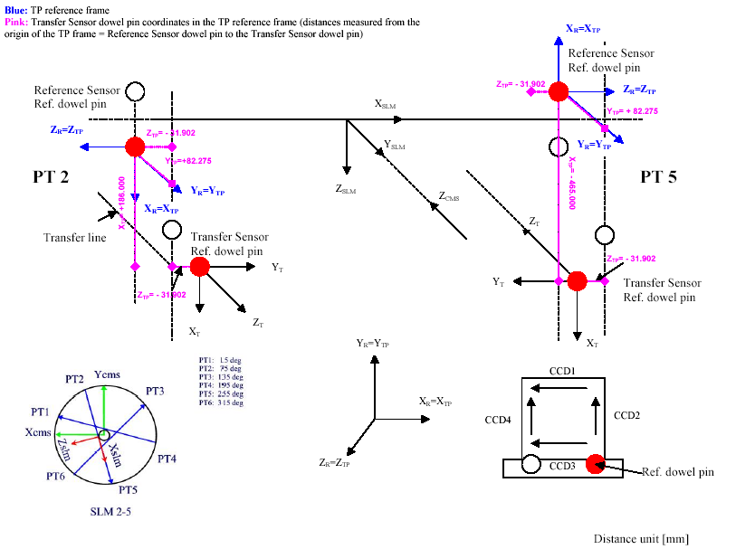

Figure 6 Coordinate transformations from Short Chamber ME+2(1)-10 to SLM 1-4 and from CMS to SLM 1-4
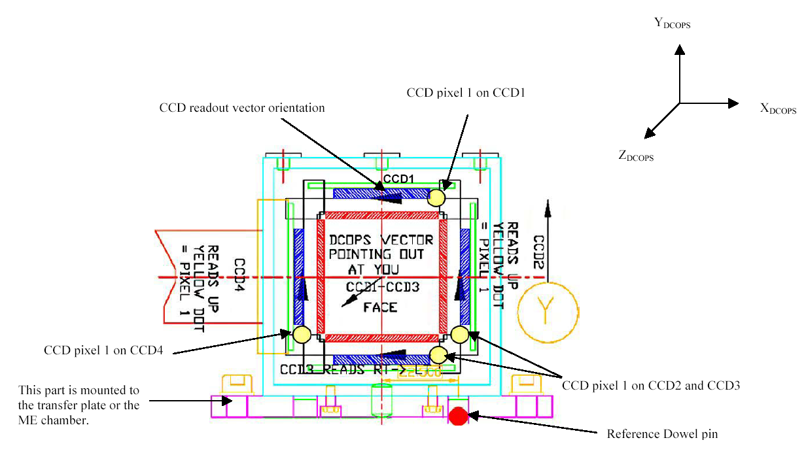

Figure 7 DCOPS CCD positions and readout vector orientations

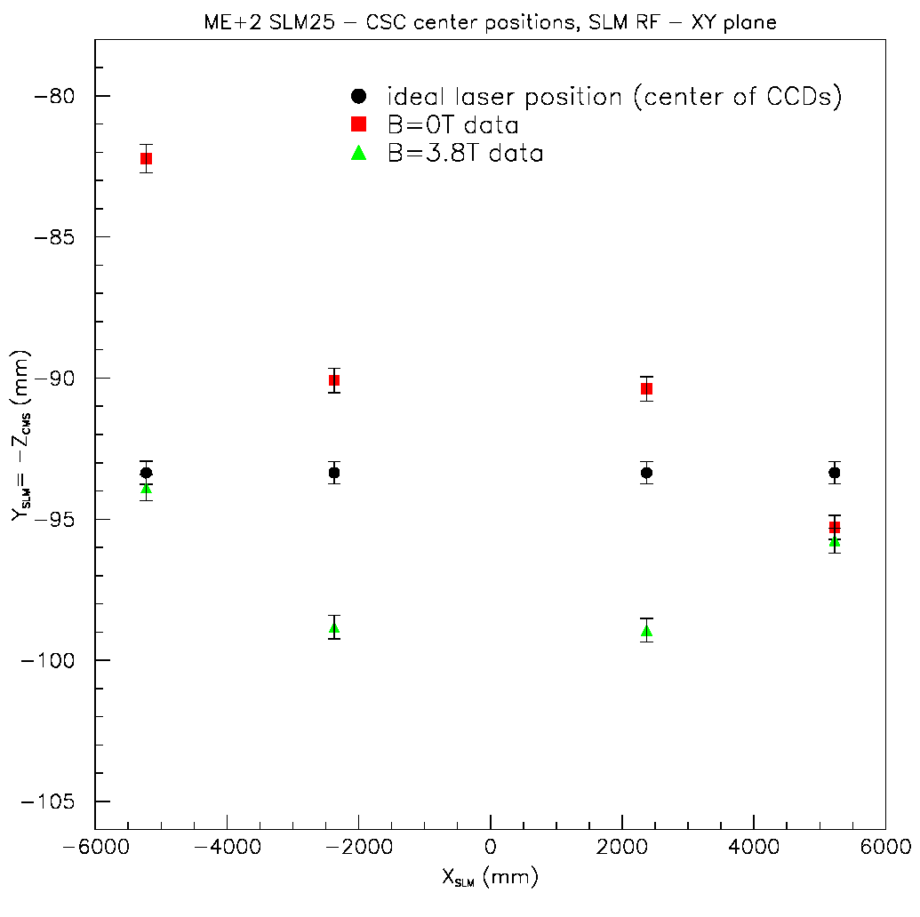
+Z_{CMS} direction
Figure 8 CSC chamber center movement in SLM X-Y plane (Y_{SLM}=Z _{CMS} direction)

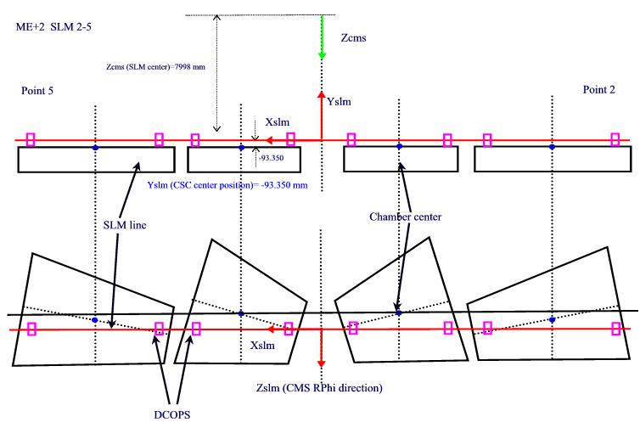

Figure 9 Projection of the chamber centers in SLM X-Y plane

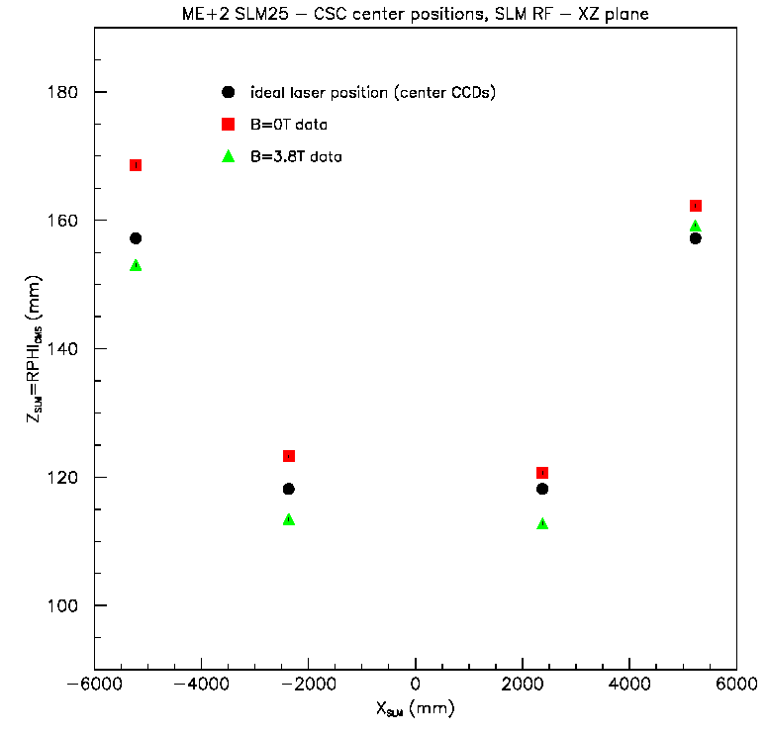

Figure 10 CSC chamber center movement in SLM X-Z plane (SLM X-Z=RPhi CMS plane)

Reference Frame | COCOA objects
CMS | SLM Line (SLM 2-5)
SLM Line (SLM 2-5) | ME+2(1)_14 (Short Chamber)
 | ME+2(1)_04 (Short Chamber)
 | ME+2(2)_27 (Long Chamber)
 | ME+2(2)_08 (Long Chamber)
ME+2(1)_14 | dcops_outer+21_14
 | dcops_inner+21_14
 | apin_outer+21_14
 | apin_inner+21_14
ME+2(1)_04 | dcops_inner+21_04
 | dcops_outer+21_04
 | apin_outer+21_04
 | apin_inner+21_04
ME+2(2)_27 | dcops_inner+21_27
 | dcops_outer+21_27
 | apin_outer+21_27
 | apin_inner+21_27
ME+2(2)_08 | dcops_inner+21_08
 | dcops_outer+21_08
 | apin_outer+21_08
 | apin_inner+21_08
SLM Line (SLM 2-5) | Transfer plate at Point 2
Transfer plate at Point 2 | las2_2
 | me+2_transfer2
 | me+2_reference2
SLM Line (SLM 2-5) | Transfer plate at Point 5
Transfer plate at Point 5 | las2_5
 | me+2_transfer5
 | me+2_reference5

Table 1 COCOA system hierarchy

Component | Placement in DCOPS Reference Frame
Component | X[mm] | Y[mm] | Direction of CCD vector  (first CCD pixel→last CCD pixel
CCD1 (Up) | -36.829 | 65.75 | +X
CCD2 (Right) | -8.171 | 57.579 | -Y
CCD3 (Down) | -36.829 | 20.75 | +X
CCD4 (Left) | -45 | 57.579 | -Y

Table 2 Distances from the DCOPS reference dowel pin to the first CCD pixel on each CCD [5]

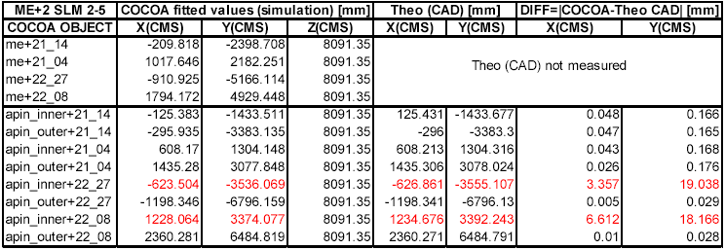

Table 3 Comparison of COCOA fits for ideal geometry with theoretical CAD values (red: positions of inner A-pin on ME+2(2) has to be verified)

DCOPS measurements with laser at point 5
dcops_outer+22_08>out |  |  | dcops_inner+22_08>out
CCD | Laser center [mm] | Uncertainty [mm] | CCD | Laser center [mm] | Uncertainty [mm]
U(CCD1) | 9.912 | 0.868 | U(CCD1) | 10.402 | 0.630
D(CCD2) | 10.458 | 0.798 | D(CCD2) | 15.772 | 3.374
L(CCD4) | 19.292 | 0.009 | L(CCD4) | 6.930 | 0.044
R(CCD2) | 0. | 28.672 | R(CCD2) | 10.304 | 5.348
Table 4 ME+2(2)-08 DCOPS measurements with crosshair laser at point 5 pointing towards the DCOPS

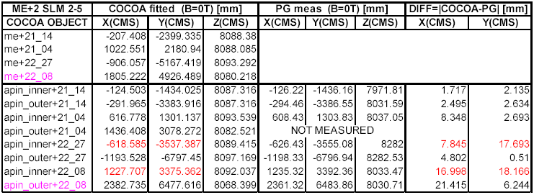
Table 5 Comparison between cocoa fitted values and measured photogrammetry values at B =0T (red: positions of inner A-pin on ME+2(2) has to be verified; pink: known problem with CCD readout)
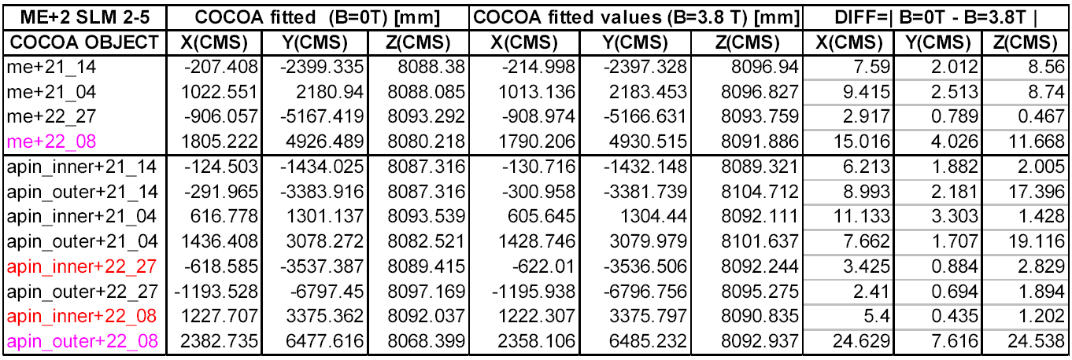
Table 6 Comparison between cocoa fitted values for B=0T and B=3.8 T data (red: positions of inner A-pin on ME+2(2) has to be verified; pink: known problem with CCD readout)

Appendix A

// Cocoa Simulation Script created by R. Lee, 13 Sept 2001
// Modified by Gyongyi Baksay - Fl. Tech, Sept 2006
//
// For chambers on in +X CMS side
// X (chamber draw.) -> -X (placement on COCOA chamber)
// Y (chamber draw.) -> -Z (placement on COCOA chamber)
// Z (chamber draw.) -> Y (placement on COCOA chamber)
//
// For chambers on in -X CMS side
// X (chamber draw.) -> X (placement on COCOA chamber)
// Y (chamber draw.) -> -Z (placement on COCOA chamber)
// Z (chamber draw.) -> Y (placement on COCOA chamber)
//
// Standard Y (Y SLM = Z CMS) offset is 51mm for standard bracket
// Standard Y (Y SLM = Z CMS) offset is 51mm for tower bracket
// These offsets are added to DCOPS mounting bracket offsets and
// include a standard shim between DCOPS mount and the bracket
// Installed system will have various sizes of shims between 4-7mmE
// This must be taken into account when shim arrangement is finalized
//
// Final AutoCad references checked and rechecked by Dave
// We expect chamber active center references are final
// Construction of Transfer Lines within 5-10 um
// Construction of SLM Lines within 10um
// Link Sensors centered (X,Y) on 2ndary Link Line (no offset)
//
// NO ADDITIONAL CHANGES IN LAYOUT OR GEOMETRY ARE EXPECTED

GLOBAL_OPTIONS
dumpOptOGlobalInReport 1
calParamInyfMatrix 1
report_verbose 3
save_matrices 1
debug_verbose 0

// 0 calculates cal+unk values
// 1 calculates only unk values
calcul_type 0

measurementErrorFromFile 1
FitQualityCut 0.1
reportOutReadSigma 0
//MaxNoFitIterations 5

//Set Script Units
length_value_dimension 1 // mm
length_error_dimension 2 // um
angle_value_dimension 3 // deg
angle_error_dimension 2 // urad

output_length_value_dimension 1//mm
output_length_error_dimension 2//um
output_angle_value_dimension 3//deg
output_angle_error_dimension 2//urad

//VRML, histogram Options (extra)

histograms 1
//VisOnly 1
//VisScale 1
//VisWriteVRML 2
VisWriteIguana 2

PARAMETERS

// x hair laser properties
prec_pos_las 200 // Uncertainty in package placement
prec_ang_las 100 // Uncertainty in package orientation
prec_ang_transfer_las 10 // Special Xlasers in Transfer Lines
prec_pos_link_las 10 // Uncertainty in Secondary Link laser
prec_ang_link_las 5 // Uncertainty in Secondary Link orientation

//apin uncertainty
prec_apin_pos 100
prec_apin_ang 100

//DCOPS Calibration Dowel-Pixel Parameters ( offset for pixels)
bi_cops_hCCDcal 57.579 // height above dowel
bi_cops_vCCDcal -36.829 // dist to left of dowel
bi_rightCCDX_disp -8.171
bi_leftCCDX2_disp -45
bi_upCCDY_disp 65.75
bi_downCCDY_disp 20.75

//DCOPS Calibration and CCD Resolution (error values)
cal_error_XCCD 65 // Uncertainty of NEU calibration
cal_error_YCCD 65 // Uncertainty of NEU calibration
prec_CCD 14 // precision of CCD measurements (sigma of mult meas)
prec_link_sensor2D 5 // precision of Link ME1/2 measurements

//Chamber Parameters
prec_chamber_pos_det 100 // global placement
prec_chamber_ang_det 100 // global orientation

// DCOPS Orientation Error on Chamber
prec_dowel_ang 2

//ME 1/2 Chamber Frame Parameters
// Frame must tie link outer sensor to DCOPS reference
// Precision relative to center of active area is same as other sensors
// Precision of link outer to DCOPS reference is on order of 50um

prec_me12chamber_ang_det 698
prec_chamber_xframe_det 83
prec_chamber_yframe_det 100
prec_chamber_zframe_det 523
prec_chamber_angframe_det 10

// Transfer Plate Uncertainty Definitions
prec_pos_det 100 // Local position error = ISR Result for ZMAB Sensor
prec_ang_det 2 // Local rotation placement error

prec_pos_tp 20 // Based on LCP8 ISR Long Term Data (20um)
prec_pos_me1tp 110 // Z4M Sensor required for ME1-MAB Standoff (100um)
prec_ang_tp 10 // Orientation of DCOPS on Transfer Plate
prec_ang_tilt 698 // Local rotation error = ISR Tiltmeter

// MAB Uncertainty Definitions
prec_pos_mab 135 // To be replaced with COCOA Link Script
prec_ang_mab 10 // These estimates are LINK
prec_pos_mab_det 50 // DCOPS location on MAB
prec_ang_mab_det 2

// Z (CMS) MAB+Transfer Line Bars/Distancemeters/Distancetargets
//
// Z Distance is measured via carbon fiber rod with two sensors on each end
// LCP8 sensor sig was 16um from ISR test
// MZ4D sensor sig was 102um from ISR test
//We can say rod is cut to 35um (.001" on each end) with no temp variation
//Adding 16, 102, 35 in quadrature gives 110um for MAB-ME1
//Adding 16, 35 in quadrature gives 39um for ME1-ME2, ME2-ME3, ME3-ME4

prec_pos_sv 50
prec_ang_sv 10
prec_pos_pg 50
prec_ang_pg 10
me1Zsensor_prec 110
Zsensor_prec 16 // Measurement precision of the LCP8 sensors

// ~~~~~ 10degree Chamber (Standard)

dowel_out_xref 1657.151
dowel_out_yref 280.199
dowel_out_zref 50.100
dowel_out_zref_tower 0

dowel_out_xref_error 100
dowel_out_yref_error 144
dowel_out_zref_error 538
dowel_out_zref_tower_error 538

dowel_in_xref 1317.833
dowel_in_yref 19.922
dowel_in_zref 50.100
dowel_in_zref_tower 0

dowel_in_xref_error 100
dowel_in_yref_error 144
dowel_in_zref_error 538
dowel_in_zref_tower_error 538

// ~~~~~ 10degree Chamber (ME1/3)

dowel_out13R1_xref 874.776
dowel_out13R1_yref 373.344
dowel_out13R1_zref 50.100

dowel_out13R2_xref 874.776
dowel_out13R2_yref 504.842
dowel_out13R2_zref 50.100

dowel_out13_xref_error 100
dowel_out13_yref_error 129
dowel_out13_zref_error 538

dowel_in13R1_xref 840.437
dowel_in13R1_yref 223.292
dowel_in13R1_zref 50.100

dowel_in13R2_xref 840.437
dowel_in13R2_yref 354.790
dowel_in13R2_zref 50.100

dowel_in13_xref_error 100
dowel_in13_yref_error 129
dowel_in13_zref_error 538

// ~~~~~ 20degree Chamber Type (ME1/2)

link_out_xref 880.221
link_out_yref 348.589
link_out_zref 220.000

link_in_xref 880.221
link_in_yref 194.571
link_in_zref 220.000

link_in_xref_error 100
link_in_yref_error 129
link_in_zref_error 538

link_ang_det 2

dowel_refR1_xref 1014.108
dowel_refR1_yref 366.822
dowel_refR1_zref 84.750

dowel_refR2_xref 1002.539
dowel_refR2_yref 498.330
dowel_refR2_zref 84.750

// Errors off of chamber frame

link_out_xref_error 56
link_out_yref_error 56
link_out_zref_error 160

dowel_refR_xref 56
dowel_refR_yref 56
dowel_refR_zref 160

// ~~~~~ 20degree Chamber Type ME2

dowel_out2_xref 992.094
dowel_out2_yref 272.081
dowel_out2_zref 50.100
dowel_out2_zref_tower 0

dowel_out2_xref_error 100
dowel_out2_yref_error 144
dowel_out2_zref_error 538
dowel_out2_zref_tower_error 538

dowel_in2_xref 884.330
dowel_in2_yref 13.107
dowel_in2_zref 50.100
dowel_in2_zref_tower 0

dowel_in2_xref_error 100
dowel_in2_yref_error 144
dowel_in2_zref_error 538
dowel_in2_zref_tower_error 538

// ~~~~~ 20degree Chamber Type ME3

dowel_out3_xref 892.145
dowel_out3_yref 272.081
dowel_out3_zref 50.100
dowel_out3_zref_tower 0

dowel_out3_xref_error 100
dowel_out3_yref_error 144
dowel_out3_zref_error 538
dowel_out3_zref_tower_error 538

dowel_in3_xref 776.567
dowel_in3_yref 22.158
dowel_in3_zref 50.100
dowel_in3_zref_tower 0

dowel_in3_xref_error 100
dowel_in3_yref_error 144
dowel_in3_zref_error 538
dowel_in3_zref_tower_error 538

// ~~~~~ 20degree Chamber Type me4

dowel_out4_xref 792.603
dowel_out4_yref 272.081
dowel_out4_zref 50.100
dowel_out4_zref_tower 0

dowel_out4_xref_error 100
dowel_out4_yref_error 144
dowel_out4_zref_error 538
dowel_out4_zref_tower_error 538

dowel_in4_xref 677.112
dowel_in4_yref 12.931
dowel_in4_zref 50.100
dowel_in4_zref_tower 0

dowel_in4_xref_error 100
dowel_in4_yref_error 144
dowel_in4_zref_error 538
dowel_in4_zref_tower_error 538

//---------- EXTRA ENTRIES
shift_det 0
devi_det 0

//---------- Precision of Calculation
prec_to_calc 100

SYSTEM_TREE_DESCRIPTION

object system slm_line
object slm_line 2 transfer_plate 2 Schamber 2 Lchamber
object transfer_plate Xlaser 2 COPS
object Schamber 2 COPS 2 APIN
object Lchamber 2 COPS 2 APIN

SYSTEM_TREE_DATA

system OCMS

// ~~~~~~~~~~~~~~~~~~~~~~~~~~~~~~~~~~~~~~~~~~~~~~~~~~~~~~~~~~~ //
// ~~~~~~~~~~~~~~~~~~~~~~~~~~~~~~~~~~~~~~~~~~~~~~~~~~~~~~~~~~~ //
// ME+2 SLM 2 //
// ~~~~~~~~~~~~~~~~~~~~~~~~~~~~~~~~~~~~~~~~~~~~~~~~~~~~~~~~~~~ //
// ~~~~~~~~~~~~~~~~~~~~~~~~~~~~~~~~~~~~~~~~~~~~~~~~~~~~~~~~~~~ //

slm_line slm22

centre

X 289.7777 1 fix
Y -77.6457 1 fix
Z 7998 1 fix

angles

X -90 1 fix
Y 0 1 fix
Z 255 1 fix

transfer_plate me+2_tp5

center
X 7175.833 prec_pos_det cal
Y -43.25 prec_pos_det cal
Z -22.500 prec_pos_det cal

angles

X 0 prec_ang_tilt cal
Y 90 prec_ang_tilt cal
Z 0 prec_ang_tilt cal

Xlaser las25
ENTRY {
angle angleBetweenAxis 90. prec_ang_las unk
}
center
X -22.500 prec_pos_tp cal
Y 43.25 prec_pos_tp cal
Z 0. prec_pos_tp fix

angles
X 0 prec_ang_tp cal
Y 0 prec_ang_tp cal
Z 0 prec_ang_tp cal

COPS me+2_reference5>in

ENTRY {
length rightCCDYtoDowel2 bi_cops_hCCDcal cal_error_YCCD cal
length leftCCDYtoDowel2 bi_cops_hCCDcal cal_error_YCCD cal
length rightCCDXtoDowel2 bi_rightCCDX_disp cal_error_XCCD cal
length leftCCDXtoDowel2 bi_leftCCDX2_disp cal_error_XCCD cal
length upCCDXtoDowel2 bi_cops_vCCDcal cal_error_XCCD cal
length upCCDYtoDowel2 bi_upCCDY_disp cal_error_YCCD cal
length downCCDXtoDowel2 bi_cops_vCCDcal cal_error_XCCD cal
length downCCDYtoDowel2 bi_downCCDY_disp cal_error_YCCD cal
}
centre

X 0 prec_pos_tp cal
Y 0 prec_pos_tp cal
Z 0 prec_pos_tp cal

angles

X 0 prec_ang_tp cal
Y 0 prec_ang_tp cal
Z 0 prec_ang_tp cal

COPS me+2_transfer5>out

ENTRY {
length rightCCDYtoDowel2 bi_cops_hCCDcal cal_error_YCCD cal
length leftCCDYtoDowel2 bi_cops_hCCDcal cal_error_YCCD cal
length rightCCDXtoDowel2 bi_rightCCDX_disp cal_error_XCCD cal
length leftCCDXtoDowel2 bi_leftCCDX2_disp cal_error_XCCD cal
length upCCDXtoDowel2 bi_cops_vCCDcal cal_error_XCCD cal
length upCCDYtoDowel2 bi_upCCDY_disp cal_error_YCCD cal
length downCCDXtoDowel2 bi_cops_vCCDcal cal_error_XCCD cal
length downCCDYtoDowel2 bi_downCCDY_disp cal_error_YCCD cal
}
centre

X -465.000 prec_pos_tp cal
Y 82.275 prec_pos_tp cal
Z -31.902 prec_pos_tp cal

angles

X 270 prec_ang_tp cal
Y 180 prec_ang_tp cal
Z 180 prec_ang_tp cal

transfer_plate me+2_tp2

centre

X -7175.829 prec_pos_det cal
Y -43.25 prec_pos_det cal
Z 22.500 prec_pos_det cal

angles

X 0 prec_ang_tilt cal
Y -90 prec_ang_tilt cal
Z 0 prec_ang_tilt cal

Xlaser las22
ENTRY {
angle angleBetweenAxis 90. prec_ang_las unk
}
center
X -22.500 prec_pos_tp cal
Y 43.25 prec_pos_tp cal
Z 0. prec_pos_tp fix
angles
X 0 prec_ang_tp cal
Y 0 prec_ang_tp cal
Z 0 prec_ang_tp cal

COPS me+2_reference2>in

ENTRY {
length rightCCDYtoDowel2 bi_cops_hCCDcal cal_error_YCCD cal
length leftCCDYtoDowel2 bi_cops_hCCDcal cal_error_YCCD cal
length rightCCDXtoDowel2 bi_rightCCDX_disp cal_error_XCCD cal
length leftCCDXtoDowel2 bi_leftCCDX2_disp cal_error_XCCD cal
length upCCDXtoDowel2 bi_cops_vCCDcal cal_error_XCCD cal
length upCCDYtoDowel2 bi_upCCDY_disp cal_error_YCCD cal
length downCCDXtoDowel2 bi_cops_vCCDcal cal_error_XCCD cal
length downCCDYtoDowel2 bi_downCCDY_disp cal_error_YCCD cal
}
centre
X 0 prec_pos_tp cal
Y 0 prec_pos_tp cal
Z 0 prec_pos_tp cal

angles

X 0 prec_ang_tp cal
Y 0 prec_ang_tp cal
Z 0 prec_ang_tp cal

COPS me+2_transfer2>in

ENTRY {
length rightCCDYtoDowel2 bi_cops_hCCDcal cal_error_YCCD cal
length leftCCDYtoDowel2 bi_cops_hCCDcal cal_error_YCCD cal
length rightCCDXtoDowel2 bi_rightCCDX_disp cal_error_XCCD cal
length leftCCDXtoDowel2 bi_leftCCDX2_disp cal_error_XCCD cal
length upCCDXtoDowel2 bi_cops_vCCDcal cal_error_XCCD cal
length upCCDYtoDowel2 bi_upCCDY_disp cal_error_YCCD cal
length downCCDXtoDowel2 bi_cops_vCCDcal cal_error_XCCD cal
length downCCDYtoDowel2 bi_downCCDY_disp cal_error_YCCD cal
}

centre
X 186.000 prec_pos_tp cal
Y 82.275 prec_pos_tp cal
Z -31.902 prec_pos_tp cal
angles

X 90 prec_ang_tp cal
Y 0 prec_ang_tp cal
Z 0 prec_ang_tp cal

//#14: short inner (1) chamber, Point5

Schamber me+21_14

centre
X 2371.279 prec_chamber_pos_det cal
Y -93.350 prec_chamber_pos_det unk
Z 118.16258 prec_chamber_pos_det unk //old 118.164

angles

X 0 prec_chamber_ang_det unk
Y 80 prec_chamber_ang_det unk
Z 0 prec_chamber_ang_det unk

COPS dcops_outer+21_14>in

ENTRY {
length rightCCDYtoDowel2 bi_cops_hCCDcal cal_error_YCCD cal
length leftCCDYtoDowel2 bi_cops_hCCDcal cal_error_YCCD cal
length rightCCDXtoDowel2 bi_rightCCDX_disp cal_error_XCCD cal
length leftCCDXtoDowel2 bi_leftCCDX2_disp cal_error_XCCD cal
length upCCDXtoDowel2 bi_cops_vCCDcal cal_error_XCCD cal
length upCCDYtoDowel2 bi_upCCDY_disp cal_error_YCCD cal
length downCCDXtoDowel2 bi_cops_vCCDcal cal_error_XCCD cal
length downCCDYtoDowel2 bi_downCCDY_disp cal_error_YCCD cal
}
centre

X dowel_out2_yref dowel_out2_yref_error cal
Y dowel_out2_zref dowel_out2_zref_error cal
Z dowel_out2_xref dowel_out2_xref_error cal

angles

X 0 prec_dowel_ang cal
Y 190 prec_dowel_ang cal
Z 0 prec_dowel_ang cal

COPS dcops_inner+21_14>in

ENTRY {
length rightCCDYtoDowel2 bi_cops_hCCDcal cal_error_YCCD cal
length leftCCDYtoDowel2 bi_cops_hCCDcal cal_error_YCCD cal
length rightCCDXtoDowel2 bi_rightCCDX_disp cal_error_XCCD cal
length leftCCDXtoDowel2 bi_leftCCDX2_disp cal_error_XCCD cal
length upCCDXtoDowel2 bi_cops_vCCDcal cal_error_XCCD cal
length upCCDYtoDowel2 bi_upCCDY_disp cal_error_YCCD cal
length downCCDXtoDowel2 bi_cops_vCCDcal cal_error_XCCD cal
length downCCDYtoDowel2 bi_downCCDY_disp cal_error_YCCD cal
}
centre

X -dowel_in2_yref dowel_in2_yref_error cal
Y dowel_in2_zref dowel_in2_zref_error cal
Z -dowel_in2_xref dowel_in2_xref_error cal

angles

X 0 prec_dowel_ang cal
Y 10 prec_dowel_ang cal
Z 0 prec_dowel_ang cal

APIN apin_inner+21_14

centre

X 0 prec_apin_pos fix
Y 0 prec_apin_pos fix
Z -968.883 prec_apin_pos fix

angles

X 0 prec_apin_ang fix
Y 0 prec_apin_ang fix
Z 0 prec_apin_ang fix

APIN apin_outer+21_14

centre

X 0 prec_apin_pos fix
Y 0 prec_apin_pos fix
Z 988.187 prec_apin_pos fix

angles

X 0 prec_apin_ang fix
Y 0 prec_apin_ang fix
Z 0 prec_apin_ang fix

//#04: short inner (1) chamber,Point 2

Schamber me+21_04

centre
X -2371.279 prec_chamber_pos_det cal
Y -93.350 prec_chamber_pos_det unk
Z 118.16258 prec_chamber_pos_det unk

angles

X 0 prec_chamber_ang_det unk
Y -80 prec_chamber_ang_det unk
Z 0 prec_chamber_ang_det unk

COPS dcops_inner+21_04>out

ENTRY {
length rightCCDYtoDowel2 bi_cops_hCCDcal cal_error_YCCD cal
length leftCCDYtoDowel2 bi_cops_hCCDcal cal_error_YCCD cal
length rightCCDXtoDowel2 bi_rightCCDX_disp cal_error_XCCD cal
length leftCCDXtoDowel2 bi_leftCCDX2_disp cal_error_XCCD cal
length upCCDXtoDowel2 bi_cops_vCCDcal cal_error_XCCD cal
length upCCDYtoDowel2 bi_upCCDY_disp cal_error_YCCD cal
length downCCDXtoDowel2 bi_cops_vCCDcal cal_error_XCCD cal
length downCCDYtoDowel2 bi_downCCDY_disp cal_error_YCCD cal
}
centre

X dowel_in2_yref dowel_in2_yref_error cal
Y dowel_in2_zref dowel_in2_zref_error cal
Z -dowel_in2_xref dowel_in2_xref_error cal

angles

X 0 prec_dowel_ang cal
Y 170 prec_dowel_ang cal
Z 0 prec_dowel_ang cal

COPS dcops_outer+21_04>out

ENTRY {
length rightCCDYtoDowel2 bi_cops_hCCDcal cal_error_YCCD cal
length leftCCDYtoDowel2 bi_cops_hCCDcal cal_error_YCCD cal
length rightCCDXtoDowel2 bi_rightCCDX_disp cal_error_XCCD cal
length leftCCDXtoDowel2 bi_leftCCDX2_disp cal_error_XCCD cal
length upCCDXtoDowel2 bi_cops_vCCDcal cal_error_XCCD cal
length upCCDYtoDowel2 bi_upCCDY_disp cal_error_YCCD cal
length downCCDXtoDowel2 bi_cops_vCCDcal cal_error_XCCD cal
length downCCDYtoDowel2 bi_downCCDY_disp cal_error_YCCD cal
}
centre

X -dowel_out2_yref dowel_out2_yref_error cal
Y dowel_out2_zref dowel_out2_zref_error cal
Z dowel_out2_xref dowel_out2_xref_error cal

angles

X 0 prec_dowel_ang cal
Y -10 prec_dowel_ang cal
Z 0 prec_dowel_ang cal

APIN apin_inner+21_04

centre

X 0 prec_apin_pos fix
Y 0 prec_apin_pos fix
Z -968.883 prec_apin_pos fix

angles

X 0 prec_apin_ang fix
Y 0 prec_apin_ang fix
Z 0 prec_apin_ang fix

APIN apin_outer+21_04

centre

X 0 prec_apin_pos fix
Y 0 prec_apin_pos fix
Z 988.187 prec_apin_pos fix

angles

X 0 prec_apin_ang fix
Y 0 prec_apin_ang fix
Z 0 prec_apin_ang fix

//# 27: long outer (2) chamber,Point5

Lchamber me+22_27

centre

X 5225.848 prec_chamber_pos_det cal
Y -93.350 prec_chamber_pos_det unk
Z 157.20274 prec_chamber_pos_det unk

angles

X 0 prec_chamber_ang_det unk
Y 85 prec_chamber_ang_det unk
Z 0 prec_chamber_ang_det unk

COPS dcops_outer+22_27>in

ENTRY {
length rightCCDYtoDowel2 bi_cops_hCCDcal cal_error_YCCD cal
length leftCCDYtoDowel2 bi_cops_hCCDcal cal_error_YCCD cal
length rightCCDXtoDowel2 bi_rightCCDX_disp cal_error_XCCD cal
length leftCCDXtoDowel2 bi_leftCCDX2_disp cal_error_XCCD cal
length upCCDXtoDowel2 bi_cops_vCCDcal cal_error_XCCD cal
length upCCDYtoDowel2 bi_upCCDY_disp cal_error_YCCD cal
length downCCDXtoDowel2 bi_cops_vCCDcal cal_error_XCCD cal
length downCCDYtoDowel2 bi_downCCDY_disp cal_error_YCCD cal
}
centre

X dowel_out_yref dowel_out_yref_error cal
Y dowel_out_zref dowel_out_zref_error cal
Z dowel_out_xref dowel_out_xref_error cal

angles

X 0 prec_dowel_ang cal
Y 185 prec_dowel_ang cal
Z 0 prec_dowel_ang cal

COPS dcops_inner+22_27>in

ENTRY {
length rightCCDYtoDowel2 bi_cops_hCCDcal cal_error_YCCD cal
length leftCCDYtoDowel2 bi_cops_hCCDcal cal_error_YCCD cal
length rightCCDXtoDowel2 bi_rightCCDX_disp cal_error_XCCD cal
length leftCCDXtoDowel2 bi_leftCCDX2_disp cal_error_XCCD cal
length upCCDXtoDowel2 bi_cops_vCCDcal cal_error_XCCD cal
length upCCDYtoDowel2 bi_upCCDY_disp cal_error_YCCD cal
length downCCDXtoDowel2 bi_cops_vCCDcal cal_error_XCCD cal
length downCCDYtoDowel2 bi_downCCDY_disp cal_error_YCCD cal
}
centre

X dowel_in_yref dowel_in_yref_error cal
Y dowel_in_zref dowel_in_zref_error cal
Z -dowel_in_xref dowel_in_xref_error cal

angles

X 0 prec_dowel_ang cal
Y 185 prec_dowel_ang cal
Z 0 prec_dowel_ang cal

APIN apin_inner+22_27

centre

X 0 prec_apin_pos fix
Y 0 prec_apin_pos fix
Z -1655.191 prec_apin_pos fix

angles

X 0 prec_apin_ang fix
Y 0 prec_apin_ang fix
Z 0 prec_apin_ang fix

APIN apin_outer+22_27

centre

X 0 prec_apin_pos fix
Y 0 prec_apin_pos fix
Z 1655.191 prec_apin_pos fix

angles

X 0 prec_apin_ang fix
Y 0 prec_apin_ang fix
Z 0 prec_apin_ang fix

//#08: long outer (2) chamber, front layer, LEFT side

Lchamber me+22_08

centre

X -5225.848 prec_chamber_pos_det cal
Y -93.350 prec_chamber_pos_det unk
Z 157.20274 prec_chamber_pos_det unk

angles

X 0 prec_chamber_ang_det unk
Y -85 prec_chamber_ang_det unk
Z 0 prec_chamber_ang_det unk

COPS dcops_inner+22_08>out

ENTRY {
length rightCCDYtoDowel2 bi_cops_hCCDcal cal_error_YCCD cal
length leftCCDYtoDowel2 bi_cops_hCCDcal cal_error_YCCD cal
length rightCCDXtoDowel2 bi_rightCCDX_disp cal_error_XCCD cal
length leftCCDXtoDowel2 bi_leftCCDX2_disp cal_error_XCCD cal
length upCCDXtoDowel2 bi_cops_vCCDcal cal_error_XCCD cal
length upCCDYtoDowel2 bi_upCCDY_disp cal_error_YCCD cal
length downCCDXtoDowel2 bi_cops_vCCDcal cal_error_XCCD cal
length downCCDYtoDowel2 bi_downCCDY_disp cal_error_YCCD cal
}
centre
X -dowel_in_yref dowel_in_yref_error cal
Y dowel_in_zref dowel_in_zref_error cal
Z -dowel_in_xref dowel_in_xref_error cal

angles

X 0 prec_dowel_ang cal
Y -5 prec_dowel_ang cal
Z 0 prec_dowel_ang cal

COPS dcops_outer+22_08>out

ENTRY {
length rightCCDYtoDowel2 bi_cops_hCCDcal cal_error_YCCD cal
length leftCCDYtoDowel2 bi_cops_hCCDcal cal_error_YCCD cal
length rightCCDXtoDowel2 bi_rightCCDX_disp cal_error_XCCD cal
length leftCCDXtoDowel2 bi_leftCCDX2_disp cal_error_XCCD cal
length upCCDXtoDowel2 bi_cops_vCCDcal cal_error_XCCD cal
length upCCDYtoDowel2 bi_upCCDY_disp cal_error_YCCD cal
length downCCDXtoDowel2 bi_cops_vCCDcal cal_error_XCCD cal
length downCCDYtoDowel2 bi_downCCDY_disp cal_error_YCCD cal
}
centre

X -dowel_out_yref dowel_out_yref_error cal
Y dowel_out_zref dowel_out_zref_error cal
Z dowel_out_xref dowel_out_xref_error cal

angles

X 0 prec_dowel_ang cal
Y -5 prec_dowel_ang cal
Z 0 prec_dowel_ang cal

APIN apin_inner+22_08

centre

X 0 prec_apin_pos fix
Y 0 prec_apin_pos fix
Z -1655.191 prec_apin_pos fix

angles

X 0 prec_apin_ang fix
Y 0 prec_apin_ang fix
Z 0 prec_apin_ang fix

APIN apin_outer+22_08

centre

X 0 prec_apin_pos fix
Y 0 prec_apin_pos fix
Z 1655.191 prec_apin_pos fix

angles

X 0 prec_apin_ang fix
Y 0 prec_apin_ang fix
Z 0 prec_apin_ang fix

MEASUREMENTS
// simulated value = real measurment (mm)
// flag for missed ccd = 0
// ~~~~~~~~~~~~~~~~~~~~~~~~~~~~~~~~~~~~~~~~~~~~~~~~~~~~~~~~~~~ //
// ~~~~~~~~~~~~~~~~~~~~~~~~~~~~~~~~~~~~~~~~~~~~~~~~~~~~~~~~~~~ //
// ME2 SLM 2 //
// ~~~~~~~~~~~~~~~~~~~~~~~~~~~~~~~~~~~~~~~~~~~~~~~~~~~~~~~~~~~ //
// ~~~~~~~~~~~~~~~~~~~~~~~~~~~~~~~~~~~~~~~~~~~~~~~~~~~~~~~~~~~ //

COPS id1

OCMS/slm22/me+2_tp2/las22 & OCMS/slm22/me+2_tp2/me+2_reference2>in

U simulated_value prec_CCD
D simulated_value prec_CCD
L simulated_value prec_CCD
R simulated_value prec_CCD

COPS id2

OCMS/slm22/me+2_tp2/las22 & OCMS/slm22/me+22_08/dcops_outer+22_08>out

U simulated_value prec_CCD
D simulated_value prec_CCD
L simulated_value prec_CCD
R simulated_value prec_CCD

COPS id3

OCMS/slm22/me+2_tp2/las22 & OCMS/slm22/me+22_08/dcops_inner+22_08>out

U simulated_value prec_CCD
D simulated_value prec_CCD
L simulated_value prec_CCD
R simulated_value prec_CCD

COPS id4

OCMS/slm22/me+2_tp2/las22 & OCMS/slm22/me+21_04/dcops_outer+21_04>out

U simulated_value prec_CCD
D simulated_value prec_CCD
L simulated_value prec_CCD
R simulated_value prec_CCD

COPS id5

OCMS/slm22/me+2_tp2/las22 & OCMS/slm22/me+21_04/dcops_inner+21_04>out

U simulated_value prec_CCD
D simulated_value prec_CCD
L simulated_value prec_CCD
R simulated_value prec_CCD

COPS id6

OCMS/slm22/me+2_tp2/las22 & OCMS/slm22/me+21_14/dcops_inner+21_14>in

U simulated_value prec_CCD
D simulated_value prec_CCD
L simulated_value prec_CCD
R simulated_value prec_CCD

COPS id7

OCMS/slm22/me+2_tp2/las22 & OCMS/slm22/me+21_14/dcops_outer+21_14>in

U simulated_value prec_CCD
D simulated_value prec_CCD
L simulated_value prec_CCD
R simulated_value prec_CCD

COPS id8

OCMS/slm22/me+2_tp2/las22 & OCMS/slm22/me+22_27/dcops_inner+22_27>in

U simulated_value prec_CCD
D simulated_value prec_CCD
L simulated_value prec_CCD
R simulated_value prec_CCD

COPS id9

OCMS/slm22/me+2_tp2/las22 & OCMS/slm22/me+22_27/dcops_outer+22_27>in

U simulated_value prec_CCD
D simulated_value prec_CCD
L simulated_value prec_CCD
R simulated_value prec_CCD

COPS id10

OCMS/slm22/me+2_tp2/las22 & OCMS/slm22/me+2_tp5/me+2_reference5>in

U simulated_value prec_CCD
D simulated_value prec_CCD
L simulated_value prec_CCD
R simulated_value prec_CCD

COPS id11

OCMS/slm22/me+2_tp5/las25 & OCMS/slm22/me+2_tp2/me+2_reference2>in

U simulated_value prec_CCD
D simulated_value prec_CCD
L simulated_value prec_CCD
R simulated_value prec_CCD

COPS id12

OCMS/slm22/me+2_tp5/las25 & OCMS/slm22/me+22_08/dcops_outer+22_08>out

U simulated_value prec_CCD
D simulated_value prec_CCD
L simulated_value prec_CCD
R simulated_value prec_CCD

COPS id13

OCMS/slm22/me+2_tp5/las25 & OCMS/slm22/me+22_08/dcops_inner+22_08>out

U simulated_value prec_CCD
D simulated_value prec_CCD
L simulated_value prec_CCD
R simulated_value prec_CCD

COPS id14

OCMS/slm22/me+2_tp5/las25 & OCMS/slm22/me+21_04/dcops_outer+21_04>out

U simulated_value prec_CCD
D simulated_value prec_CCD
L simulated_value prec_CCD
R simulated_value prec_CCD

COPS id15

OCMS/slm22/me+2_tp5/las25 & OCMS/slm22/me+21_04/dcops_inner+21_04>out

U simulated_value prec_CCD
D simulated_value prec_CCD
L simulated_value prec_CCD
R simulated_value prec_CCD

COPS id16

OCMS/slm22/me+2_tp5/las25 & OCMS/slm22/me+21_14/dcops_inner+21_14>in

U simulated_value prec_CCD
D simulated_value prec_CCD
L simulated_value prec_CCD
R simulated_value prec_CCD

COPS id17

OCMS/slm22/me+2_tp5/las25 & OCMS/slm22/me+21_14/dcops_outer+21_14>in

U simulated_value prec_CCD
D simulated_value prec_CCD
L simulated_value prec_CCD
R simulated_value prec_CCD

COPS id18

OCMS/slm22/me+2_tp5/las25 & OCMS/slm22/me+22_27/dcops_inner+22_27>in

U simulated_value prec_CCD
D simulated_value prec_CCD
L simulated_value prec_CCD
R simulated_value prec_CCD

COPS id19

OCMS/slm22/me+2_tp5/las25 & OCMS/slm22/me+22_27/dcops_outer+22_27>in

U simulated_value prec_CCD
D simulated_value prec_CCD
L simulated_value prec_CCD
R simulated_value prec_CCD

COPS id20

OCMS/slm22/me+2_tp5/las25 & OCMS/slm22/me+2_tp5/me+2_reference5>in

U simulated_value prec_CCD
D simulated_value prec_CCD
L simulated_value prec_CCD
R simulated_value prec_CCD

measurements_from_file slm_simu.txt
//measurements_from_file slm25_b4t_data.txt
//measurements_from_file slm25_b0t_data.txt

Appendix B

Transfer plate CAD drawings (by D. Eartly)

AFFLp-02.00.00BLK
AFFLp-02.00.00BLK
Appendix C (B=0 T data) Data from 10/31/06

DATE: 00/00/00 00:00

COPS id1

U 8.694 4.200
D 8.274 130.200
L 18.242 54.600
R 18.382 63.000

COPS id2

U 20.048 8.400
D 20.244 4.200
L 19.208 47.600
R 18.172 35.000

COPS id3

U 18.550 11.200
D 18.088 12.600
L 18.760 71.400
R 18.004 74.200

COPS id4

U 17.808 36.400
D 17.724 11.200
L 16.478 72.800
R 15.624 91.000

COPS id5

U 16.604 21.000
D 20.720 64.400
L 17.332 140.000
R 16.604 154.000

COPS id6

U 13.216 35.000
D 13.174 28.000
L 12.712 280.000
R 12.222 322.000

COPS id7

U 13.356 138.600
D 13.048 137.200
L 4.648 336.000
R 4.410 350.000

COPS id8

U 10.822 392.000
D 11.438 392.000
L 2.954 308.000
R 17.010 7.000

COPS id9

U 9.702 109.200
D 10.094 124.600
L 16.996 9.800
R 16.660 5.600

COPS id10

U 8.778 47.600
D 8.974 46.200
L 18.354 1.400
R 17.794 2.800

COPS id11

U 18.354 854.000
D 15.582 3290.000
L 18.354 4.200
R 18.494 4.200

COPS id12

U 9.912 868.000
D 10.458 798.000
L 19.292 9.800
R 0.000 28672.000

COPS id13

U 10.402 630.000
D 15.722 3374.000
L 6.930 44.800
R 10.304 5348.000

COPS id14

U 9.954 602.000
D 12.152 3220.000
L 6.440 57.400
R 7.504 3584.000

COPS id15

U 10.318 448.000
D 10.794 64.400
L 13.594 78.400
R 13.188 61.600

COPS id16

U 9.786 140.000
D 10.262 392.000
L 19.040 23.800
R 17.332 2898.000

COPS id17

U 0.000 28672.000
D 11.830 336.000
L 17.220 15.400
R 17.220 12.600

COPS id18

U 10.262 56.000
D 10.248 116.200
L 17.318 28.000
R 17.024 25.200

COPS id19

U 10.220 182.000
D 10.668 238.000
L 16.996 4.200
R 16.660 4.200

COPS id20

U 8.890 138.600
D 10.108 182.000
L 18.354 2.800
R 17.794 7.000

Appendix D (B=3.8 T data) Data from 10/25/06

DATE: 00/00/00 00:00

COPS id1

U 8.680 4.200
D 8.344 1.400
L 18.340 1.400
R 18.508 2.800

COPS id2

U 20.118 5.600
D 20.300 4.200
L 19.250 4.200
R 18.214 5.600

COPS id3

U 18.634 4.200
D 18.172 14.000
L 18.060 7.000
R 17.318 5.600

COPS id4

U 17.920 5.600
D 19.264 14.000
L 15.750 11.200
R 14.868 2.800

COPS id5

U 16.982 40.600
D 17.486 68.600
L 16.702 7.000
R 15.904 4.200

COPS id6

U 13.132 7.000
D 15.512 64.400
L 20.650 19.600
R 20.104 14.000

COPS id7

U 13.188 26.600
D 19.432 75.600
L 21.448 18.200
R 21.294 21.000

COPS id8

U 11.368 26.600
D 20.524 133.000
L 22.316 29.400
R 0 28672.000

COPS id9

U 9.156 29.400
D 11.928 49.000
L 26.222 39.200
R 25.830 43.400

COPS id10

U 7.700 33.600
D 10.640 168.000
L 27.566 252.000
R 0 28672.000

COPS id11

U 15.932 121.800
D 0 28672.000
L 25.368 1400.000
R 25.368 64.400

COPS id12

U 12.572 70.000
D 0 28672.000
L 25.802 114.800
R 25.172 71.400

COPS id13

U 12.516 63.000
D 0 28672.000
L 21.126 46.200
R 20.650 5.600

COPS id14

U 12.278 54.600
D 0 28672.000
L 18.158 72.800
R 17.612 50.400

COPS id15

U 12.054 53.200
D 12.026 57.400
L 16.772 28.000
R 16.324 39.200

COPS id16

U 11.088 53.200
D 11.522 44.800
L 17.234 12.600
R 17.010 22.400

COPS id17

U 13.132 98.000
D 13.104 224.000
L 15.946 8.400
R 15.904 11.200

COPS id18

U 10.752 26.600
D 10.752 12.600
L 16.198 19.600
R 15.848 14.000

COPS id19

U 10.234 7.000
D 10.724 5.600
L 17.052 2.800
R 16.730 4.200

COPS id20

U 8.708 2.800
D 9.898 116.200
L 18.354 2.800
R 17.780 8.400

Appendix E (simulation: ideal laser position)

DATE: 00/00/00 00:00

COPS id1

U 14.329 14
D 14.329 14
L 14.329 14
R 14.329 14

COPS id2

U 14.329 14
D 14.329 14
L 14.329 14
R 14.329 14

COPS id3

U 14.329 14
D 14.329 14
L 14.329 14
R 14.329 14

COPS id4

U 14.329 14
D 14.329 14
L 14.329 14
R 14.329 14

COPS id5

U 14.329 14
D 14.329 14
L 14.329 14
R 14.329 14

COPS id6

U 14.329 14
D 14.329 14
L 14.329 14
R 14.329 14

COPS id7

U 14.329 14
D 14.329 14
L 14.329 14
R 14.329 14

COPS id8

U 14.329 14
D 14.329 14
L 14.329 14
R 14.329 14

COPS id9

U 14.329 14
D 14.329 14
L 14.329 14
R 14.329 14

COPS id10

U 14.329 14
D 14.329 14
L 14.329 14
R 14.329 14

COPS id11

U 14.329 14
D 14.329 14
L 14.329 14
R 14.329 14

COPS id12

U 14.329 14
D 14.329 14
L 14.329 14
R 14.329 14

COPS id13

U 14.329 14
D 14.329 14
L 14.329 14
R 14.329 14

COPS id14

U 14.329 14
D 14.329 14
L 14.329 14
R 14.329 14

COPS id15

U 14.329 14
D 14.329 14
L 14.329 14
R 14.329 14

COPS id16

U 14.329 14
D 14.329 14
L 14.329 14
R 14.329 14

COPS id17

U 14.329 14
D 14.329 14
L 14.329 14
R 14.329 14

COPS id18

U 14.329 14
D 14.329 14
L 14.329 14
R 14.329 14

COPS id19

U 14.329 14
D 14.329 14
L 14.329 14
R 14.329 14

COPS id20

U 14.329 14
D 14.329 14
L 14.329 14
R 14.329 14

3) CMSSW and COCOA related information

HOW TO START WITH THIS PROJECT?

Register with FERMILAB:

When you register with Fermilab (as an off-site user) you automatically get
several accounts.
Here is the web link where you can apply for the accounts and cryptocard:
https://computing.fnal.gov/cgi-bin/remedy/Remote.pl
Login to Fermilab account:

ssh –t username@cmsuaf.fnal.gov
(or if you wan to use xterm: ssh –x username@cmsuaf.fnal.gov )

If you have firewall you may need to use:
ssh –C –X cmsuaf.fnal.gov –l username
{otherwise you cannot use Xserver on your local machine}

Cryptocard:

To login to your Fermilab account use the following sequence of buttons on your cryptocard:

Menu (on screen: Pin?)
Enter your pin number (Pin # provided at Fermilab registration; this can be changed to any pin number at first use)
Ent (on screen: Contrast)
Menu (on screen: ReSync)
Ent (on screen: blinking cursor)
Enter your 8 digit challenge number (shown at login to Fermilab account)
Ent (on screen: 8 digit displayed response)
Enter your 8 digit displayed number (shown at login to Fermilab account)

Steps to build CMSSW frame in your own directory:

Start:

Create work and project directories:
mkdir work
mkdir project

Create file muon_lpc_setup.csh to setup environment:

Settings in muon_lpc_setup.csh file:
source /afs/fnal.gov/files/code/cms/setup/cshrc uaf
setenv SCRAM_ARCH slc3_ia32_gcc323
setenv GEANEUSED TRUE
cd /uscms/home/your_username/work/cocoa {this is your work directory where you will create your local CMSSW project. }

Use the following command line at each startup/login:
source muon_lpc_setup.csh

To create CMSSW project:

scramv1 list {lists current projects & directories}
cd “link to project”
{link example:/uscms/prod/sw/cms/Releases/CMSSW/CMSSW_version #}
eval `scramv1 run –csh` {set local environment}
cd “work directory” {work directory defined in muon_lpc_setup.csh}
scramv1 project CMSSW CMSSW_version# {create a project in own directory}
cd CMSSW_version#/src
project CMSSW
cmscvsroot CMSSW
cvs login {password: “98passwd”}
cvs co Alignment { this should create also cocoa.cpp, BuildFile, etc.… in the /src/Alignment/CocoaApplication/bin directory}
cvs co CondFormats

Note: Update to a new CMSSW version is recommended but not necessary all the time.
Update of “Alignment” & “CondFormats” is required with each new CMSSW release.

To build cocoa:

cd /uscms/home/username/work/cocoa/CMSSW_version#/src/Alignment/CocoaApplication/bin
eval ‘scramv1 run –csh`
scramv1 build

this will put cocoa (executable) in
/uscms/home/username/work/cocoa/CMSSW_version#/bin/slc3_ia32_gcc323/bin
directory {own directory}

at next login, if set eval ‘scramv1 run –csh` cocoa will run from your directory.

An example how to run cocoa:

There is an example .txt file in the /uscms/home/username/work/cocoa/CMSSW_version#/bin/slc3_ia32_gcc323/bin directory {simple2D.txt}

Use:
cocoa simple2D.txt

To request xml output from cocoa (versions before CMSSW_1_2_0_pre8 )

Uncomment lines {take out /* and */}

/* ALIstring…
xmlname…
CocoaToDDL…
*/

also {take out //} from

//#include “OpticalAlignment …./CocoaToDDLMgr.h”

build cocoa again:

scramv1 build

run cocoa again (on text file):

cocoa filename.txt

now this will create also an xml output:

filename.txt.xml

How to run IGUANA (this setup works only in some older CMSSW versions; example: CMSSW_0_4_1 ). Ask for Iguana support for new versions of CMSSW. You will need the proper .cfg and configuration file to be able to open your file with new iguana versions.

If logged in for the first time start with
source muon_lpc_setup.csh

then:

cd …/CMSSW_version#/…. (in own directory)
eval `scramv1 run -csh` {you can use any subdirectory from CMSSW_version# to set environment}
which iguana

Note: “which iguana” shows that iguana runs from the directory:
/uscms/prod/sw/cms/Releases/IGUANA/IGUANA_version#/bin/slc3_ia32_gcc323/iguana

Iguana is linked to your local CMSSW_verion# project.
See configuration file: /uscms/home/username/work/cocoa/CMSSW_version#/src/config/CMSconfiguration

cd to your analysis directory, where you should have the files:

configuration.xml
geom-nofield.cfg {has an include call to configuration.xml}
filename.txt {cocoa input file}
filename.xml {cocoa output file; you should get this when you run cocoa}

run iguana using:

iguana –p geom-nofield.cfg &

Iguana is functional only in:

/uscms/home/username/work/cocoa/CMSSW_0_4_1

set ‘eval’ in this directory to run iguana! (eval `scramv1 run -csh`)

Note: One can use a different CMSSW frame to run cocoa (example: CMSSW_0_6_0_pre1). Be careful! Once you set ‘eval’ in this CMSSW directory the new iguana version will be linked. To use the old iguana version change directory to /uscms/home/username/work/cocoa/CMSSW_0_4_1 and set ‘eval’ again.

COCOA related settings & modifications

Default GLOBAL_OPTIONS can be set in:

…/CMSSW#/src/Alignment/CocoaUtilities/src/GlobalOptionMgr.cc file

To change these default values use the GLOBAL_OPTIONS section in the COCOA SDF file.

Note: earlier cocoa versions (versions before CMSSW_1_2_0_pre8) cannot provide CMS coordinates in the report.out (cocoa output) file.

In the new CMSSW versions (CMSSW_1_2_0_pre8 & up) the following default value is included in the GlobalOptionMgr.cc file:

theGlobalOptions[ ALIstring("dumpOptOGlobalInReport") ] = 0;

To obtain COCOA fitted values in CMS coordinates:

To get cocoa fitted values in global CMS coordinates set

dumpOptOGlobalInReport 1
in the GLOBAL_OPTIONS section of the system description file (SDF)= cocoa input text file.
Histograms:

There is no default histogram in COCOA.
You can produce histograms the standard CMSSW way.

To get a short output for the unknown values set:

histograms 1

in the Global_Options section.

To set fit quality:

FitQualityCut #

“#” = your value

default value is 0.1 set in GlobalOptionMgr.cc file.

[Ref]: /afs/cern.ch/user/r/rivero/public/magnetest-complete.txt (cd to this directory on your fnal.gov account)
This is an example file from link people.
(Celso Martinez Rivero, e-mail: mrivero@ifca.unican.es)

To understand cocoa fits also take a look at:

http://cmsdoc.cern.ch/cms/MUON/alignment/software/COCOA/LeastSquareMethods/

To be able to choose dimensions for the output:

In the file Alignment/CocoaUtilities/src/ALIUtils.cc there is a variable that contains the dimension factor for lengths:
ALIUtils::OutputLengthValueDimensionFactor()
Replace in OpticalObjectMgr::dumpOptOsGlobal( std::ostream& out ) const
{
ALIUtils::dump3v( (*vocite)->centreGlobal(), (name + " CENTRE GLOBAL: ").c_str(), out );
by
ALIUtils::dump3v( (*vocite)->centreGlobal()/ALIUtils::OutputLengthValueDimensionFactor(), (name + " CENTRE GLOBAL: ").c_str(), out );

To suppress the long list of correlation output:

…/CMSSW#/src/Alignment/CocoaFit/src (“…/” is your work directory)
(GB’s current version: CMSSW_1_2_0_pre8)

In the Fit.cc file:

void Fit::dumpEntryCorrelations( ALIFileOut& fileout, const int nEntUnk )
{
ALIdouble minCorrel = 1.E-6;
set minCorrel to a high value (will get a correlation output in the report.out file for CORR values above the minCorrel value)

Here are some useful links to COCOA related documents:

http://home.fnal.gov/~maeshima/alignment/COCOA/COCOA_Simulation.htm

http://cmsdoc.cern.ch/~arce/alignment/

http://cmsdoc.cern.ch/~arce/alignment/doc/cocoa.html

http://cmsdoc.cern.ch/~arce/alignment/doc/basic_objects.html

Link to documentation about cocoa fits:
http://cmsdoc.cern.ch/cms/MUON/alignment/software/COCOA/LeastSquareMethods/

